Mathematics 5N1833 – Trial Paper Solutions

2024

Course(s):
AA [Applied Science: Laboratory Techniques]
AB [Applied Biology: Food Health & Nutrition]
Extra Maths

Total Marks: 800marks

Weighting: 40%

Time Allowed: 2 Hours

Section A (400 Marks)
10 short questions.
Answer ALL 10
40 marks each
1. |  | Determine the equation of a line in the form  $y=mx+c$ if the points (1,2) and (3,4) are on the line  Slope m = $\frac{y2-y1}{x2-x1}$ = $\frac{4-2}{3-1}$ = $1$  Equation = $y-y1=m(x-x1)$  $$y-2=1\left(x-1\right)$$  $$y-2=x-1$$  $$y=x+1$$ | 40 marks
2. |  | The age distribution of a group of people who wear glasses is shown on this histogram.
200
150
100
50
0 |  | 10 |  | 20 |  | 30 |  |  |  | 50
 |  |  |  |  |  |  |  |  | Age-group

 |  | If there are 200 people in the 20 – 30 age-group, find
 | (i) | The number of people in the 30 – 50 age group 150 | 20 marks
 | (ii) | The total number of people wearing glasses = 75+50+50+200+150 = 525 | 20 marks
3. |  | How many different 3-digit numbers can be formed from the digits 1, 2, 3, 4
 | (i) | If no digit is repeated in the number? $=4*3*2=24$ | 20 marks
 | (ii) | How many of these begin with 3? = $1*3*2=6$ | 20 marks
4. |  | a  4cm  a  d  55º  40º  c  b
In the given triangle abc, ad ⊥ bc.
If ǀadǀ = 4cm, ǀ$∠$abdǀ = 55º and ǀ$∠$acdǀ = 40º,
 | (i) | Find ǀbcǀ to 1 decimal place  $tan40=\frac{4}{dc}$ $dc=\frac{4}{tan40}= 4.8$  $tan55=\frac{4}{bd} bd=\frac{4}{tan55}=$2.8  $$bc=bd+dc$$  $=4.8+2.8=7.6$cm | 20 marks
 | (ii) | Find ǀacǀ to 1 decimal place  $${ac}^{2}={ad}^{2}+{dc}^{2}$$  ${ac}^{2}$= $4^{2}$+${4.8}^{2 }$  $$=39.04$$  $$∴ac=\sqrt{39.04}=6.2$$ | 20 marks
5. |  | Using differentiation, calculate the slope of the tangent to the curve  $$y=2x^{3}-x^{2}+5 at x=3$$  $$\frac{dy}{dx}=6x^{2}-2x$$  Slope $when x=3,$ = $\frac{dy}{dx}=$6($3^{2})-2\left(3\right)=48$ | 40 marks
6. |  | $$If f\left(x\right)= \frac{x-1}{4}$$
 | (i) | Find $f\left(6\right)$  $$f\left(6\right)= \frac{6-1}{4}=\frac{5}{4}$$ | 20 marks
 | (ii) | Find $f^{-1}\left(3\right)$  $$x→\frac{x-1}{4}$$  $$4x→x-1$$  $$4x+1→x$$  $$f^{-1}\left(x\right)=4x+1$$  $$f^{-1}\left(3\right)=4\left(3\right)+1=13$$ | 20 marks
7. |  | $$y=2sinx+{2e}^{4x} find the derivative \frac{dy}{dx}$$  $$\frac{dy}{dx}= 2cosx+8e^{4x}$$ | 40 marks
8. |  | Evaluate $\int{(3x^{3}-cos2x+e^{4x})dx}$  =$\frac{{3x}^{4}}{4}$ -$\frac{\sin{2x}}{2}+\frac{e^{4x}}{4}+c$ | 40 marks
9. |  | If $w=3-5i$ and $z=4+6i$evaluate the following:
 | (i) | $$z-3w$$  $$4+6i-3\left(3-5i\right)=4+6i-9+15i$$  $$=-5+21i$$ | 20 marks
 | (ii) | $$\frac{z }{2w}$$  $$=\frac{\left(4+6i\right)}{\left(6-10i\right)}\frac{\left(6+10i\right)}{\left(6+10i\right)}$$  $$= \frac{24+76i+60i^{2}}{36-100i^{2}}$$  $$=\frac{24+76i-60}{36+100}$$  $$=\frac{-36+76i}{136}$$  $$=\frac{-36}{136}+\frac{76i}{136}$$  $$\frac{-9}{34}+\frac{19i}{34}$$ | 20 marks
10. |  | Calculate the size of the angle at vertex A (angle CAB) in the triangle below. Give your answer correct to one decimal place, if necessary. | 40 marks
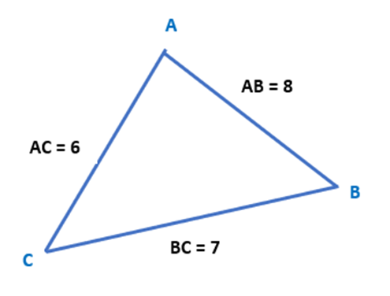
$$let ∠CAB=A$$
$$a=7, b=6, c=8$$

$$a^{2}=b^{2}+c^{2}-2bc\cos{A}$$

$$7= 6^{2}+8^{2}-2\left(6\right)\left(8\right)cosA$$

$$49=36+64-96\cos{A}$$

$$\cos{A=\frac{36+64-49}{96}}=0.53125$$

$$A=\cos^{-1}{0.53125={57.9}^{0} }$$

Section B (200 Marks)
2 Structured Questions.
Answer ALL questions
100 marks each
1. | (a) | The equation of the line$l$ is $y=5x+2$
 | (i) | Find the slope of a line perpendicular to line$l$  $$m=-\frac{1}{5}$$ | 10 marks
 | (ii) | Find the equation of the line $m$ perpendicular to line $l$ and which passes through the point (-2, 1)  $$y-y1=m(x-x1)$$  $$y-1=-\frac{1}{5}\left(x-\left(-2\right)\right)$$  $$y-1=-\frac{1}{5}(x+2)$$  $$5y-5=-x-2$$  $$x+5y-3=0$$ | 10 marks
 | (b) | Draw a graph of $f\left(x\right)=x^{3}+3x^{2}-4x-12$  `  in the domain $\left\{-3≪x≪2\right\}, x∈R$  x x³ 3x² -4x -12 f(x)  -3 -27 27 12 -12 0  -2 -8 12 8 -12 0  -1 -1 3 4 -12 -6  0 0 0 0 -12 -12  1 1 3 -4 -12 -12  2 8 12 -8 -12 0  x f(x)  -3 0  -2 0  -1 -6  0 -12  1 -12  2 0 | 30 marks
 |  | Use the graph to write down the following
 | (i) | Roots of the equation $f\left(x\right)=0$  $$x=-3, -2, 2$$  $$Points: \left(-3,0\right), \left(-2,0\right), (2,0)$$ | 10 marks
 | (ii) | Find the coordinates of the local minimum point. (0.53,-13.1) | 10 marks
 | (iii | Find the coordinates of the local maximum point. (-2.53, 1.13) | 10 marks
 | (iv | The domain of values of x for which $f\left(x\right)$is negative  -2 $<x<$ 2 | 10 marks
 | (v) | The domain of values of x for which $f\left(x\right)$is negative and increasing. | 10 marks
 |  | 0.53 $<x<$2
2. | (a)
 | (i) | Explain in your own words what is meant by the term ‘mode’ in relation to statistics?  Mode is the value that appears most often in a set of data values | 10 marks
 | (ii) | Complete the cumulative frequency table below from the given grouped frequency distribution table.  Length in mm (x) 1-5 6-10 11-15 16-20 21-25 26-30 31-35  Frequency (f) 4 8 10 12 11 6 4
 |  | Length in mm (x) ≤5 ≤10 ≤15 ≤20 ≤25 ≤30 ≤35  Frequency (f) 4 12 22 34 45 51 55 | 10 marks
 |  | Using the cumulative frequency table above, draw the cumulative frequency curve(ogive) on graph paper and use your graph to provide answers for the following:  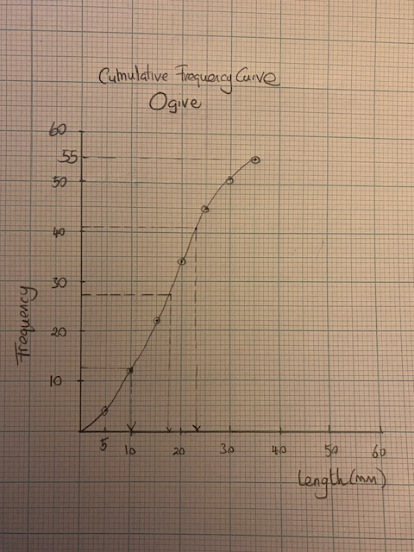 | 10 marks
 | (iii) | Interquartile range  Upper quartile value at frequency of 41.25 (75% of 55) = approx. 23mm  Lower quartile value at frequency of 13.75 (25% of 55 = approx. 10mm  Interquartile range = 23-10 = 13mm | 10 marks
 | (iv) | Median  Median – Value at middle frequency of 27.5 (50% of 55) – approx. 17.5mm | 10 marks
2. | (b) | A card is selected at random from a pack of 52 and then replaced. A second card is then selected. What is the probability that
 | (i) | The first card is a heart = $\frac{13}{52}=\frac{1}{4}$ | 10 marks
 | (ii) | Both cards are hearts =$\frac{13}{52}.\frac{13}{52}=\frac{1}{4}.\frac{1}{4}$ = $\frac{1}{16}$ | 10 marks
 | (iii) | The first card is red and the second card is black  $\frac{26}{52}.\frac{26}{52}=\frac{1}{2}.\frac{1}{2}$ = $\frac{1}{4}$ | 10 marks
 | (iv) | The first card is a queen and the second card is black  $\frac{4}{52}.\frac{26}{52}=\frac{1}{13}.\frac{1}{2}$ = $\frac{1}{26}$ | 10 marks
 | (v) | Neither card is a heart  $\frac{39}{52}.\frac{39}{52}=\frac{3}{4}.\frac{3}{4}$ = $\frac{9}{16}$ | 10 marks

Section C (200 Marks)
2 structured questions. Answer ALL 2.
100 marks each
3. | (a) | Differentiate with respect to x
 |  | $y=\frac{ 2x^{2}-2x+5}{x-3}$  $$quotient rule: u= 2x^{2}-2x+5 v=x-3$$  $$\frac{dy}{dx}=\frac{v.\frac{du}{dx}-u.\frac{dv}{dx}}{v^{2}}$$  $$\frac{du}{dx}= 4x-2 \frac{dv}{dx}=1$$  $$\frac{dy}{dx}=\frac{\left(x-3\right).\left(4x-2\right)-\left(2x^{2}-2x+5\right).1}{{(x-3)}^{2}}$$  $$\frac{dy}{dx}=\frac{4x^{2}-14x+6-2x^{2}+2x-5}{x^{2}-6x+9}$$  $$\frac{dy}{dx}=\frac{2x^{2}-12x+1}{x^{2}-6x+9}$$ | 30 marks
 | (b) | Using integration, find the area bound by the curve  $y={2x}^{2}-x+3$ the $x axis$ and the lines $x=2$ and $x=4$  $$\int_{2}^{4}{{(2x}^{2}-x+3)dx}$$  $$=\left\lceil \frac{{2x}^{3}}{3}-\frac{x^{2}}{2}+3x+c\right\rceil \begin{matrix}4 \\ 2\end{matrix}$$  $=\left\lfloor \frac{{2(4}^{3})}{3}-\frac{({4)}^{2}}{2}+3\left(4\right)+c\right\rfloor$–$\left\lfloor \frac{{2(2}^{3})}{3}-\frac{{(2}^{2})}{2}+3\left(2\right)+c\right\rfloor$  =$\left[\frac{128}{3}-\frac{16}{2}+12+c\right]-\left[\frac{16}{3}-2+6+c\right]$  = $\frac{112}{3}$  = 37$\frac{1}{3}{units}^{2}$ | 30 marks
 | (c) | Find the turning points of the curve $y=\frac{x^{3}}{3}+\frac{x^{2}}{2}-2x$  and determine if they are minimum or maximum turning points  $$y=\frac{x^{3}}{3}+\frac{x^{2}}{2}-2x$$  $$\frac{dy}{dx}= x^{2}+x-2$$  $$\frac{dy}{dx}= 0$$  $$x^{2}+x-2 =0$$  $$\left(x+2\right)\left(x-1\right)=0$$  $$x=-2 or x=1$$  $$when x=-2 y=\frac{10}{3}$$  $$∴\left(-2,\frac{10}{3}\right)is a turning point$$  $$when x=1 y=-\frac{7}{6}$$  $$∴\left(1,-\frac{7}{6}\right)is also a turning point$$  $$\frac{{dy}^{2}}{{dx}^{2}}=2x+1$$  $$At x=-2 \frac{{d^{2}y}^{ }}{{dx}^{2}}=-3 which is negative ∴local max$$  $$∴\left(-2,\frac{10}{3}\right)is a maximum turning point$$  $$At x=1 \frac{{d^{2}y}^{ }}{{dx}^{2}}=3 which is positive ∴local min$$  $$∴\left(-2,\frac{10}{3}\right) is a minimum turning point$$ | 20 marks  20 marks
4. | (a) | Solve for $x$and $y$ in the following equation
 |  | $2\left(x+yi\right)=4\left(2+3i\right)-2(1-2i)$  $$2x+2yi=8+12i-2+4i$$  $$2x+2yi=6+16i$$  $$2x=6 ∴x=3$$  $$2y=16 ∴y=8$$ | 30 marks
 | (b) | Evaluate $i^{8}$  $$={\sqrt{-1}}^{8}$$  =${\left(\sqrt{-1}.\sqrt{-1}\right).\left(\sqrt{-1}.\sqrt{-1}\right).\left(\sqrt{-1}.\sqrt{-1}\right).(\sqrt{-1})}^{ }(\sqrt{-1})$  = (-1)(-1)(-1))(-1) = 1 | 20 marks
 | (c) | Solve the complex equation $z^{2}-5z+15=0$  Write your answers in the form a+bi  $$z=\frac{-b±\sqrt{b^{2}-4ac}}{2a}$$  $$\frac{5±\sqrt{{-5}^{2}-4\left(1\right)\left(15\right)}}{2\left(1\right)}$$  =$\frac{5±\sqrt{25-60}}{\begin{aligned}2 \\ \end{aligned}}$  $$= \frac{5±\sqrt{-35}}{2}$$  $$=\frac{5±\sqrt{35} i}{2}$$  $$z=\frac{5}{2}+\frac{\sqrt{35}}{2} i or z= \frac{5}{2}-\frac{\sqrt{35}}{2} i$$ | 50 marks

