Negative Angles
When a line is rotated in a clockwise direction it generates a negative angle. Some negative angles are shown below:

60˚
150˚

-60˚

-150˚

Example 1
Find cos 168˚
The cos ratio is negative in the 2nd quadrant.
168˚
=> cos 168˚ = - cos (180˚ - 168˚)
12˚
= - cos 12˚
= - 0.9781

Example 2
If tan A = ¾ , find two values for sin A, where 0˚ ≤ A ≤ 360˚, giving your answers as fractions.
90˚

tan A = ¾ => sin A = ³/₅
5
3
tan +

A
180˚
0˚
4
tan +

If tan A = ¾ , then A may be an angle
270˚
- between 0˚ and 90˚, or
- between 180˚ and 270˚, since the tan ratio is positive in both of these quadrants.

=> sin A = ³/₅ (1st quadrant) or – ³/₅ (3rd quadrant).

Questions
Use a calculator to write down the values of these ratios:
(i) sin 134˚ (ii) cos 210˚ (iii) tan 318˚ (iv) cos 159˚
(v) tan 311˚ (vi) sin 197˚ (vii) cos 330˚ (viii) tan 254˚

If tan 120 = -tan 60, copy and complete the following in the same way:
(i) sin 140˚ = (ii) tan 104˚ = (iii) cos 210˚ =
(iv) tan 290˚ = (v) sin 254˚ = (vi) cos 153˚ =

If sin A = 0.2483, find 2 values of A if 0˚ ≤ A ≤ 360˚

If tan B = -1.2474, find 2 values of B if 0˚ ≤ B ≤ 360˚

Find A if sin A = -⁴/₅ and cos A = -³/₅

If tan A = ½ and 180˚ < A < 270˚, which of the following is equal to sin A?
(i) ²/_{√ 5} (ii) -¹/_{√ 5} (iii) -²/_{√ 5} (iv) ¹/_{√ 5}

Trigonometric Graphs
Graph and Analyse the Functions y = sin x, y = cos x, y = tan x

Consider the function f: → ; x → sin x

The field of all rational and irrational numbers is called the real numbers, or simply the "reals," and denoted .

The set of reals is denoted by .
(in this case π and √3 are irrational)

A function is a mathematical relation such that each element of one set is associated with at least one element of another set.

By preparing a table of values, we can plot the graph of y = f(x) = sin x

for -2π ≤ x ≤ 2π

x | -2π | -^{3π}/₂ | -π | -^{π}/₂ | 0 | ^{π}/₂ | π | ^{3π}/₂ | 2π
y = sin x | 0 | 1 | 0 | -1 | 0 | 1 | 0 | -1 | 0

Thus, the following set of points belongs to the curve y = sin x:

{(-2π, 0), (-^{3π}/₂, 1), (-π, 0), (-^{π}/₂, -1), (0, 0), (^{π}/₂, 1), (π, 0), (^{3π}/₂, -1), (2π, 0)}

y = sin x
(see also Google: y = sin x)

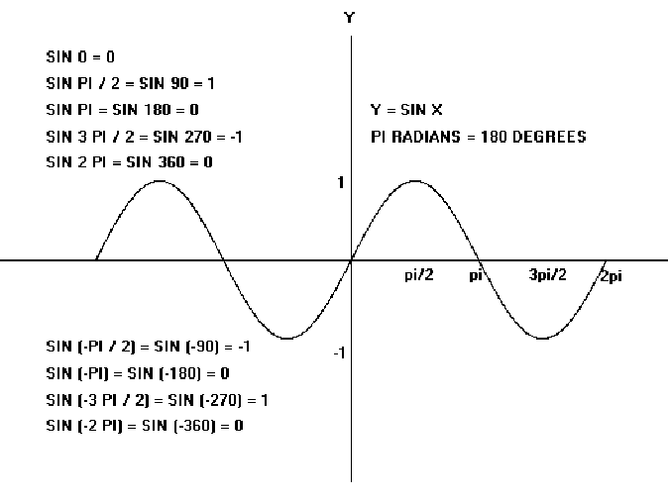
y = sin x

We must notice certain features of the graph.
- The graph is smooth, i.e. there are no sharp points. It is rounded at the top and at the bottom. This could easily be verified by taking many more values of x between those already taken.
- The range of the function, i.e. the interval from the lowest y-value to the greatest y-value is [-1, 1]. Thus

-1 ≤ sin x ≤ 1, for all x

- The graph follows a regular pattern, so we could easily have extended it in either direction by continuing this pattern.
2π

In fact the graph maybe considered
to be a row of the ‘building blocks’ shown on the right, continued to infinity in each direction.

A graph, which has this property, is said to be periodic, and the period is the horizontal length of the building block. It is clear from the graph that the period of
y = sin x is 2π, or 360˚.

Note 1: The graph of f: R → R; x → cos x, i.e y = cos x can be constructed in the same way and is shown below.

x | -2π | -^{3π}/₂ | -π | -^{π}/₂ | 0 | ^{π}/₂ | π | ^{3π}/₂ | 2π
y = cos x | 1 | 0 | -1 | 0 | 1 | 0 | -1 | 0 | 1
Graph of:
y = cos x

Note 2: The shape of the cosine graph is the same as that of the sine graph. Indeed, the cosine graph may be considered as the sine graph simply shifted ^{π}/₂ to the left. Thus, the cosine graph has a range [-1, 1] and period 2π, or 360˚.

Note 3: The graph of the function f: x → tan x is unlike the graph of either a sine or cosine function. On constructing a table of values, we obtain the following graph.

x | -2π | -^{3π}/₂ | -π | -^{π}/₂ | 0 | ^{π}/₂ | π | ^{3π}/₂ | 2π
y = tan x | 0 | ∞ | 0 | ∞ | 0 | ∞ | 0 | ∞ | 0

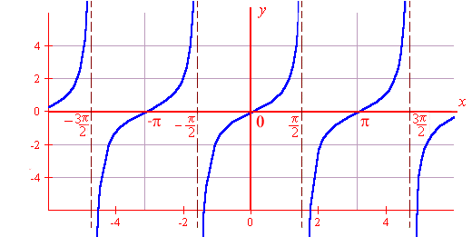
y = tan x

From the graph above, note that:
- The function is not defined for x = ± ^{π}/_{2,} ± ^{3π}/₂, ……., where it tends to infinity.
- The range of the function is , i.e. - ∞ < tan x < ∞, for all x ε .
- The function is periodic, and its period is π, or 180˚.

Derive the Period, amplitude and Phase of Trigonometric Functions
Sine and cosine functions have the form of a periodic wave:

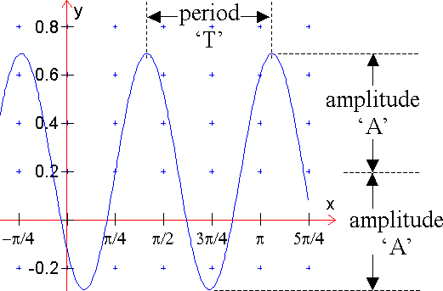
Range
  - The period, T, is the distance between any two repeating points on the function.
  - The amplitude, A, is the distance from the midpoint to the highest or lowest point of the function.
  - Phase shift is the amount of horizontal displacement of the function from its original position.

A function of the form f(x) = a + b sin (cx + ε)

is called a sine function. The graph of a sine function is similar to that of y = sin x, but its period, range and location may be different. In the same way, the graph of the cosine function
f(x) = a + b cos (cx + ε)

is similar to that of y = cos x.

The sine function f(x) = a + b sin (cx + ε) and the cosine function
f(x) = a + b cos (cx + ε) have

- range = [a – b, a + b] if b > 0, or [a + b, a – b] if b < 0
- period = 2π or 360˚
c c
Example 1
Find the range and the period of f(x) = 2 – 3 sin (3x + ^{π}/₂)

Solution
- Range = [2 – 3, 2 + 3] = [-1, 5]
- Period = ^{2π}/₃ = ^{360˚}/₃ = 120˚

Note 5: In practice, one very efficient approach to sketching the graph of a sine function or cosine function is to:

- Write down the period and the range.
- Construct a small table of values, with intervals of one quarter of the period, for one period only. Take as the starting value that value of the variable that makes the angle equal to zero.
- Extend the graph to the required domain.

Example 2
Sketch a graph of the function

f: x → 1 – 2 sin (3x + ^{π}/₂), for –π ≤ x ≤ π

Solution
Period = ^{2π}/₃. Quarter of period = ^{2π}/₃ * ¼ = ^{π}/₆.

Range = [1 – 2, 1 + 2] = [-1, 3]

Put angle = 0. => 3x + ^{π}/₂ = 0 => x = - ^{π}/₆

X | - ^{π}/₆ | 0 | ^{π}/₆ | ^{π}/₃ | ^{π}/₂
3x + ^{π}/₂ | 0 | ^{π}/₂ | π | ^{3π}/₂ | 2π
sin (3x + ^{π}/₂) | 0 | 1 | 0 | -1 | 0
- 2 sin (3x + ^{π}/₂) | 0 | -2 | 0 | 2 | 0
y = 1 – 2 sin (3x + ^{π}/₂) | 1 | -1 | 1 | 3 | 1

Plot these points and extend to – π ≤ x ≤ π
f: x → 1 – 2 sin (3x + ^{π}/₂), for –π ≤ x ≤ π

We model cyclical behaviour using the sine and cosine functions. An easy way to describe these functions is as follows. Imagine a bicycle wheel whose radius is one unit, with a marker attached to the rim of the rear wheel, as shown in the following figure.
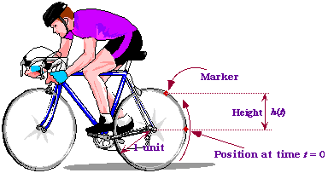

As the wheel rotates, the height h(t) of the marker above the centre of the wheel, fluctuates between 1 and +1.The faster the wheel rotates, the faster the oscillation. Let us now choose our units of measurement so that the wheel has a radius of one unit. Then the circumference of the wheel (the distance all around) is known to be 2, where = 3.14159265.... When the outer edge of the wheel has travelled this distance, it has gone through exactly one revolution, and so it is back where it started. Thus, if at time t = 0 the marker started off at position h(0) = 0, then it is back to zero after one revolution. If the cyclist happens to be moving at a speed of one unit per second, it will take the bicycle wheel 2 seconds to make one complete revolution, and so the wheel is back where it started after that time.

The function h(t) we get in the above way is called the sine function, denoted by sin(t). Here is its graph.
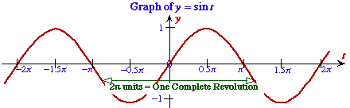

Sine Function

Bicycle Wheel Definition
If a wheel of radius 1 unit rotates at a speed of 1 unit of length per second, and is in the position shown in the figure at time t = 0, then its height after t seconds is given by h(t) = sin(t).

Geometric Definition
The sine of a real number t is given by the y-coordinate (height) of the point P in the following diagram, in which t is the distance of the arc shown.
sin(t) = y-coordinate of the point P.
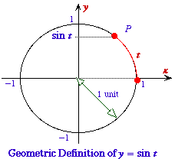

Introduction to Microsoft Excel (data entry, charts of various functions)

Example 1
Function f(x)=x²-3x+5 in the domain –3 to 4.

x | -3 | -2 | -1 | 0 | 1 | 2 | 3 | 4
x² | 9 | 4 | 1 | 0 | 1 | 4 | 9 | 16
-3x | 9 | 6 | 3 | 0 | -3 | -6 | -9 | -12
+5 | +5 | +5 | +5 | +5 | +5 | +5 | +5 | +5
f(x) | 23 | 15 | 9 | 5 | 3 | 3 | 5 | 9

Example 2

f(x)=sin x
x | 0 | 45 | 90 | 135 | 180 | 225 | 270 | 315 | 360
Sin x | 0 | .707 | 1 | .707 | 0 | -.707 | -1 | -.707 | 0

Example 3

f(x)=e^{x}
X | -3.0 | -2.5 | -2.0 | -1.5 | -1.0 | -0.5 | 0 | 0.5 | 1 | 1.5 | 2.0 | 2.5 | 3.0
e^{x} | 0.05 | 0.08 | 0.14 | 0.22 | 0.37 | 0.61 | 1 | 1.65 | 2.72 | 4.48 | 7.39 | 12.18 | 20.09
e^{-x} | 20.09 | 12.18 | 7.39 | 4.48 | 2.72 | 1.65 | 1 | 0.61 | 0.37 | 0.22 | 0.14 | 0.08 | 0.05

Questions
Find the period and range of each of the following functions:
- f(x) = 3 + 2 sin 5x
- f(x) = 3 – 2 sin (^{π}/₃ – x)
- f(x) = -1 + sin 3x
- f(x) = 4 cos 2x
- f(x) = 3 – 4 sin 2x

Sketch the graph of each of the following functions in the stated domain.
- y = 5 + sin x, –2π ≤ x ≤ 2π
- y = 2 sin ( x + ^{π}/₂), –2π ≤ x ≤ 2π
- y = 1 – 3 sin (2x - ^{π}/₃), –2π ≤ x ≤ 2π
- y = 3 – 2 sin (¹/₂x - ^{π}/₂), –4π ≤ x ≤ 4π
- y = 2 cos (2x + ^{π}/₂), -π ≤ x ≤ π

