Quadrants

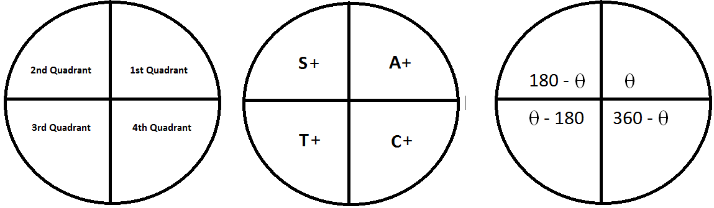

You can calculate the sin, cos or tan of any angle using the diagram above and multiplication(log) tables.
Example
cos 200^{ο} = ?

- It is in the 3rd quadrant so cos is – in this quadrant. The only one which is + in this quadrant is tan.
- As it is the 3rd quadrant the angle is 200 – 180 = 20^{ο}. Therefore this is the same as cos 20^{ο}
- In the cosine tables(maths or log tables)the cos 20^{ο} = .9397
- Therefore cos 200^{ο} = -0.9397

Exercises
Find the answer to the following without using a calculator
- tan 35^{ο}
- sin 305^{ο}
- cos 100^{ο}
- tan 290^{ο}
- sin 92^{ο}
- cos 250^{ο}

Note
- One degree = 60 minutes
- 1 ^{ο} = 60^{I}

Answers
1 0.7002, 2 –0.8192, 3 – 0.1736, 4 –2.7475 , 5 0.9994, 6 –0.3420

