Folding Symmetry
Using a square, traced and cut from construction paper, how many times can you fold the shape to divide it so that it has symmetrical sides—this is its line of symmetry? Fold the shape to show where the line of symmetry is. Is there another? Some shapes may have more than one line of symmetry. Keep folding until you have found the four lines of symmetry for a square (horizontally, vertically, and across both diagonals).

Next, look around the room for shapes and objects that are symmetrical. Identify the line(s) of symmetry in each object you choose.

Start a chart on the board like this:
Shape | Number of sides | Number of lines of folding symmetry | Order of rotational symmetry

Triangle
Square | 4 | 4 | 4
Pentagon
Hexagon
Heptagon
Octagon

Determine the number of sides and lines of symmetry in the table above. Discuss the pattern and relationship of the number of sides to the lines of symmetry.

Examples of rotational symmetry in common structures are as follows;

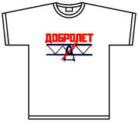

Etc.
Rotational Symmetry Activity
Trace the outline of an equilateral triangle onto a piece of white paper. Rotate the shape until it matches its traced outline again. How many times will the triangle match the outline as you spin it completely around once? (Three times) You can then say that the triangle has three orders of rotational symmetry.
a
c
b
Note: If a shape “matches” itself only once in a full rotation, it does not have rotational symmetry.
a
c
b
a
c
b

An object has rotational symmetry if there is a centre point, around which the object is turned a certain number of degrees, and the object still looks the same (matches itself) a number of times while being rotated. Rotate a given shape to find how many orders of rotational symmetry it has. Add that number to the chart above.

The number of repeated elements in rotational symmetry can vary significantly, although three is the minimum number of repetitions. Natural examples of rotational symmetry can be found in starfish, flowers, and snowflakes. Many cultural objects exhibit rotational symmetry including tile work, basket patterns, and kaleidoscopes (see below).
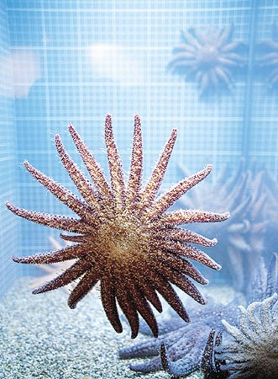
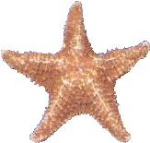
Starfish

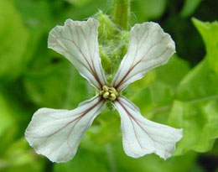

Flowers
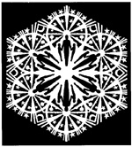

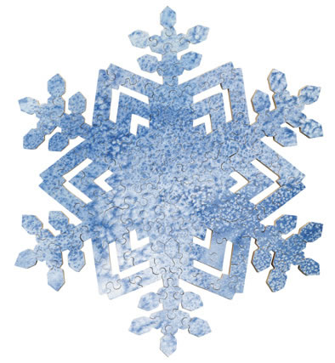

Snowflakes

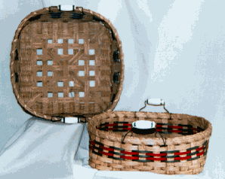
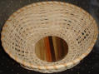

Baskets

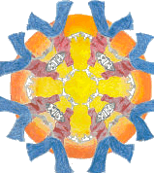
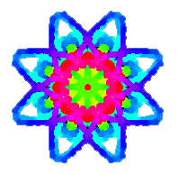

Kaleidoscopes

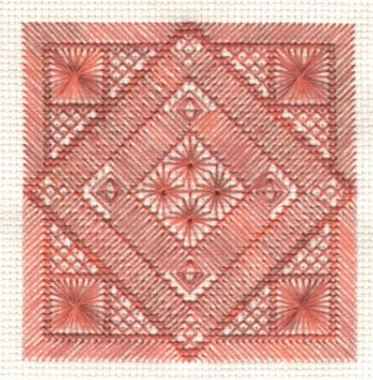

Carpet pattern

Making Shapes with Rotational Symmetry
Determine how many orders of rotational symmetry each design has, and enter the findings into the chart below:

Number of folds | Order of rotational symmetry
One
Two
Three, etc.

Mirror or reflection symmetry divides a figure or design into halves that are mirror images of each other. The axis can be located either vertically or horizontally. Mirror symmetry is found in both natural and man-made objects. Butterflies are good examples of natural mirror symmetry. Human faces have symmetry! In fact, most animals and plants exhibit some form of symmetry (bi-lateral) in their body shape and their markings.
Different (equilateral ) shapes

Square Triangle

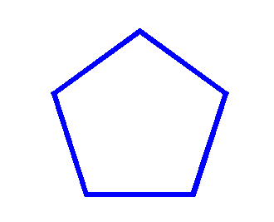

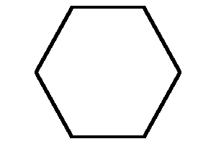

Pentagon Hexagon

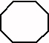

Heptagon

Describe Pattern
Pattern with regard to objects is the repetition of a unique shape

Pattern with regard to recurring numbers occurs when a number or several numbers are recurring to infinity
.

0.03 = 0.0333333333333333…
..

0.21 = 0.2121212121212121…
..

2.517 = 2.51717171717171717…

Trigonometric Graphs
Graph and Analyse the Functions y = sin x, y = cos x, y = tan x

Consider the function f: → ; x → sin x

The field of all rational and irrational numbers is called the real numbers, or simply the "reals," and denoted .

The set of reals is denoted by .
(in this case π and √3 are irrational)

A function is a mathematical relation such that each element of one set is associated with at least one element of another set.

By preparing a table of values, we can plot the graph of y = f(x) = sin x

for -2π ≤ x ≤ 2π

x | -2π | -^{3π}/₂ | -π | -^{π}/₂ | 0 | ^{π}/₂ | π | ^{3π}/₂ | 2π
y = sin x | 0 | 1 | 0 | -1 | 0 | 1 | 0 | -1 | 0

Thus, the following set of points belongs to the curve y = sin x:

{(-2π, 0), (-^{3π}/₂, 1), (-π, 0), (-^{π}/₂, -1), (0, 0), (^{π}/₂, 1), (π, 0), (^{3π}/₂, -1), (2π, 0)}

y = sin x
(see also Google: y = sin x)

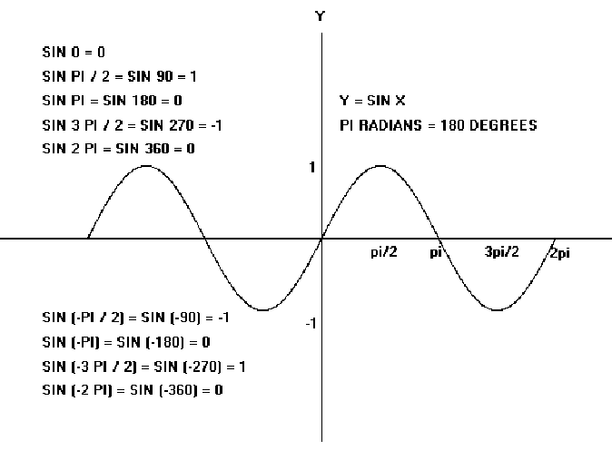
y = sin x

We must notice certain features of the graph.
- The graph is smooth, i.e. there are no sharp points. It is rounded at the top and at the bottom. This could easily be verified by taking many more values of x between those already taken.
- The range of the function, i.e. the interval from the lowest y-value to the greatest y-value is [-1, 1]. Thus

-1 ≤ sin x ≤ 1, for all x

- The graph follows a regular pattern, so we could easily have extended it in either direction by continuing this pattern.
2π

In fact the graph maybe considered
to be a row of the ‘building blocks’ shown on the right, continued to infinity in each direction.

A graph, which has this property, is said to be periodic, and the period is the horizontal length of the building block. It is clear from the graph that the period of
y = sin x is 2π, or 360˚.

Note 1: The graph of f: R → R; x → cos x, i.e y = cos x can be constructed in the same way and is shown below.

x | -2π | -^{3π}/₂ | -π | -^{π}/₂ | 0 | ^{π}/₂ | π | ^{3π}/₂ | 2π
y = cos x | 1 | 0 | -1 | 0 | 1 | 0 | -1 | 0 | 1
Graph of:
y = cos x

Note 2: The shape of the cosine graph is the same as that of the sine graph. Indeed, the cosine graph may be considered as the sine graph simply shifted ^{π}/₂ to the left. Thus, the cosine graph has a range [-1, 1] and period 2π, or 360˚.

Note 3: The graph of the function f: x → tan x is unlike the graph of either a sine or cosine function. On constructing a table of values, we obtain the following graph.

x | -2π | -^{3π}/₂ | -π | -^{π}/₂ | 0 | ^{π}/₂ | π | ^{3π}/₂ | 2π
y = tan x | 0 | ∞ | 0 | ∞ | 0 | ∞ | 0 | ∞ | 0

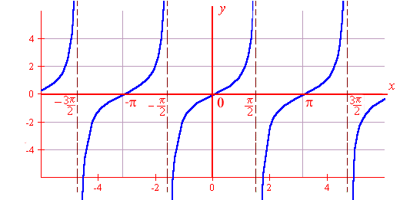
y = tan x

From the graph above, note that:
- The function is not defined for x = ± ^{π}/_{2,} ± ^{3π}/₂, ……., where it tends to infinity.
- The range of the function is , i.e. - ∞ < tan x < ∞, for all x ε .
- The function is periodic, and its period is π, or 180˚.

Derive the Period, amplitude and Phase of Trigonometric Functions
Sine and cosine functions have the form of a periodic wave:

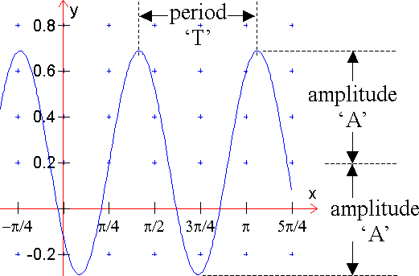
Range
  - The period, T, is the distance between any two repeating points on the function.
  - The amplitude, A, is the distance from the midpoint to the highest or lowest point of the function.
  - Phase shift is the amount of horizontal displacement of the function from its original position.

A function of the form f(x) = a + b sin (cx + ε)

is called a sine function. The graph of a sine function is similar to that of y = sin x, but its period, range and location may be different. In the same way, the graph of the cosine function
f(x) = a + b cos (cx + ε)

is similar to that of y = cos x.

The sine function f(x) = a + b sin (cx + ε) and the cosine function
f(x) = a + b cos (cx + ε) have

- range = [a – b, a + b] if b > 0, or [a + b, a – b] if b < 0
- period = 2π or 360˚
c c
Example 1
Find the range and the period of f(x) = 2 – 3 sin (3x + ^{π}/₂)

Solution
- Range = [2 – 3, 2 + 3] = [-1, 5]
- Period = ^{2π}/₃ = ^{360˚}/₃ = 120˚

Note 5: In practice, one very efficient approach to sketching the graph of a sine function or cosine function is to:

- Write down the period and the range.
- Construct a small table of values, with intervals of one quarter of the period, for one period only. Take as the starting value that value of the variable that makes the angle equal to zero.
- Extend the graph to the required domain.

Example 2
Sketch a graph of the function

f: x → 1 – 2 sin (3x + ^{π}/₂), for –π ≤ x ≤ π

Solution
Period = ^{2π}/₃. Quarter of period = ^{2π}/₃ * ¼ = ^{π}/₆.

Range = [1 – 2, 1 + 2] = [-1, 3]

Put angle = 0. => 3x + ^{π}/₂ = 0 => x = - ^{π}/₆

X | - ^{π}/₆ | 0 | ^{π}/₆ | ^{π}/₃ | ^{π}/₂
3x + ^{π}/₂ | 0 | ^{π}/₂ | π | ^{3π}/₂ | 2π
sin (3x + ^{π}/₂) | 0 | 1 | 0 | -1 | 0
- 2 sin (3x + ^{π}/₂) | 0 | -2 | 0 | 2 | 0
y = 1 – 2 sin (3x + ^{π}/₂) | 1 | -1 | 1 | 3 | 1

Plot these points and extend to – π ≤ x ≤ π
f: x → 1 – 2 sin (3x + ^{π}/₂), for –π ≤ x ≤ π

We model cyclical behaviour using the sine and cosine functions. An easy way to describe these functions is as follows. Imagine a bicycle wheel whose radius is one unit, with a marker attached to the rim of the rear wheel, as shown in the following figure.
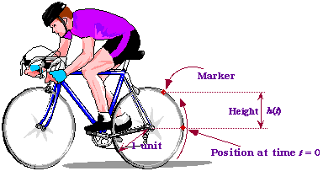

As the wheel rotates, the height h(t) of the marker above the centre of the wheel, fluctuates between 1 and +1.The faster the wheel rotates, the faster the oscillation. Let us now choose our units of measurement so that the wheel has a radius of one unit. Then the circumference of the wheel (the distance all around) is known to be 2, where = 3.14159265.... When the outer edge of the wheel has travelled this distance, it has gone through exactly one revolution, and so it is back where it started. Thus, if at time t = 0 the marker started off at position h(0) = 0, then it is back to zero after one revolution. If the cyclist happens to be moving at a speed of one unit per second, it will take the bicycle wheel 2 seconds to make one complete revolution, and so the wheel is back where it started after that time.

The function h(t) we get in the above way is called the sine function, denoted by sin(t). Here is its graph.
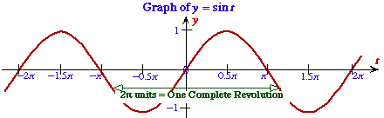

Sine Function

Bicycle Wheel Definition
If a wheel of radius 1 unit rotates at a speed of 1 unit of length per second, and is in the position shown in the figure at time t = 0, then its height after t seconds is given by h(t) = sin(t).

Geometric Definition
The sine of a real number t is given by the y-coordinate (height) of the point P in the following diagram, in which t is the distance of the arc shown.
sin(t) = y-coordinate of the point P.
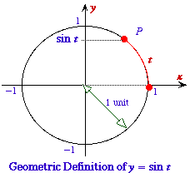

Introduction to Microsoft Excel (data entry, charts of various functions)

Example 1
Function f(x)=x²-3x+5 in the domain –3 to 4.

x | -3 | -2 | -1 | 0 | 1 | 2 | 3 | 4
x² | 9 | 4 | 1 | 0 | 1 | 4 | 9 | 16
-3x | 9 | 6 | 3 | 0 | -3 | -6 | -9 | -12
+5 | +5 | +5 | +5 | +5 | +5 | +5 | +5 | +5
f(x) | 23 | 15 | 9 | 5 | 3 | 3 | 5 | 9

Example 2

f(x)=sin x
x | 0 | 45 | 90 | 135 | 180 | 225 | 270 | 315 | 360
Sin x | 0 | .707 | 1 | .707 | 0 | -.707 | -1 | -.707 | 0

Example 3

f(x)=e^{x}
X | -3.0 | -2.5 | -2.0 | -1.5 | -1.0 | -0.5 | 0 | 0.5 | 1 | 1.5 | 2.0 | 2.5 | 3.0
e^{x} | 0.05 | 0.08 | 0.14 | 0.22 | 0.37 | 0.61 | 1 | 1.65 | 2.72 | 4.48 | 7.39 | 12.18 | 20.09
e^{-x} | 20.09 | 12.18 | 7.39 | 4.48 | 2.72 | 1.65 | 1 | 0.61 | 0.37 | 0.22 | 0.14 | 0.08 | 0.05

Questions
Find the period and range of each of the following functions:
- f(x) = 3 + 2 sin 5x
- f(x) = 3 – 2 sin (^{π}/₃ – x)
- f(x) = -1 + sin 3x
- f(x) = 4 cos 2x
- f(x) = 3 – 4 sin 2x

Sketch the graph of each of the following functions in the stated domain.
- y = 5 + sin x, –2π ≤ x ≤ 2π
- y = 2 sin ( x + ^{π}/₂), –2π ≤ x ≤ 2π
- y = 1 – 3 sin (2x - ^{π}/₃), –2π ≤ x ≤ 2π
- y = 3 – 2 sin (¹/₂x - ^{π}/₂), –4π ≤ x ≤ 4π
- y = 2 cos (2x + ^{π}/₂), -π ≤ x ≤ π

