Define sine, cosine and tangent as ratios of sides of a right triangle

opposite side
sin A =
hypotenuse
hypotenuse

opposite
side (to A)
adjacent side
cos A =
hypotenuse

opposite side
tan A =
A
adjacent side
Adjacent side (to A)

Memory aid: Oh Hell, Another Hour, Of Algebra, sin, cos and tan.

The angles 30˚ and 60˚.
In the equilateral triangle abc below, each side is 2 units in length. The perpendicular from the vertex a to the base gives a triangle of 90˚, 60˚ and 30˚.
a

sin 60˚ = ^{√3}/₂ sin 30˚ = ½
30˚
2
cos 60˚ = ½ cos 30˚ = ^{√3}/₂
√3

tan 60˚ = ^{√3}/₁ tan 30˚ = ¹/_{√3}
60˚

1
b
c

The 45˚ angle
The triangle below is isosceles where the equal sides are each 1 unit in length. The hypotenuse is √2 units in length.

√2
sin 45˚ = ¹/_{√2}

cos 45˚ = ¹/_{√2}

tan 45˚ = 1
1

45˚
1

Given the sides of a Triangle, Calculate the Angles.
Given a value of sin Ө, cos Ө or tan Ө, we can find the value of the angle Ө using the sin⁻¹, cos⁻¹ or tan⁻¹ keys, respectively. On most calculators, sin⁻¹, cos⁻¹ and tan⁻¹ is obtained by first pressing INV or 2nd F and then pressing sin, cos or tan, respectively.

Example
Find the value of Ө, to the nearest minute, given that:
(i) sin Ө = 0.5 (ii) cos Ө = 0.3896

(i) sin Ө = 0.5, therefore [Press: 0.5 INV sin]
Ө = 30º

(ii) cos Ө = 0.3896, therefore [Press: 0.3896 INV cos]
Ө = 67.07038747

Converting from Decimals to Minutes
To get the minutes we multiply the decimal part by 60.
So cos Ө above = 0.07038747º * 60 = 4.223248446’ = 4’ (nearest minute)
Therefore Ө = 67º 4’ [to the nearest minute]

Solve right triangles using sine, cosine, tangent

Questions
Find the measure (to the nearest degree) of the angle marked with a capital letter in the triangles below:

B
12
4.5

5
A
C

8 7 3.4
b

In the given diagram acd is a straight line and bd ad. If bd = 6 cm, ab = 11 cm, find
11 cm
6 cm
- bad
- ad , correct to 1 decimal place.
c
a
d

A tree’s shadow is exactly 30 metres long. If that tree is growing upright, and the sun is at 30˚ elevation in the sky, what is the tree’s height?


30 m
30˚

In the given diagram cb = k
Express ab in terms of k.
60˚
c

60˚
k

60˚
30˚
b
a

Find ab in the given isosceles triangle abc, if bc = √3 and abc = 30˚
a

c
b
30˚

√3
Solve Practical Problems (angles of elevation / depression, bearings, simple surveying problems).
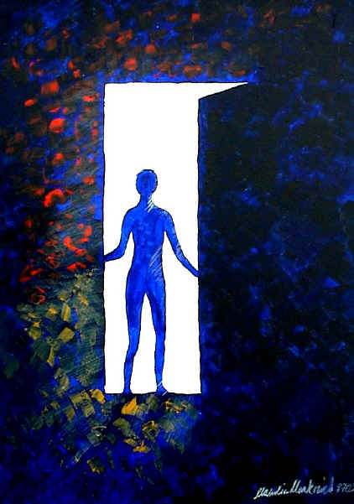

Line of observation
B
Angle of
depression

Line of observation
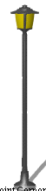

Angle of
elevation
A

The angle marked A is called an angle of elevation.
The angle marked B is called an angle of depression.

Example
Surveyors use the tangent (tan) function a lot. For example, they can use trigonometry to figure out the distance across rivers.
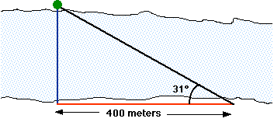
We first set up a survey post directly across the river from some landmark (like a tree). Then we head downstream a distance that we can measure; in this case, 400 meters. That's the red horizontal line in the drawing. Now we take a sighting on the tree from downstream. That's the black line in the drawing. The surveying instruments will tell us what our sighting angle is. In this case, it's 31 degrees. We know from the previous page that the tangent of 31 degrees is equal to the length of the blue line divided by the length of the red line (400 meters). So, if we multiply the tangent of 31 degrees by 400 meters, we'll get the distance across the river. The tangent of 31 degrees is about 0.60. That means that the distance across the river is 0.6 times 400 meters, or 240 meters.

Questions
A rod of length 7√2 cm is inclined to the horizontal at an angle of ^{π}/₄ radians. A shadow is cast immediately below it from a lamp directly overhead. What is the length of the shadow? What is the new length of the shadow if the rod’s inclination is changed to ^{π}/₃ to the vertical?

A building casts a horizontal shadow 8√3m long. If a line were to be drawn from the end of the shadow to the top of the building it would be inclined to the horizontal at 60˚. What is the height of the building?

A prop in the form of an isosceles triangle constructed out of timber is placed against a vertical wall. If the length of the side along the horizontal ground is 3.4 m, what is the length of the hypotenuse to 2 decimal places?

45˚

45˚
3.4 m

A bicycle frame is in the form of an isosceles triangle with the horizontal crossbar forming the hypotenuse. If the crossbar is 53 cm long, find the length of each of the other two sides to the nearest mm.

N

Simple Bearing Problems
A
Compass Directions
The direction to a point is stated as a number of degrees East or West of North and South.
B
50º
70º
W
E

60º
45º

D

A is N 50º E
C
B is N 70º W
S
C is S 45º W
D is S 60º E

Note: N 50º E means 50º East of North.
Questions
An observer in a lighthouse 140m high observes the angle of depression of a boat to be 40º 25’. If the foot of the lighthouse is at sea level, how far is the boat form the base of the lighthouse?

Two ships leave a harbour at the same time. One sails in a direction S 73º E and the other in a direction S 17º W at 5 km/h and 5¼ km/h, respectively. How far are the ships apart after 4 hours’ sailing?
p

On leaving a port p, a fishing boat sails in the direction South 30º East for 2 hours at 10 km/h, as shown. What distance has the boat then sailed? The boat next sails in the direction North 60º East, at 10 km/h, until it is due East of the port p. Draw a diagram of the boat’ journey. Calculate how far the boat is from the port.
30º

Define sine, cosine and tangent functions as related to the unit circle

The Unit Circle
p(x, y)
The circle on the right has centre at (0,0) and radius 1 unit in length. It is generally referred to as the unit circle.
Ө
0
1
c
x
y

Let p(x, y) be any point on the circle, as shown above.
p(cos Ө , sin Ө)
^{X}/₁ = cos Ө => x = cos Ө

^{y}/₁ = sin Ө => y = sin Ө
Ө

=> the co-ordinates of p are (cos Ө , sin Ө)

The co-ordinates of any point on the unit circle are (cos Ө, sin Ө)
Remember
Sin, Cos and Tan of 0˚, 90˚, 180˚, 270˚ and 360˚.
The unit circle is particularly useful when finding the sine or cosine of the angles 0˚, 90˚, 180˚, 270˚ and 360˚. The diagram below shows the values of sine and cosine of the angles mentioned above.
(cos 90˚, sin 90˚)
(0,1)

1

1 1
(cos 0˚, sin 0˚)
(1,0)
(cos 180˚, sin 180˚)
(-1,0)

1
(cos 270˚, sin 270˚)
(0,-1)

From the unit circle above:

cos 0˚ = 1 cos 90˚ = 0 cos 180˚ = -1 cos 270˚ = 0
sin 0˚ = 0 sin 90˚ = 1 sin 180˚ = 0 sin 270˚ = -1

Note: sine and cosine of 0º are the same as sine and cosine 360˚.

Since tan Ө = ^{sin Ө}/_{cos Ө}, we can also use the unit circle to find the value of the tangent of the angles 0˚, 90˚, 180˚, 270˚ or 360˚.

Thus
- tan 0˚ = ⁰/₁ = 0
- tan 90˚ = ¹/₀ …(not a real number)
- tan 180˚ = ⁰/₋₁ = 0
- tan 270˚ = ⁻¹/₀ …(not a real number)

The Four Quadrants
90˚
The x-axis and y-axis divide a full rotation of 360˚ into 4 quadrants as shown on the right.
Second Quadrant
First Quadrant

360˚
180˚

Fourth
Quadrant
Third
Quadrant

270˚
The unit circle below shows an angle of Ө in each of the four quadrants. The signs shown in each triangle determine whether a ratio is positive or negative. The signs of the sine, cosine and tangent of an angle in each quadrant are shown.
90˚

sin +
cos -
tan -
sin +
cos +
tan +

+ +
360˚
0˚
Ө
Ө
_
+
180˚
Ө
Ө

_ _
sin -
cos -
tan +
sin -
cos +
tan -

270˚

Remember CAST!
The diagram shows the positive ratios in the four quadrants.
- In the 1st quadrant, all (A) positive.
- In the 2nd quadrant, sin (S) only positive.
- In the 3rd quadrant, tan (T) only positive.
- In the 4th quadrant, cos (C) only positive.

S+
A+

C+
T+

Finding the Ratio of an Angle between 90˚ and 360˚
A calculator will give you the sine, cosine and tangent of any angle including the negative sign, if it exists. If Mathematics Tables are used these steps should be followed:
- Determine in which quadrant the angle lies.
- Hence, state if the sign of the ratio is positive or negative.
- Determine the angle (< 90˚) between the rotated line and the x-axis.
- Read the required ratio of the angle from your tables and insert the sign from (ii) above.

