4-6 Integration
Integration is used to find areas under curves. Integration is the reversal of differentiation hence functions can be integrated by indentifying the anti-derivative.
However, we will learn the process of integration as a set of rules rather than identifying anti-derivatives.
Terminology
- Indefinite and Definite integrals
There are two types of integrals: Indefinite and Definite.
Indefinite integrals are those with no limits and definite integrals have limits.
When dealing with indefinite integrals you need to add a constant of integration. For example, if integrating the function f(x) with respect to x:
∫(f x) dx = g(x) + C , where g(x) is the integrated function.
- C is an arbitrary constant called the constant of integration.
- dx indicates the variable with respect to which we are integrating, in this case, x.
- The function being integrated, f(x), is called the integrand.

Rules on next page – see Log Tables/Mathematics Tables
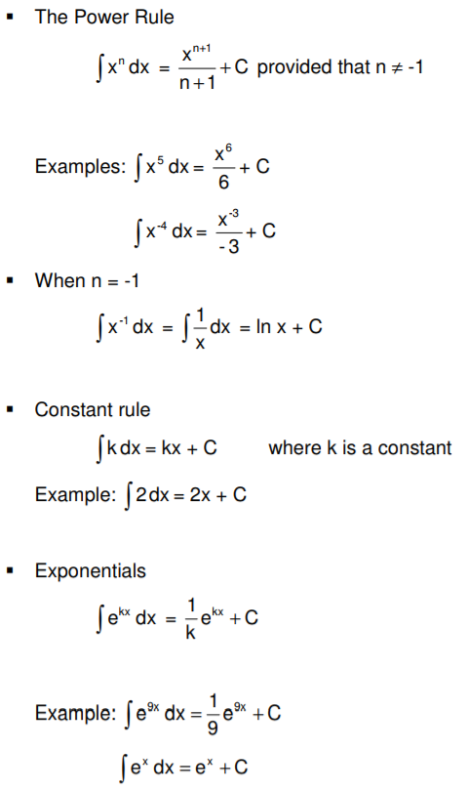
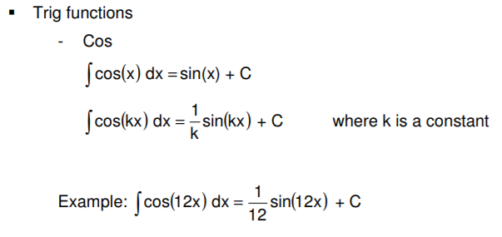
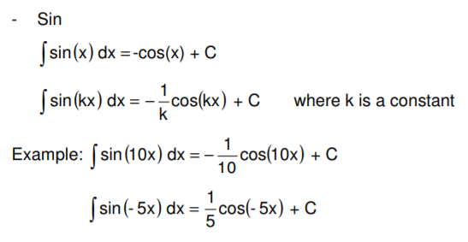
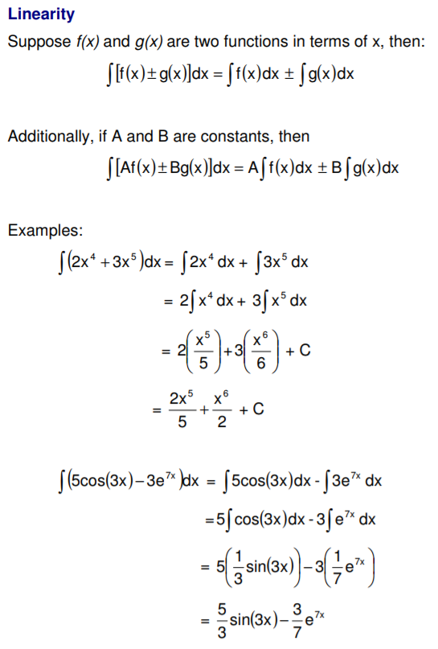
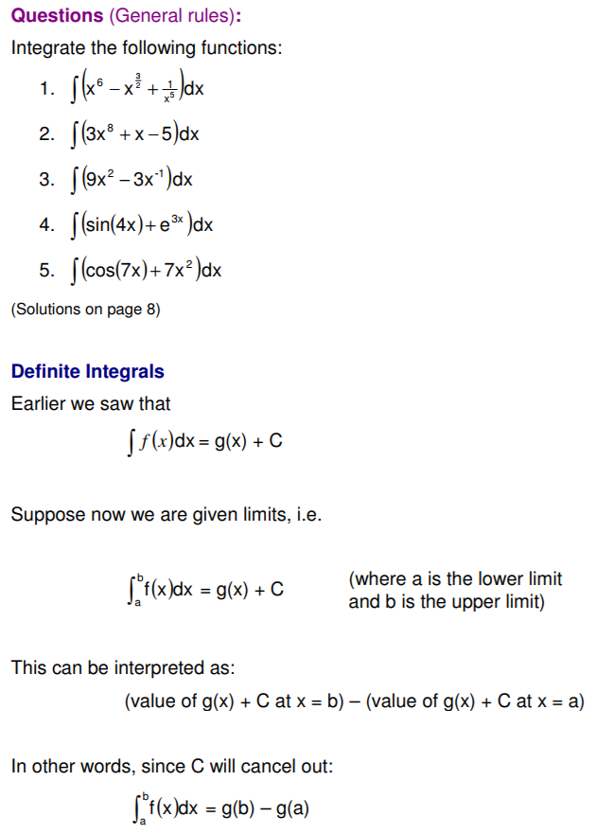
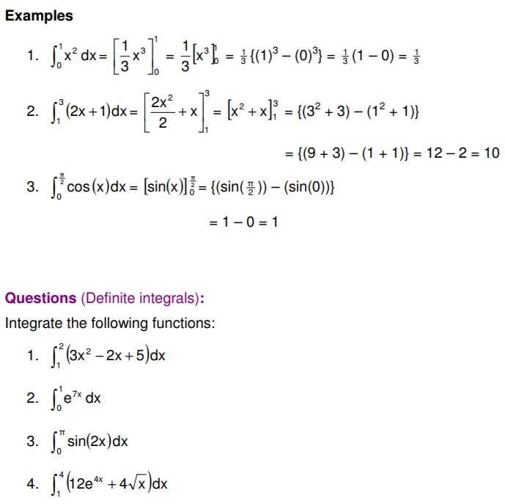

Integration – Calculating area under a curve
