Integration 2

Area under a Curve
Calculating the area under a curve.

Definite Integrals
So far when integrating, there has always been a constant term left. For this reason, such integrals are known as indefinite integrals. With definite integrals, we integrate a function between 2 points, and so we can find the precise value of the integral and there is no need for any unknown constant terms [the constant cancels out].
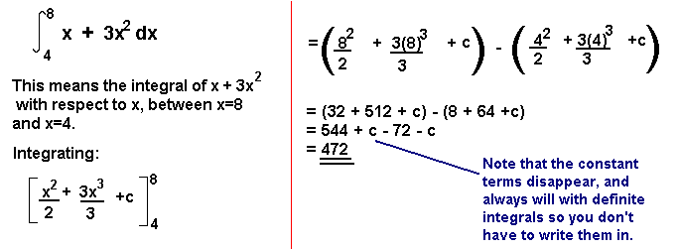
The Area Under a Curve
The area under a curve between two points can be found by doing a definite integral between the two points.
To find the area under the curve y = f(x) between x = a and x = b, integrate y = f(x) between the limits of a and b.

Example 1
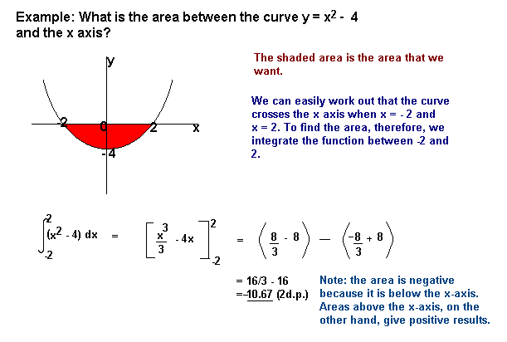
Example 2
Areas under the x-axis will come out negative and areas above the x-axis will be positive. This means that you have to be careful when finding an area which is partly above and partly below the x-axis.
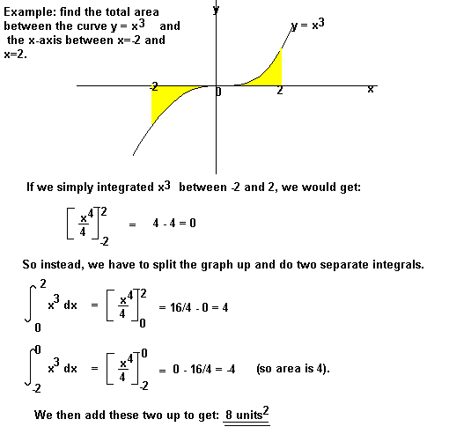
You may also be asked to find the area between the curve and the y-axis. To do this, integrate with respect to y.

Example 3
Example
Find the area bounded by the lines y = 0, y = 1 and y = x².
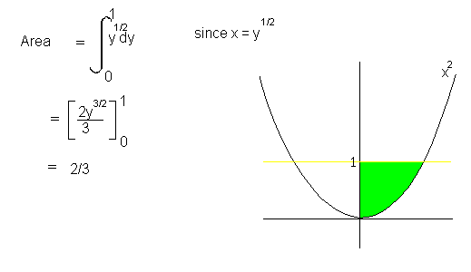

Exercise
Find the coordinates of the points (eg a and b) of intersection of the curve $f\left(x\right)=x^{2}+4$ and the line $y=13$
Find the area bounded by the by $f\left(x\right)$, the x-axis and the lines x=a and x=b.
Solution
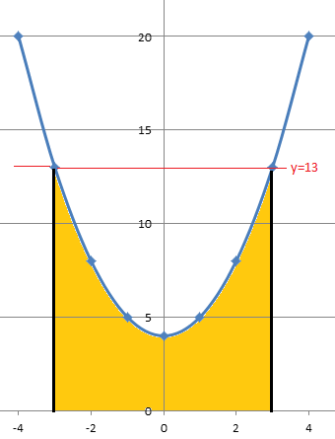
$$13=x^{2}+4$$
$$13-4=x^{2}$$
$$9=x^{2}$$
$$±3=x or x=±3$$

$\int_{-3}^{3}{x^{2}+4}$ = $\left\lfloor {\frac{1}{3}x}^{3}+4x+c\right\rfloor$ for $x=±3$
Substituting we get
$\left\lfloor {\frac{1}{3}(3)}^{3}+4(3)+c\right\rfloor - \left\lfloor {\frac{1}{3}(-3)}^{3}+4(-3)+c\right\rfloor$
=$\left\lfloor 9+12+c\right\rfloor —9-12+c=21+c+21-c$ (+c and –c cancel out)
Area = 42units²

