**Graphs & Functions**

**Learning Outcomes**

1. Describe the properties of basic mathematical functions to include linear, quadratic, exponential, log and trigonometric functions
2. Define the inverse of a function
3. Graph linear and quadratic functions showing the relationship between the domain and range
4. Derive the inverse of a function from its algebraic expression
5. Calculate the equation of a straight line using a range of formulae to include distance between two points, slope, parallel lines and perpendicular lines
6. Solve maximum and minimum problems with limitations given by linear inequalities from graphs of linear inequalities and half planes
7. Analyse graphs of linear and quadratic functions for important properties to include domain and range, maximum and minimum values, increasing and decreasing intervals, periodicity

**What is a function?**

A function is a special relationship where each input has a single output. It is often written as "f(x)" where x is the input value. Example: f(x)= $\frac{x}{2}$  *("f of x equals x divided by 2").* It is a function because each input "x" has a single output $\frac{x}{2}$:

Eg  : f(2) = $\frac{2}{2}=1$.

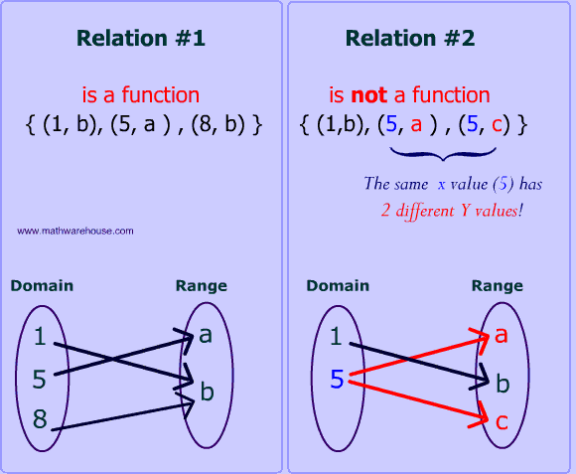

Example fx=x2 **Input** (Domain) -> Function -> **Output** (Range)  
2 $f\left(x\right)=\frac{x}{2}$ 1

**Function Notation**

# Function Notation

Function notation is used to name functions for easy reference. Imagine if every function in the world had to start off with y =. Pretty soon, you would become confused about which y = you were talking about. You need some other way of naming things. Hence, we have function notation. $f\left(x\right)=, g\left(x\right)=, etc.$

**Function Definition**

*f*(*x*) = 3*x* + 2

*g*(*x*, *y*) = *x*2 + 3*y*

In this example, the f is a function of x. That is, x is the independent variable, and the value of f depends on what x is. Also, g is a function of both x and y. The notation f(x) does not mean f times x. It means the "value of f evaluated at x" or "value of f at x" or simply "f of x".

**Function Evaluation**

*f*(3) = 3(3) + 2 = 9 + 2 = 11

*f*(3) does not mean *f* times 3. It means the "value of *f* evaluated when *x* is 3".

*f*(*t*) = 3(*t*) + 2 = 3*t* + 2

Whatever is in parentheses on the left side of the function (*t* in this case) is substituted for the value of the independent variable on the right side.

*f*(*x* + *h*) = 3(*x* + *h*) + 2 = 3*x* + 3*h* + 2

Every occurrence of the independent variable is replaced by the quantity in parentheses. A common mistake is to take a quantity and apply linear transformations to it.

*f*(*x* + *h*) does not equal *f*(*x*) + *h* = 3*x* + 2 + *h*

*f*(*x* + *h*) does not equal *f*(*x*) + *f*(*h*) = 3*x*+2 + 3*h* + 2 = 3*x* + 3*h* + 4

It does equal 3(*x* + *h*) + 2 = 3*x* + 3*h* + 2

*f*(3*x*) does not equal 3 * *f*(*x*) = 3( 3*x*+2) = 9*x* + 6

##### It does equal 3(3*x*) + 2 = 9*x* + 2

You also specify which function you want to use when you use function notation.

*g*(*x*, *y*) = *x*2 + 3*y*

Consider:

*g*(2, 1) = (2)2 + 3(1) = 4 + 3 = 7

Since the order of the independent variables in the original definition was *x* and then *y*, the function *g* is evaluated when *x* = 2 and *y* = 1.

The notation *y* = *f*(x) means: *‘the value of y depends on the value of x’*. Hence, *y* and *f*(*x*) are interchangeable, and the *Y* axis can also be called the *f*(*x*) axis.

**Note:** When graphing a function it is very important not to draw the graph outside the given domain (i.e., the given values of *x*).

**Exercises**

If f(x) = 2x-1 and g(x)=4x find the solutions to the following:

1. f(3)
2. f(-4)
3. f(0)
4. f(c)
5. g(5)
6. g(-1)
7. g(0)
8. g(a)
9. fg(1)
10. gf(2)
11. fg(x)
12. gf(x)

**Inverse Function**

In mathematics, an inverse function (or anti-function) is a function that "reverses" another function: if the function f applied to an input x gives a result of y, then applying its inverse function g to y gives the result x, and vice versa, i.e., f(x) = y if and only if g(y) = x.

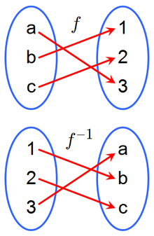

Calculating the inverse function

|  |  |  |  |  |
| --- | --- | --- | --- | --- |
| Function | Evaluating Inverse Function |  | Function | Evaluating Inverse Function |
| x $→$  3x+2 | x $→$  3x+2 |  | x $→$ 4x**–**15 | x $→$  4x**–**15 |
|  | x−2 $→$  3x |  |  | $$x+15→4x$$ |
|  | $$\frac{x-2}{3}→x$$ |  |  | $$\frac{x+15}{4}→x$$ |
|  | $$f^{-1}\left(x\right)=\frac{x-2}{3}$$ |  |  | $$f^{-1}\left(x\right)=\frac{x+15}{4}$$ |

**Exercises**

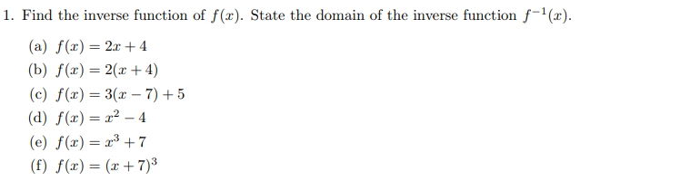

**Solutions**

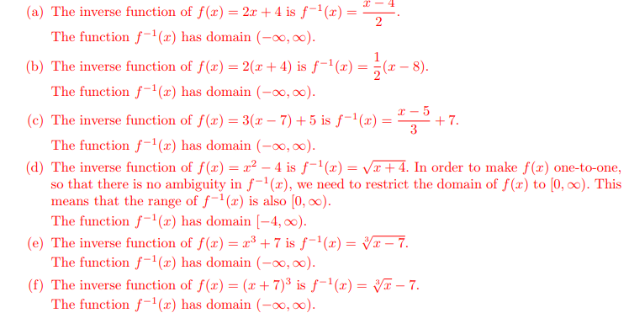

**Linear Functions -** https://www.mathsisfun.com/data/function-grapher.php

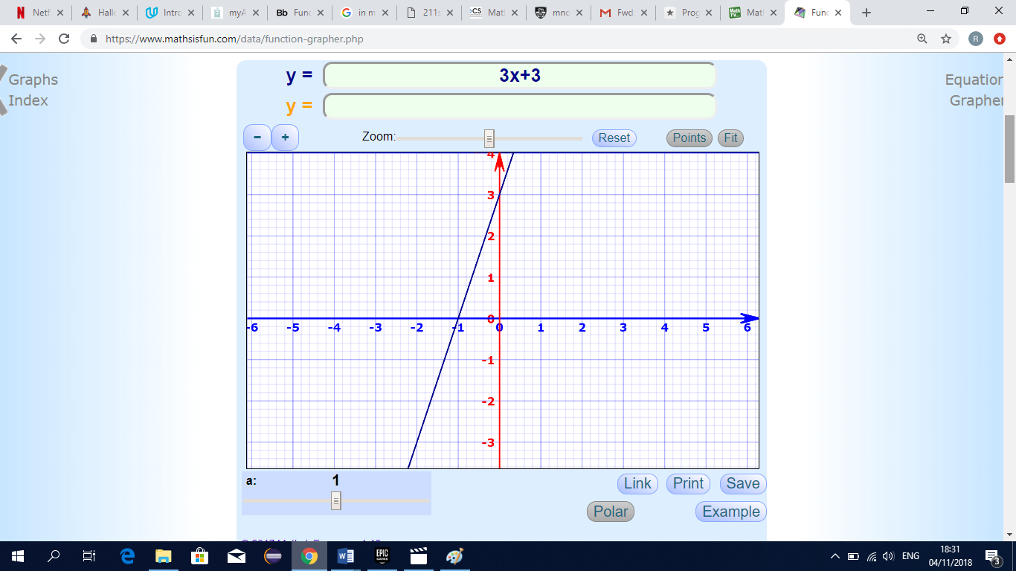

**The above function has index of 1, subtract 1 from this which gives 0. This is a line with 0 turns, hence it must be a straight line(eg. A Linear function).**

**Quadratic Functions**

$$f\left(x\right)=x^{2}+2x-5$$

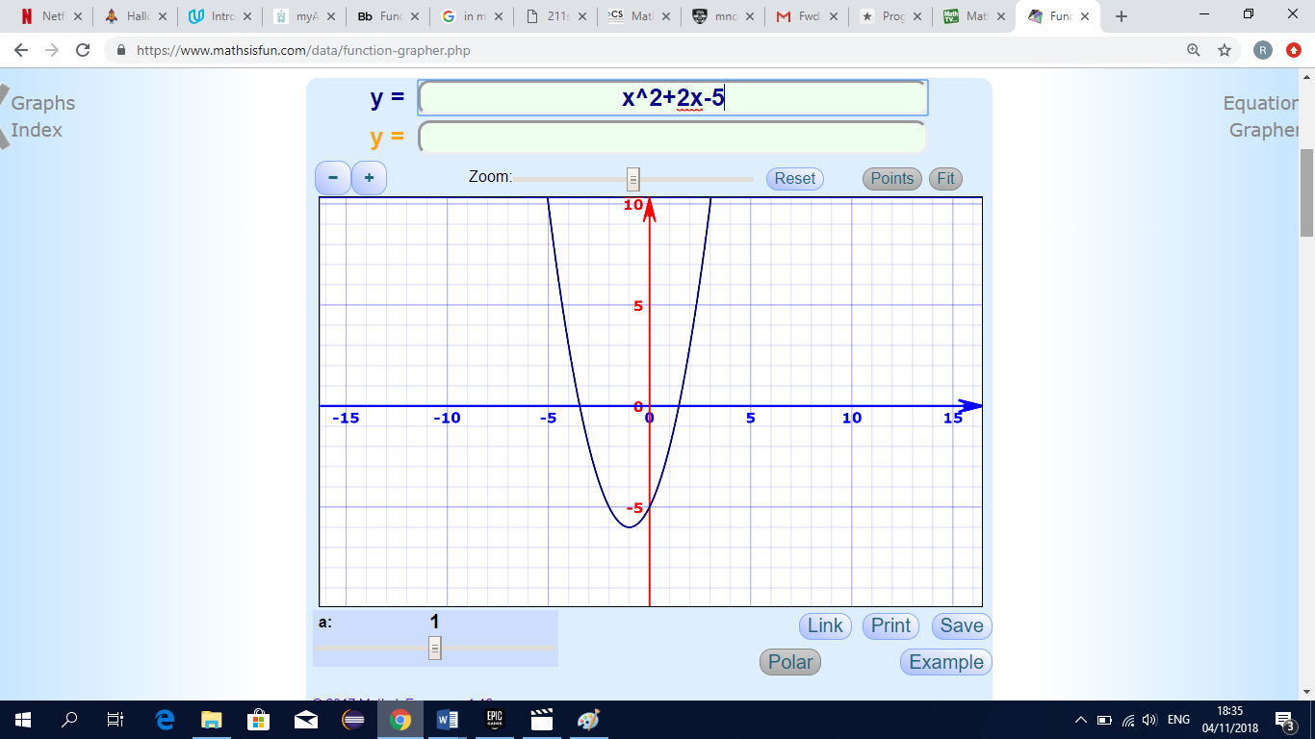

**The above function has an index of 2, subtract 1 from this which gives 1. This is a line with 1 turn, hence it must be a “U” or “n” shape as shown (eg. A Quadratic function). Note: A positive coefficient of $x^{2} gives a u shape and a negative coefficient of{ x}^{2} gives a n shape.$**

**Cubic Functions**

$${f\left(x\right)=x}^{3}+{2x}^{2}-3x-6$$

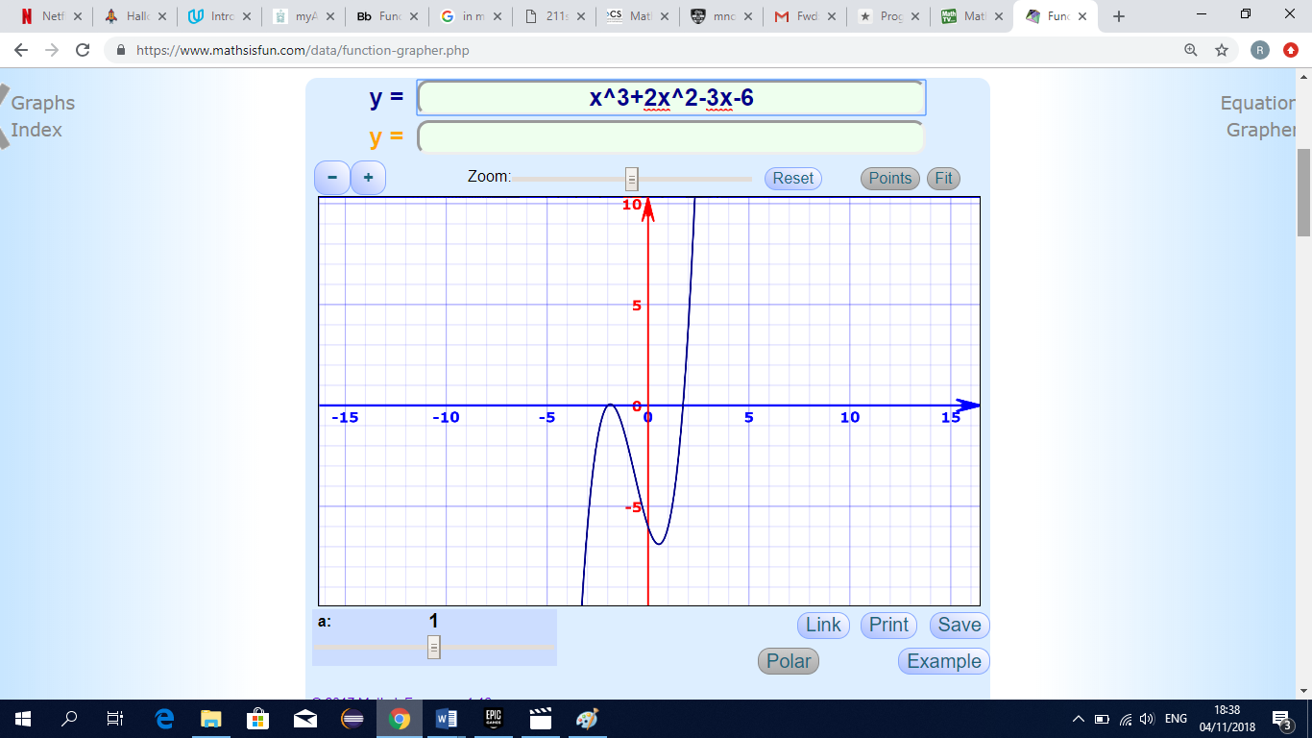

**The above function has an index of 3, subtract 1 from this which gives 2. This is a line with 2 turns, hence it must be a sideways “S” shape as shown (eg. A Cubic function).**

**Exponential Function**

The graph of ${y=x}^{2}$, is a function with an exponent. But it's not an exponential function. In an exponential function, the independent variable, or x-value, is the exponent, while the base is a constant. For example, ${y=2}^{x}$ would be an exponential function.

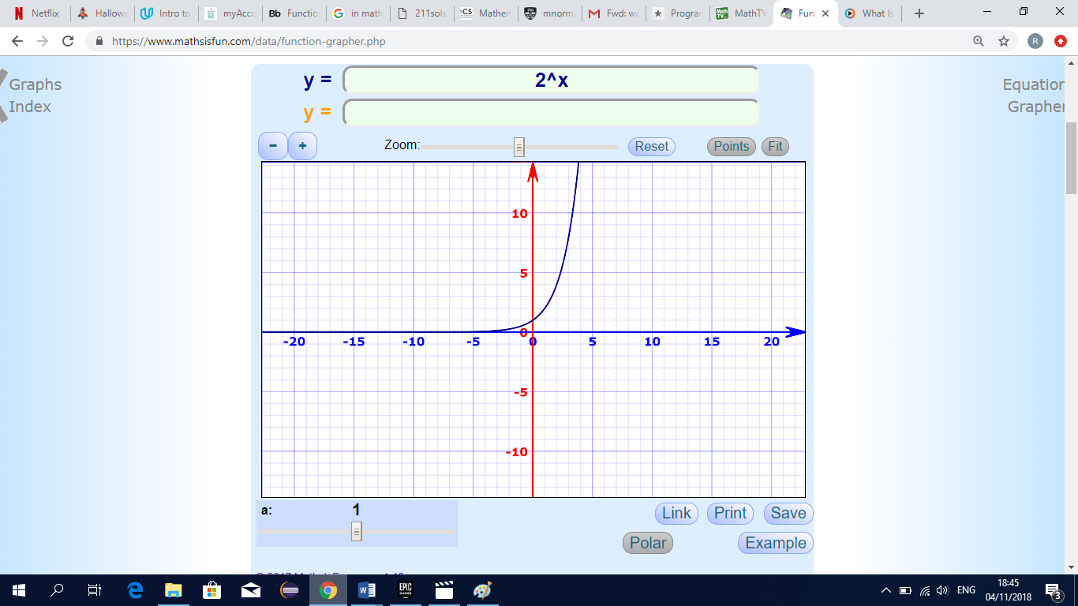

**Logarithmic functions**

Logarithmic functions are the inverses of exponential functions, and any exponential function can be expressed in logarithmic form. Similarly, all logarithmic functions can be rewritten in exponential form. Logarithms are really useful in permitting us to work with very large numbers while manipulating numbers of a much more manageable size. The word logarithm, abbreviated log, is introduced to satisfy this need. y = (the power on base 2) to equal x. This equation is rewritten as y = log2x.

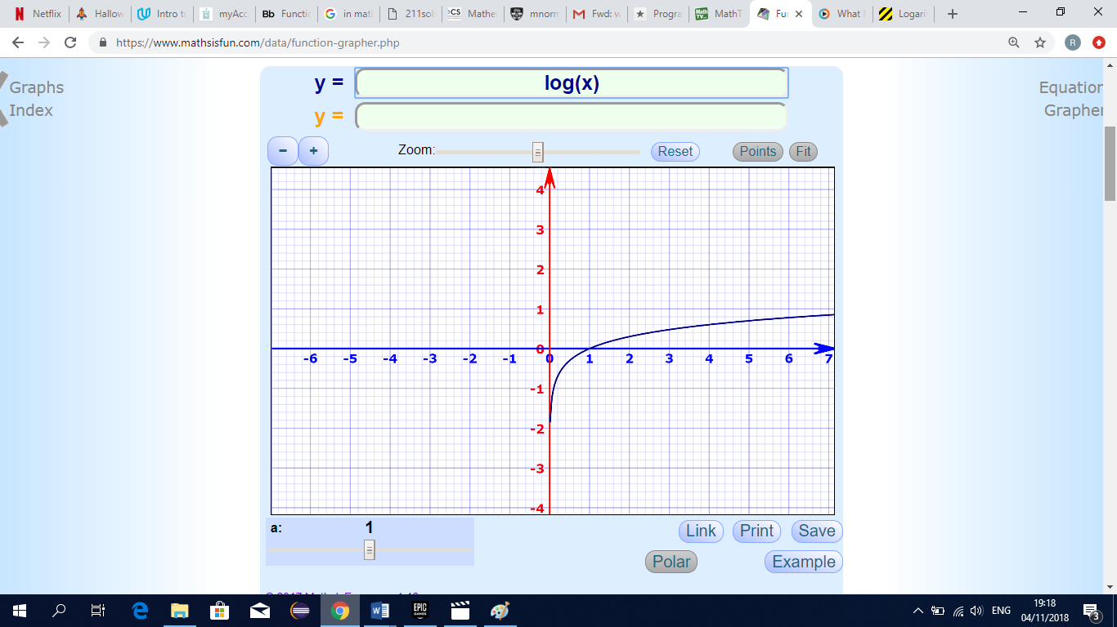

**Trigonometric Functions**

$$y or f\left(x\right)=sinx$$

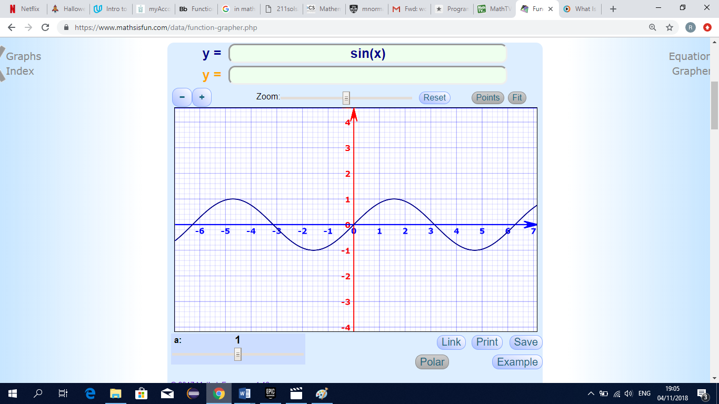

f(x)=3−cos(2x−1)

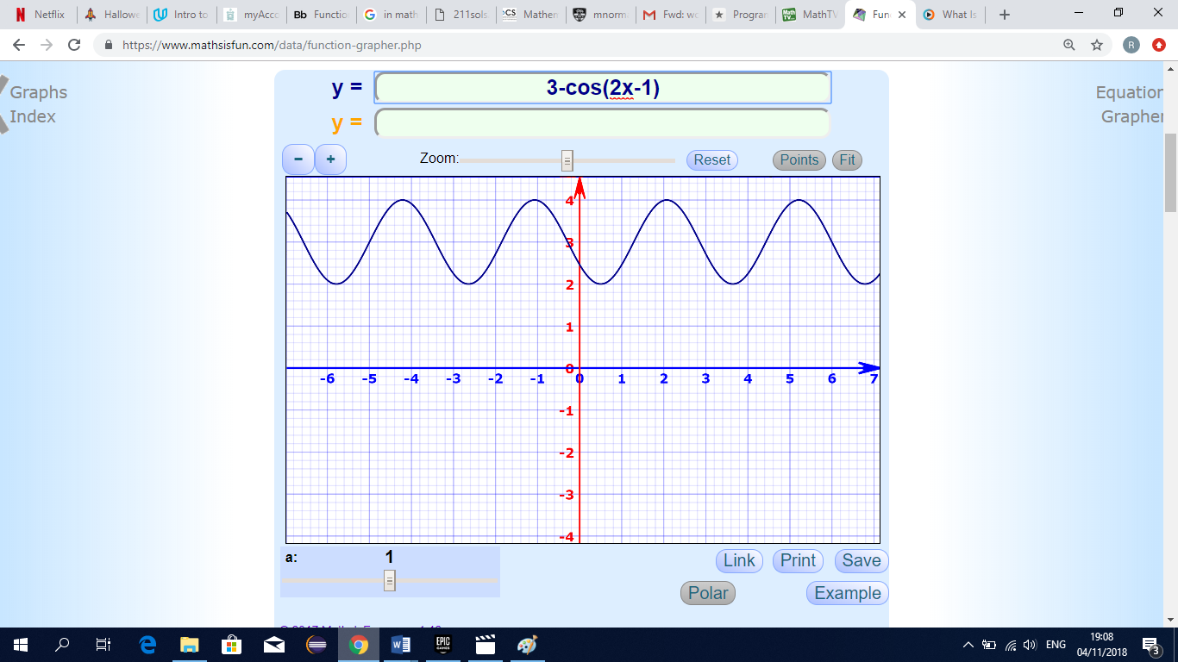

**Example 1 – Linear Function**

|  |  |  |  |  |  |  |  |
| --- | --- | --- | --- | --- | --- | --- | --- |
| Draw a graph of the function f(x) = 5x - 2 in the domain {-3 < x < 3} | | | | | | | |
|  |  |  |  |  |  |  |  |
| x | -3 | -2 | -1 | 0 | 1 | 2 | 3 |
| 5x | -15 | -10 | -5 | 0 | 5 | 10 | 15 |
| -2 | -2 | -2 | -2 | -2 | -2 | -2 | -2 |
| y | -17 | -12 | -7 | -2 | 3 | 8 | 13 |
| https://lh3.googleusercontent.com/w34a6UEEKkMrnoeKWRnA6JPRCIyg88YbNtEiIN9MgmYfgS9mg82UWwCkDm59S7dIZFcXPYRD4U11nGj-qizfnJ_WEX4efohXYJ8kQoL9u3-Ik216HvUftndHbYpFaSZUife36Cpn   |  | | --- | |  | |  |  |  |  |  |  |  |
|  |  |  |  |  |  |  |  |

* Domain is {-3,-2,-1,0,1,2,3}
* Range is {-17,-12,-7,-2,3,8,13}

**Example 2 – Quadratic Function**

|  |  |  |  |  |  |  |  |
| --- | --- | --- | --- | --- | --- | --- | --- |
| Draw a graph of the function f(x) = 5x^2 - 2x+3 in the domain {-3 < x < 3} | | | | | | | |
|  |  |  |  |  |  |  |  |
| x | -3 | -2 | -1 | 0 | 1 | 2 | 3 |
| 5x^2 | 45 | 20 | 5 | 0 | 5 | 20 | 45 |
| -2x | 6 | 4 | 2 | 0 | -2 | -4 | -6 |
| 3 | 3 | 3 | 3 | 3 | 3 | 3 | 3 |
| y | 54 | 27 | 10 | 3 | 6 | 19 | 42 |

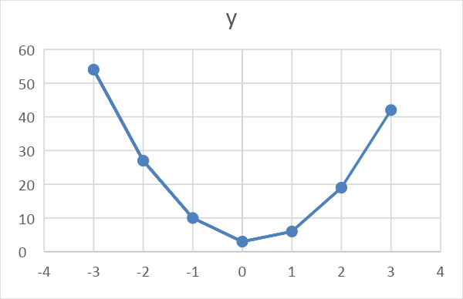

* Domain is {-3,-2,-1,0,1,2,3}
* Range is {54,27,10,3,6,19,42}

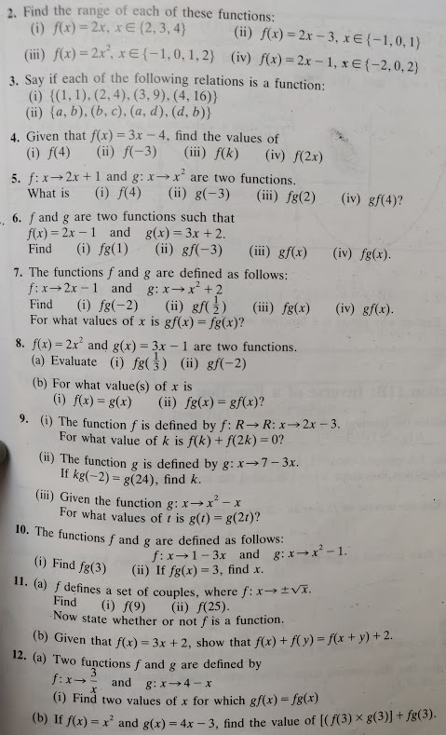

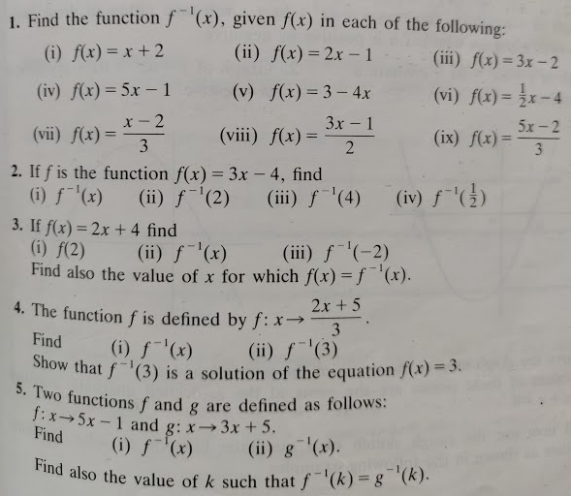

<https://mathbitsnotebook.com/Algebra1/Functions/FNNotationEvaluation.html>

Graphing Linear Functions [Video](https://www.google.ie/search?rlz=1C1CHBF_enIE799IE799&ei=FLTZW5mkM83ikgWAwZ_4Ag&q=graphing+linear+functions&oq=graphing+linear+functions&gs_l=psy-ab.3..0i7i30k1l6j0l4.101884.103024.0.105424.6.6.0.0.0.0.114.524.3j3.6.0....0...1c.1.64.psy-ab..0.6.519....0.Qp_n01y76AU#kpvalbx=1)

Excel worksheets with examples of Linear and Quadratic Functions and Graphs – see Linear_and_Quadratic_Functions_and_Graphs file on website.

Graphs creator(linear/quadratic/trig/etc) - <https://www.mathsisfun.com/data/function-grapher.php>

**Linear Functions**

## Example

Graph the function *g* : *x* → 2*x* + 1, in the domain –3 ≤ *x* ≤ 2, *x* Є **R**.

## Solution

*Y*

Let *y* = *g*(*x*) => *y* = 2*x* + 1.

**1.**

**2.**

Let *x* = -3 and *x* = 2

*g*(*x*)

(2, 5)

**3.**

*y* = 2*x* + 1

*x* = 2

*y* = 2(2) + 1

*y* = 4 + 1

*y* = 5

(2, 5)

*x* = -3

*y* = 2(-3) + 1

*y* = -6 + 1

*y* = -5

(-3, -5)

*X*

(-3, -5)



###### Questions

Graph each of the following functions in the given domain (*x* Є **R** in each case):

1. *f* : *x* → *x* + 3 in the domain –4 ≤ *x* ≤ 2
2. *g* : *x* → *x* –2 in the domain –3 ≤ *x* ≤ 3
3. *h*: *x* → 2*x* + 3 in the domain –2 ≤ *x* ≤ 4
4. *g* : *x* → 3*x* –2 in the domain –3 ≤ *x* ≤ 5
5. *f* : *x* → 5*x* + 1 in the domain –4 ≤ *x* ≤ 2

## What are the domain and range of each graph?

What are the minimum and maximum values of each graph?

## Definitions

**Function** A function is a relation (rule) that assigns each element in the domain to exactly one element in the range.

# ****Domain**** The set of all the values that may be input into a function. That is, the set of all the values the independent variable may assume. Graphically, the domain is the set of all the *x* co-ordinates.

**Range** The set of all the values that are output when the function is evaluated at all the input values from the domain. That is, the set of all the values the dependent variable may assume. Graphically, the range is the set of all the *y* co-ordinates.

## Graphing Quadratic Functions

A quadratic function is usually given in the form *f* : *x* → *ax*2 + *bx* + *c*, *a* ≠ 0, and *a*, *b*, *c* are constants. To draw a quadratic function a table is drawn using the given values of *x* to find the corresponding values of *y*. These points are plotted and joined by a smooth curve.

1. Work out each column separately, i.e. all the *x*2 terms first, then all the *x* terms and finally the constant term (watch for patterns in the numbers).
2. Work out each corresponding value of *y*.
3. The **only** column that changes sign is the *x* term (middle) column. If the given values of *x* contain 0, then the x term column will make one sign changes, either from + to – or from – to +, where *x* = 0.
4. The other two columns **never** change sign. They remain either all +’s or all –‘s. These columns keep the sign given in the question.

**Note**: Decide where to draw the *X* and *Y* axes by looking at the table to see what the largest and smallest values of *x* and *y* is. In general, the units on the *X* axis are larger than the units on the *Y* axis. Try to make sure that the graph extends almost the whole width and length of the page.

## Quadratic Functions

## Example

Graph the quadratic function

*f* : *x* → *x*2 + 3*x* – 2, in the domain –5 ≤ *x* ≤ 2, *x* Є **R**

## Solution

A table is drawn with the given values of *x*, from –5 to 4, to find the corresponding values of *y*.

Let *y* = *f*(*x*) => *y* = *x*2 + 3*x* -2

|  |  |  |
| --- | --- | --- |
| *x* | *x*2 + 3*x* -2 | *y* |
| -5 | 25 – 15 – 2 | 8 |
| -4 | 16 – 12 – 2 | 2 |
| -3 | 9 – 9 – 2 | -2 |
| -2 | 4 – 6 – 2 | -4 |
| -1 | 1 – 3 – 2 | -4 |
| 0 | 0 + 0 – 2 | -2 |
| 1 | 1 + 3 – 2 | 2 |
| 2 | 4 + 6 – 2 | 8 |

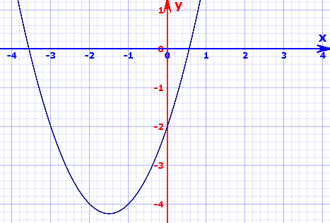

###### Questions

Graph each of the following functions in the given domain (*x* Є **R** in each case):

*f* : *x* → *x*2 – 3*x* + 2 in the domain –1 ≤ *x* ≤ 4.

*f* : *x* → *x*2 – 2*x* –3in the domain –2 ≤ *x* ≤ 4.

*f* : *x* → *x*2 +2*x* –8in the domain –5 ≤ *x* ≤ 3.

*g* : *x* → 2*x*2 – 3*x* –8in the domain –3 ≤ *x* ≤ 4.

*h* : *x* → 2*x*2 – *x* –3in the domain –2 ≤ *x* ≤ 3.

## What are the domain and range of each graph?

What are the minimum and maximum values of each graph?

**Graphs of Quadratic Functions and Questions on Graphs**

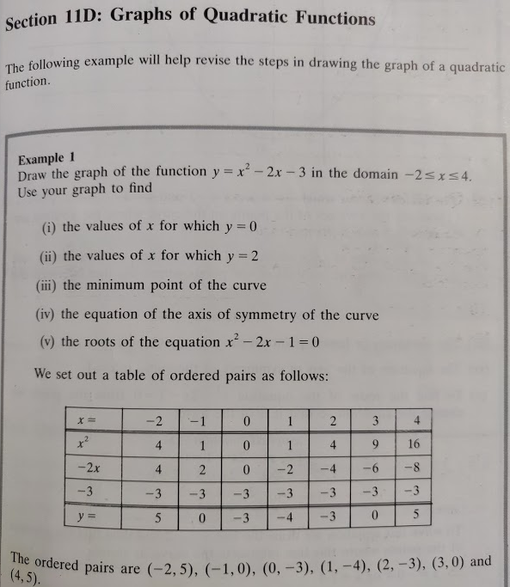

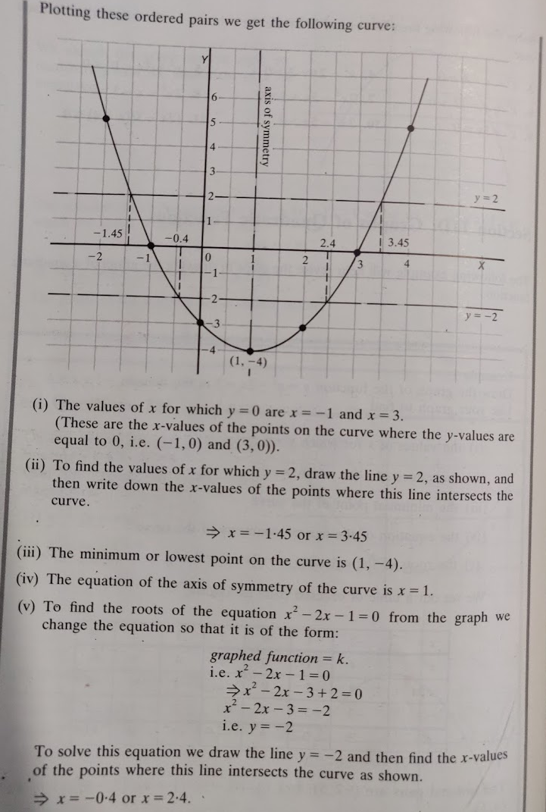

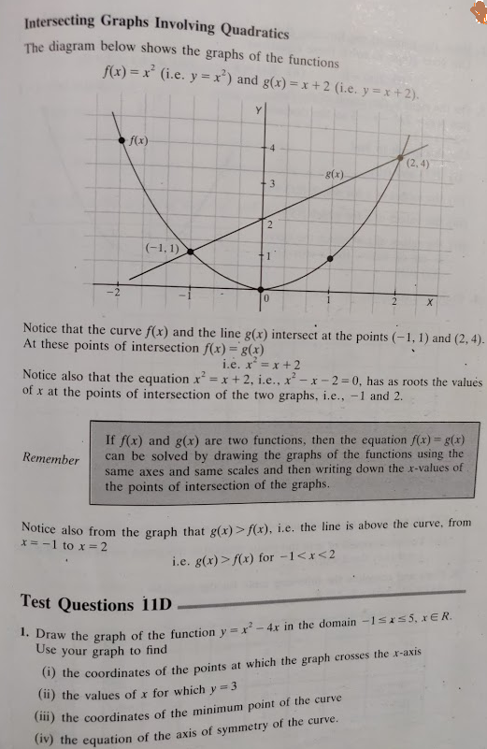

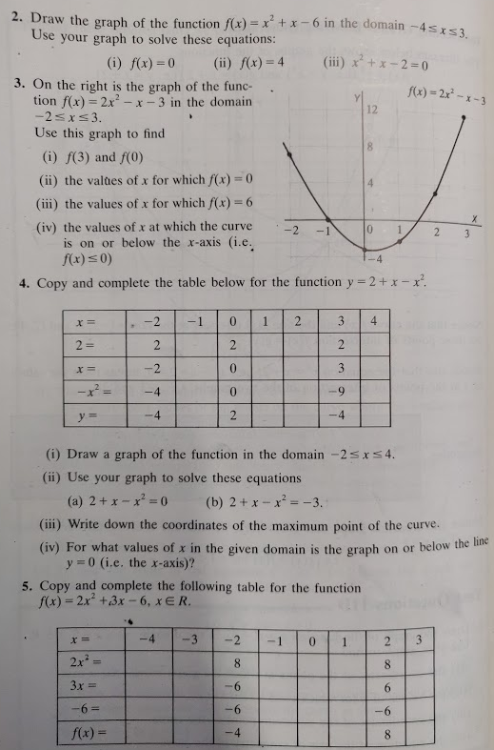

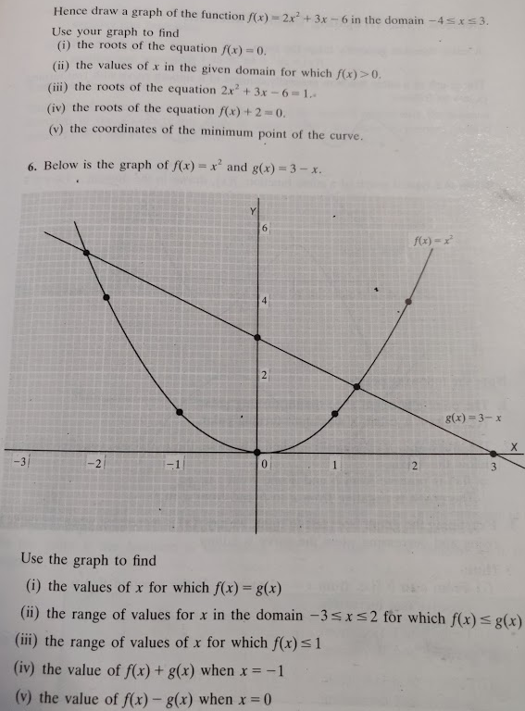

Q4 Solution

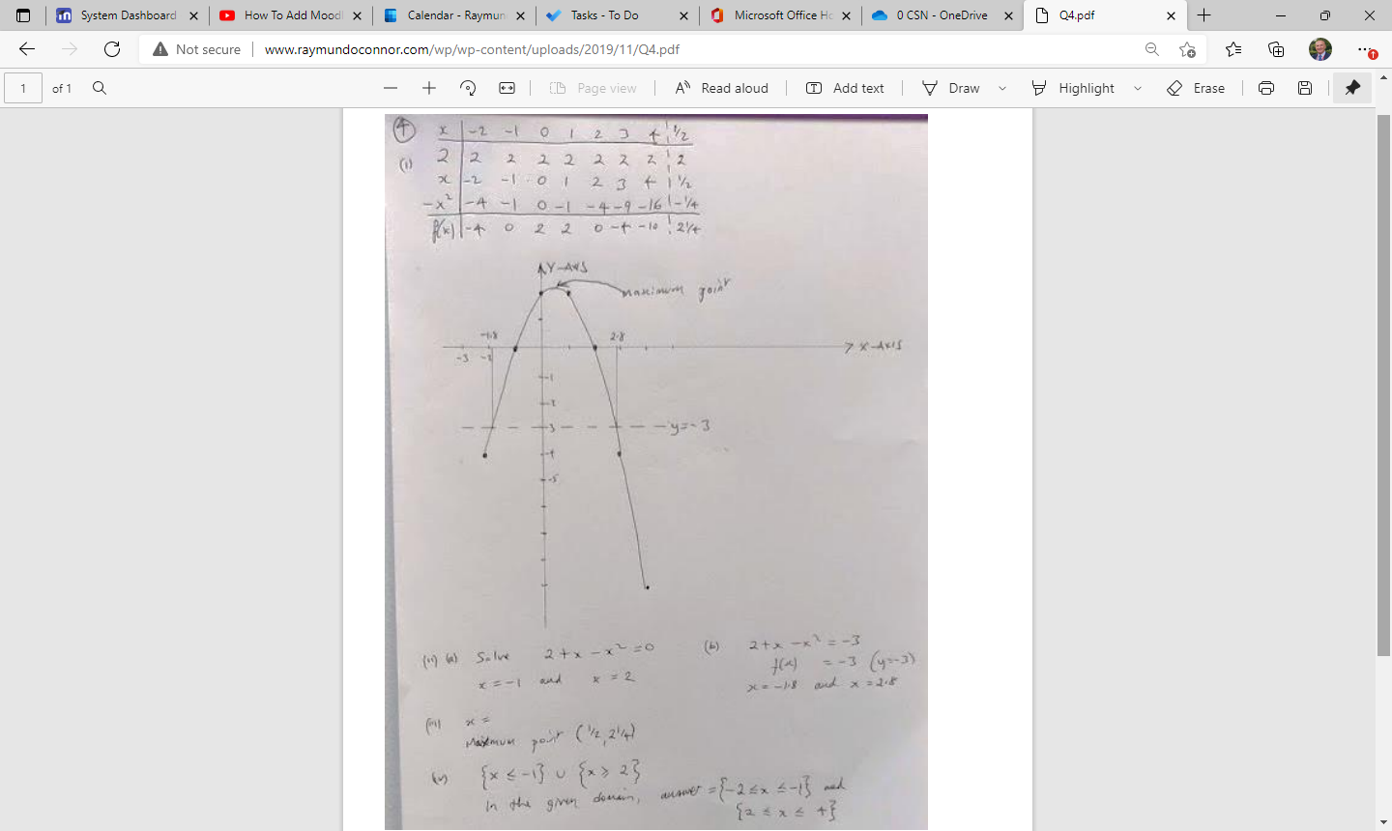

Q5 Solution

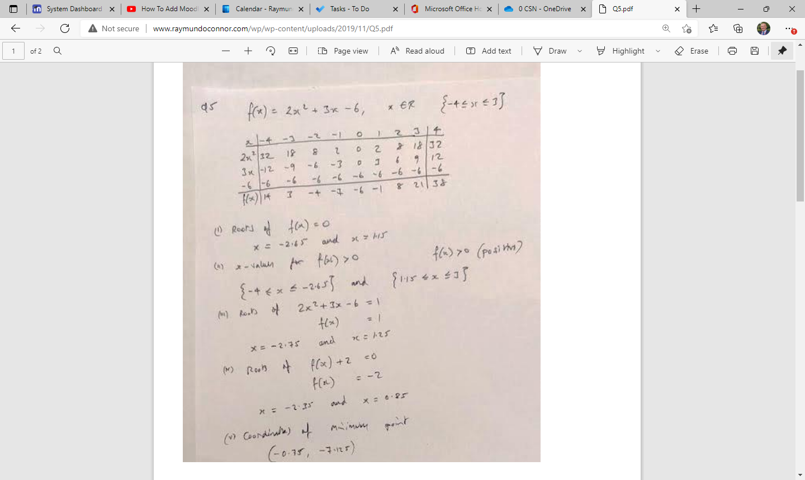

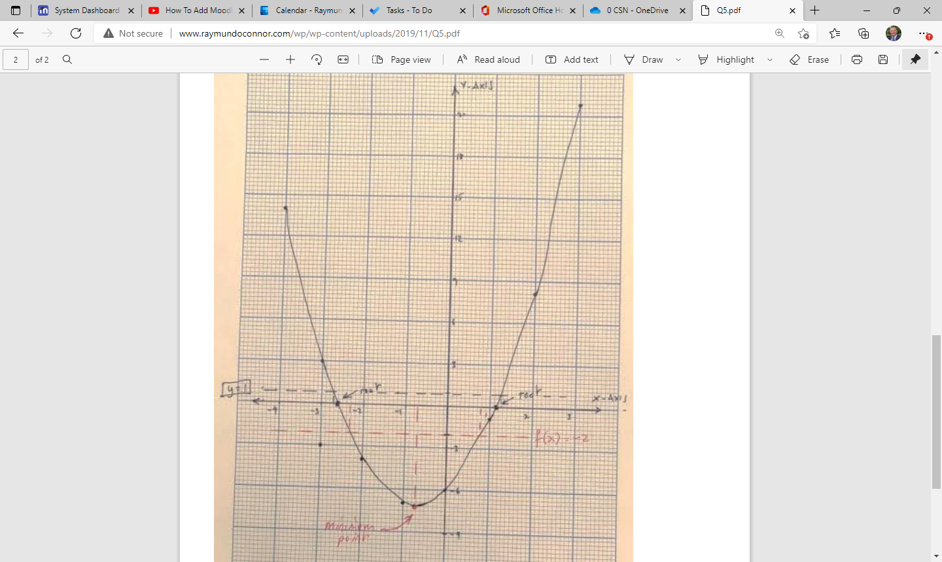

Q6 Question & Solution

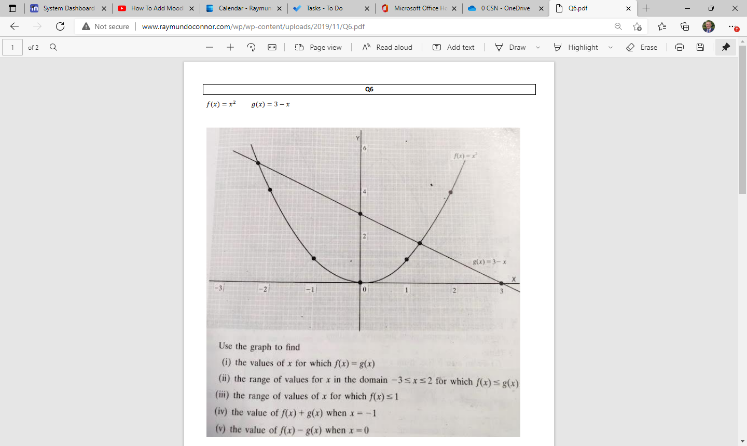

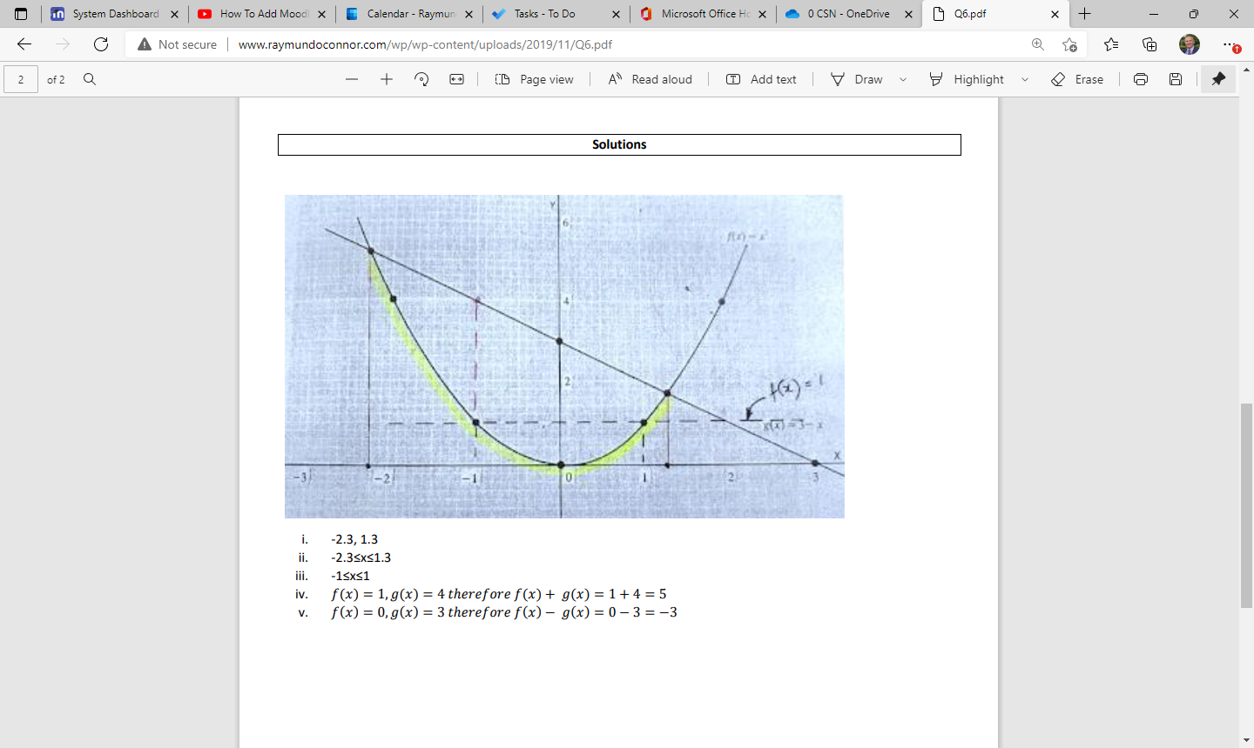

Draw a graph in a given domain

|  |  |
| --- | --- |
| 1 | Draw the graph of the following $f\left(x\right)=6x^{2}+x-2$ in the domain -2 $≤$ x $≤$ 2  Use your graph to solve $6x^{2}+x-2=0$ What are the coordinates of the minimum point?  What is the range of x values for $f\left(x\right)<0$ |
| 2 | Draw the graph of the following $f\left(x\right)=3x^{2}+11x-20$ in the domain -6 $≤$ x $≤$ 3  Use your graph to solve $3x^{2}+11x-20=0$ What are the coordinates of the minimum point?  What is the range of x values for $f\left(x\right)$ is positive?  What is the rang of x values where f(x) is decreasing? |

**Pre – Assignment (Important)**

|  |  |  |  |
| --- | --- | --- | --- |
| Q4 | (a) | *f* and *g* are functions such that $f:x→2x+7 and g:x→3x-2$ |  |
|  | (i) | Find $f\left(-1\right), f\left(0\right), g\left(\frac{1}{3}\right), g\left(-4\right)$ |  |
|  | (ii) | The value of $x$ when $f\left(x\right)= -5$ |  |
|  | (iii) | The value of $x$ when $f^{-1}\left(x\right)=10$ |  |
|  | (iv) | For what value of $x$ is $f\left(x\right)= g(x)$ |  |
|  | (v) | Evaluate $fg\left(x\right)+gf\left(x\right)-1$ |  |
|  |  |  |  |
|  | (b) | Using the same axes and the same scales, graph the functions $$f:x→x^{2}+x-3$$ $$g:x→2x+1$$ in the domain $-4≤x ≤ 3$ Use the graph to find, as accurately as you can |  |
|  |  |  |  |
|  | (i) | The roots of the equation $x^{2}+x-3=0$ |  |
|  | (ii) | The roots of the equation $x^{2}+x-1=0$ |  |
|  | (iii) | The minimum value of $f(x)$ |  |
|  | (iv) | The range of x values for which $f\left(x\right)<g(x)$ |  |
|  | (v) | The values of $x$ for which $f\left(x\right)=g(x)$ |  |
|  | (vi) | The values of $x$ for which $f\left(x\right)$ is increasing |  |

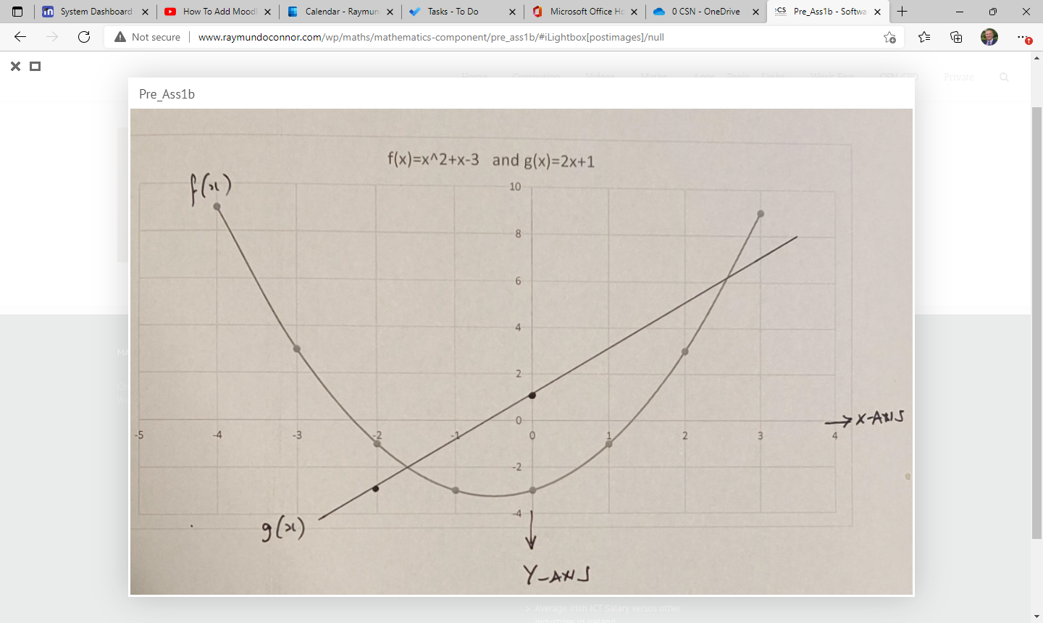

Max/min points – increasing/decreasing

**Functions and Graphs Exercises – Vertex Max Min**

Draw the graph of f(x) = x2 + x +1 in the domain {-4 ≤ x ≤ 2}

Use your graph

* to estimate the values of 𝑥 when 𝑦 = 5.
* the coordinated of the minimum point
* the range of x values for f(x)>0
* the range of x values for f(x) increasing
* to find the axis of symmetry

Draw the graph of 𝑥2 + 𝑦2 = 4 and 𝑥 + 𝑦 = 1 on the same axis. Domain = {-2 ≤ x ≤ 2}

Use your graph to

* solve 𝑥2 + 𝑦2 = 4 and 𝑥 + 𝑦 = 1

Draw the graph of f(x) = x2+2x+1 in the domain {-5 ≤ x ≤ 5}

Use your graph to

* coordinates of vertex
* axis of symmetry
* x-intercept
* y-intercept
* coordinates of max/min
* value
* domain
* range

Draw the graph of f(x) = 3x2-6x+4 in the domain {-2 ≤ x ≤ 4}

Use your graph to

* coordinates of vertex
* axis of symmetry
* x-intercept
* y-intercept
* coordinates of max/min
* value
* domain
* range

Draw a graph of f(x) = x3 -9x2 +24x -20

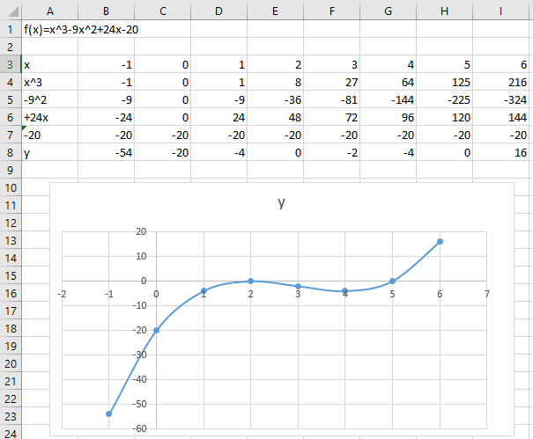

Draw a graph of f(x) = x3 +2x2 -4x -8

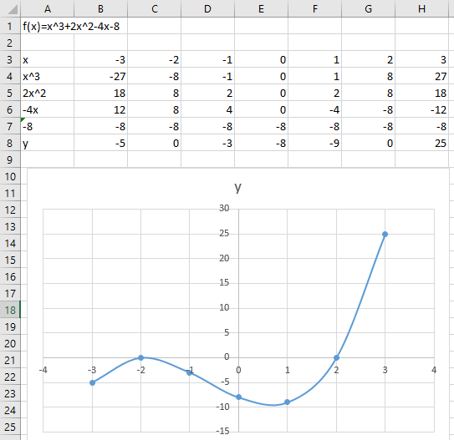

Real Life Examples of Linear Functions and Graphs

**Linear Functions and Graphs**

**Example 1**

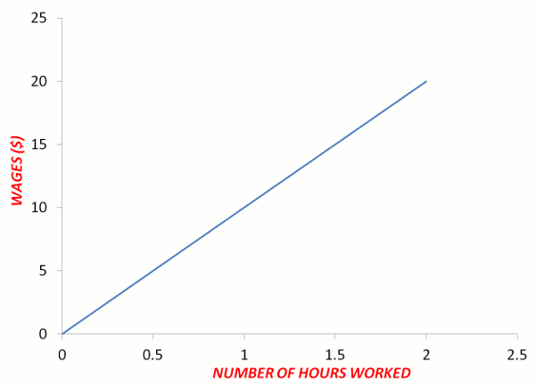

**Example 2**

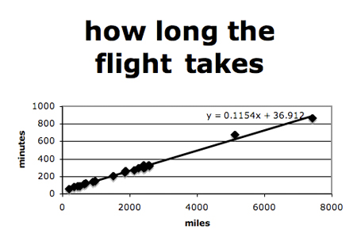

**Example 3**

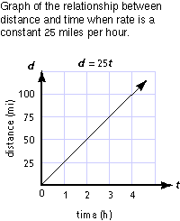

**Example 4**

