1 MODELLING USING MATHEMATICS
1.1 Explain the concept of a mathematical model to include the difference between mathematical models and physical models.
1.2 Explain the modelling process in diagrammatic form.
1.3 Solve simple mathematical models to include identifying situations requiring mathematical modelling, and using appropriate mathematical skills and processes.
1.4 Apply simple mathematical models to explain and predict behaviour.

Physical Models
Physical models are three-dimensional representations of reality. In general, two types of physical models exist:
- mock-up
- prototypes

Mock-up
This type of physical model is an appearance, conceptual or physical mock-up. It is used to evaluate the styling, balance, colour, or other aesthetic feature of a technology artifact. Mock-ups are generally constructed of materials that are easy to work with. Commonly these materials include wood, clay, paper, and various kinds of cardboard.
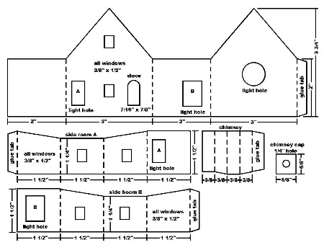
Prototype
A prototype is a physical model which is also a working model of a system, assembly, or a product. Prototypes are constructed to test the operation, maintenance and safety of an item. Prototypes are generally constructed from the same material as the final product. Prototypes can be used to test and evaluate the solutions.
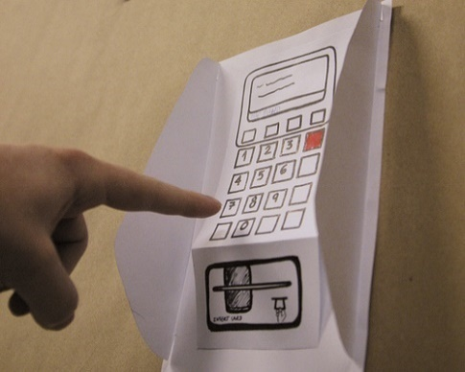

Mathematical Models
Mathematical models are comprised of numbers, mathematical formulae, equations, etc and used to provide a solution to a Real-World problem (eg cost of painting a room with a wall surface area of 60m²).
Examples of Physical and Mathematical Models:
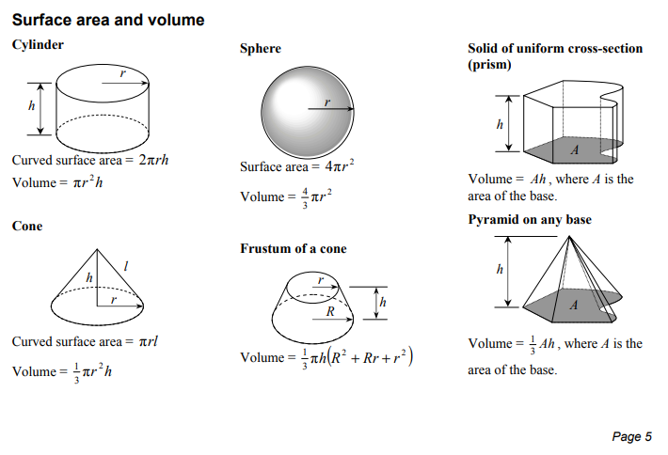
Physical Model - Real world challenge to calculate the area of a field (eg non standard geometric shape as shown below)
Mathematical Model – this is the maths formula as shown.
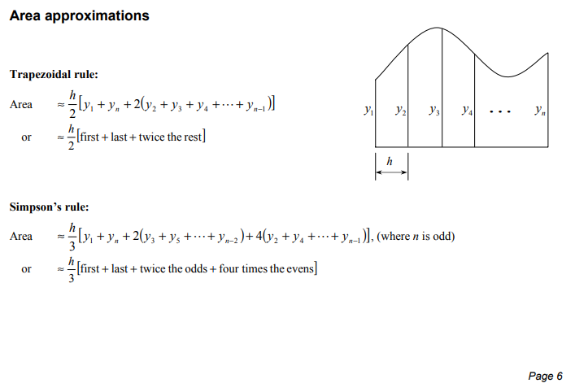
Mathematical Modelling
Method of simulating real-life situations with mathematical equations to forecast their future behaviour. Mathematical modelling uses tools such as decision-theory, queuing theory, and linear programming, and requires large amounts of number crunching.
- Mathematics is a very precise language which helps us formulate ideas.
- Mathematics is a concise language comprising of numbers and symbols, with well-defined rules (eg BIRDMAS, BOMDAS).
- Mathematical modelling is about using results that mathematicians have proved over hundreds of years.
- Computers can be used to perform numerical calculations.
  - (https://www.mathsisfun.com/data/function-grapher.php)
- Any formula/equation/etc can be considered a mathematical model.
  - (e.g. $y=mx+c$ where m is the slope of the line and c is the y-intercept in other words where the line cuts the y-axis)
- Linear Programming is a good example of where we use mathematics concepts, formula, etc to provide valuable information in real world scenarios.
Mathematical Modelling objectives
- Develop mathematical/scientific understanding from current knowledge of a system.
- Test the effect of changes in a system using various data (eg numbers, etc).
- Aid decision making, including:
  - tactical decisions made by managers,
  - strategic decisions made by planners.

Using Mathematical Modelling to Solve Real World Problems
Creating a mathematical model
- We begin with a word problem (eg real world problem).
- Determine what the objective is or what question we are to answer.
- Assign variables to quantities in the problem so you can calculate an answer using these variables (eg x, y)
- Derive mathematical equations/inequalities containing these variables.
- Use these equations/inequalities to find the values of these variables.
- Determine the answer to the problem.
In Real World situations we often make use of a Model World where models play an important role in planning and decision-making.
In mathematical modelling, we translate those beliefs into the language of mathematics. This has many advantages:  - Mathematics is a very precise language. This helps us to formulate ideas and identify underlying assumptions.  - Mathematics is a concise language, with well-defined rules for manipulations.  - All the results that mathematicians have proved over hundreds of years are at our disposal.  - Computers can be used to perform numerical calculations. | What objectives can modelling achieve?  - Developing scientific understanding - through quantitative expression of current knowledge of a system (as well as displaying what we know, this may also identify what we do not know);  - Test the effect of changes in a system;  - Aid decision making, including:  (i) tactical decisions by managers; (ii) strategic decisions by planners

Benefits of using mathematical/physical models:

- Models help us communicate.
- Models allow us to clarify and test understanding.
- Models create credibility and accountability.
- Models help you organize your thoughts.
- Models simplify and solve problems.
- Models help you understand your data.

Mathematical Modelling Process in Diagrammatic form
Hypothesis - In mathematics, a hypothesis is an unproven statement which is supported by all the available data and results.
Example 1 | 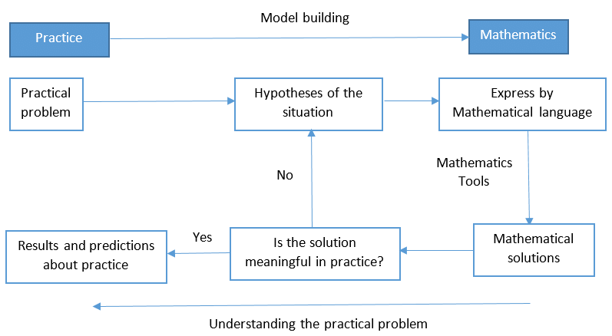
Example 2 | 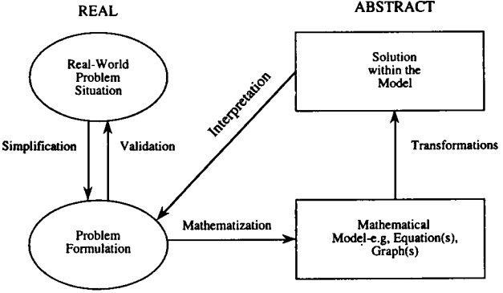
Example 3 | 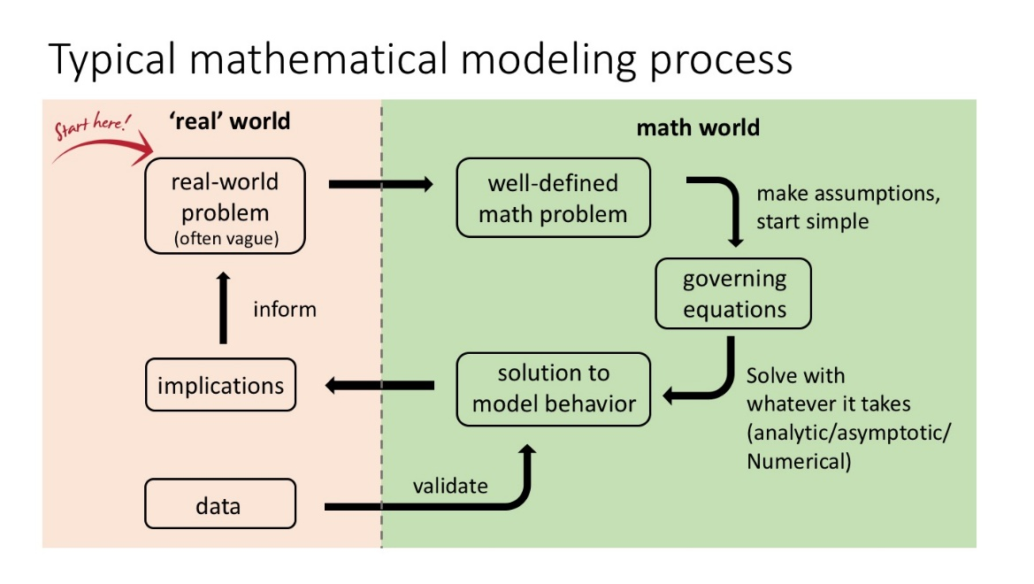

Real World Challenge – Calculate the Distance between 2 locations
- Using our Physical Model: Determine the geolocation (eg GPS coordinates of each city or location).
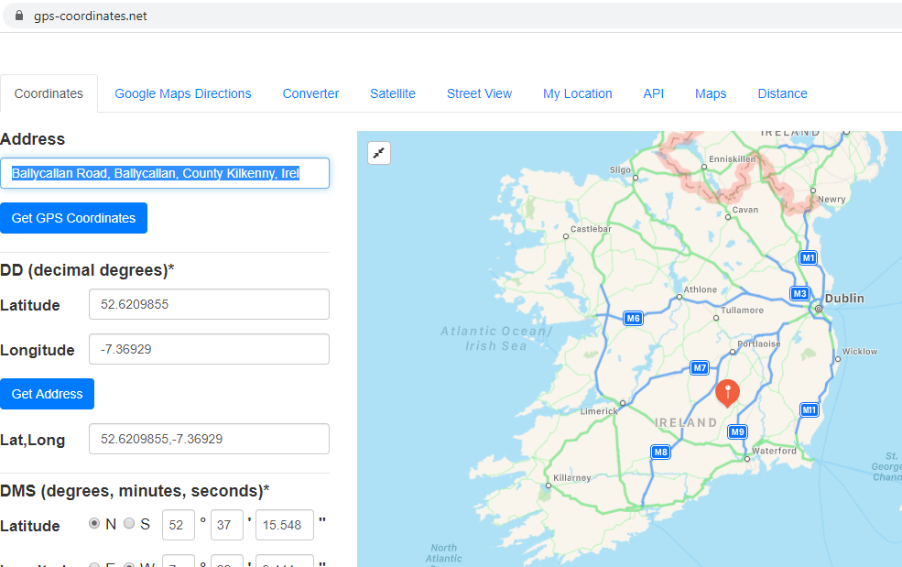
- Use the Mathematical Model below to calculate the distance based on the GPS coordinates.
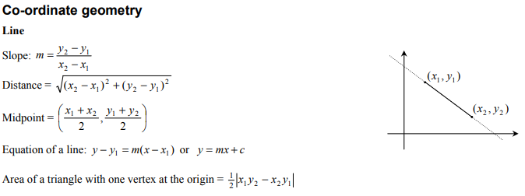
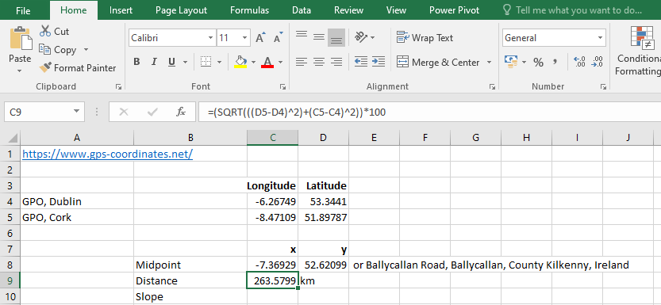
- We can use pen/paper or calculator or software to calculate the correct answer to our challenge.

Solving Real World challenges using Mathematical Modelling
- Example: 3 tennis balls(radius = 2cm) in a tube - how much plastic is required to make a simple tube(surface area required).
- Example: 4 golf balls(radius = 12mm) in a cardboard box - how much cardboard is required to make the cardboard container(surface area required)
- 8 dice (side = 3.25cm) in a container etc?? Answer will depend on the container design???

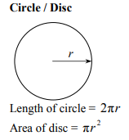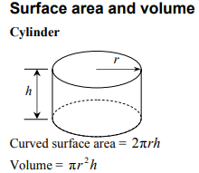

Solutions

Exercises – Questions

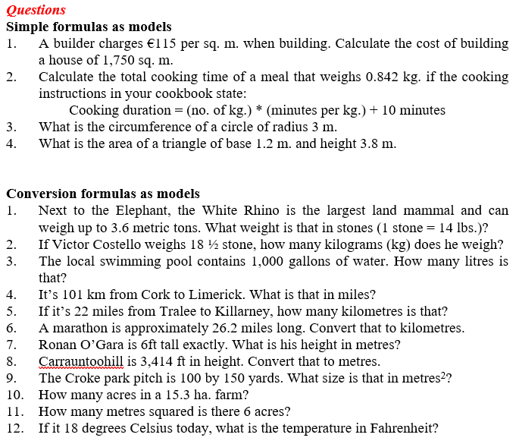
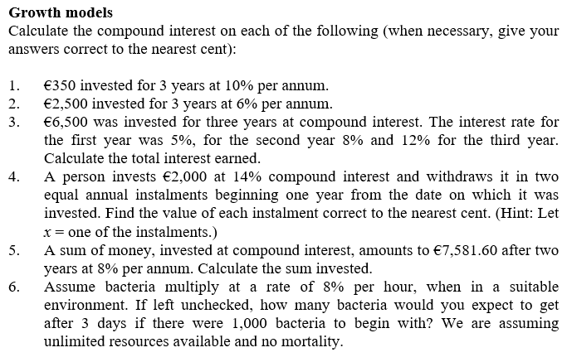
Solutions to Exercises at end of “Maths-Modelling-Diagrammatic-Form”

Simple Formula as Models
- 115(1750) = €201,250
- Assuming it takes 10 minutes per kg to cook (0.842)(10) + 10 = 18.42 minutes
- Circumference $C=2πr$, 2($π)\left(3\right)=6π or 18.857142857….m$
- Area = ½ Base by Perpendicular Height, ½ (1.2)(3.8) = 2.28m²
Conversion Formula as Models
- Weight by Conversion Factor (1 ton = 157.47 stone), (3.6)(157.47) = 566.892 stone
- Conversion Factor (1 stone = 6.35029kg), (18.5)(6.35029) = 117. 480365kg
- Conversion Factor (1gallon = 3.78541litres), (1000)( 3.78541) = 3785.41litres
- Conversion Factor (1km = 0.6214miles), (101)( 0.6214) = 62.7614 miles
- Conversion Factor (1mile = 1.60934km), (22)(1.60934) = 35.40548km
Growth Models
- $A=P{(1+\frac{r}{100})}^{n}$, $A=350{(1+\frac{10}{100})}^{3}$ = $A=350{(1.1)}^{3}$ = $350(1.1331)$ = €465.85
- $A=P{(1+\frac{r}{100})}^{n}$, $A=2500{(1+\frac{6}{100})}^{3}$ = $A=2500{(1.06)}^{3}$ = $2500(1.191016)$ = €2977.54
- 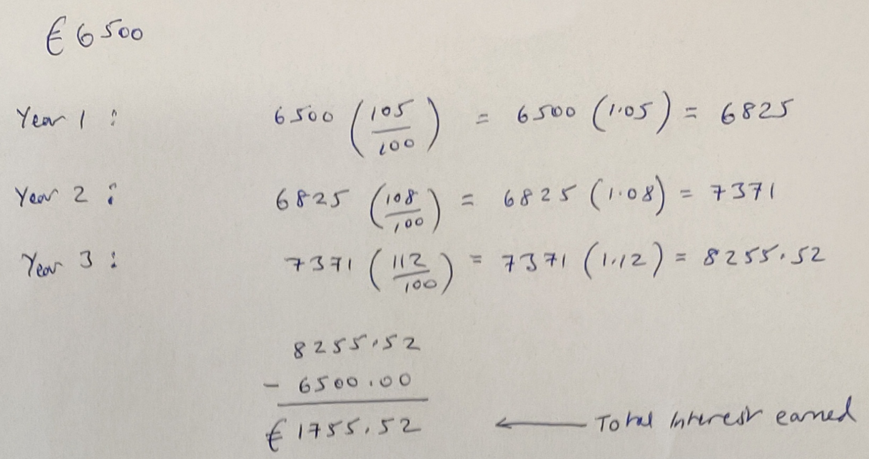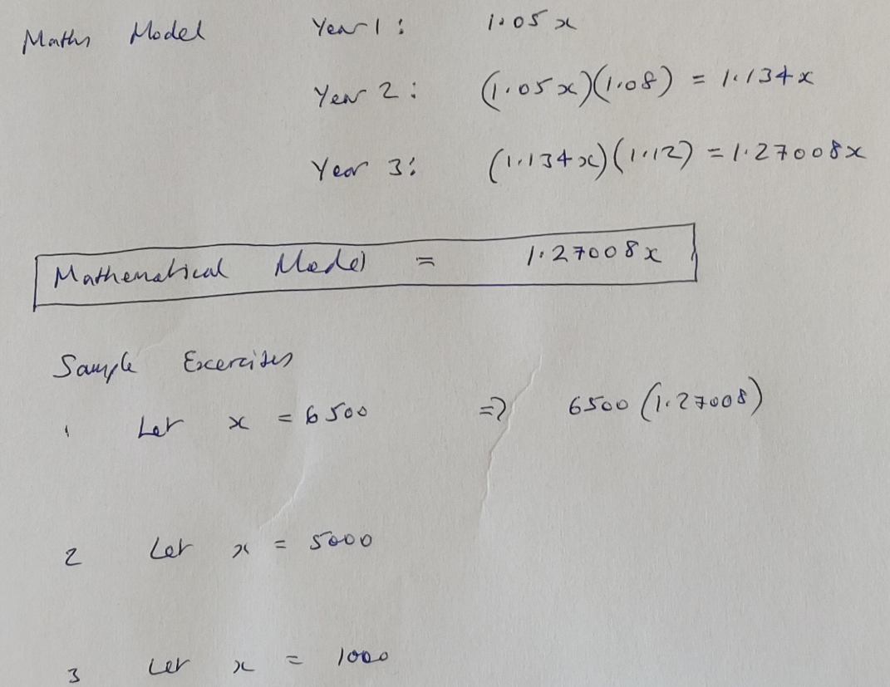

$2000(1+\frac{14}{100})$
$$(\left(2000\left(1.14\right)-x\right)\left(1.14\right))-x=0$$
$$\left((2280-x\right)1.14)-x=0$$
$$\left(2599.20-1.14x\right)-x=0$$
$$2599.20-2.14x=0$$
$$2599.20=2.14x$$
$$\frac{2599.20}{2.14}=x$$
$$1,214.579439252336=x$$
$$1,214.58=x$$
- $7581.60=x{(1+\frac{8}{100})}^{2}$ = 7581.60${=x(1.08)}^{2}$ = $\frac{7581.60}{1.1664}$=x therefore x= 6500
- 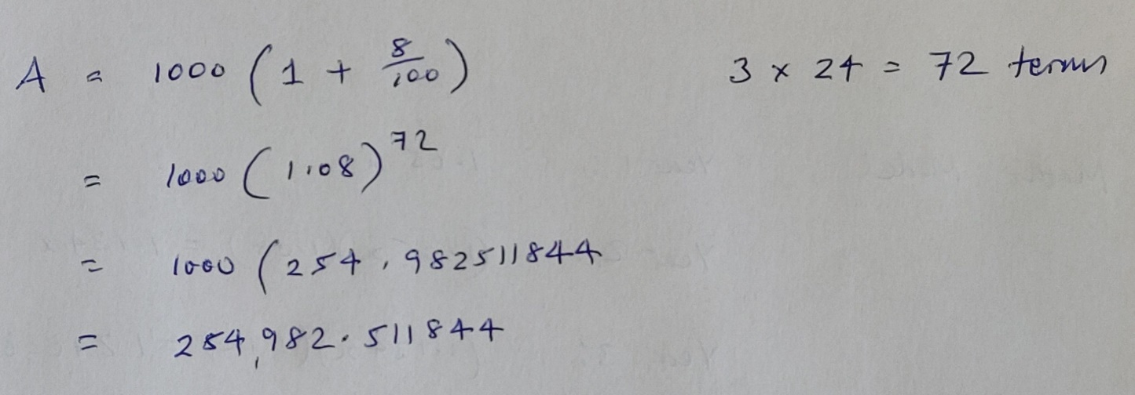

Mathematical Models to explain and predict behaviour.
Maths and Science have many kinds of models:
- Animal Models: - To study human diseases.
- Physical Models: - To demonstrate the apparent truth of a principle.
- Mathematical Models: - To gain insight and understanding of a phenomenon which is being observed.

Inputs ⇒ MODEL ⇒ Outputs

Models can be used to:
- Understand the problem/challenge/phenomenon better.
- Make predictions of how outcome change with inputs.

Use graphical models to make predictions or assist in decision making.

Example | Description
1 | Aim: How do we use data to make predictions – (eg linear regression)?  Scenario: A candle is 6cm tall after burning for 1 hour. After 3 hours, it is 5.5cm tall. Write a linear equation to model the height y of the candle after burning for x hours.  Mathematical Model:  Question: How tall would the candle be after burning for 4 hours  $$y=-\frac{1}{4}\left(4\right)+6\frac{1}{4} =-1+6\frac{1}{4} =5\frac{1}{4}cm or 5.25cm$$  It was easy to make a prediction as to how tall the candle would be using the mathematical model.
2 | The table shows the temperature of a fish tank during an experiment. Write the appropriate linear equation for the given situation and use the equation to predict the temperature at the 7th hour.  Solution :  Step 1 :  Notice that the change in the temperature is the same for each increase of 1 hour in time. So, the relationship is linear.  Since we want to find the temperature at the 7th hour, the appropriate linear equation for the given situation is slope-intercept form (y = mx + b), assuming "y" as temperature and "x" as hours.  Step 2 :  Choose any two points in the form (x, y), from the table to find the slope :  For example, let us choose (0, 82) and (1, 80).  Use the slope formula.  $m=\frac{y_{2}-y_{1}}{x_{2}-x_{1}}=\frac{80-82}{1-0}=\frac{-2}{1}=-2$  Step 3 :  Find the y-intercept(b) using the slope and any point from the table.  Slope-intercept form equation of a line :  y = mx + b  Substitute m = -2, and (x, y) = (0, 82).  82 = -2(0) + b  82 = 0 + b  82 = b  Step 4 :  Now, substitute m = -2 and b = 82 in slope-intercept form equation of a line.  y = mx + b  y = -2x + 82  Step 5 :  Predict the temperature at the 7th hour.  Substitute x = 7 in the equation y = -2x + 82.  y = -2(7) + 82  y = -14 + 82  y = 68  So, the temperature at the 7th hour is 68⁰ F.
3 | Elizabeth’s cell phone plan lets her choose how many minutes are included each month. The table shows the plan’s monthly cost y for a given number of included minutes x. Write an equation in slope-intercept form to represent the situation and use it to predict cost of plan for 800 minutes included.  Solution :  Step 1 :  Notice that the change in cost is the same for each increase of 100 minutes. So, the relationship is linear.  Step 2 :  Choose any two points in the form (x, y), from the table to find the slope :  For example, let us choose (100, 14) and (200, 20).  Use the slope formula and substitute values for y₂,y₁,etc :  .  $$m=\frac{y_{2}-y_{1}}{x_{2}-x_{1}}=\frac{20-14}{200-100}=\frac{6}{100}=0.06$$  Step 3 :  Find the y-intercept using the slope and any point from the table.  Slope-intercept form equation of a line :  y = mx + b  Substitute m = 0.06, and (x, y) = (100, 14).  14 = 0.06(100) + b  14 = 6 + b  8 = b  Step 4 :  Now, substitute m = 0.06 and b = 8 in slope-intercept form equation of a line.  y = mx + b  y = 0.06x + 8  Step 5 :  Predict cost of plan for 800 minutes included.  Substitute x = 800 in the equation y = 0.06x + 8.  y = 0.06(800) + 8  y = 48 + 8  y = 56  So, the cost of plan for 800 minutes included is €56.
4 | The rent charged for space in an office building is a linear relationship related to the size of the space rented. At West Main Street office rentals, €750 rent charged for 600 square feet of space and €1150 rent charged for 900 square feet of space. Write an equation in slope-intercept form for the rent at West Main Street Office Rentals and use it to predict the rent for 1200 square feet of space.  Solution :  Step 1 :  Identify the independent and dependent variables.  The independent variable (x) is the square footage of floor space.  The dependent variable (y) is the monthly rent.  Step 2 :  Write the information given in the problem as ordered pairs.  The rent for 600 square feet of floor space is $750 :  (600, 750)  The rent for 900 square feet of floor space is $1150 :  (900, 1150)  Step 3 :  Find the slope by substituting values as shown:  (x₁, y₁) = (600, 750)  (x₂, y₂) = (900, 1150)  $$m=\frac{y_{2}-y_{1}}{x_{2}-x_{1}}=\frac{1150-750}{900-600}=\frac{400}{300}=\frac{4}{3}=0.06$$  Substitute :  Step 4 :  Find the y-intercept.  Use the slope $\frac{4}{3}$ and one of the ordered pairs (600, 750).  Slope-intercept form :  y = mx + b  Substitute m = 4/3, x = 600 and y = 750.  750 = $\frac{4}{3}$(600) + b  750 = 800 + b  -50 = b  Step 5 :  Substitute the slope and y-intercept.  Slope-intercept form  y = mx + b  Substitute m = $\frac{4}{3}$and b = -50.  y = ($\frac{4}{3}$)x + (-50)  y = ($\frac{4}{3}$)x - 50  Step 6 :  Predict the rent for 1200 square feet of space.  Substitute x = 1200 in the equation y = ($\frac{4}{3}$)x - 50.  y = ($\frac{4}{3}$)(1200) - 50  y = 1600 - 50  y = 1550  So, the rent for 1200 square feet of space is €1550.
4 | 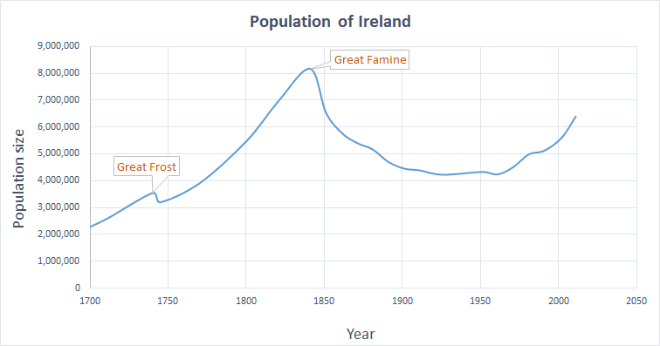
5

 | 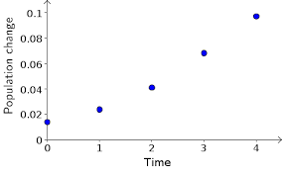
 | 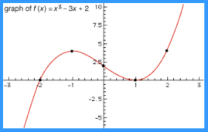

Coordinate Geometry – Line
Cartesian Plane (names after the French mathematician De Cartes)
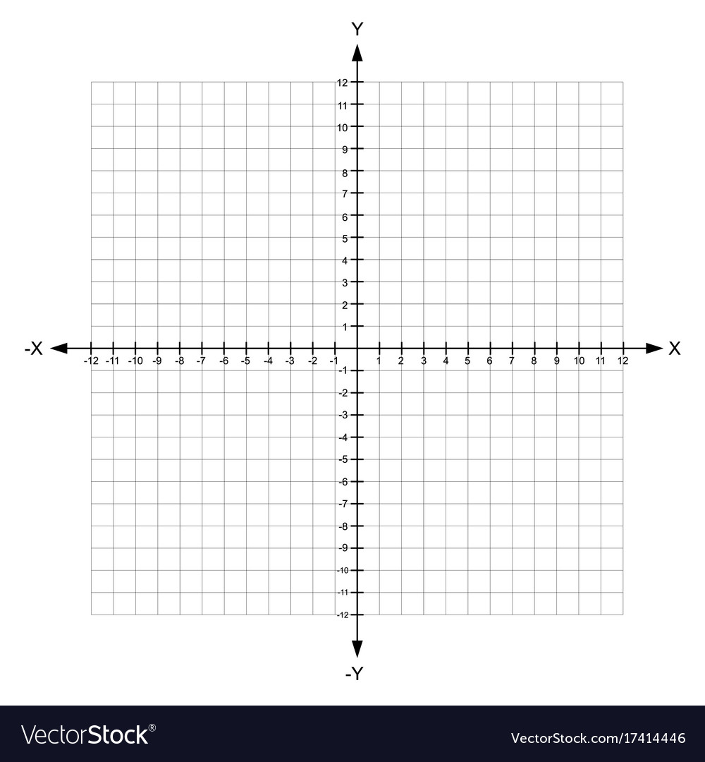

Plot the following points on the cartesian plane:
- (3,6)
- (-2,8)
- (-4,-2)
- (6,-6)

Graphing lines
y=2x-4
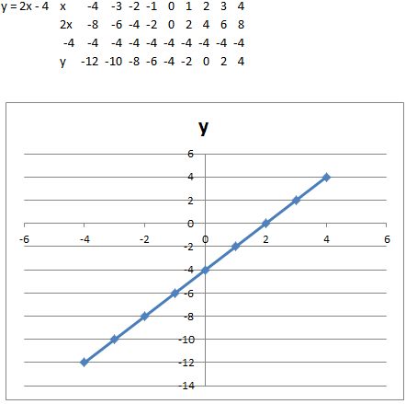
5x-2y=6
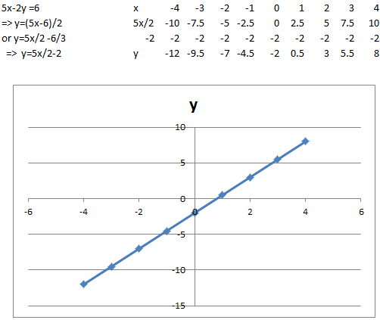

3x+4y-12=0

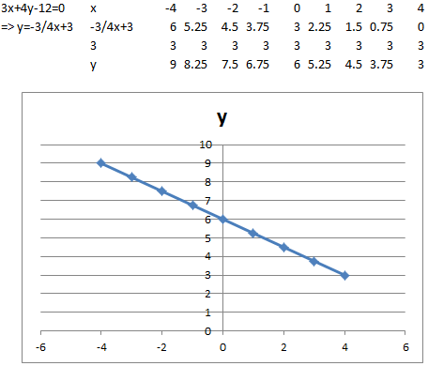

Formula
Midpoint of a line segment $\left(\frac{x_{1}+ x_{2}}{2} , \frac{y_{1}+ y_{2}}{2}\right)$
Equation of a line $y-y_{1}=m(x-x_{1})$
Slope of a line $y=mx+c$
Slope of a line given points on line $m=\frac{y_{2}- y_{1}}{x_{2}- x_{1}}$
Length of line segment or distance between 2 points $\sqrt{{(x_{2}-x_{1})}^{2}+{(y_{2}-y_{1})}^{2}}$
Parallel lines have the same slope $m_{1}=m_{2}$
Perpendicular lines slopes multiply to give -1 $m_{1}.m_{2}=-1$
Exercises
Find the Mid-point, Slope, Length of line segment and Equation of the lines for the following points:
- $\left(-1, 1\right)$ and $\left(3, 4\right)$
- $\left(1, 2\right)$ and $\left(-2, 6\right)$

Perpendicular Lines
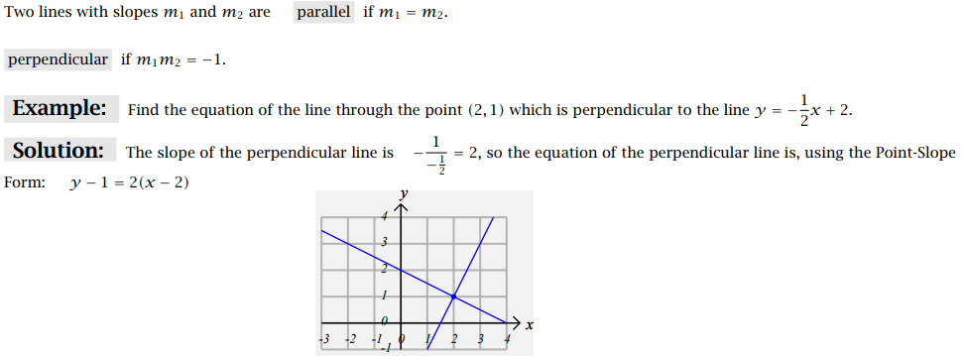
Intersecting Lines – Simultaneous Equations
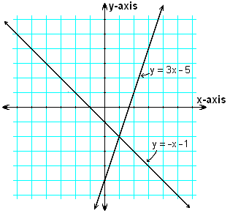
$$y=3x-5 \\ y=-x-1$$
Cancel either the x’s or y’s. In this example we will cancel the y’s so to do this we must multiply the bottom equation by -1.
$$y=3x-5 \\ -y=+x+1$$
A -y cancels with a +y, 3x+x=4x, etc
$$0=4x-4 therefore 4x=4 so x=\frac{4}{4} and x=1$$
X=1 so we can substitute this into either equation
$$y=3(1)-5 \\ y=3-5 \\ y=-2$$
Intersection point is $$(1,-2)$$

Solving Simultaneous Equations
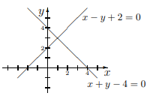
$$x+y-4=0$$
$$x-y+2=0$$

$$y+y-4=0$$
$$x-y+2=0$$

Using Linear Programming to solve simple mathematical models and mathematical modelling
Today we will do this using straight lines as our equations, and we will solve the problem by drawing these lines (graphing).
This process is called “Linear Programming” and is one of the most powerful mathematical methods used by businesses and companies to solve problems and help them make the best decisions.
“Operations Research” is the profession that applies mathematical methods like this to problems arising in industry, healthcare, finance, etc.
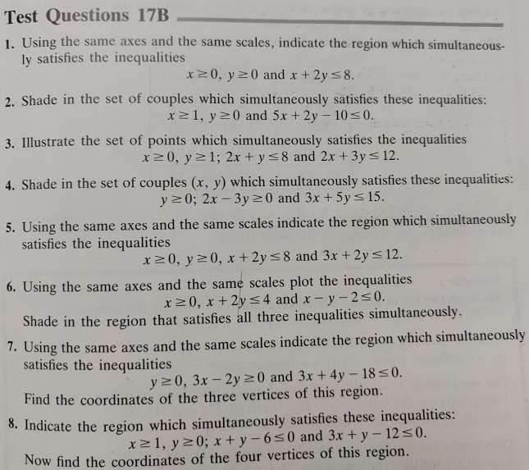

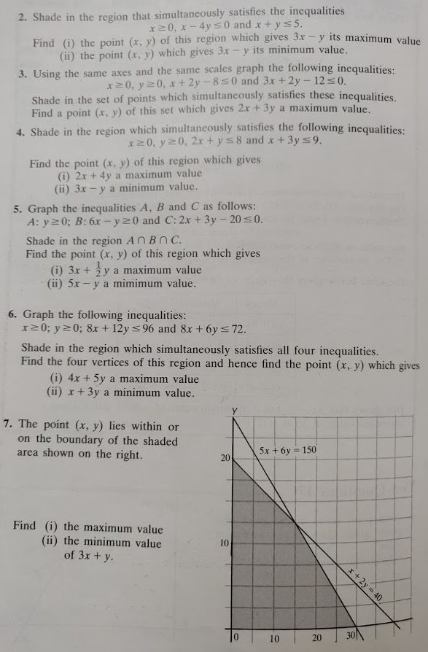

Linear Programming Examples
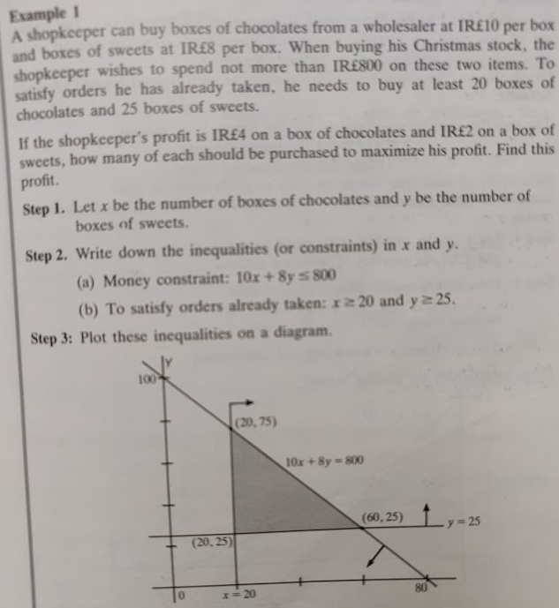
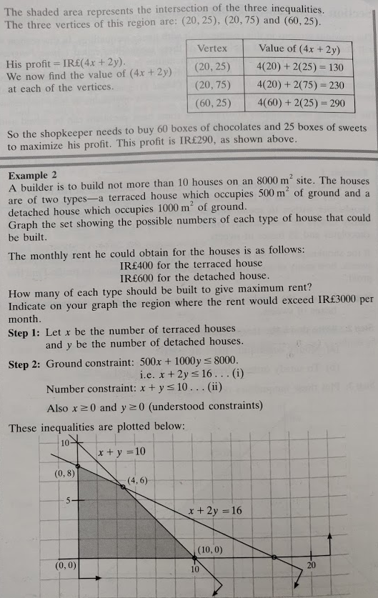
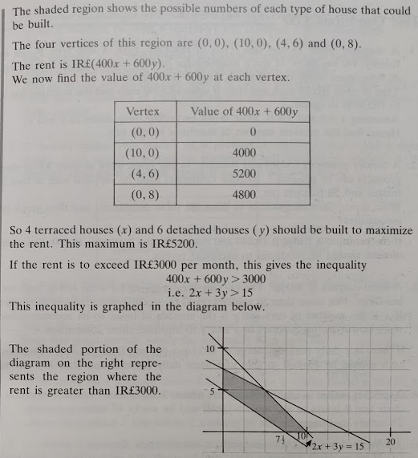

Linear Programming Examples

Linear Programming Exercises - Several
