**Using Linear Programming to solve simple mathematical models and mathematical modelling**

Today we will do this using straight lines as our equations, and we will solve the problem by drawing these lines (graphing).

This process is called “Linear Programming” and is one of the most powerful mathematical methods used by businesses and companies to solve problems and help them make the best decisions.

“Operations Research” is the profession that applies mathematical methods like this to problems arising in industry, healthcare, finance, etc.

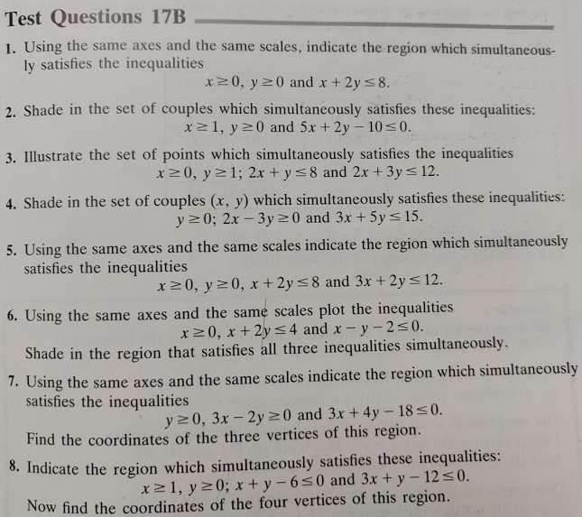

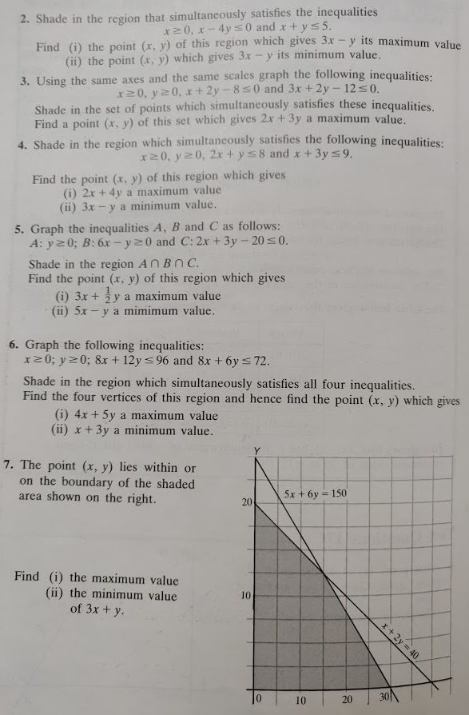

Linear Programming Examples

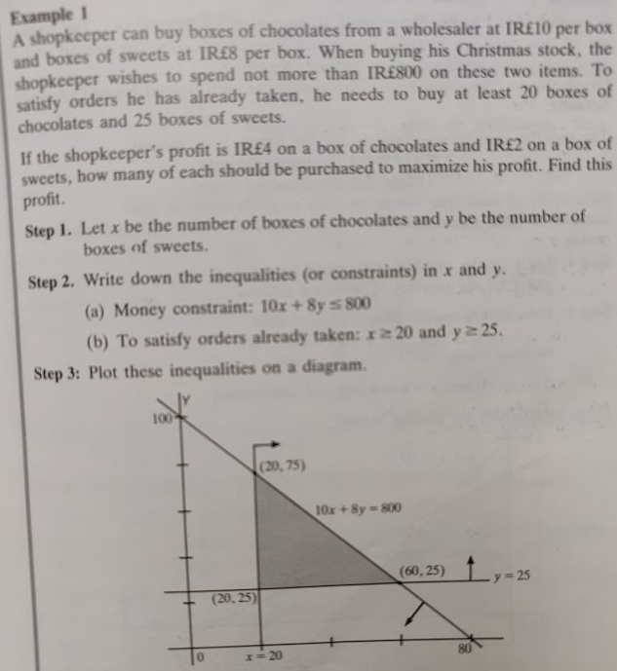

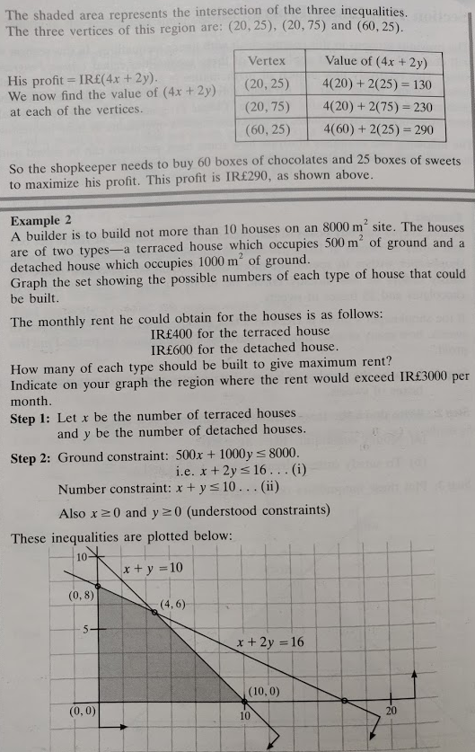

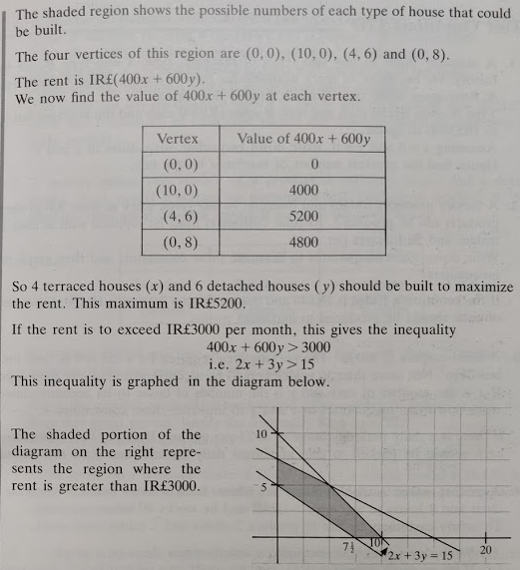

Linear Programming Examples







Linear Programming Exercises - Several

