Histogram Exercise (Equal Widths)
The histogram below shows the efficiency level (in miles per gallons) of 110 cars.
a) How many cars have have an efficiency between 15 and 20 miles per gallon?
b) How many cars have have an efficiency more than 20 miles per gallon?
c) What percentage of cars have have an efficiency less than 20 miles per gallon?

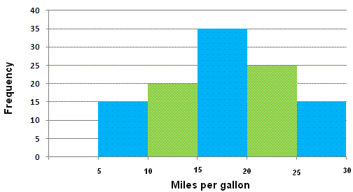

Solutions

a) 35 cars
b) 25 + 15 = 40 cars
c) (15 + 20 + 35) / 110 = 0.636 = 63.6%

Histogram with Different Widths Example
When constructing a histogram with non-uniform (unequal) class widths, we must ensure that the areas of the rectangles are proportional to the class frequencies.

Remember that the histogram differs from a bar chart in that it is the area of the bar that denotes the value, not the height. This means that we would need to consider the widths in order to determine the height of each rectangle.

Example
The following frequency distribution gives the masses of 48 objects measured to the nearest gram. Draw a histogram to illustrate the data.
Mass (g) | 10 – 19 | 20 – 24 | 25 – 34 | 35 – 50 | 51 – 55
Frequency | 6 | 4 | 12 | 18 | 8
Solution:
Evaluate each class widths.
Mass (g) | 10 – 19 | 20 – 24 | 25 – 34 | 35 – 50 | 51 – 55
Frequency | 6 | 4 | 12 | 18 | 8
Class width | 10 | 5 | 10 | 15 | 5

Since the class widths are not equal, we choose a convenient width as a standard and adjust the heights of the rectangles accordingly. We notice that the smallest width size is 5. We can choose 5 to be the standard width. The other widths are then multiples of the standard width.
The table below shows the calculations of the heights of the rectangles.
Mass (g) | 10 – 19 | 20 – 24 | 25 – 34 | 35 – 50 | 51 – 55
Frequency | 6 | 4 | 12 | 18 | 8
Class widths | 10 | 5 | 10 | 15 | 5
 | 2 × standard | standard | 2 × standard | 3 × standard | standard
Rectangle’s height in histogram | 6 ÷ 2 = 3 | 4 | 12 ÷ 2 = 6 | 18 ÷ 3 = 6 | 8

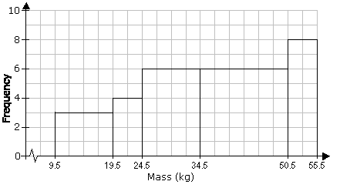

Pie Chart
When we represent data in a pie chart we must remember we are using 360 degrees.
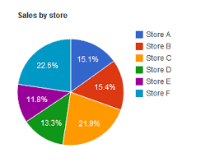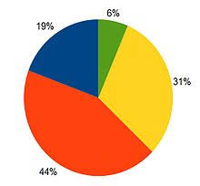

Example
Table: Favorite Type of Movie
Comedy | Action | Romance | Drama | SciFi
4 | 5 | 6 | 1 | 4

Comedy | Action | Romance | Drama | SciFi | TOTAL
4 | 5 | 6 | 1 | 4 | 20
20% | 25% | 30% | 5% | 20% | 100%
4/20 × 360°  = 72° | 5/20 × 360°  = 90° | 6/20 × 360°  = 108° | 1/20 × 360°  = 18° | 4/20 × 360°  = 72° | 360°
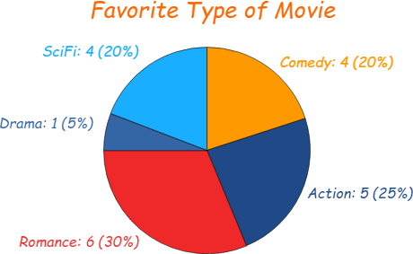

Bar Chart

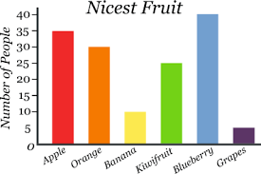

Trend Graph
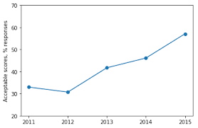

Exercise

Represent the following data of student grades in a pie chart, bar chart and trend graph.
A | B | C | D
4 | 12 | 10 | 2

Histograms
Question
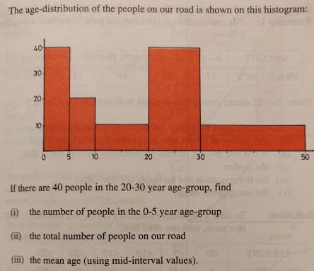

Answer
- 20
- 100
Mid-interval value | 2.5 | 7.5 | 15 | 25 | 40
x | 0_5 | 5_10 | 10_20 | 20_30 | 30_50
f | 20 | 10 | 10 | 40 | 20
 | 50 | 75 | 150 | 1000 | 800 | 2075
 | 20 | 10 | 10 | 40 | 20 | 100
 |  |  |  |  | Mean = | 20.75
- 20.75

Data
Data is a collection of facts, such as numbers, words, measurements, observations or even just descriptions of things. Data can be Descriptive (like "high" or "fast") or Numerical (numbers). Numerical Data can be Discrete or Continuous:

Population - Sample Population
In stats, a sample is a part of a population. A population is a whole, it’s every member of a group. A population is the opposite to a sample, which is a fraction or percentage of a group. Sometimes it’s possible to survey every member of a group. A classic example is the Census in Ireland. Note: if you do manage to survey everyone, it is called a census:

Qualitative vs Quantitative
Data can be qualitative or quantitative. Qualitative data is descriptive information (it describes something). Quantitative data is numerical information (numbers). Quantitative data can be Discrete or Continuous:

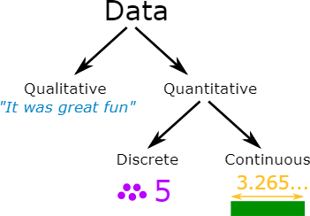

Discrete Data
Discrete Data can only take certain values. Discrete data is counted. Discrete data can only take certain values (like whole numbers)
Examples:
- The number of students in a class. We can't have half a student!
- The result of rolling a die - Only has the values 1, 2, 3, 4, 5 or 6

Continuous Data
Continuous data is measured. Continuous data can take any value (within a range)

Examples:
- A person's height: could be any value (within the range of human heights), not just certain fixed heights
- Time in a race: you could even measure it to fractions of a second
- A dog's weight
- The length of a leaf

Continuous Variables
A variable is a quantity that has a changing value; the value can vary from one example to the next. A continuous variable is a variable that has an infinite number of possible values. In other words, any value is possible for the variable. A continuous variable is the opposite of a discrete variable, which can only take on a certain number of values. A continuous variable doesn’t have to have every possible number (like -infinity to +infinity), it can also be continuous between two numbers, like 1 and 2. For example, discrete variables could be 1,2 while the continuous variables could be 1,2 and everything in between: 1.00, 1.01, 1.001, 1.0001…

Examples of continuous variables: (Heights, weights are examples of continuous variables)
- Time it takes a computer to complete a task. You might think you can count it, but time is often rounded up to convenient intervals, like seconds or milliseconds. Time is actually a continuum: it could take 1.3 seconds or it could take 1.333333333333333… seconds.
- A person’s weight. Someone could weigh 180 pounds, they could weigh 180.10 pounds or they could weigh 180.1110 pounds. The number of possibilities for weight are limitless.
- Income. You might think that income is countable (because it’s in dollars) but who is to say someone can’t have an income of a billion dollars a year? Two billion? Fifty nine trillion? And so on…
- Age. So, you’re 25 years-old. Are you sure? How about 25 years, 19 days and a millisecond or two? Like time, age can take on an infinite number of possibilities and so it’s a continuous variable.
- The price of gas. Sure, it might be $4 a gallon. But one time in recent history it was 99 cents. And give inflation a few years it will be $99. not to mention the gas stations always like to use fractions (i.e. gas is rarely $4.47 a gallon, you’ll see in the small print it’s actually $4.47 9/10ths

Discrete Variables
A variable is a quantity that has changing values. A discrete variable is a variable that can only take on a certain number of values. In other words, they don’t have an infinite number of values. If you can count a set of items, then it’s a discrete variable. The opposite of a discrete variable is a continuous variable. Continuous variables can take on an infinite number of possibilities.
Examples of discrete variables:
- Number of quarters in a purse, jar, or bank. Discrete because there can only be a certain number of coins (1,2,3,4,5…). Coins don’t come in amounts of 2.3 coins or 10 1/2 coins, so it isn’t possible for there to be an infinite number of possibilities. In addition, a purse or even a bank is restricted by size so there can only be so many coins.
- The number of cars in a parking lot. A parking lot can only hold a certain number of cars.
- Points on a 10-point rating scale. If you’re graded on a 10-point scale, the only possible values are 1,2,3,4,5,6,7,8,9, and 10.
- Ages on birthday cards. Birthday cards only come in years…they don’t come in fractions. So there are a finite amount of possibilities (presumably, about one hundred).

Standard Deviation

Example 1
Calculate the mean and standard deviation of the following:

9, 2, 5, 4, 12, 7, 8, 11, 9, 3, 7, 4, 12, 5, 4, 10, 9, 6, 9, 4
Mean (μ) = 9+2+5+4+12+7+8+11+9+3+7+4+12+5+4+10+9+6+9+420 = 140/20 = 7 Mean=7
=> 4, 25, 4, 9, 25, 0, 1, 16, 4, 16, 0, 9, 25, 4, 9, 9, 4, 1, 4, 9

= 4+25+4+9+25+0+1+16+4+16+0+9+25+4+9+9+4+1+4+9 = 178

Variance

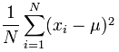 Variance = (1/20) × 178 = 8.9

Standard Deviation

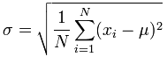 Standard Deviation σ = √(8.9) = 2.983

Example 2

Occurance(x):(in separated lines) Frequency of Occurance(f)
1 5
2 12
3 8
4 3
5 0
6 0
7 1

Occurance(X) | Frequency(f) | Freq*X | (X-mean) | (X-mean)2 | f*(X-mean)2
1 | 5 | 5 | -1.483 | 2.199 | 10.993
2 | 12 | 24 | -0.483 | 0.233 | 2.797
3 | 8 | 24 | 0.517 | 0.268 | 2.14
4 | 3 | 12 | 1.517 | 2.302 | 6.906
5 | 0 | 0 | 2.517 | 6.337 | 0
6 | 0 | 0 | 3.517 | 12.371 | 0
7 | 1 | 7 | 4.517 | 20.405 | 20.405
Total -> | 29 | 72 | - | - | 43.241
Mean = 2.483
Standard Deviation = 1.221
Variance = 1.491

Standard Deviation from list of numbers
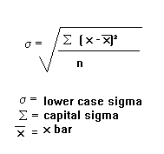

Standard Deviation from Frequency Distribution Table
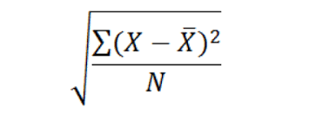

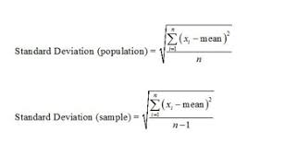

Frequency Distribution of a Discrete Variable
Since, a discrete variable can take some or discrete values within its range of variation, it will be natural to take a separate class for each distinct value of the discrete variable as shown in the following example relating to the daily number of car accidents during 30 days of a month.
3 4 4 5 5 3
4 3 5 7 6 4
4 3 4 5 5 5
5 5 3 5 6 4
5 4 4 6 5 6

Table No. 2: Showing frequency distribution for daily number of car accidents during a month.
Number of car accidents | Frequency
3 | 5
4 | 9
5 | 11
6 | 4
7 | 1
Total | 30

Frequency Distribution of a Continuous Variable
For a continuous variable if we take a class for each distinct value of the variable, the number of classes will become unduly large, thus defeating the purpose of tabulation. In fact, since a continuous variable can assume an infinite number of values within its range of variation, the classification or sub-division of such data is necessarily artificial. Some guidelines that should be followed while dividing continuous data into classes are as follows:
- The classes should be mutually exclusive, i.e., non-overlapping. No two classes should contain the same interval of values of the variable.
- The classes should be exhaustive, i.e., they must cover the entire range of the data.
- The number of classes and the width of each class should neither be too small nor too large. In other words, there should be relatively fewer classes if the difference between the least value of the variable and its highest value is small and relatively more classes if the same difference is large. This difference between the least value of the variable and the greatest value of the variable is called the range of the variable or the data set.
- The classes should, preferably, be of equal width.
Let us consider the following example regarding daily maximum temperatures in in a city for 50 days.
28 28 31 29 35 33 28 31 34 29
25 27 29 33 30 31 32 26 26 21
21 20 22 24 28 30 34 33 35 29
23 21 20 19 19 18 19 17 20 19
18 18 19 27 17 18 20 21 18 19
Minimum Value= 17
Maximum Value=35
Range=35-17=18
Number of classes=5 (say)
width of each class=4

Table No. 3: Showing frequency distribution of temperature in a city for 50 days.
Class Intervals(Temperatures in ) | Frequency
17-20 | 17
21-24 | 7
25-28 | 10
29-32 | 9
33-36 | 7
Total | 50

Standard Deviation
Random Sample
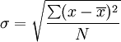
Calculate the standard deviation of the following numbers: 4, 2, 5, 8, 6.
Example of Frequency Distribution Table
Frequency Distribution
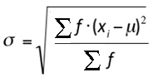
Calculate the standard deviation from the following:
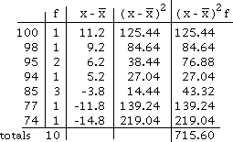

Exercise – Student Ages Data
A survey was carried out in a Further Education college where students were asked what age they were on the first day of college. The results were counted and presented in a grouped frequency table as shown below:
Age | 18_28 | 28_38 | 38_48 | 48_58 | 58_68 | 68_78
No. of Students | 131 | 172 | 152 | 32 | 12 | 1

You are required to answer the following:
- What is the modal class?
- Calculate the mean.
- Calculate the standard deviation.

Solution

Mean
Mid interval value | 23 | 33 | 43 | 53 | 63 | 73
Age | 18_28 | 28_38 | 38_48 | 48_58 | 58_68 | 68_78
No. of Students | 131 | 172 | 152 | 32 | 12 | 1 | Sum of f -> | 500
f by mid interval | 3013 | 5676 | 6536 | 1696 | 756 | 73 | Sum of fx -> | 17750 |  | Mean(µ)= | 35.5

Mean = $\frac{\sum{fx}}{\sum{f}}$

Standard Deviation
x | f | Mean | (x-M)^2 | f(x-M)^2
23 | 131 | 35.5 | 156.25 | 20468.8
33 | 172 | 35.5 | 6.25 | 1075
43 | 152 | 35.5 | 56.25 | 8550
53 | 32 | 35.5 | 306.25 | 9800
63 | 12 | 35.5 | 756.25 | 9075
73 | 1 | 35.5 | 1406.25 | 1406.25
 | 500 |  |  | 50375
 |  |  | St. Dev(σ)= | 10.0374

Standard Deviation formula σ = $\sqrt{\frac{\sum{{f(x-µ)}^{2}}}{\sum{f}}}$ (µ represents the Mean)

Answers

- Modal class = 28 to 38 years old
- Mean = 35.5 years old
- Standard deviation = 10.0374 years old

Microsoft Excel
A | B | C | D | E | F | G | H | I | J | K | L | M
1 | A
2
3 | x | 7 | 8 | 9 | 10 | 11 | 12 | 13
4 | f | 1 | 3 | 5 | 7 | 5 | 3 | 1
5
6 | Mean => f X x | 7 | 24 | 45 | 70 | 55 | 36 | 13 | 250 | <= sum of f X x | Mean => | 10
7 |  | 1 | 3 | 5 | 7 | 5 | 3 | 1 | 25 | <= sum of f
8
9 | Standard deviation =>(x-M) | -3 | -2 | -1 | 0 | 1 | 2 | 3
10 | (x-M)^2 | 9 | 4 | 1 | 0 | 1 | 4 | 9 | 28 | <= sum of (x-M)^2
11 | f(x-M)^2 | 9 | 12 | 5 | 0 | 5 | 12 | 9 | 52 | <= sum of f(x-M)^2 | Variance => | 2.08
12
13 | Standard Deviation=> | 1.44222051
14
15 | FORMULA
16 | x | 7 | 8 | 9 | 10 | 11 | 12 | 13
17 | f | 1 | 3 | 5 | 7 | 5 | 3 | 1
18
19 | Mean => f X x | =C16*C17 | =D16*D17 | =E16*E17 | 70 | 55 | 36 | 13 | =SUM(C19:I19) | <= sum of f X x | Mean => | =J19/J20
20 |  | =C17 | =D17 | =E17 | 7 | 5 | 3 | 1 | =SUM(C20:I20) | <= sum of f
21
22 | Standard deviation =>(x-M) | =C16-$M$6 | =D16-$M$6 | =E16-$M$6 | 0 | 1 | 2 | 3
23 | (x-M)^2 | =C22^2 | =D22^2 | =E22^2 | 0 | 1 | 4 | 9 | =SUM(C23:I23) | <= sum of (x-M)^2
24 | f(x-M)^2 | =C23*C17 | =D23*D17 | =E23*E17 | 0 | 5 | 12 | 9 | =SUM(C24:I24) | <= sum of f(x-M)^2 | Variance => | =J24/J20
25
26 | Standard Deviation => | =SQRT(M24)

