Tallying
Tallying is a useful way of counting or collecting data as shown below. The data can then be represented in a frequency distribution table or grouped frequency distribution table.
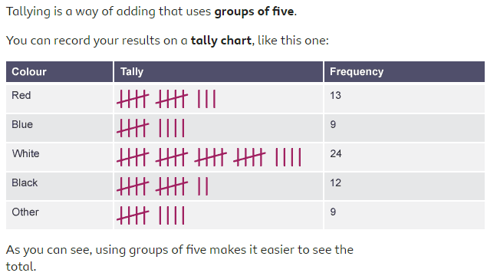

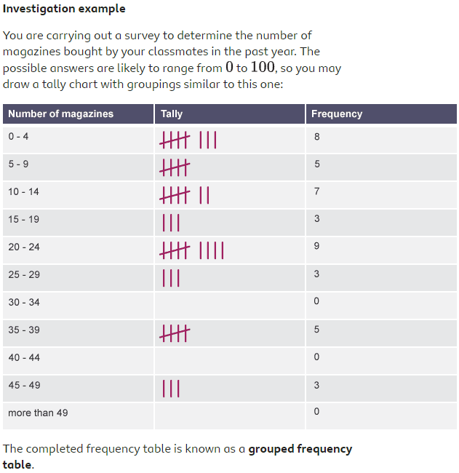
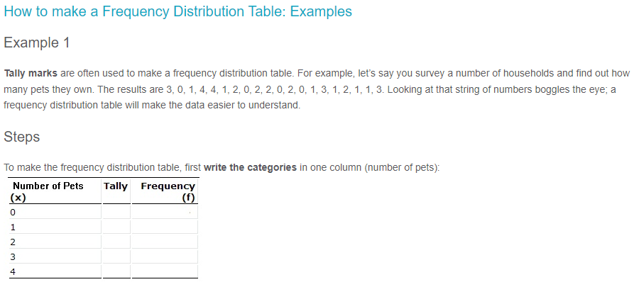
Exercises

Ex 1 | Raw data | 1 | 3 | 4 | 1 | 2 | 1 | 6 | 7
 | Ordered data
 | Mode =
 | Median =
 | Mean =
Ex 2 | Raw data | 1 | 0 | 3 | 5 | 0 | 6 | 7
 | Ordered data
 | Mode =
 | Median =
 | Mean =
Ex 3 | Raw data | 8 | 0 | 3 | 3 | 1 | 7 | 4 | 1 | 4 | 4
 | Ordered data
 | Mode =
 | Median =
 | Mean =

Ex 4
Find the mean of the following: x, x+3, x+1, x-3, x-1

Ex 5
The mean of the numbers 1, x, 3, 6, 8 is 7, What is the number represented by x?

Ex 6
On a particular day the number of goals scored in 30 football matches was recorded as follows. Input the data in a frequency distribution table and calculate the mean/mode/median.
1 | 3 | 4 | 3 | 2 | 1 | 6 | 5 | 1 | 2 | 3 | 2 | 1 | 2 | 4 | 3 | 1 | 4 | 6 | 2 | 5 | 2 | 4 | 6 | 2 | 1 | 6 | 2 | 1 | 5

Solutions
Ex 1 | Raw data | 1 | 3 | 4 | 1 | 2 | 1 | 6 | 7
 | Ordered data | 1 | 1 | 1 | 2 | 3 | 4 | 6 | 7
 | Mode = | 1
 | Median = | 2.5
 | Mean = | 3.125
Ex 2 | Raw data | 1 | 0 | 3 | 5 | 0 | 6 | 7
 | Ordered data | 0 | 0 | 1 | 3 | 5 | 6 | 7
 | Mode = | 0
 | Median = | 3
 | Mean = | 3.142857143
Ex 3 | Raw data | 8 | 0 | 3 | 3 | 1 | 7 | 4 | 1 | 4 | 4
 | Ordered data | 0 | 1 | 1 | 3 | 3 | 4 | 4 | 4 | 7 | 8
 | Mode = | 4
 | Median = | 3.5
 | Mean = | 3.5

Ex 4
Find the mean of the following: x, x+3, x+1, x-3, x-1
$$\frac{x+x+3+x+1+x-3+x-1}{5}=\frac{5x}{5}=x$$
Ex 5
$$\frac{1+ x+3+6+ 8}{5}=7$$
$$\frac{ x+18}{5}=7$$
$$x+18=35$$
$$x=17$$
Ex 6
x | 1 | 2 | 3 | 4 | 5 | 6 |  | Totals
f | 7 | 8 | 4 | 4 | 3 | 4 |  | 30
xf | 7 | 16 | 12 | 16 | 15 | 24 |  | 90
Mean = | 3
Mode = | 2
Median = | 2.5 | (Note: 30/2 = so its 15th and 16th numbers divided by two)

Weighted Mean
Formula
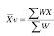
Example: Calculating grades
Suppose a class has quizzes, homework and three exams. The scores are weighted as follows:
Quiz | HW | Exam1 | Exam2 | Final
10% | 10% | 20% | 20% | 40%
Suppose your averages are as follows:
Quiz | HW | Exam1 | Exam2 | Final
80% | 89% | 79% | 84% | 87%

How is your grade calculated?
Multiply percentages by respective weights (written as decimals)
0.1(80)+0.1(89)+0.2(79)+0.2(84)+0.4(87)
= 84.3% final grade

Example: Price Increase
Type of Meat | Pork | Mutton | Beef | Poultry
% Price Increase | 2% | 8% | 3% | 5%

Mean Price Increase = $\frac{2+8+3+5}{4}=4.5\%$

Type of Meat | Pork | Mutton | Beef | Poultry
% Price Increase | 2% | 8% | 3% | 5%
Weight | 3 | 1 | 4 | 2

Weighted Mean = $\frac{6+8+12+10}{3+1+4+2}=\frac{36}{10}=3.6$%
Exercises
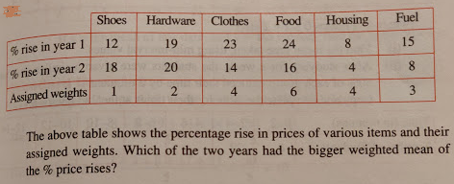
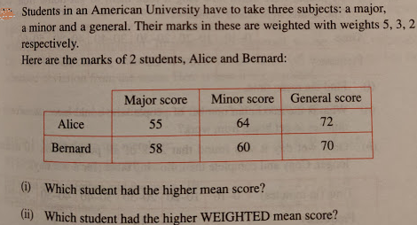

Answers
1
% rise in Year 1 | 12 | 38 | 92 | 144 | 32 | 45 | 18.15
% rise in Year 2 | 18 | 40 | 56 | 96 | 16 | 24 | 12.5
Year 1 Weighted Mean | 18.15
Year 2 Weighted Mean | 12.5

Answer = Year 1 has bigger weighted mean.

2
Weights | 5 | 3 | 2
 | Major | Minor | General |  |  |  |  |  | Sums
Alice | 55 | 64 | 72 |  | 275 | 192 | 144 | => | 611
Bernard | 58 | 60 | 70 |  | 290 | 180 | 140 | => | 610
Mean Scores
Alice | 63.67
Bernard | 62.67
Weighted Mean Scores
Alice | 61.1
Bernard | 61

- Alice has highest mean score
- Alice has highest weighted mean score.

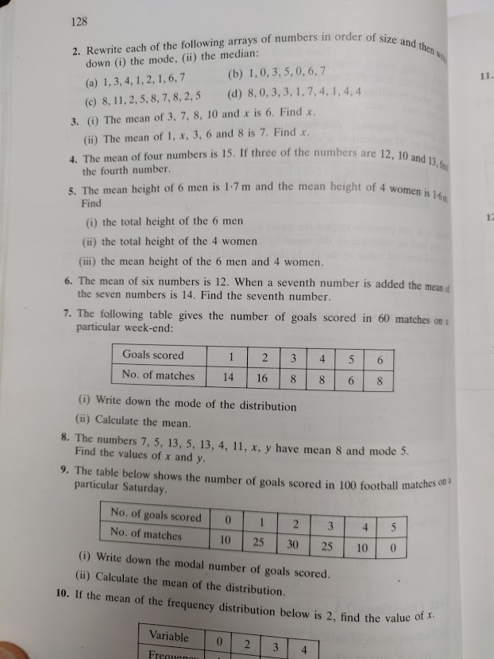
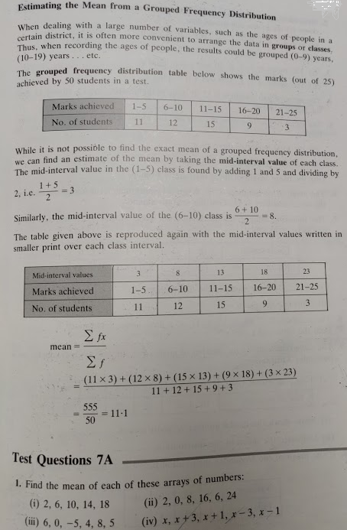
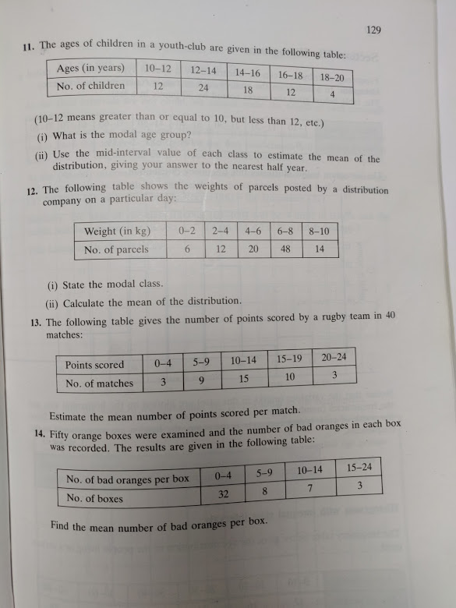

A Cumulative Frequency Graph is a graph plotted from a cumulative frequency table. A cumulative frequency graph is also called an ogive or cumulative frequency curve..
Example 1
Draw a cumulative frequency graph for the frequency table below.

Length (x mm) | Frequency
11 – 15 | 2
16 – 20 | 4
21 – 25 | 8
25 – 30 | 14
31 – 35 | 6
36 – 40 | 4
41 – 45 | 2

Solution
We need to add a class with 0 frequency before the first class and then find the upper boundary for each class interval.
Length  (x mm) | Frequency | Upper Class Boundary | Length  (x mm) | Cumulative  Frequency
6 – 10 | 0 | 10.5 | x ≤ 10.5 | 0
11 – 15 | 2 | 15.5 | x ≤ 15.5 | 2
16 – 20 | 4 | 20.5 | x ≤ 20.5 | 6
21 – 25 | 8 | 25.5 | x ≤ 25.5 | 14
25 – 30 | 14 | 30.5 | x ≤ 30.5 | 28
31 – 35 | 6 | 35.5 | x ≤ 35.5 | 34
36 – 40 | 4 | 40.5 | x ≤ 40.5 | 38
41 – 45 | 2 | 45.5 | x ≤ 45.5 | 40

And then plot the cumulative frequency against the upper class boundary of each interval and join the points with a smooth curve.

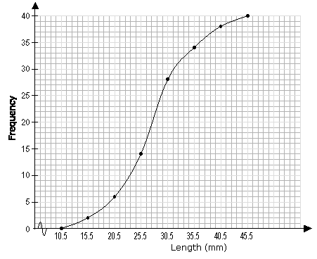

Example 2

Age (years) | Frequency
10 | 5
11 | 10
12 | 27
13 | 18
14 | 6
15 | 16
16 | 38
17 | 9
:
Age (years) | Frequency | Cumulative Frequency
10 | 5 | 5
11 | 10 | 5+10 = 15
12 | 27 | 15+27 = 42
13 | 18 | 42+18 = 60
14 | 6 | 60+6 = 66
15 | 16 | 66+16 = 82
16 | 38 | 82+38 = 120
17 | 9 | 120+9 = 129

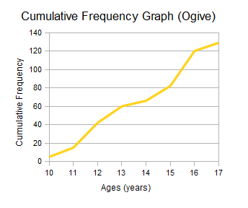
Exam Results Example - Cumulative Frequency Curve (Ogive)
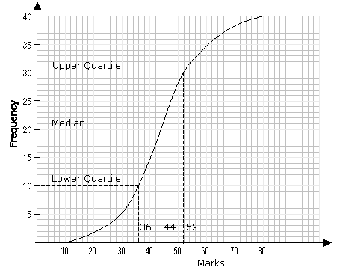

Percentile
A percentile is a certain percentage of a set of data.

Median
The median corresponds to the 50th percentile i.e. 50% of the total frequency.
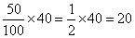
From the graph, 20 on the vertical axis corresponds to 44 on the horizontal axis. The median mark is 44.

Upper Quartile
The upper quartile corresponds to the 75th percentile i.e. 75% of the total frequency.
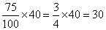

From the graph, 30 on the vertical axis corresponds to 52 on the horizontal axis. The upper quartile is 52.

Lower Quartile
The lower quartile corresponds to the 25th percentile i.e. 25% of the total frequency.
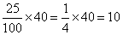
From the graph, 10 on the vertical axis corresponds to 36 on the horizontal axis. The lower quartile is 36.

Inter Quartile Range

Upper - Lower Quartile = 52 - 36 = 16

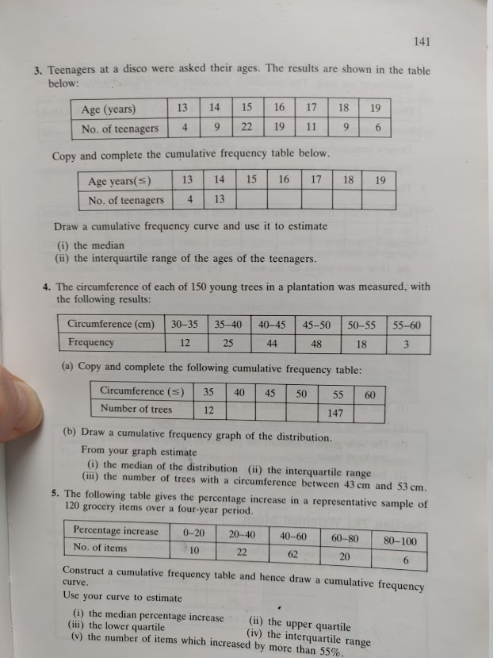
Ogive – Cumulative Frequency Curve
Question 3
Age (x) | 13 | 14 | 15 | 16 | 17 | 18 | 19
No. of Teenagers (f) | 4 | 9 | 22 | 19 | 11 | 9 | 6

Age | ≤13 | ≤14 | ≤15 | ≤16 | ≤17 | ≤18 | ≤19
No. of Teenagers | 4 | 13 | 35 | 54 | 65 | 74 | 80

Cumulative Frequency Curve (Ogive)
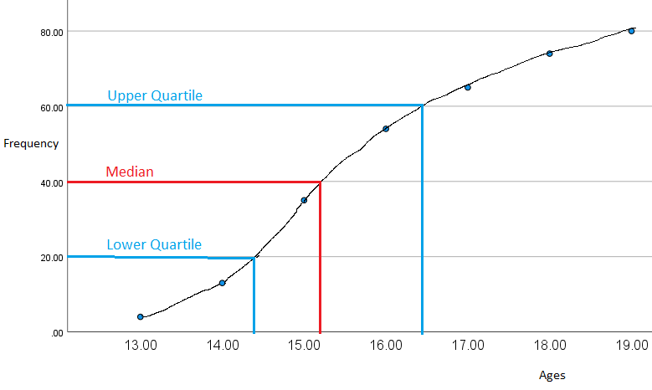

- Median (middle value) = 15.2 years old
- Interquartile Range

$Interquartile Range=Upper Qurtile-Lower Quartile$
$16.4-14.4=2 years$
Mean (arithmetic average)
x | 52 | 126 | 330 | 304 | 187 | 162 | 114 |  | sum of fx = | 1275
f | 4 | 9 | 22 | 19 | 11 | 9 | 6 |  | sum of f = | 80
 |  |  |  |  |  |  |  |  | Mean = | 15.9375

Mode (most common value or the value with the biggest frequency)
Mode = 15 years

Range (highest x value – lowest x value)
19 – 13 = 6
Range = 6 years

Question 4
Circumference (cm) | 30_35 | 35_40 | 40_45 | 45_50 | 50_55 | 55_60
Frequency | 12 | 25 | 44 | 48 | 18 | 3

Circumference (cm) | ≤35 | ≤40 | ≤45 | ≤50 | ≤55 | ≤60
Frequency | 12 | 37 | 81 | 129 | 147 | 150

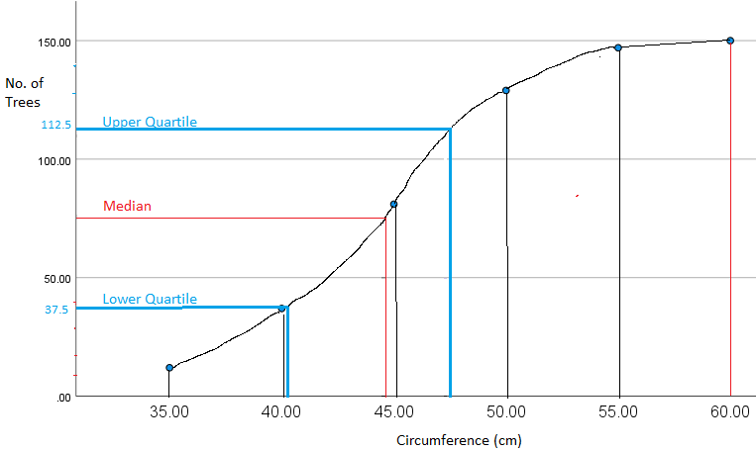

- Median (middle value of 75) = 44 cm
- Interquartile Range $Interquartile Range=Upper Qurtile-Lower Quartile$
$47.5-41=6.5 cm$
- 122 – 62 = 60 trees 