Solving Equations using De Moivre’s Theorem
Exercise 1 Use de Moivre's theorem to derive a formula for the 4th roots of 8.
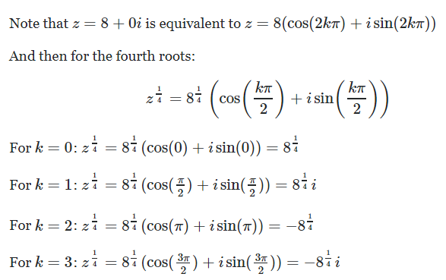

Exercise 2
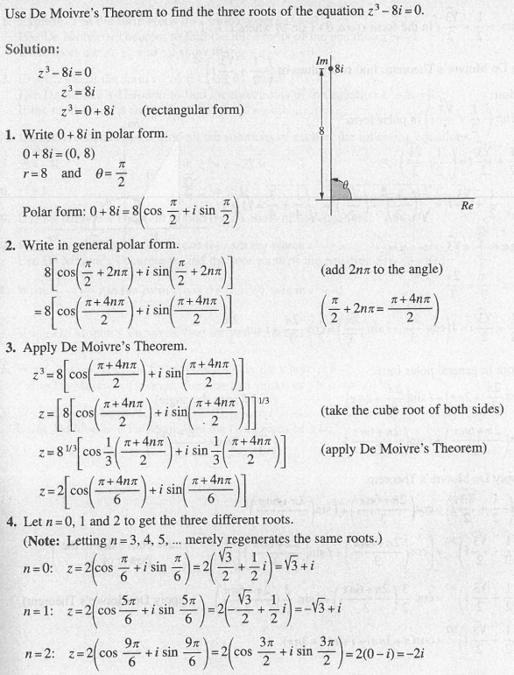

Exercises
