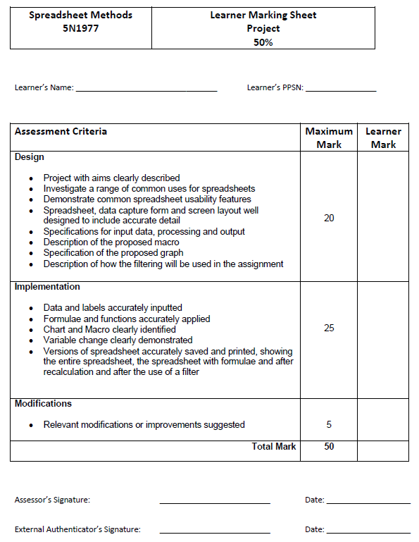

Title and Code of Minor Award: Spreadsheets 5N1977
Assessment Technique: Project
Weighting: 50%
Teacher: Ray
- Investigate a range of common uses for spreadsheets

- Explore key spreadsheet elements including cells, cell references, numeric, alpha, and alphanumeric data, formulae, functions, graphs and macros.
- Demonstrate common spreadsheet usability features to include use of toolbars, window management, sorting and filtering.
- Use spreadsheet design features involving data and cell formatting techniques which enhance understanding and legibility.
- Automate routine multi-step tasks through the creation, execution, and management of simple macros.
- Print complete or partial sections of a spreadsheet, formatted fit for presentation.
- Use advanced spreadsheet features including absolute and relative cell references, conditional IF statements, statistical, financial, and date and time functions.
- Generate a variety of types of graphs, with appropriate titles and labels, from spreadsheet data.
- Produce a spreadsheet, with minimal supervision, that meets a simple design specification and is fit for purpose.
- Demonstrate personal initiative and resourcefulness in editing and amending spreadsheets to ensure they are fit for purpose.

ISSUE DATE: Jan 2019 SUBMISSION DATE : Last day before the Easter holidays

WRITE YOUR NAME IN BLOCK CAPITALS

I confirm that this is my own original work.

Signed: Date:
Feedback Given: Date:

5N1977 Project Brief

You are required to create a spreadsheet on any topic you wish, but it must contain at least the following

- At least 10 rows of data, including character, numeric and a date type.
- An overall heading [generally centre top].
- Column headings (row headings if required).
- At least 2 different cell alignments (left, right, centre)
- A range of different cell formats (currency, %, decimal, date)
- Use of colour (fore + back), font sizes, different fonts, bold, etc

Design phase

You need to produce a report with evidence of designing your spreadsheet. This should include at least the following

- A general introduction to spreadsheets explaining their use (give examples)
- A description of the problem the spreadsheet is being created to solve.
- The proposed solution.
- A design for the screen layout.
- A design for a data capture form.
- A clear breakdown of which data is
- Input Data
- Output Data
- Processed data (formula’s)

Note formula’s to include at least the following
- a simple and conditional if
- Average and sum functions
- Date/time functions
- Absolute cell references

- A specification of all formats, alignments, column widths, etc used
- A specification for the proposed graph
- A specification for the proposed Macro
- A specification for a sort/filter.

Implementation phase

All printouts will have a footer/header, column and row headings, landscape and fit on the page.

- Printout of the whole spreadsheet(s).
- Printout of spreadsheet(s) showing formula.
- Printout of the graph (heading, legend, etc).
- Printout of the spreadsheet sorted.
- Printout of the spreadsheet before and after various data changes.
- Printout of before and after macro.

Critical analysis of project

- A section on how the project went, things you learned, mistakes made and corrected, ideas implemented and discarded.
- Suggestions as to any modifications or improvements to your project.

Deadline : Last day before the Easter holidays

***Work will NOT be accepted after this date***

Table of Contents

Introduction 6
A general introduction to Spreadsheets 7
Aim of the project 8
Problems faced by the Buying Teams 8
Solutions and Benefits of the project 8
Screen Layout 9
Input / Processing / Output 10
Data Capture Form 11
Formula’s 12
Cell Description 13
Spreadsheet 1 (sales12-01) 14
Spreadsheet 1 (sales12-01 formulas) 15
Spread Sheet 2 with Input, Calculation and Output data (Profit12-01) 16
Spreadsheet 2 (Profit12-01 Formulas) 17
Spread Sheet 3 variable changes & sort Specification and printouts 18
Chart Specifications and printout 20
Macros (specification and printouts) 22
Modifications 23
Critical analysis 25

Introduction

This project is based on my former role as a chart music buyer for a large record store in Newcastle upon Tyne, where I worked between 2013 and 2016.

THE (Total Home Entertainment) Record Store is an entertainment retail company with branches throughout Europe and the USA. The Newcastle branch employs around 60 full and part time staff, although these figures double between October and January as temporary staff are hired to cope with the Christmas rush. The project focuses on the busiest department, ‘chart albums’, and its performance during the busiest month of the year.

The store target for December is €6 million, this equates to almost 25% of the yearly sales target, so getting more staff available to help customers over Christmas is crucial. By introducing Excel to the collation of sales and profit figures, we hope to streamline the information gathering process, allowing the back of house teams to get out and support the staff on the floor. By rolling out the new process, we estimate that over a week, an extra 64 man hours can be deployed to the sales floor, allowing us to restock key areas and deal with queries more efficiently.

A general introduction to Spreadsheets

Viscalc was the first spreadsheet application brought out in 1979 on the Apple II. It was a huge success until IBM brought out lotus 123 in 1980. Lotus 123 was massive for several years and was a major factor in IBM’s growth. More recently Microsoft have Excel as an integral part of their office suite. It is fair to say Excel is now the standard go to spreadsheet.

A spreadsheet is an application for organization, analysis and storage of data in tabular form.
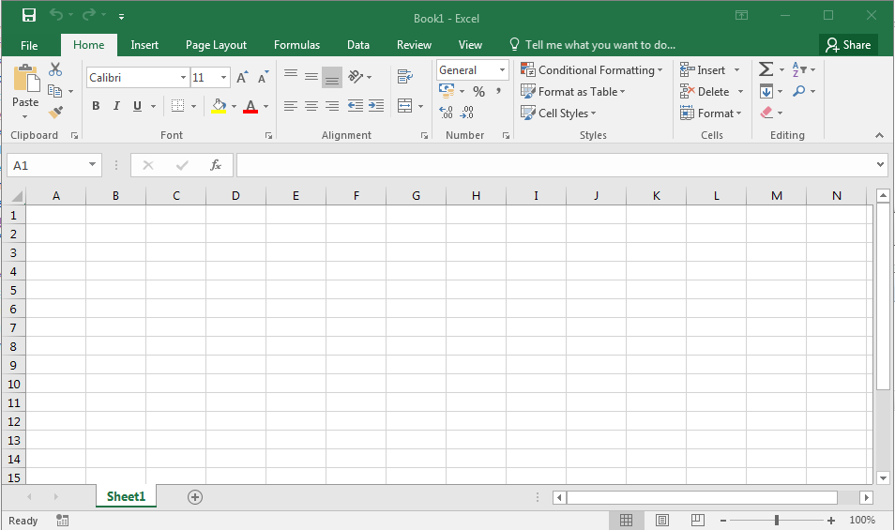

It is made up of a grid of cells which are referenced by the column letter and row number (eg) A10. You can then perform numerous mathematical operations (eg Sum, average, financial functions, etc ) on those cells to produce quite sophisticated data analysis.

If you change a data element the total spreadsheet is updated automatically in a few seconds. They are an invaluable tool in data manipulation and analysis.

Aim of the project

Problems faced by the Buying Teams

While the stock control and buying processes were computerised at store level, the sales and margins for individual titles were not. For a while, buyers would try to compile this information manually for the monthly sales meetings but this proved to be unworkable as the task was so labour intensive.

Solutions and Benefits of the project

By copying the monthly purchasing data, and pasting it on to a simple spreadsheet, each department could check the sales and profitability of their chart or other best-selling lines. This allowed for very detailed and more productive sales meetings and, as the EPOS ordering system was compatible with Excel, the information could be updated instantly.

The new system also gave the purchasing team a crucial insight into seasonal performance trends, ensuring they didn’t order too much and leave “dead” money sat on stockroom shelves, or even worse, run out of stock and allow our customers to walk out and shop elsewhere.

The sales12-01spreadsheet contains the sales, by unit and currency, of the top ten chart albums in the store for the month ending 31/12/2013.

Our company had deals with the four main music distributors that afforded us file discounts when ordering chart titles, reducing our monthly bill by a set percentage.

In addition to this, there was also Xmas Cashback, a seasonal incentive from October to December whereby our bill would be further reduced per title dependent on cost price and purchases, by €1000 if the cost price was €8.50 or above and we bought at least 2000 units, or €500 for €7.50 cost and 1000+ units purchased. This data is contained in the profit12-01spreadsheet.

Screen Layout

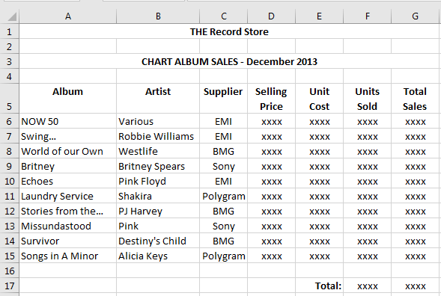

Input / Processing / Output

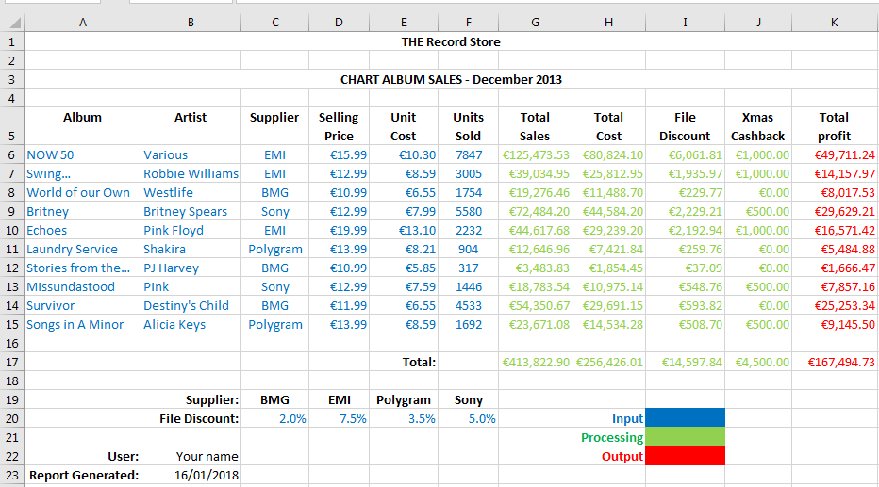

Data Capture Form

The form below is a replica of the actual physical form used to record the details for ordering an album.

Album _____________________________
Artist _____________________________
Supplier _____________________________
Selling Price _____________________________
Cost Price _____________________________
Units Sold _____________________________
Line Discount _____________________________

Formula’s

To calculate the Total Sales, I multiplied the Selling Price by Units Sold, and I calculated the Total cost in the same way, using Cost Price instead of Selling Price.

For the File Discount column, the level of discount was a percentage dictated by the supplier, so I used the hlookup function, for the table shown below, to establish the level of discount and multiplied the Total Cost column by this percentage to calculate the discount.

Supplier: | BMG | EMI | Polygram | Sony
File Discount: | 2.0% | 7.5% | 3.5% | 5.0%

The Xmas Cashback discount (€1000 if the cost price was €8.50 or above and we bought at least 2000 units, or €500 for €7.50 cost and 1000+ units purchased) was calculated using the example if formula below, taking the Unit Cost and Units Sold columns as the selection criteria.

=IF(AND(E6>8.5,F6>=2000),1000,IF(AND(E6>7.5,F6>=1000),500,0))

The Total Profit was established by subtracting the Total Cost, File Discount and Xmas Cashback totals from the Total Sales. All bottom line totals were calculated by applying the sum() function to the column above them.

Finally, I used the today() function to show when the report was generated.

Cell Description

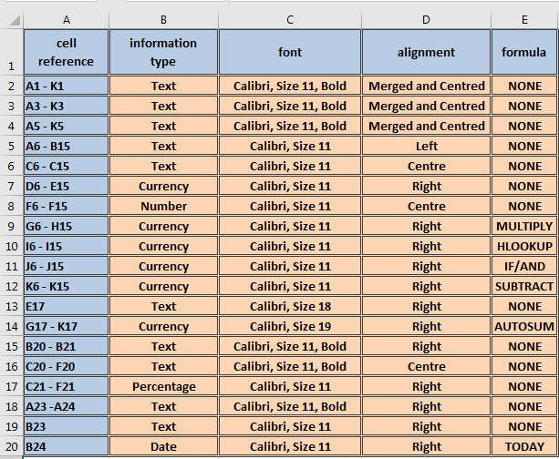

Spreadsheet 1 (sales12-01)

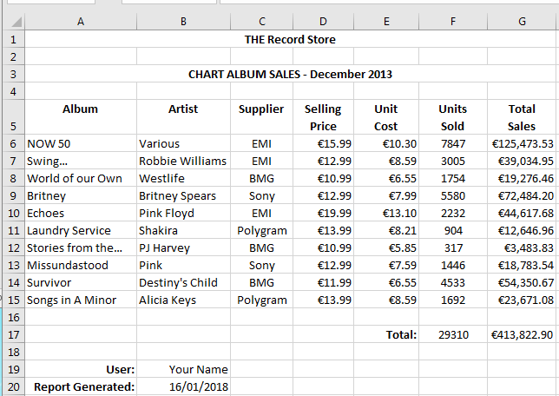

Spreadsheet 1 (sales12-01 formulas)

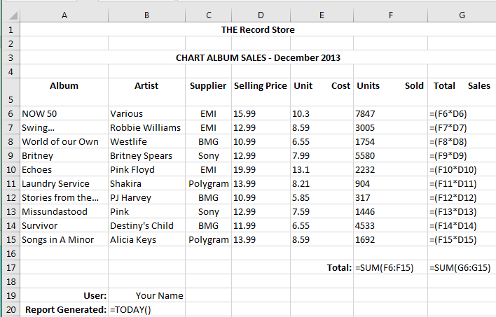

Spread Sheet 2 with Input, Calculation and Output data (Profit12-01)

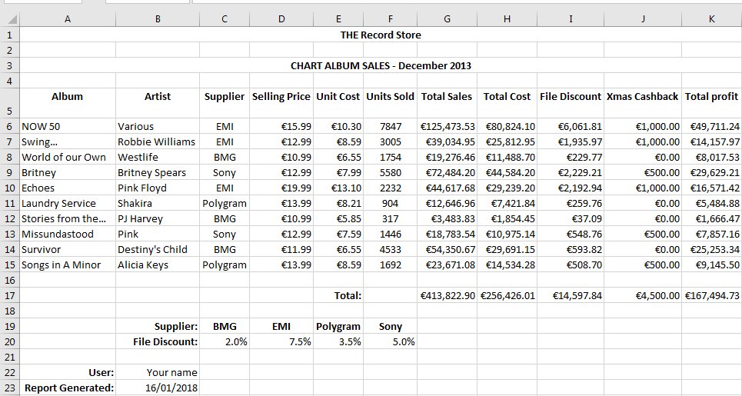

Spreadsheet 2 (Profit12-01 Formulas)

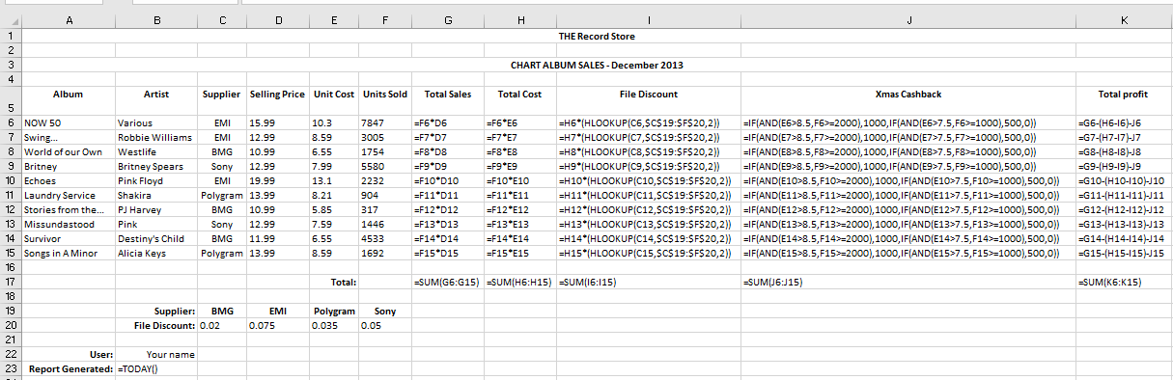

Spread Sheet 3 variable changes & sort Specification and printouts

I made the following changes to the spreadsheet

- Changed the file discount for BMG to 4% and Sony 5%.

- I sorted the top ten albums on the total profit.

- Changed the selling price for PJ harvey to €12.50.

- Changed the unit cost of west life to €7.12

- Left aligned the album heading.

These are all clearly indicated by the blue background in the screen shot below. The Spreadsheet updated instantaneously. These changes can be verified by comparing the spreadsheet below to the one in spreadsheet two (two pages above).

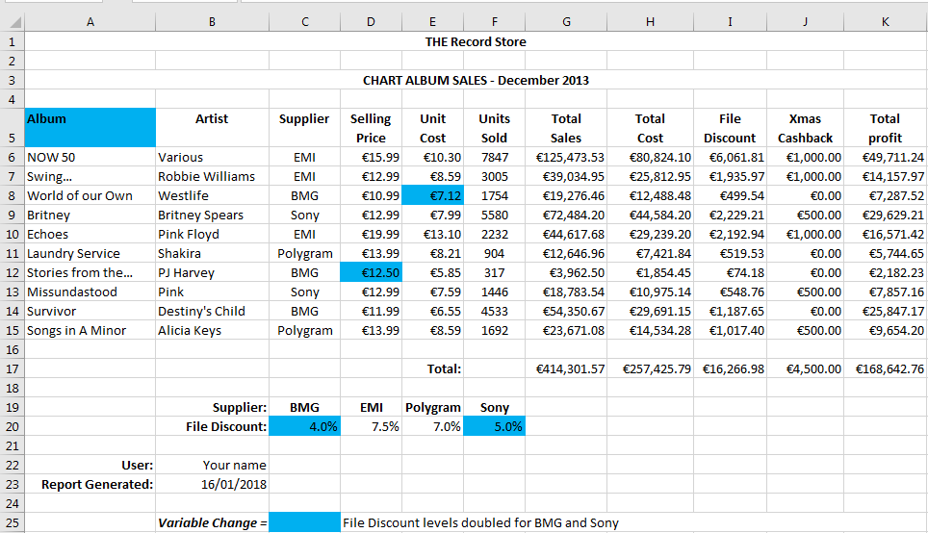

Chart Specifications and printout

This shows the 2 columns used for the chart. I used data from the sales12-01 spreadsheet. The chart shows the units sold for the top 10 albums.

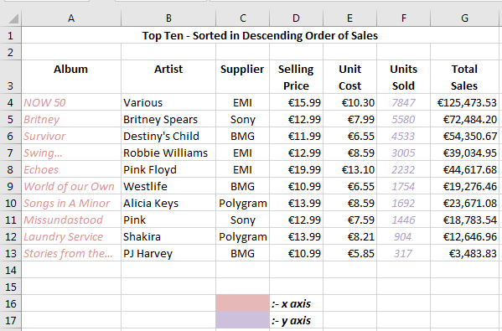

- I added a chart heading “Top ten albums December 2013”
- I added x and y axis headings.
- I made the colour changes below

Macros (specification and printouts)

A macro is a recording of a list of commands which get used often and can be run over and over (eg) create a chart, format a heading, etc. macros are not available by default. We need to go into File-> options->customize ribbon and tick the developer tab (see below).

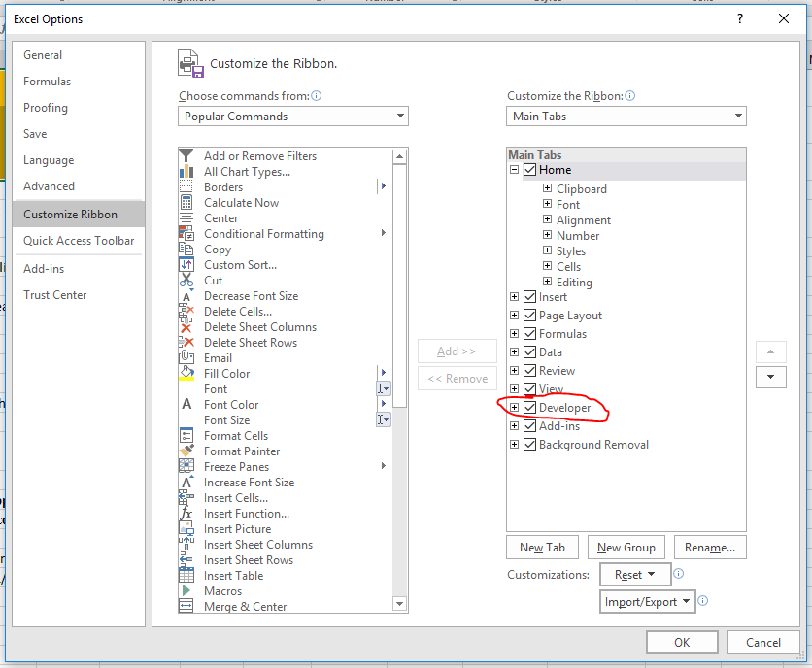

This creates the developer tab on our ribbon. Click on the developer tab and choose record macro.

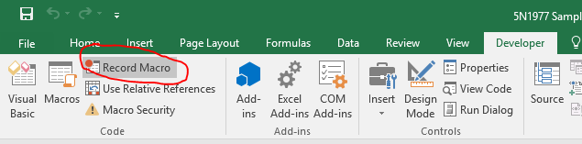

Give the macro a name (macroheading in this case)

For the project I did the following
- I highlighted cells A1 to K3 (the headings).
- I changed the font size to 22.
- I put an orangey background
- I put a border around the selected area.

Click stop recording.

If you now click on the macros icon

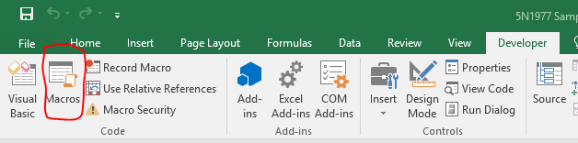

This will list all the macros you have recorded. Pick the one you want and run it.

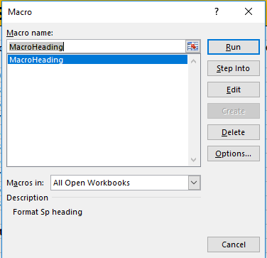

Below is the effect of running my Macroheading macro

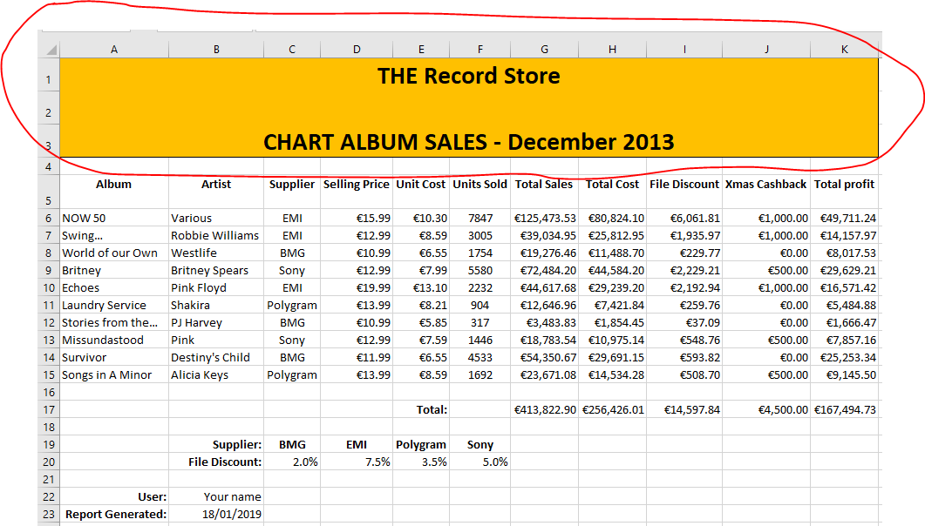

Modifications

On the first spreadsheet, I calculated the Department Contribution by dividing the individual departments’ Total Sales by the Store Total Sales. I also repeated this formula under the Total Profit column to calculate the departments’ profit contribution to the store.

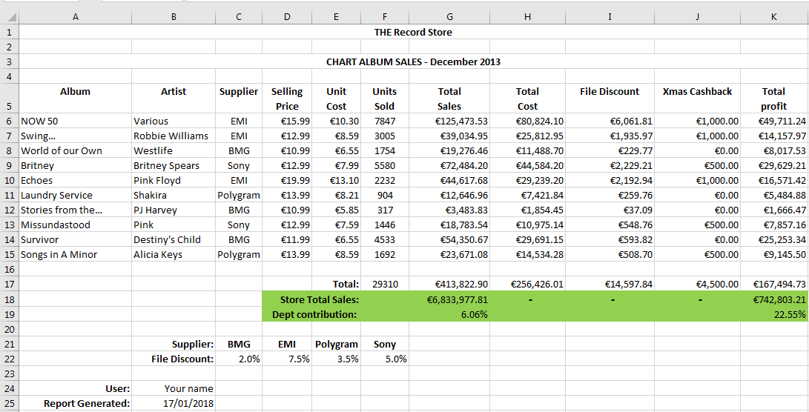
As an aside, with a view to collating information on chart albums in more detail, I produced a second modified spreadsheet to show the average sales and profit figures and the highest figures in each column. By analyzing this data, buyers have a useful template going forward and can increase the profitability throughout the store with better purchasing decisions.

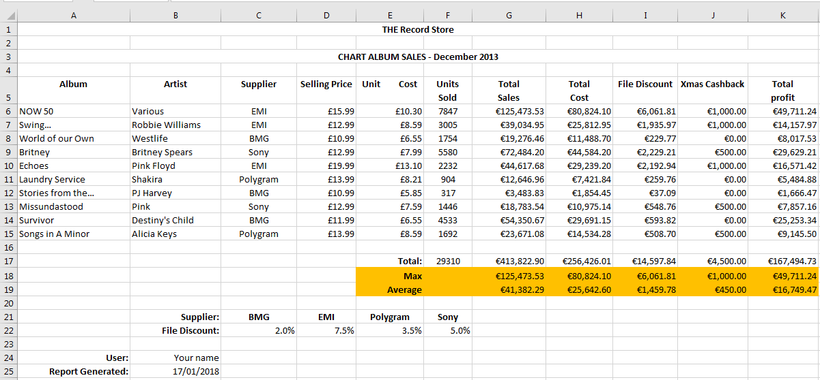

Critical analysis

In this section you need to review your project objectively. Some ideas below (not exhaustive)

- Maybe comment on how you went about doing things and maybe how if you did it again how you would approach it differently.
- Maybe you might change the layout of the spreadsheet.
- Maybe you might include more / other data.
- Maybe you might calculate other output as it could be more relevant.
- Maybe you would now consider different or tweaked formulae.
- Maybe you would use a different chart or have more charts.

- Did you find the project useful from an educational point of view? What did you learn?
- Did the project give you an insight into how useful spreadsheets could be in the work place.
- Would you feel confident in being able to create a “real life” spreadsheet in a work environment ?

