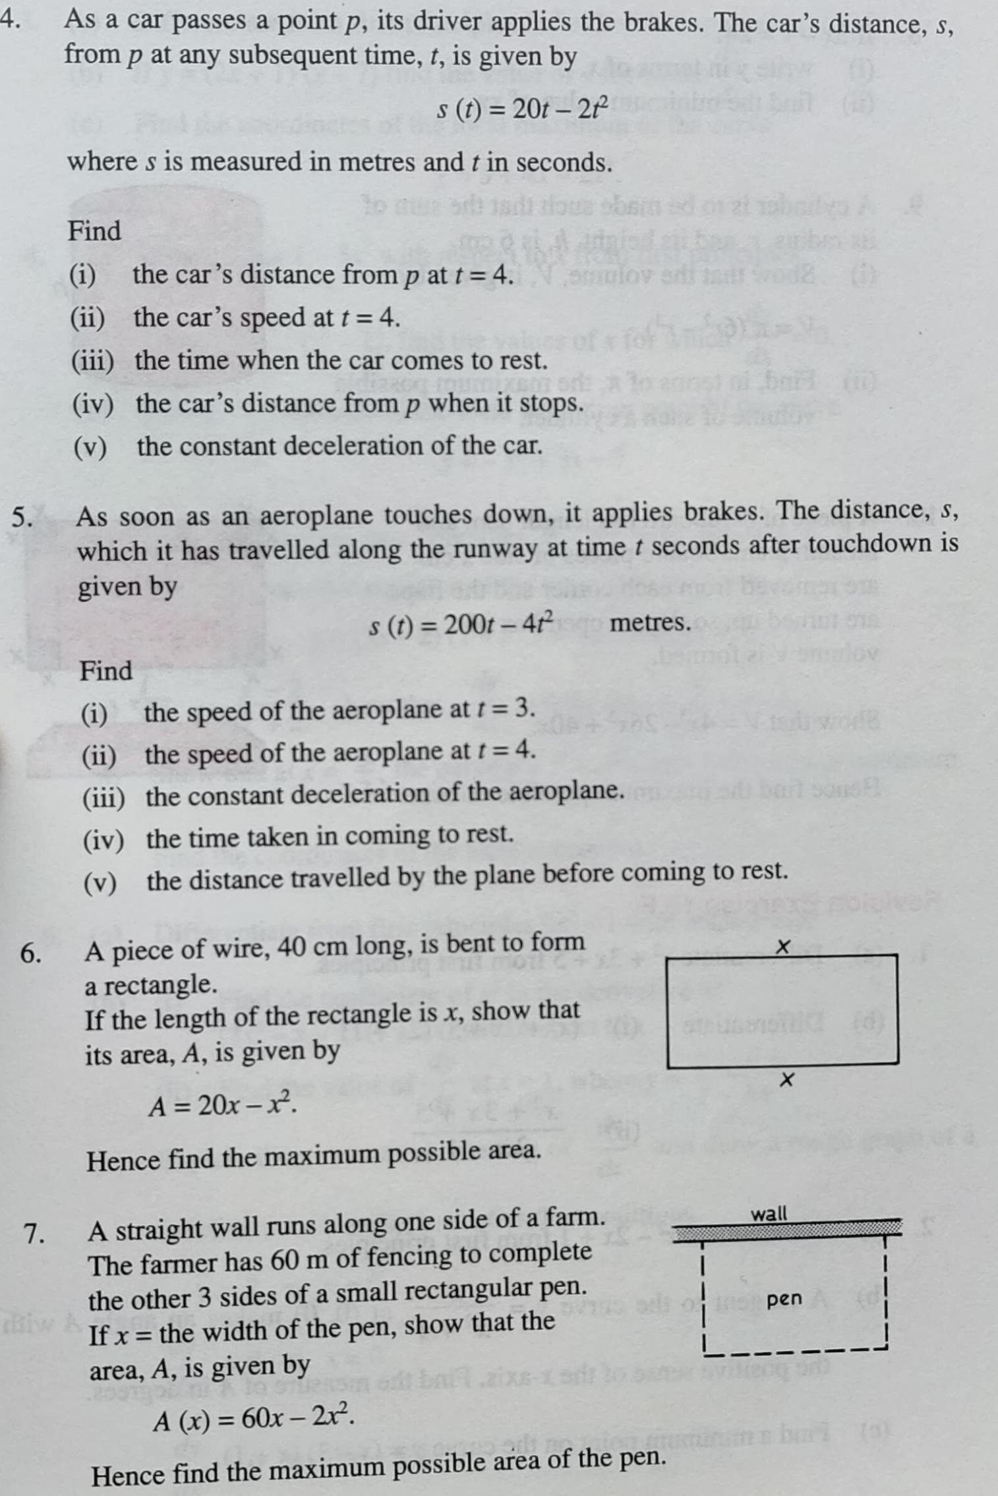
Differentiation - Exercises and Solutions

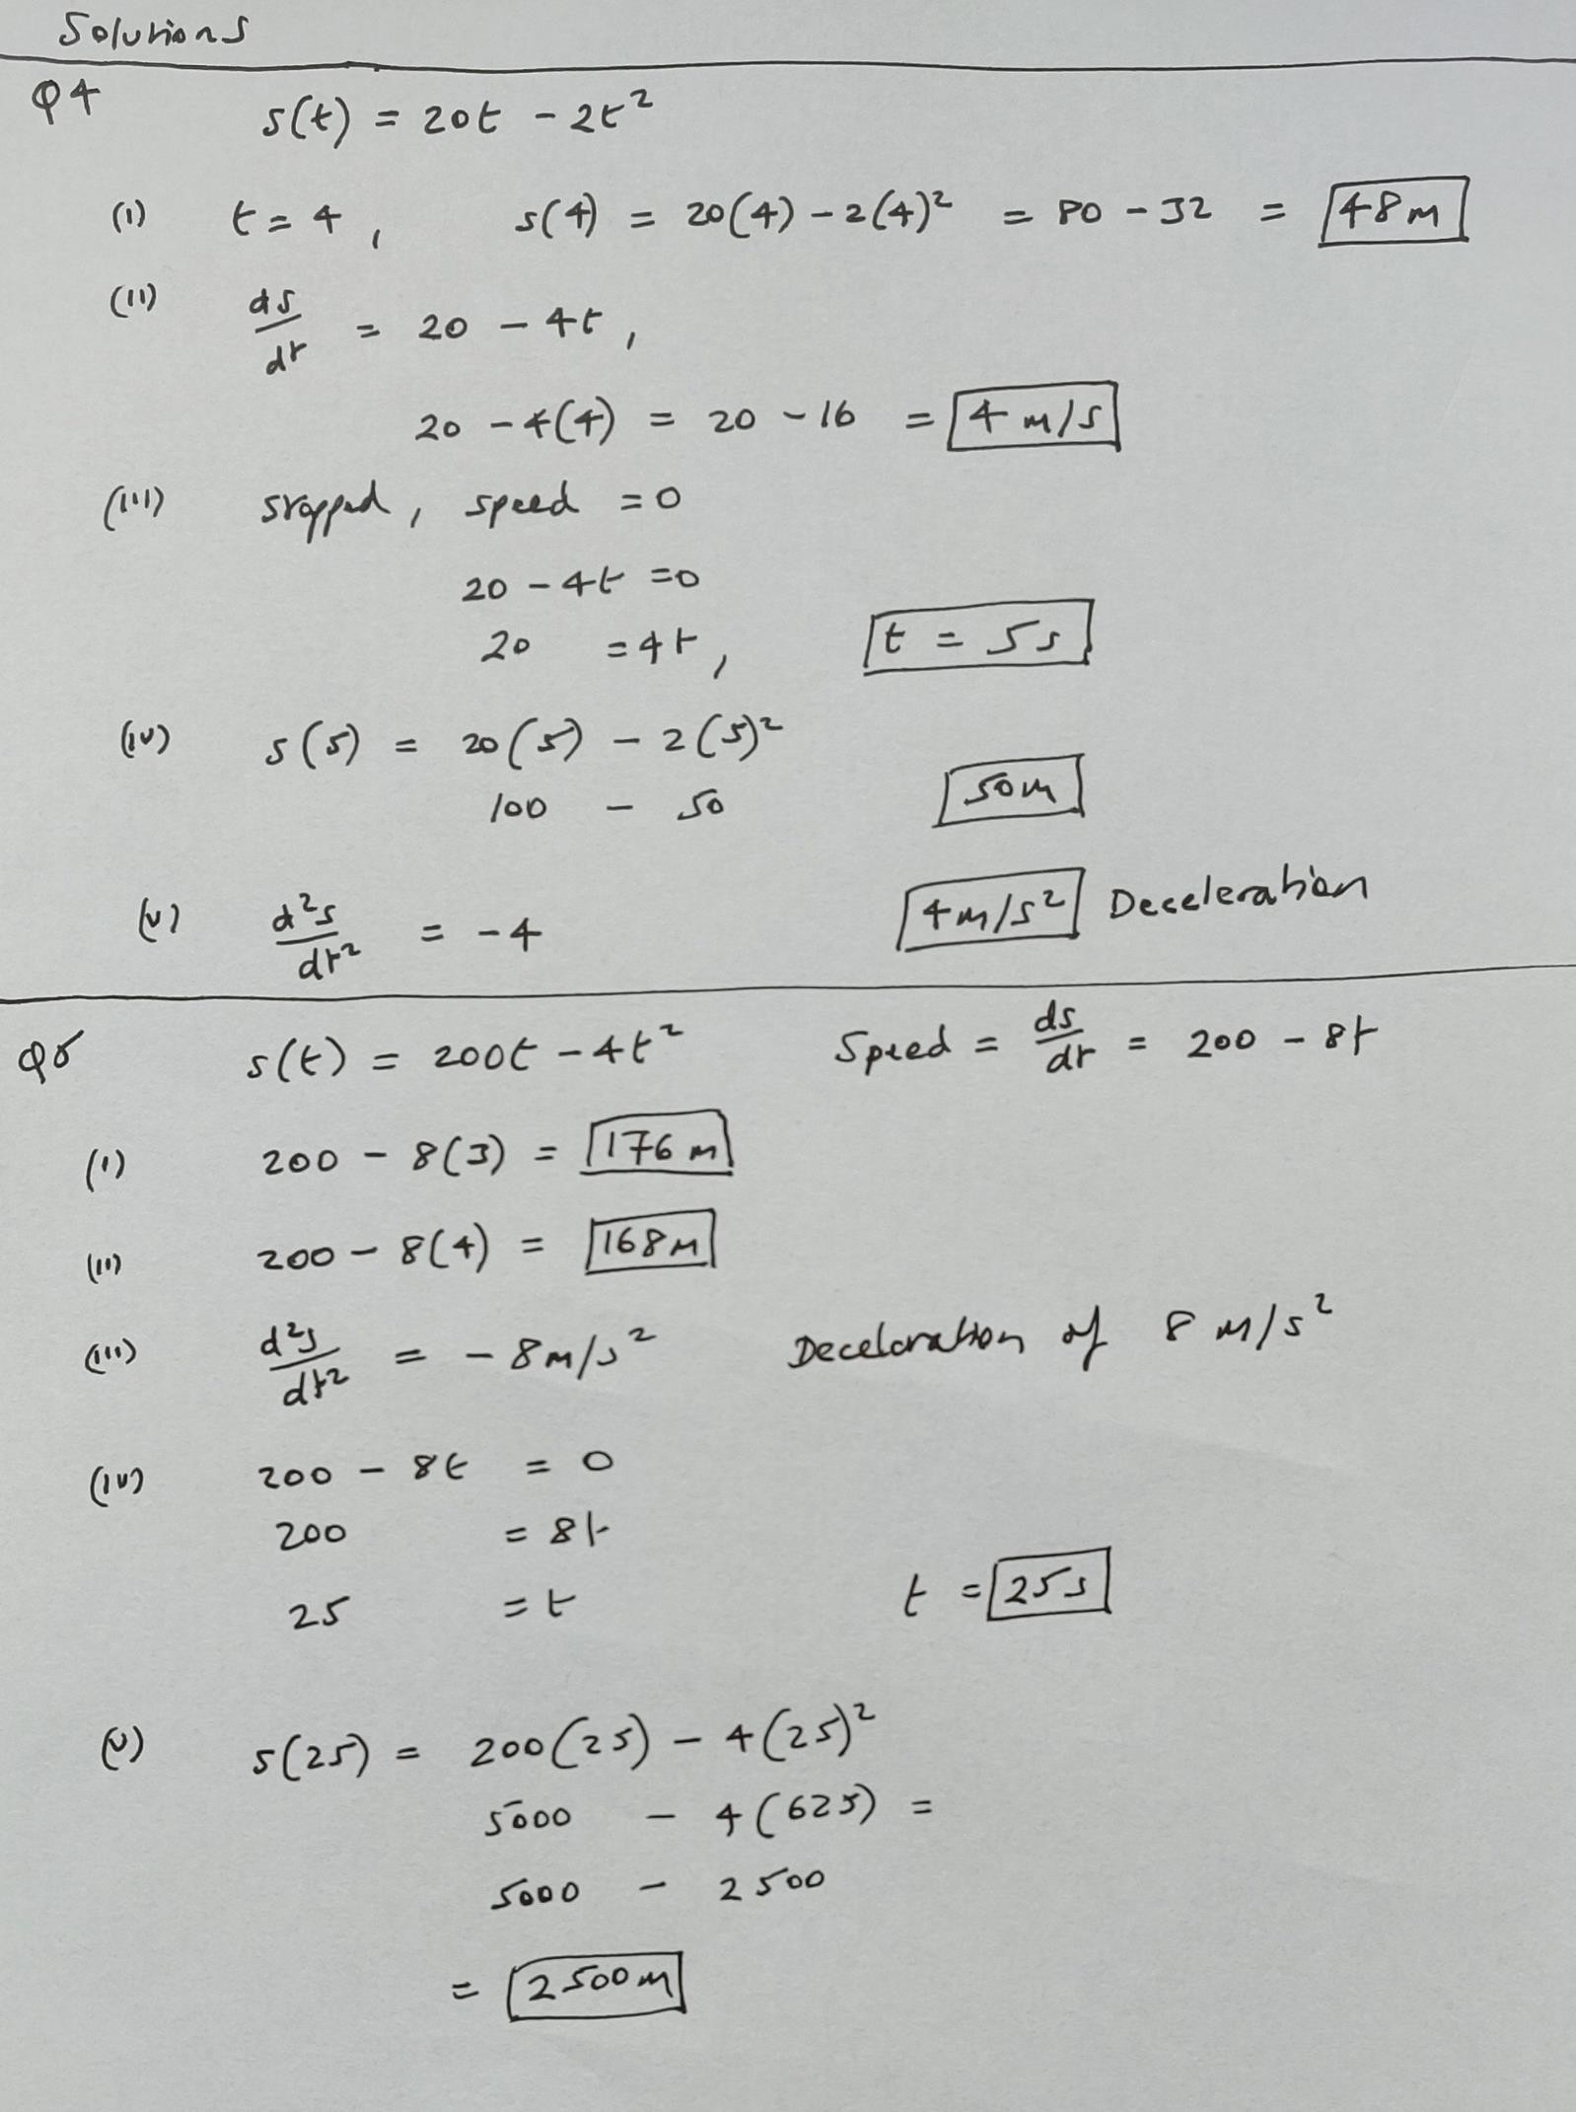

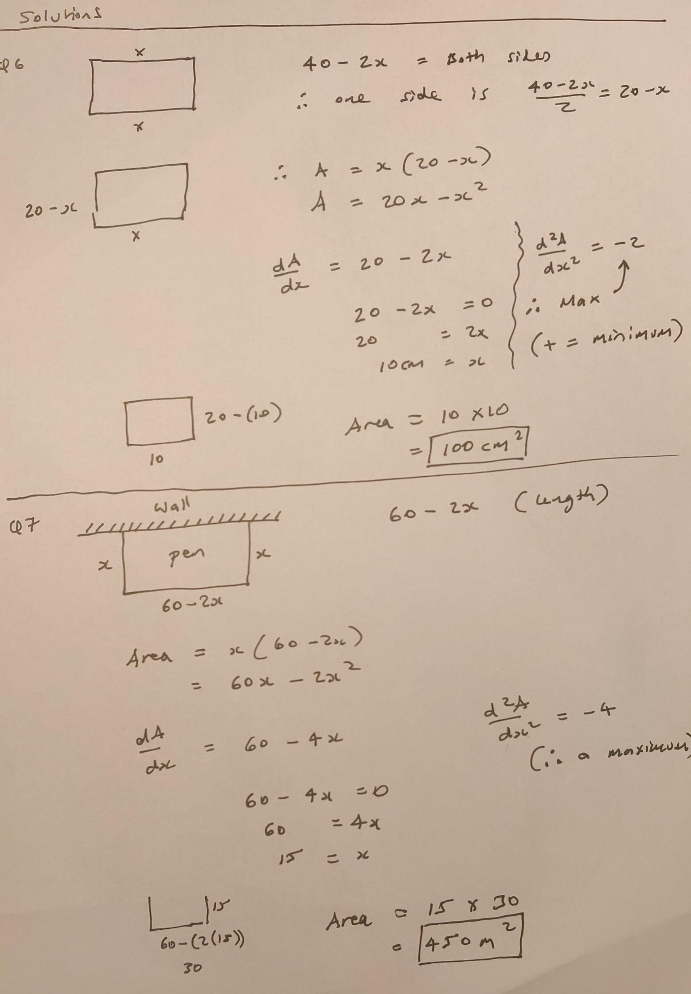

Applications of Differentiation – Turning Points

Find the local maximum and minimum turning points for the following function
$$f\left(x\right)=x^{3}+6x^{2}+9x+2$$

Assorted Exercises

To find the exact x and y coordinates find f(-1) and f(3). This will provide the y values hence you have the local maximum and local minimum points.

Maximum is (-1, 0 ) and minimum is (3, -8)

Calculus – Differentiation
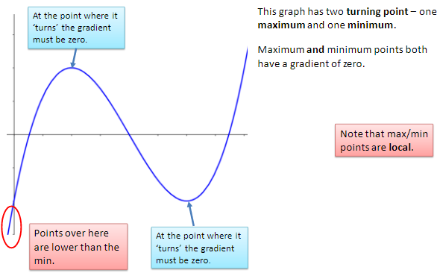
Maximum, Minimum Points of Inflection
The value f '(x) is the gradient at any point but often we want to
find the Turning or Stationary Point (Maximum and Minimum
points) or Point of Inflection
These happen where the gradient is zero, f '(x) = 0.
- f ''(x) is negative the function is maximum turning point
- f ''(x) is zero the function may be a point of inflection
- f ''(x) is positive the function is minimum turning point

Example
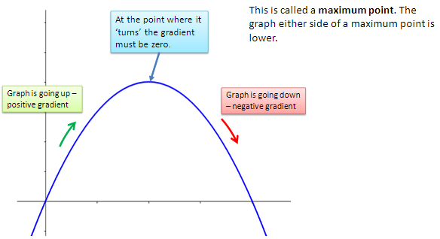
Find the maximum and minimum points of
- ${f\left(x\right)=2x}^{3}-{3x}^{2}-6$
Differentiate twice as follows
- ${f^{I}\left(x\right)=6x}^{2}-6x$
- ${f^{II}\left(x\right)=}^{ } 12x-6$
Turning points at $f^{I}\left(x\right)=0$ therefore
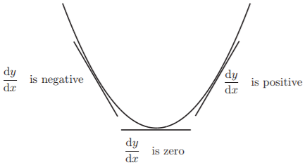
- ${6x}^{2}-6x=0$
- $6x(x-1)=0$
- $6x=0 or (x-1)=0$
- $x=0 or x=1$
Substituting x values into the function f(x)
- ${f\left(0\right)=2(0)}^{3}-{3\left(0\right)}^{2}-6 therefore f\left(x\right) or y=-6. Point (0,-6)$
- ${f\left(1\right)=2(1)}^{3}-{3\left(1\right)}^{2}-6 therefore f\left(x\right) or y=-7. Point (1,-7)$
Determining which is max/min
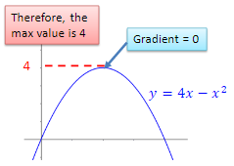
- ${f^{II}\left(0\right)=}^{ } 12\left(0\right)-6=-6$ (Maximum)
- ${f^{II}\left(1\right)=}^{ } 12\left(1\right)-6= 6$ (Minimum)
Maximum and minimum points
- Maximum turning point = $(0,-6)$
- Minimum turning point = $(1,-7)$

Exercise
- Find the turning points of the following and determine the maximum or minimum
  - ${f\left(x\right)=x}^{2}-2x-2$
  - ${f\left(x\right)=x}^{3}-{6x}^{2}+9x-2$

- The diagram shows a rectangular enclosure with a wall forming one side. A rope 20m long is used to form the remaining 3 sides. The width of the enclosure is x metres. Find the maximum length of x which gives the maximum area. Hence find the maximum area. You can call the length of the enclosure y.
Solution to 2 on following page(s)
More exercises (answer on next page)
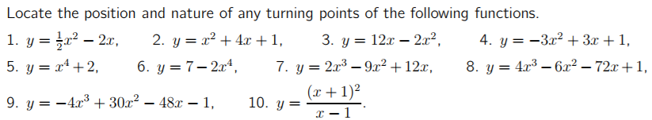

Solution to 2
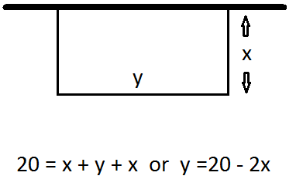
Area $=xy$
Area $=x(20-2x)$
$={20x-2x}^{2}$ This is the equation for graph of area against width
Maximum or minimum area occurs where $\frac{dA}{dx}=0$
- $\frac{dA}{dx}=20-4x$
- $20-4x=0$
- $20=4x$
- $5=x$
Maximum Area
- $\frac{d^{2}A}{dx^{2}}=-4$
Area in metre²
$$5\left(20-2\left(5\right)\right)=$$
$$5\left(20-10\right)=$$
$$5\left(10\right)=$$
$$Area=50m^{2}$$

Answers to exercises on previous page
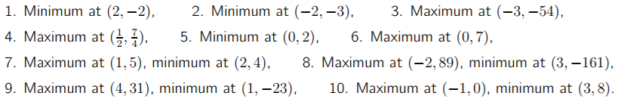

Applied Maximum and Minimum Problems
The process of finding maximum or minimum values is called optimisation.
We are trying to do things like maximise the profit in a company, or minimise the costs, or find the least amount of material to make a particular object.
These are very important in the world of industry.

Example 1
The daily profit, P, of an oil refinery is given by
$$P=8x-0.02x^{2}$$where x is the number of barrels of oil refined. How many barrels will give maximum profit and what is the maximum profit?
Solution
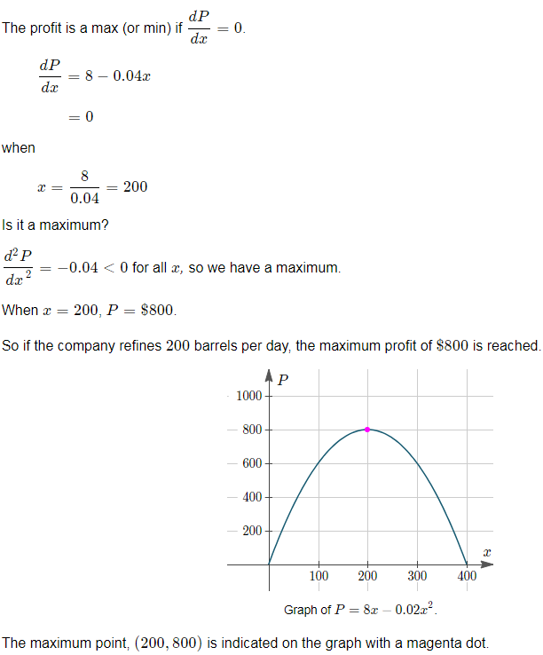

Example 2
A rectangular storage area is to be constructed along the side of a tall building. A security fence is required along the remaining 3 sides of the area. What is the maximum area that can be enclosed with 800 m of fencing?

Solution
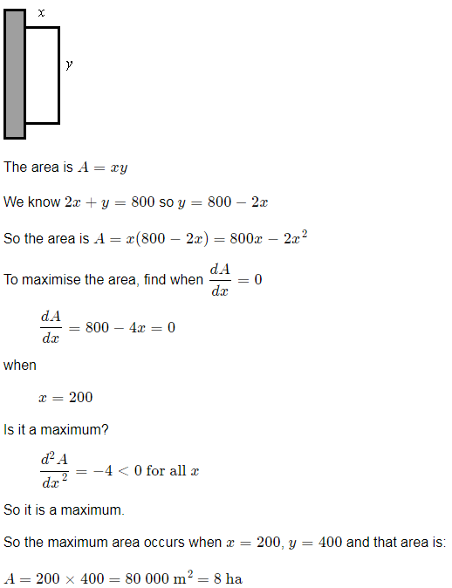

Example 3
A box with a square base has no top. If 64 cm² of material is used, what is the maximum possible volume for the box?

Solution
