5. Facilitate the learner to automate routine multi-step tasks through the creation, execution, and management of simple macros.
- Create simple macros consisting of at least five commands
- Execute previously created macros

Macros – Ensure the Developer tab is visible in the menu bar
To get access to the Developer tab – click File – More – Options.
Select Custom Ribbon and click the Developer checkbox as shown below. Click OK.
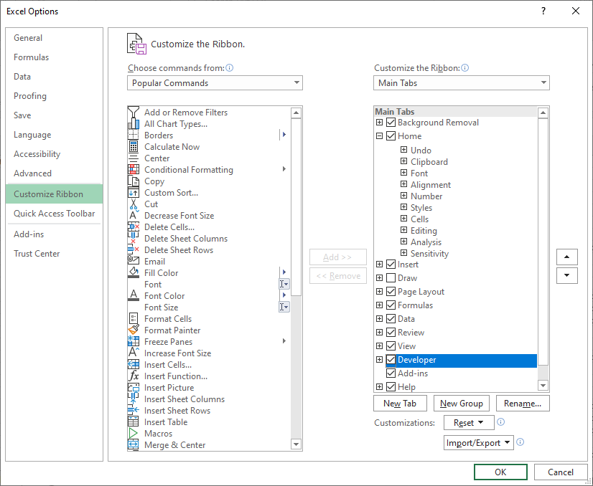
The Developer option is now available in the Menu bar as shown.
Record a Macro
Click on the Developer tab and select Record Macro.
Make the changes to fonts/size/colour/cell formatting/etc. Note that every instruction you make is being recorded by the Macro.

Run a Macro
Click the Macros icon in the Developer menu. Select the required Macro and click Run.

Sample Data File on my site
Use the “Sample_Data_FIle_Excel_Macros” file to practice recording Macros. Run and look at Editing the code of the macro. Note that every time you make a change to a font/etc the Macro is recording each step and writing the Visual Basic for Applications code so Excel can execute the macro at a later date. It is possible to write/edit/modify the code of a macro but this is risky unless you are sure of what you are doing. Macros give Excel strength and flexibility and are widely used in Industry for repeating multiple tasks.

Sample Macro code
