Probability - Permutation & Combinations
Fundamental Principle of Counting
The Fundamental Counting Principle (also called the counting rule) is a way to figure out the number of outcomes in a probability problem. Basically, you multiply the events together to get the total number of outcomes.
For example, if the first event can occur 3 ways, the second event can occur 4 ways, and the third event can occur 5 ways, then you can find the number of unique choices by multiplying: 3 * 4 * 5 = 60 unique choices in total.

Example
How many couples can be made from the letters a,b,c,d,e,f if identical couples are not permitted? (i.e. (c,a) but NOT (c,c) )
Solution: There are 6 choices for the first component { a,b,c,d,e,f}. For each first component, there are 5 choices for the corresponding second component.
Therefore, there 6 x 5 = 30 such couples.

Example
If there is a 6 course meal at a restaurant, you might have 3 appetizer choices, 2 soup choices, and 4 salad choices, along with 5 main course choices, 10 beverage choices, and 3 dessert choices. To find out how many unique 6-course meals you can make, multiply the number of possibilities for each course as follows:
3 * 2 * 4 * 5 * 10 * 3 = 3,600 possible unique meals

Example
Another situation might be the creation of license plates. Again, you have 6 slots to fill. The first two slots must be letters (26 choices) and the remaining 4 slots must be numbers (10 choices each). If you fill in the 6 'slots' with the number of choices and multiply you get the number of licence plates you can make.
26 * 26 * 10 * 10 * 10 * 10 = 6,760,000

Permutation / Arrangement
In permutations/arrangements the order of objects is very important. The arrangement must be in the stipulated order of the number of objects, taken only some or all at a time.
We define permutation as different ways of arranging some or all the members of a set in a specific order. It implies all the possible arrangement or rearrangement of the given set, into distinguishable order.

For example, all possible permutation created with letters x, y, z –
- By taking all three at a time are xyz, xzy, yxz, yzx, zxy, zyx.
- By taking two at a time are xy, xz, yx, yz, zx, zy.

Total number of possible permutations of n things, taken r at a time, can be calculated as:

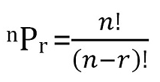

In the example above

Taking all 3 $3.2=6$

Taking 2 at a time $\frac{3!}{\left(3-2\right)!}= \frac{3!}{\left(1\right)!}=3.2=6$

Definition of Combination / Selection
The combination is defined as the different ways, of selecting a group, by taking some or all the members of a set, without the following order. In relation to combinations, the order does not matter at all.

For example, All possible combinations chosen with letter m, n, o :
- When three out of three letters are to be selected, then the only combination is mno

- When two out of three letters are to be selected, then the possible combinations are mn, no, om.

Total number of possible combinations of n things, taken r at a time can be calculated as:
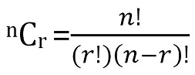

Permutations(Arrangements) – Combinations(Selections) Exercises
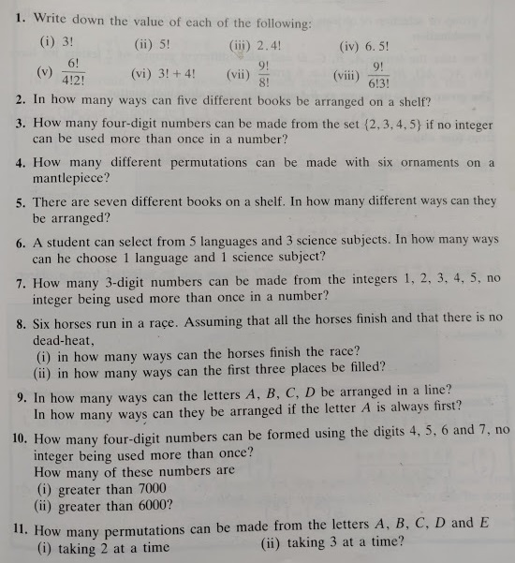
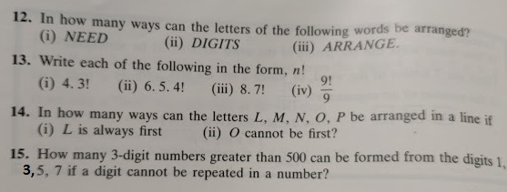
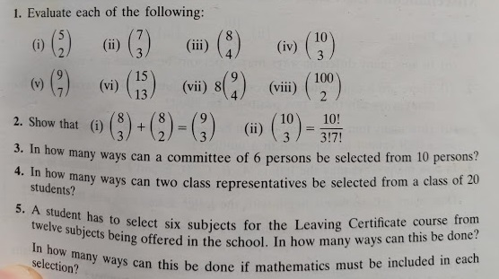
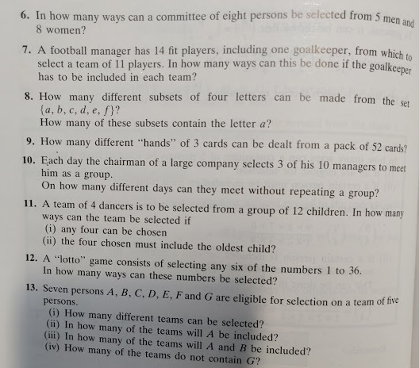

Solutions

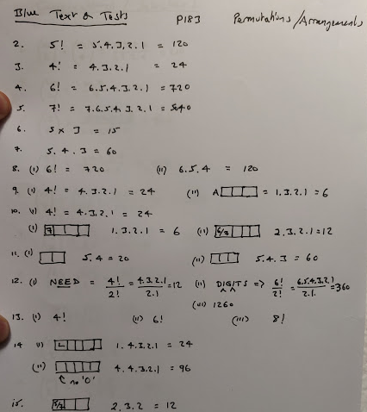

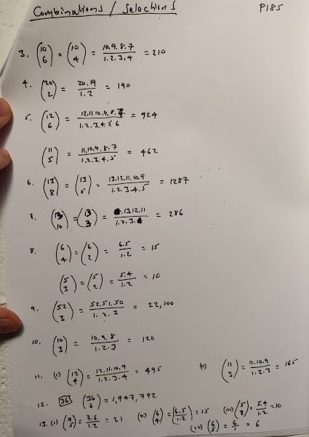

Question
In how many ways can the letters of the word SCOTLAND be arranged in a line?
- In how many of these arrangements do the two vowels come together?
- How many of the arrangements begin with S and end with the two vowels?

Solution
The letters of the word SCOTLAND can be arranged in 8! Ways.
8! = 8 X 7 X 6 X 5 X 4 X 3 X 2 X 1 = 40320 ways

- If the two vowels come together, we treat them as one “unit”.
 |  |  | A | O

There are now seven “units” (or boxes) and these can be arranged in 7! = 5040 ways.
For each arrangement of these boxes, the box containing AO can be arranged in 2! Ways.
Therefore the number of arrangements is 7! X 2! – 5040 X 2 = 10080 ways.

- Arrangements beginning with S and ending with AO or OA.
S |  |  |  |  |  | AO

The S is fixed and we treat AO as one “unit” and that is also fixed. The remaining 5 letters can be arranged in 5! Ways.
For each of these arrangements, AO can be arranged in 2! Ways, therefore the number of arrangements is 5! X 2! = 120 X 2 = 240

Question
Three girls and four boys are to sit in a row of seven chairs. How many different arrangements are possible
- If the girls sit beside one another?
- If no two boys may sit beside each other?

Solution
(i)
3 girls 4 boys
 |  | Girl | Girl | Girl

5! X 3! = 5.4.3.2.1.3.2.1 = 720

(ii)
Boy | Girl | Boy | Girl | Boy | Girl | Boy

We can arrange the boys in 4! Ways and the girls in 3! Ways hence the total number of arrangements is 4! X 3! = 4.3.2.1.3.2.1 = 144

Permutations and Arrangements Exercises and Solutions
Question 1
In how many ways can 5 students be arranged in a line such that
- two particular students are always together
- two particular students are never together.
Solutions
- We consider the arrangements by taking 2 particular students together as one and hence the remaining 4 can be arranged in 4! = 24 ways. Again two particular students taken together can be arranged in two ways. Therefore, there are 24 × 2 = 48 total ways of arrangement.
- Among the 5! = 120 permutations of 5 students, there are 48 in which two students are together. In the remaining 120 – 48 = 72 permutations, two particular students are never together.

Question 2
If all permutations of the letters of the word AGAIN are arranged in the order as in a dictionary. What is the 49th word?
Solution
(Dictionary – in alphabetical order) Arrange words alphabetically using permutations/arrangement method to find out the number of each.
Starting with letter A, and arranging the other four letters, there are 4! = 24 words. These are the first 24 words. Then starting with G, and arranging A, A, I and N in different ways, there are $\frac{4! }{2!1!1! }$12 = words. Next the 37th word starts with I. There are again 12 words starting with I. This accounts up to the 48th word. The 49th word is NAAGI.
Question 3
In how many ways 3 mathematics books, 4 history books, 3 chemistry books and 2 biology books can be arranged on a shelf so that all books of the same subjects are together
Solution
First we take books of a particular subject as one unit. Thus there are 4 units which can be arranged in 4! = 24 ways. Now in each of arrangements, mathematics books can be arranged in 3! ways, history books in 4! ways, chemistry books in 3! ways and biology books in 2! ways. Thus the total number of ways = 4! × 3! × 4! × 3! × 2! = 41472.

Question 4
Three married couples are to be seated in a row having six seats in a cinema hall. If spouses are to be seated next to each other, in how many ways can they be seated? Find also the number of ways of their seating if all the ladies sit together.
Solution
Let us denote married couples by S1, S2, S3, where each couple is considered to be a single unit as shown in the following figure:
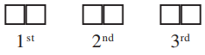
Then the number of ways in which spouses can be seated next to each other is 3! = 6 ways. Again each couple can be seated in 2! ways. Thus the total number of seating arrangement so that spouses sit next to each other = 3! × 2! × 2! × 2! = 48.

Now we want three ladies to sit together so we will tie them together(eg in one block or group). Thus we have 4 units now that is 3 men + ladies tied together.
Also, there will be 3! possible arrangements of ladies among themselves.
The number of possible ways in which ladies sit together.
= 4! x 3!
= 24 x 6
= 144

Video

https://www.youtube.com/watch?v=ay0STK95Wmw

Probability

Measure Probabilities on a scale from 0 to 1 and assign meanings to points on this scale.
Single Events
When a coin is tossed we know that it is just as likely to come down ‘heads’ as ‘tails’. We say that there is a 50 – 50 chance of showing ‘heads’. So if a coin is tossed ten times, for example, we ‘expect’ to get heads on five of these tosses. Of course this does not always happen. We may get 6 heads and 4 tails or 7 heads and 3 tails.

Now toss a coin 20 times and record the number of harps you get. In general, the greater the number of times you toss a coin the closer you will get to your ‘expected’ result. In an experiment at the beginning of the last century a statistician named Karl Pearson tossed a coin 24,000 times and got 12,012 heads. This, as you can see is very close to the ‘expected’ value of 12,000.

Thus when tossing a coin, we have one chance in two of obtaining a head. Expressing this in a more formal way we say:
The probability of obtaining a head (H) is ¹/₂
We write this as P (H) = ¹/₂

Similarly, when a die is thrown, we are equally likely of getting any one of the numbers 1, 2, 3, 4, 5, 6. That is, we have one chance in six of obtaining the number 2, for example, => P (2) = ¹/₆

Example 1
If a card is drawn 200 times from a well shuffled pack of 52. How many of the cards drawn would you expect to be hearts?

¹/₄ of the cards are hearts. So we expect hearts on ¹/₄ of 200 occasions i.e. 50 hearts.

P (E) = number of favourable outcomes in E
number of possible outcomes

Notes: 1. The probability of any event E cannot be less than 0 or greater than 1,
i.e., 0 ≤ P (E) ≤ 1

2. The probability of a certainty is 1.
3. The probability of impossibility is 0.

Example 2
If a card is drawn from a pack of 52, find the probability that it is
(i) a king (ii) a spade (iii) a red card

(i) There are 4 kings in the pack => P (king) = ⁴/₅₂ = ¹/₁₃
(ii) There are 13 spades in the pack => P (spade) = ¹³/₅₂ = ¼
(iii) There are 26 red cards => P (red card) = ²⁶/₅₂ = ½

Questions
Make out a sample space to show all the possible outcomes when two dice are thrown. Use this to write down the probability that,
- The sum of the two numbers is 3

The sum of the two numbers is 9
- An even number appears on both dice
- The sum of the two numbers is 10 or more
- An odd number greater than 1 appears on both dice
- The difference between the two numbers is 1

A, B, and C are horses equally likely to win a 3-horse race. List all the ways in which the horses can finish, assuming that all the horses finish the race and that there is no dead-heat.
(i) What is the probability that the horses finish in the order A, B and C?
(ii) What is the probability that A wins?

If I throw a die, what is the probability that I get?
(i) 5 (ii) an odd number (iii) a multiple of 3?

A bag contains 5 red beads, 4 black beads and 3 green beads. If one bead is drawn at random from the bag, find the probability that
(i) the bead is red (ii) the bead is green
In a casino a pointer is spun and you win the amount shown in the sector where it comes to rest. Assuming that the pointer is equally likely to come to rest in any sector, what is the probability that you win?

(i) some money (ii) 5 Euros 0 10
(iii) no money (iv) more than 5 Euros
(v) at least 5 Euros? 5 0

20 1

0 5

The Probability that an Event does not occur
P (E not occurring) = 1 – P (E)

Example
The probability of drawing a spade from a pack of 52 cards is ¹³/₅₂ = ¼.
Therefore, the probability of not drawing a spade from a deck of 52 is 1 – ¼ = ¾.

Mutually Exclusive Events – Events A or B
Consider the following two events when drawing a card from a pack of 52:
A: drawing an ace
B: drawing a king

These events cannot occur together and are said to be mutually exclusive. If A and B are events that cannot occur together, then
P (A or B) = P (A) + P(B)

Example 1
A number is selected at random from the numbers 1 – 30 inclusive. Find the probability that it will be either a multiple of 7 or a multiple of 8.
The multiples of 7 are 7, 14, 21, and 28.
The multiples of 8 are 8, 16, and 24.
These events cannot occur together (i.e., they are mutually exclusive).
    - P (multiple of 7 or multiple of 8)
    - = P (multiple of 7) + P (multiple of 8)
    - = ⁴/₃₀ + ³/₃₀ = ⁷/₃₀

Note: If three events A, B and C cannot occur together, then
P (A or B or C) = P (A) + P (B) + P (C)

Example 2
The names Andrew, Barry, Christine and Diana are put in a hat to select two representatives for a competition. Make a list of all the possible pairs of names that could be drawn from the hat. (Use the capital letters A, B, C and D for these names and note that AB is the same as BA.)

Set out a sample space giving all the possible outcomes.
AB, AC, AD, BA, BC, BD, CA, CB, CD, DA, DB and DC. However, AB = BA etc. Therefore, we have to remove BA, CA, CB, DA and DC as they have already been declared. We are then left with a sample space of AB, AC, AD, BC, BD and CD. Therefore there are 6 possible pairs.

What is the probability of drawing?
(i) Andrew and Barry? (ii) A boy and a girl?
(iii) A pair which includes Diana? (iv) A pair that does not include Barry?

(i) = P(AB) = number of favourable outcomes in E = 1
number of possible outcomes 6

(ii) = P (AC) or P (AD) or P (BC) or P (BD) = ⁴/₆ = ²/₃.

(iii) = P (AD) or P (BD) or P (CD) = ³/₆ = ½.

(iv) = P (AC) or P (AD) or P (CD) = ³/₆ = ½.

Events that are not Mutually Exclusive
If an event consists of selecting an ace or a heart from a pack of 52 cards, then
P (ace) = 4/52 and P (heart) = 13/52
However, the number of aces or hearts in a pack of cards is 16 (and not 17, i.e. 13 + 4), because of the 13 hearts and 4 aces, one card is the ace of hearts.
=> P (ace or heart) is not equal to P (ace) + P (heart)

In general, when two events A and B can occur at the same time, then

P (A or B) = P(A) + P(B) – P(A and B)

Questions

A card is drawn at random from a pack of 52. What is the probability that the card is
- A club
- A king
- A club or a king
- A red card
- A queen
- A red card or a queen
- A red card and a queen?

The letters of the word EXERCISES are written on 9 cards and placed in a box. If a card is drawn at random, what is the probability that the letter on the card is
  - The letter E
  - A vowel
  - Not the letter X
  - The letter C or the letter E
  - The letter X and C?
Events A AND B – The Multiplication Rule
If a coin is tossed twice, the result of the first toss has no bearing on the outcome of the second. The two tosses of the coin are said to be independent events.

The sample space for tossing a coin twice is {HH, HT, TH, TT}

The probability of getting 2 heads is ¼. However, since each trial is independent of the other, we know that the probability of getting a head on the first toss of the coin is ½ and the probability of getting a head on the second toss is also ½.

Multiplying the two probabilities we get ½ * ½ = ¼.

This is the same answer that was found above by using a sample space. This illustrates the multiplication law of probability, which states that

Probability of A and B occurring = prob. of A occurring * prob. of B occurring

P (A and B) = P(A) * P(B)

Example
When two dice are thrown, what is the probability of getting 2 sixes?
The probability of getting a 6 with the first die = ¹/₆
The probability of getting a 6 with the second die = ¹/₆
=> P(2 sixes) = ¹/₆ * ¹/₆ = ¹/₃₆.

What if more than two events occur, e.g. what is the probability of getting 5 heads in succession: = ½ * ½ * ½ * ½ * ½ = ¹/₃₂

Events which are not Independent
For example, if a card is drawn from a pack of 52 and not replaced, the probability of drawing a king is ¹/₁₃. Assuming that the first card is a king, the probability of drawing a king on the second card is ³/₅₁, since there are only 3 kings left and 51 cards left.

Therefore the probability of drawing a king on both cards is ¹/₁₃ * ³/₅₁ = ¹/₂₂₁

Example
A box contains 6 black discs, 4 white discs and 2 green discs. A disc is removed at random and not replaced. A second disc is then removed. Find the probability that
(i) Both discs are black
(ii) The first is white and the second is green
(i) There are 12 discs in the bag.
P (1st black) = ⁶/₁₂ = ½
P (2nd black) = ⁵/₁₁, provided the first was black.
P (both black) = ½ * ⁵/₁₁ = ⁵/₂₂

(ii) P (1st white) = ⁴/₁₂ = ¹/₃
P (2nd green) = ²/₁₁, provided the first was white
P (1st white and 2nd green) = ¹/₃ * ²/₁₁ = ²/₃₃

Questions
A coin is tossed twice. What is the probability of getting
(i) 2 heads (ii) A head on the first and a tail on the second?

A coin is tossed and a die is thrown. What is the probability of getting
(i) A head and a 6 (ii) A tail and an even number
(iii) A head and a multiple of 3?

A bag contains 7 red sweets and 3 yellow sweets. Jane takes a sweet at random and eats it. Barry then also takes a sweet at random. Find the probability that both sweets are
(i) red (ii) yellow
(iii) Find the probability that the first is yellow and the second is red.

A box contains 12 tickets numbered 1 to 12. An event consists of picking at random a ticket from the box and throwing a die.
- Find the probability of getting 3 on the ticket and 6 on the die.
- Find the probability of getting the same number on the ticket and on the die.

Sample Spaces
1 Coin and 1 Die
(H, 1) (H, 2) (H, 3) (H, 4) (H, 5) (H, 6)
(T, 1) (T, 2) (T, 3) (T, 4) (T, 5) (T, 6)

2 dice – Sample Space
(1, 1) (1, 2) (1, 3) (1, 4) (1, 5) (1, 6)
(2, 1) (2, 2) (2, 3) (2, 4) (2, 5) (2, 6)
(3, 1) (3, 2) (3, 3) (3, 4) (3, 5) (3, 6)
(4, 1) (4, 2) (4, 3) (4, 4) (4, 5) (4, 6)
(5, 1) (5, 2) (5, 3) (5, 4) (5, 5) (5, 6)
(6, 1) (6, 2) (6, 3) (6, 4) (6, 5) (6, 6)

Questions
Question 1: A die is rolled, find the probability that an even number is obtained.
Question 2: Two coins are tossed, find the probability that two heads are obtained.
Question 3: Which of these numbers cannot be a probability?
a) -0.00001
b) 0.5
c) 1.001
d) 0
e) 1
f) 20%
Question 4: Two dice are rolled, find the probability that the sum is
a) equal to 1
b) equal to 4
c) less than 13
Question 5: A die is rolled and a coin is tossed, find the probability that the die shows an odd number and the coin shows a head.
Question 6: A card is drawn at random from a deck of cards. Find the probability of getting the 3 of diamond.
Question 7: A card is drawn at random from a deck of cards. Find the probability of getting a queen.
Question 8: A jar contains 3 red marbles, 7 green marbles and 10 white marbles. If a marble is drawn from the jar at random, what is the probability that this marble is white?
Question 9: The blood groups of 200 people is distributed as follows: 50 have type A blood, 65 have B blood type, 70 have O blood type and 15 have type AB blood. If a person from this group is selected at random, what is the probability that this person has O blood type?
Exercises
a) A die is rolled, find the probability that the number obtained is greater than 4.
b) Two coins are tossed, find the probability that one head only is obtained.
c) Two dice are rolled, find the probability that the sum is equal to 5.
d) A card is drawn at random from a deck of cards. Find the probability of getting the King of heart.

Solutions
Question 1: A die is rolled, find the probability that an even number is obtained.
Solution Let us first write the sample space S of the experiment.
S = {1,2,3,4,5,6}
Let E be the event "an even number is obtained" and write it down.
E = {2,4,6}
We now use the formula of the classical probability.
P(E) = n(E) / n(S) = 3 / 6 = 1 / 2

Question 2: Two coins are tossed, find the probability that two heads are obtained.
Note: Each coin has two possible outcomes H (heads) and T (Tails).
Solution
The sample space S is given by.
S = {(H,T),(H,H),(T,H),(T,T)}
Let E be the event "two heads are obtained".
E = {(H,H)}
We use the formula of the classical probability.
P(E) = n(E) / n(S) = 1 / 4

Question 3: Which of these numbers cannot be a probability?
a) -0.00001
b) 0.5
c) 1.001
d) 0
e) 1
f) 20%
Solution
A probability is always greater than or equal to 0 and less than or equal to 1, hence only a) and c) above cannot represent probabilities: -0.00010 is less than 0 and 1.001 is greater than 1.

Question 4: Two dice are rolled, find the probability that the sum is
a) equal to 1
b) equal to 4
c) less than 13
Solution
a) The sample space S of two dice is shown below.
S = { (1,1),(1,2),(1,3),(1,4),(1,5),(1,6)
(2,1),(2,2),(2,3),(2,4),(2,5),(2,6)
(3,1),(3,2),(3,3),(3,4),(3,5),(3,6)
(4,1),(4,2),(4,3),(4,4),(4,5),(4,6)
(5,1),(5,2),(5,3),(5,4),(5,5),(5,6)
(6,1),(6,2),(6,3),(6,4),(6,5),(6,6) }
Let E be the event "sum equal to 1". There are no outcomes which correspond to a sum equal to 1, hence
P(E) = n(E) / n(S) = 0 / 36 = 0
b) Three possible outcomes give a sum equal to 4: E = {(1,3),(2,2),(3,1)}, hence.
P(E) = n(E) / n(S) = 3 / 36 = 1 / 12
c) All possible outcomes, E = S, give a sum less than 13, hence.
P(E) = n(E) / n(S) = 36 / 36 = 1

Question 5: A die is rolled and a coin is tossed, find the probability that the die shows an odd number and the coin shows a head.
Solution
The sample space S of the experiment described in question 5 is as follows
S = { (1,H),(2,H),(3,H),(4,H),(5,H),(6,H)
(1,T),(2,T),(3,T),(4,T),(5,T),(6,T)}
Let E be the event "the die shows an odd number and the coin shows a head". Event E may be described as follows
E={(1,H),(3,H),(5,H)}
The probability P(E) is given by
P(E) = n(E) / n(S) = 3 / 12 = 1 / 4

Question 6: A card is drawn at random from a deck of cards. Find the probability of getting the 3 of diamond.
Solution
The sample space S of the experiment in question 6 is shwon below
ample space deck of card

Let E be the event "getting the 3 of diamond". An examination of the sample space shows that there is one "3 of diamond" so that n(E) = 1 and n(S) = 52. Hence the probability of event E occurring is given by
P(E) = 1 / 52

Question 7: A card is drawn at random from a deck of cards. Find the probability of getting a queen.
Solution
The sample space S of the experiment in question 7 is shwon above (see question 6)
Let E be the event "getting a Queen". An examination of the sample space shows that there are 4 "Queens" so that n(E) = 4 and n(S) = 52. Hence the probability of event E occurring is given by
P(E) = 4 / 52 = 1 / 13

Question 8: A jar contains 3 red marbles, 7 green marbles and 10 white marbles. If a marble is drawn from the jar at random, what is the probability that this marble is white?
Solution
We first construct a table of frequencies that gives the marbles color distributions as follows
color frequency
red 3
green 7
white 10
We now use the empirical formula of the probability
P(E) = Frequency for white color / Total frequencies in the above table
= 10 / 20 = 1 / 2

Question 9: The blood groups of 200 people is distributed as follows: 50 have type A blood, 65 have B blood type, 70 have O blood type and 15 have type AB blood. If a person from this group is selected at random, what is the probability that this person has O blood type?
Solution
We construct a table of frequencies for the the blood groups as follows
group frequency
a 50
B 65
O 70
AB 15

We use the empirical formula of the probability
P(E) = Frequency for O blood / Total frequencies
= 70 / 200 = 0.35

Exercises
a) A die is rolled, find the probability that the number obtained is greater than 4.
b) Two coins are tossed, find the probability that one head only is obtained.
c) Two dice are rolled, find the probability that the sum is equal to 5.
d) A card is drawn at random from a deck of cards. Find the probability of getting the King of heart.

Answers to above exercises:
a) 2 / 6 = 1 / 3
b) 2 / 4 = 1 / 2
c) 4 / 36 = 1 / 9
d) 1 / 52

Probability Not / Or Exercise and Solution
QUESTION
M&M sweets are of varying colours and the different colours occur in different proportions. The table below gives the probability that a randomly chosen M&M has each colour, but the value for tan candies is missing.
Colour | Brown | Red | Yellow | Green | Orange | Tan
Probability | 0.3 | 0.2 | 0.2 | 0.1 | 0.1 | ?

(a) What value must the missing probability be?
(b) You draw an M&M at random from a packet. What is the probability of each of the following events?
- You get a brown one or a red one.
- You don’t get a yellow one.
- You don’t get either an orange one or a tan one.
- You get one that is brown or red or yellow or green or orange or tan.

SOLUTION:
(a) The probabilities must sum to 1.0 Therefore, the answer is 1−0.3−0.2−0.2−0.1−0.1 = 1−0.9 = .1.
(b) Simply add and subtract the appropriate probabilities.
- 0.3 + 0.2 = 0.5 since it can’t be brown and red simultaneously (the events are incompatible).
- 1 − P(yellow) = 1 − 0.2 = 0.8.
- 1 − P(orange or tan) = 1 − P(orange) − P(tan) = 1 − 0.1 − 0.1 = 0.8 (since orange and
- tan are incompatible events).
- This must happen; the probability is 1.0

