4. Facilitate the learner to use spreadsheet design features involving data and cell formatting techniques which enhance understanding and legibility.
- Recognise the feature available on toolbars
- Insert and delete rows and columns
- Adjust column width
- Format column entries for example decimal, currency, alignment and date

Features available on toolbars
Home toolbar
Insert toolbar
Page Layout toolbar
Formula toolbar
Data toolbar

Insert Rows / Columns
Click on the row number (eg 7) or column letter as shown and right click, select insert from menu below as required.
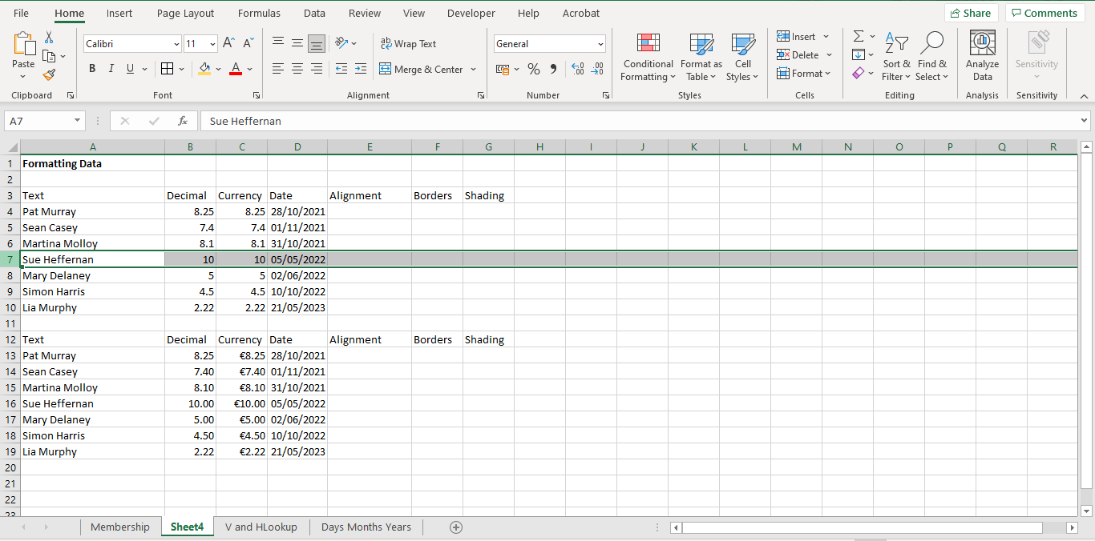
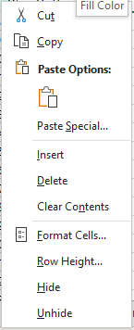

Note a new row or column is always inserted in front of the select one. In the example above we select row 7 and the new row was inserted in front of it.

To delete a row or column, click on the row number or column letter, right click and select Delete.

To adjust column width
- Autofit(best fit) - Double click on the symbol which appears with you move the mouse pointer between columns
- Specified column width – select the column and right click on the column letter as shown below and select Column Width. Enter a number to represent the column width.
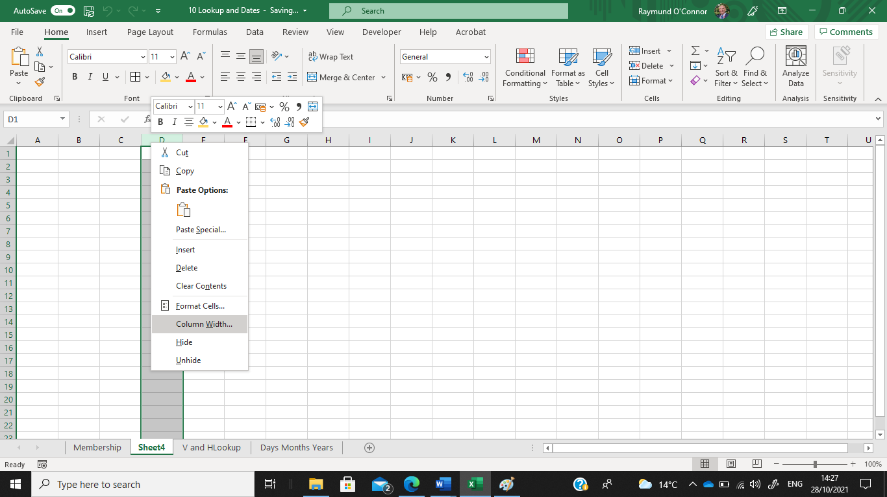
Input the required column width as shown below
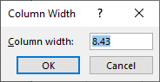

Format column entries for example decimal, currency, alignment and date

Create a spreadsheet file and input the following data:
To change the width of column A to 25, click on A and right click, select Column Width and input 25, click Ok
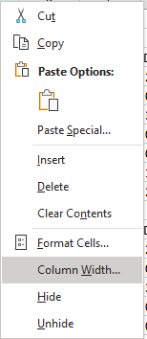
Setting the number of decimal places
Highlight the cells as shown below, right click mouse button, select Format Cells, select Number and enter number of decimal places (2 in this example)
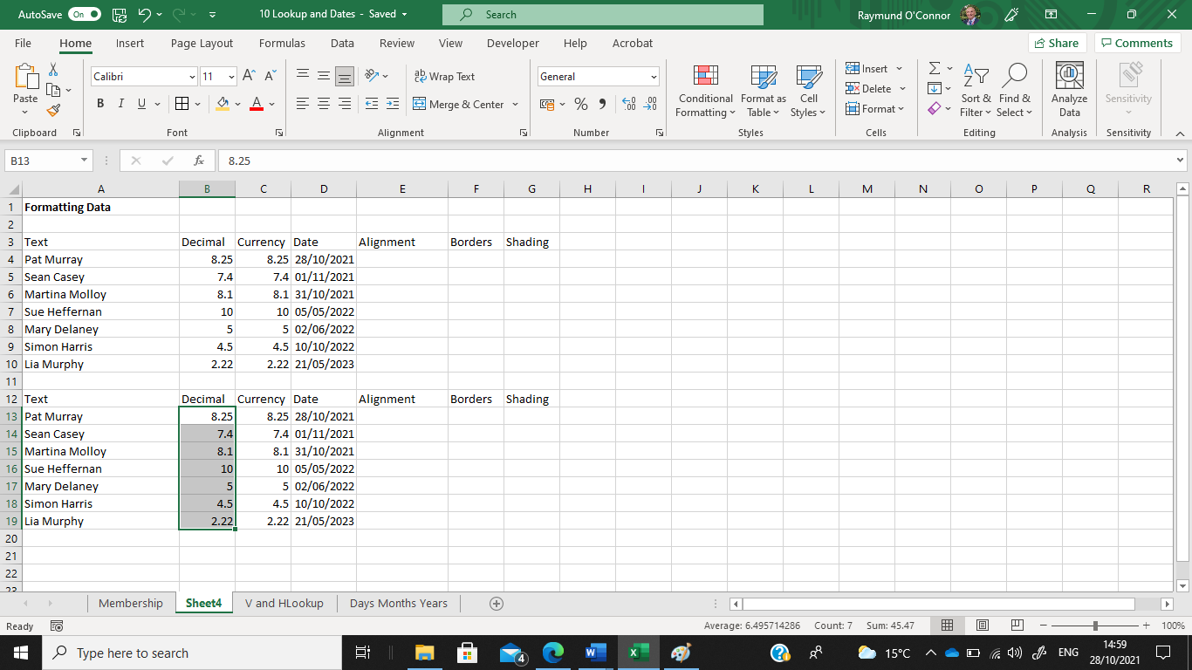
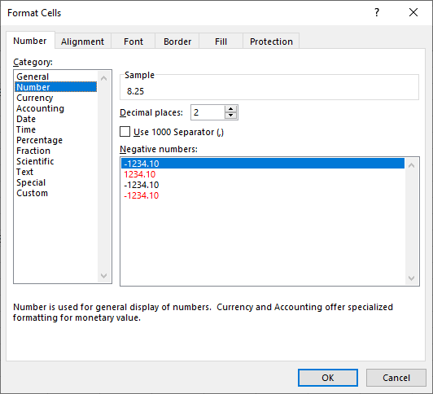

Currency Symbol (€)
Highlight the cells, right click and select Format Cells, click on Currency and select number of decimals if required as shown.

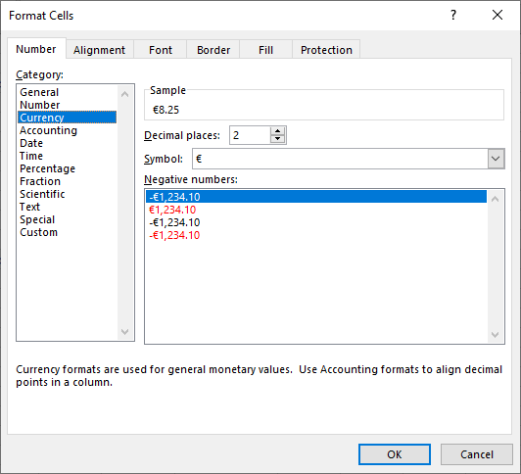

Aligning data
Highlight the cell or cells, right click and select Format Cells, click the Alignment tab and choose the alignment style.
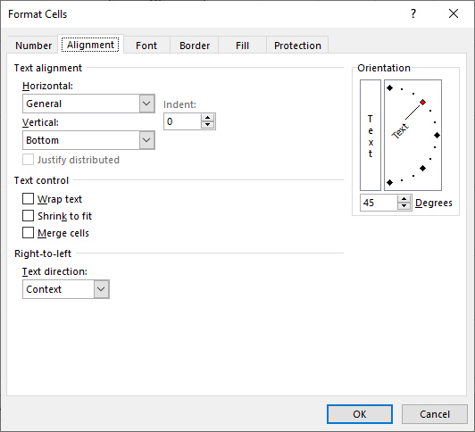

Borders
Highlight cell or cells as shown and select the Borders drop down arrow from the Home toolbar as shown. Scroll down to More Borders and select as required (outline/inside/colour/style/etc)

Shading
Highlight cell or cells, select Drop down arrow for Shading as shown. Select the shade as required.

Alternatively you can highlight cell or cells, right click and select Format Cells and select the Shading tab. Select the required shade as shown below.
