Learning Outcomes

- Investigate a range of common uses for spreadsheets.
- Explore key spreadsheet elements including cells, cell references, numeric, alpha, and alphanumeric data, formulae, functions, graphs and macros.
- Demonstrate common spreadsheet usability features to include use of toolbars, window management, sorting, and filtering.
- Use spreadsheet design features involving data and cell formatting techniques which enhance understanding and legibility.
- Automate routine multi-step tasks through the creation, execution, and management of simple macros.
- Print complete or partial sections of a spreadsheet, formatted fit for presentation.
- Use advanced spreadsheet features including absolute and relative cell references, conditional IF statements, statistical, financial, and date and time functions.
- Generate a variety of types of graphs, with appropriate titles and labels, from spreadsheet data.
- Produce a spreadsheet, with minimal supervision, that meets a simple design specification and is fit for purpose.
- Demonstrate personal initiative and resourcefulness in editing and amending spreadsheets to ensure they are fit for purpose.

Assessment
Project – 50%
Practical Exam – 50%

Software
Microsoft Excel (Office 365 suite app)

Indicative Content
1. Facilitate the learner to investigate a range of common uses for spreadsheets.
- Investigate common uses for a spreadsheet and consider the advantages of
- using spreadsheets over alternative options
- Investigate an application suitable for creating a spreadsheet
2. Explore with the learner the key spreadsheet elements including cells, cell references, numeric, alpha, and alphanumeric data, formulae, functions, graphs and macros.
- Explore the following terms: spreadsheet, row, column, cell, cell reference, label, value, formula
- Understand the name box, formula bar and auto fill
- Understand how to enter numeric, character and alphanumeric data to a spreadsheet
- Use formula to generate results using basic functions for example summation, division, addition and multiplication
- Replicate formula over a range of cells using relative cell references and auto fill
- Explore the uses of graphs and macros
3. Explore with the learner effective methods to demonstrate common spreadsheet usability features to include use of toolbars, window management, sorting, and filtering.
- Save the spreadsheet, load an existing spreadsheet and exit from the application
- Edit functions on a toolbar
- Employ window management techniques to for example freezing panes, arranging windows and switching windows
- Sort a spreadsheet on a selected key and using a custom sort
- Use filters to which may include numbers, text and colour and their related options for example equals, less than, greater than
4. Facilitate the learner to use spreadsheet design features involving data and cell formatting techniques which enhance understanding and legibility.
- Recognise the feature available on toolbars
- Insert and delete rows and columns
- Adjust column width
- Format column entries for example decimal, currency, alignment and date
5. Facilitate the learner to automate routine multi-step tasks through the creation, execution, and management of simple macros.
- Create simple macros consisting of at least five commands
- Execute previously created macros
6. Explore with the learner methods to print complete or partial sections of a spreadsheet, formatted fit for presentation.
- Print a specified area of a spreadsheet using print area, orientation, scaling,margins and header and footers
- Use sheet presentation features for printing titles, gridlines and row and column headings
- Print a spreadsheet in whole, in part, with values, with formulae, with/without borders, gridlines and row and column identifiers
7. Facilitate the learner to use advanced spreadsheet features including absolute and relative cell references, conditional IF statements, statistical, financial, and date and time functions.
- Create formula using a variety of both absolute and relative cell
- referencing
- Use the single condition IF function with relational operators for example
- =, <, <=, >, >=, <>
- Use a selection of statistical functions for example maximum, minimum,
- average, median, mode, standard deviation
- Use a nested IF functions with a logical operator AND, OR or NOT
- Use a financial function for example depreciation or net present value
- Use a lookup function for example the VLOOKUP and HLOOKUP functions
- Perform a calculation using date and time functions for example NOW or TODAY
8. Facilitate the learner to generate a variety of types of graphs, with appropriate titles and labels, from spreadsheet data.
- Create at least two basic graph types for example bar and pie
- Save and retrieve graphs
- Print graphs with appropriate titles and labels
- Create a graph from existing data
9. Enable the learner to produce a spreadsheet, with minimal supervision, that meets a simple design specification and is fit for purpose.
• Create a design specification for a given spreadsheet application which
may include:
- Data input and format
Data processing
- Data output and its format
• Create a spreadsheet from a design specification
10. Facilitate the learner to demonstrate personal initiative and resourcefulness in editing and amending spreadsheets to ensure they are fit for purpose.
- Which may include the use of protect/unprotect or hide/display facilities
- Recalculate a spreadsheet

Learning Outcome Assessment

No. | Learning Outcome Assessment | Technique
1 | Investigate a range of common uses for spreadsheets. | Project / Examination
2 | Explore key spreadsheet elements including cells, cell references, numeric, alpha, and alphanumeric data, formulae, functions, graphs and macros. | Project / Examination
3 | Demonstrate common spreadsheet usability features to include use of toolbars, window management, sorting, and filtering. | Project / Examination
4 | Use spreadsheet design features involving data and cell  formatting techniques which enhance understanding and  legibility. | Project / Examination
5 | Automate routine multi-step tasks through the creation,  execution, and management of simple macros. | Project
6 | Print complete or partial sections of a spreadsheet, formatted fit  for presentation. | Project / Examination
7 | Use advanced spreadsheet features including absolute and  relative cell references, conditional IF statements, statistical, financial, and date and time functions. | Project / Examination
8 | Generate a variety of types of graphs, with appropriate titles and  labels, from spreadsheet data. | Project / Examination
9 | Produce a spreadsheet, with minimal supervision, that meets a  simple design specification and is fit for purpose. | Project
10 | Demonstrate personal initiative and resourcefulness in editing and amending spreadsheets to ensure they are fit for purpose. | Project / Examination

1 Facilitate the learner to investigate a range of common uses for spreadsheets.
- Investigate common uses for a spreadsheet
- consider the advantages of using spreadsheets over alternative options
- Investigate an application suitable for creating a spreadsheet
Background of emergence of Spreadsheet software
- First spreadsheet (Visicalc) designed in 1979 by accounting lecturer to simply and assist with accounting exercises. He never patented the concept and others exploited this.
- Next improved software application emerged was Lotus 123 based on earlier spreasheet.
- Today Microsoft is one of the biggest software company in the world hence, Excel is the world's most used spreadsheet program.
Common Uses
- Data entry, organisation, and storage in a tabular form
- Record keeping and project management
- Organise and sort data in various worksheets
- Personal finance planning
- Budgeting and producing invoices
- Preparing wages and data analytics
- Finance, accounting, and bookkeeping
- Predictions based on data
- Producing graphical representations of data (eg pie chart/bar chart/trend graph/etc)
- Recording attendance and calculating student assessment results.
Advantages of using Spreadsheets
One of the key advantages is that when using pen and paper to perform a large calculation it can take time to write all the figures and numbers down and if an error is made then you may have to recalculate the whole thing. Using a spreadsheet application means you can simply re enter the correct number in a cell and all linked calculations are correct immediately. Also, a spreadsheet has thousands of rows and columns so you are less likely to be limited by the size of a page/whiteboard/etc when working on an account exercise,
In addition, there are multiple other advantages such as:
- You can use formula to perform calculations.
- Calculations are always correct.
- Data is easy to input and sort.
- Data can also be filtered allowing easy analysis.
- Graphical representation of data can be produced easily using various charts (eg pie chart/bar chart/trend graph/etc).
Application suitable for creating a spreadsheet
- Microsoft Excel
- Google Sheets, OpenOffice Calc
- Quattro Pro, VisiCalc, Lotus 123

2. Explore with the learner the key spreadsheet elements including cells, cell references, numeric, alpha, and alphanumeric data, formulae, functions, graphs and macros.
- Explore the following terms: spreadsheet, row, column, cell, cell reference, label, value, formula
- Understand the name box, formula bar and auto fill
- Understand how to enter numeric, character and alphanumeric data to a spreadsheet
- Use formula to generate results using basic functions for example summation, division, addition and multiplication
- Replicate formula over a range of cells using relative cell references and auto fill
- Explore the uses of graphs and macros
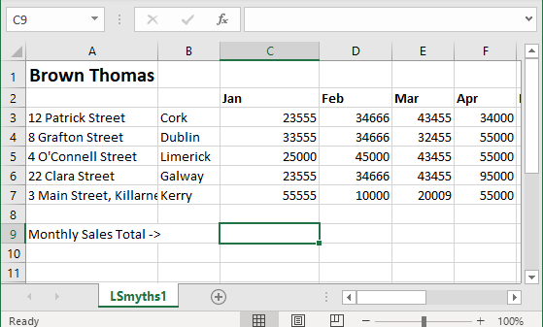

Terms
Term | Description
Spreadsheet | this is a software application such as Excel
Row | You will notice in the screenshot above each row is numbered 1,2 ,3, etc
Column | You will notice in the screenshot above each column is labelled A, B, C, etc
Cell | A cell occurs at the intersection of a row and column (eg a simple box or cell)
Cell reference | Each cell or box is referenced with a letter first and then a number as shown above eg C9 (this is the cell that is highlighted)
Label | Sometimes labels are used to identify data such as the columns for each month as shown in the screenshot above.
Value | A value is the content of a cell (usually text/number/date/etc) eg 23555 as above
Formula | A formula always begins with = . For example =sum(C3:C7) sums or adds all the cells C3 to and including C7. Formula give spreadsheets there power and usefulness.

Understand the name box, formula bar and auto fill
Formula Bar
Name box

Autofill – clicking on the bottom right corner and dragging it over cells results in a menu allowing you select as shown
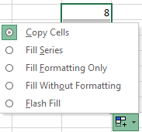

Understand how to enter numeric, character and alphanumeric data to a spreadsheet
- Simply click on the cell your require and type from your keyboard.

Use formula to generate results using basic functions for example summation, division, addition and multiplication

Examples of formula
- User defined functions such as =B2 * C2 (in this example there user can use any formula as used in mathematics. (* means multiply, / means divide, ^ means to the power of, etc)
- =A1 + B1 this results in the contents of cell A1 being added to contents of B1
- =C7 / 10 this results in the value stored in cell C7 being divided by 10.
- =C7^2 this results in the value stored in cell C7 being squared
- Spreadsheet functions such as =sum(B2:D2) this adds all numbers between and including cells B2 and D2
- =sum(Shop) this adds the contents of all cells in a named range (eg Shop).
- =SQRT(B2) calculates the square root of the value stored in cell B2.
- =Average(A1:A10) displays the arithmetic average by adding all values and dividing by the number of cells.
- =Max(A1:A10) displays the biggest number in a range, =Min(A1:A10) displays the smallest number in a range.
- In fact there are a whole list of varios mathematical/financial/etc functions for use in Excel.

Replicate formula over a range of cells using relative cell references and auto fill

Using of graphs
Highlight the headings and numbers and click Insert and select required chart eg Pie/Bar/Trend/etc.

Macros
An Excel macro is an action or a set of actions that you can record, give a name, save and run as many times as you want and whenever you want. Macros help you to save time on repetitive tasks involved in data manipulation and data reports that are required to be done frequently.

To record a Macro click on View in the menubar following by clicking the Macros icon in the toolbar as shown below. Note that macros are saved and computer programmers can edit the code which is written as the macro is being recorded.
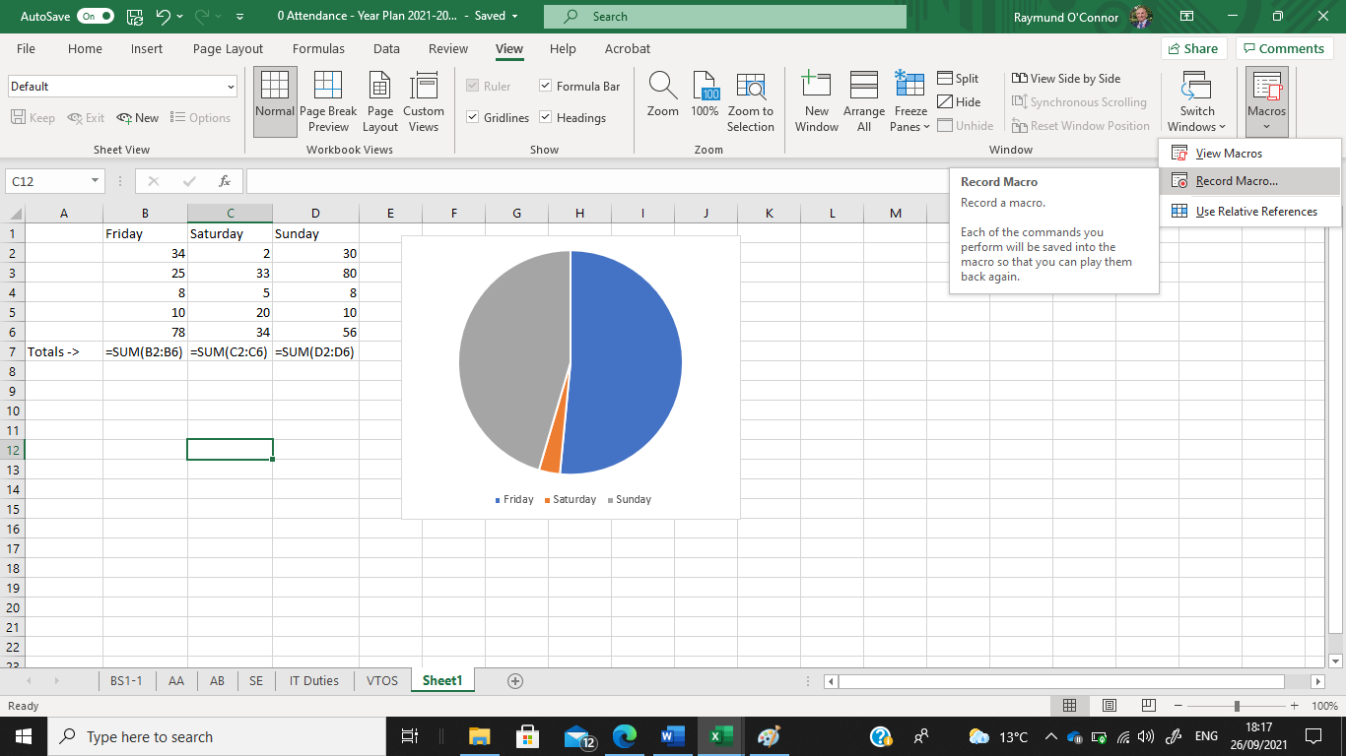

In this example, we click on Record and enter the formula to add all number in the Friday column. Once the answer appears we click on Macros and Stop Recording.
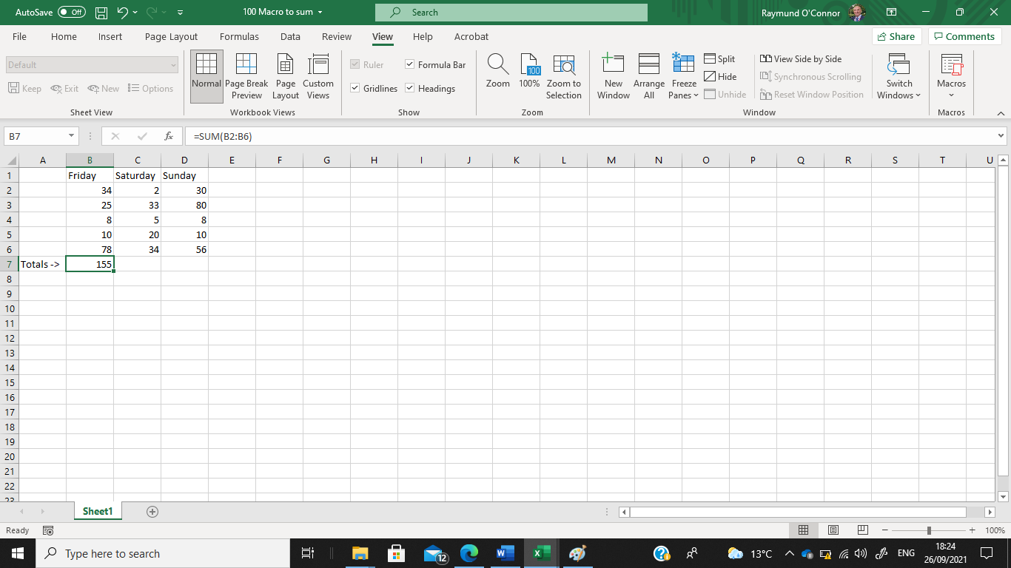
Then click in cell C7 and click Macros, select View Macros, click the macro you require (eg Day_Total) and click Run. The Macro will automatically repeat the instructions you recorded resulting in the total appearing.
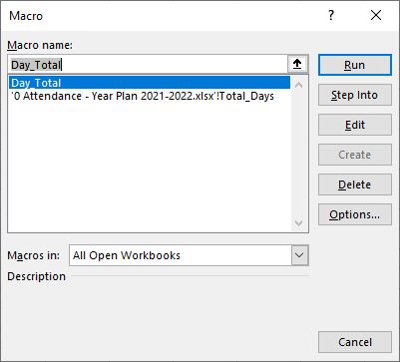

If you click a Macro and click on Edit it displays the following which is the coded instructions in Visual Basic for Applications (this is a specific computer programming language used by programmers for performing advanced calculations, etc.
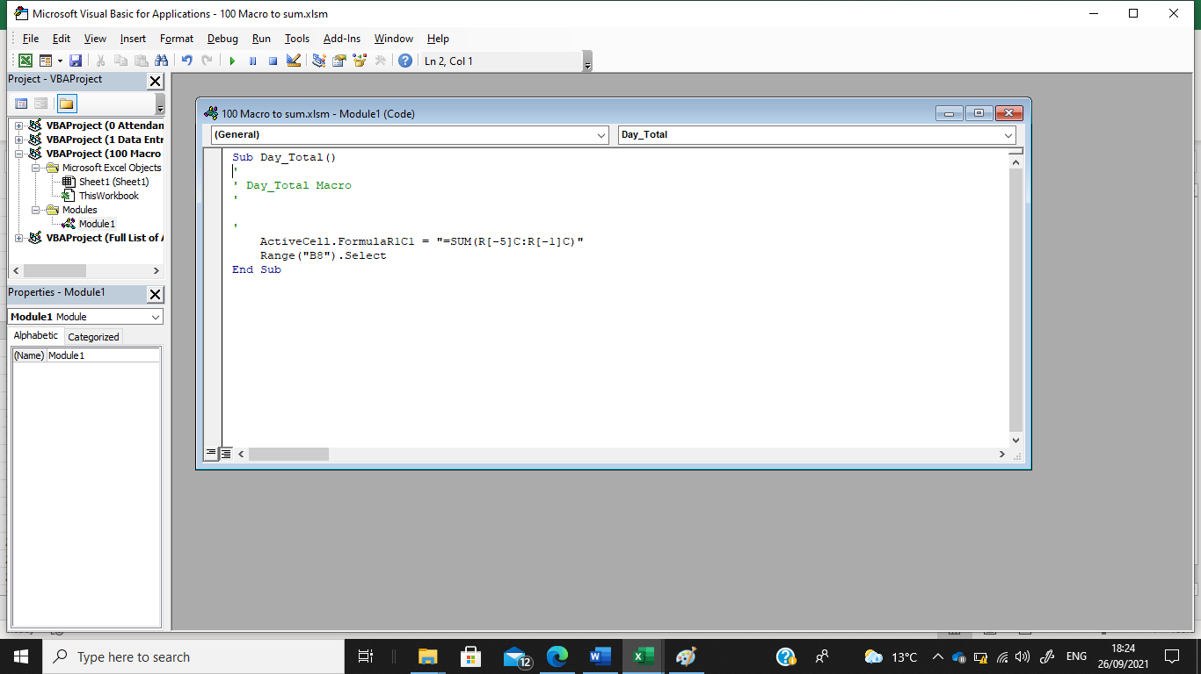

3 Explore with the learner effective methods to demonstrate common spreadsheet usability features to include use of toolbars, window management, sorting, and filtering.
- Save the spreadsheet, load an existing spreadsheet and exit from the application
- Edit functions on a toolbar
- Employ window management techniques to for example freezing panes, arranging windows and switching windows
- Sort a spreadsheet on a selected key and using a custom sort
- Use filters to which may include numbers, text and colour and their related options for example equals, less than, greater than

Load and Save Excel file
- To open a file you have two options (1 use File Explorer or 2 In OneDrive double click the file)
- Click File and Save A Copy (Note all files are autosaved)
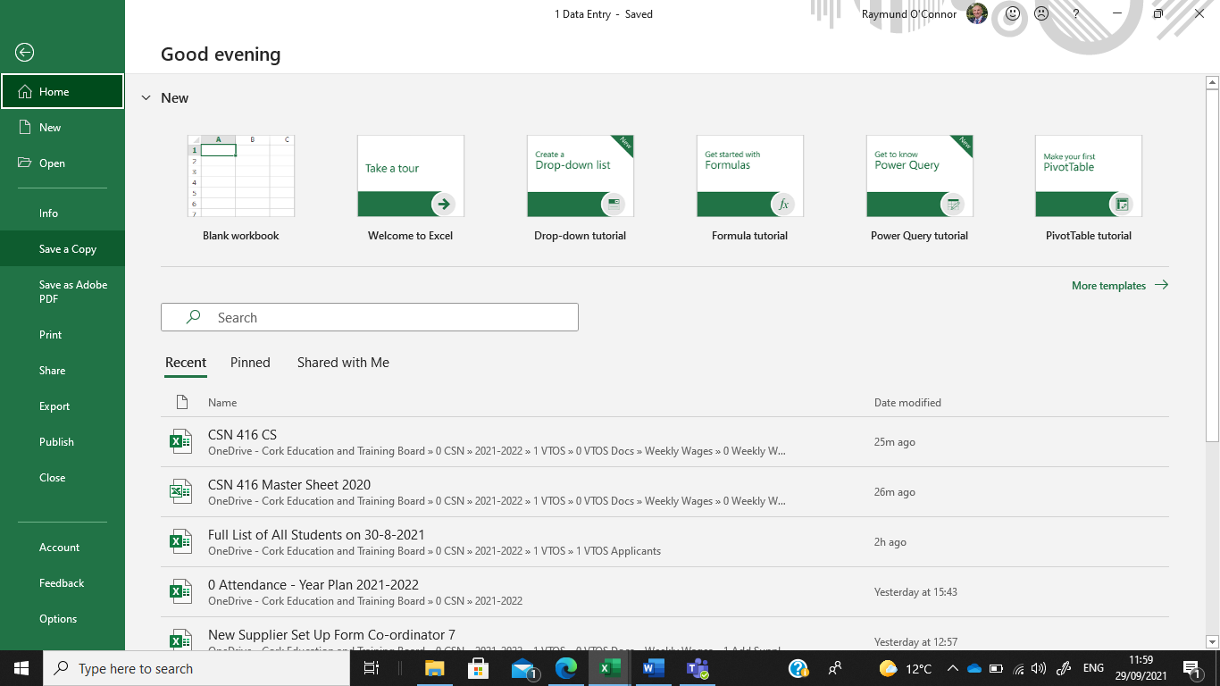

Edit functions on a toolbar
Right click anywhere on the toolbar ribbon and select Customise the Ribbon as shown.
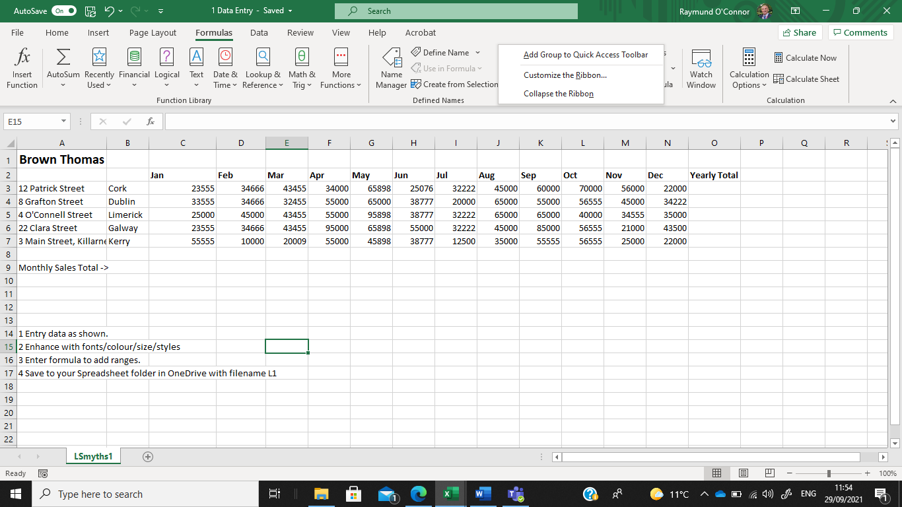
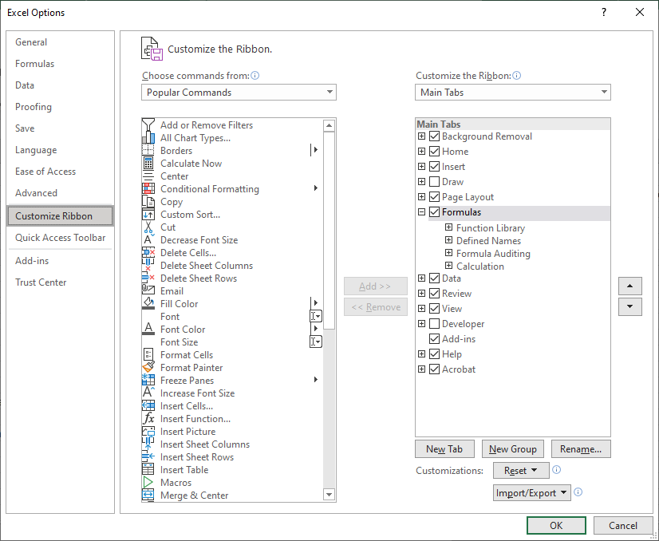

4. Facilitate the learner to use spreadsheet design features involving data and cell formatting techniques which enhance understanding and legibility.
- Recognise the feature available on toolbars
- Insert and delete rows and columns
- Adjust column width
- Format column entries for example decimal, currency, alignment and date

Features available on toolbars
Home toolbar
Insert toolbar
Page Layout toolbar
Formula toolbar
Data toolbar

To adjust column width
- Autofit(best fit) - Double click on the symbol which appears with you move the mouse pointer between columns
- Specified column width – select the column and right click on the column letter as shown below and select Column Width. Enter a number to represent the column width.
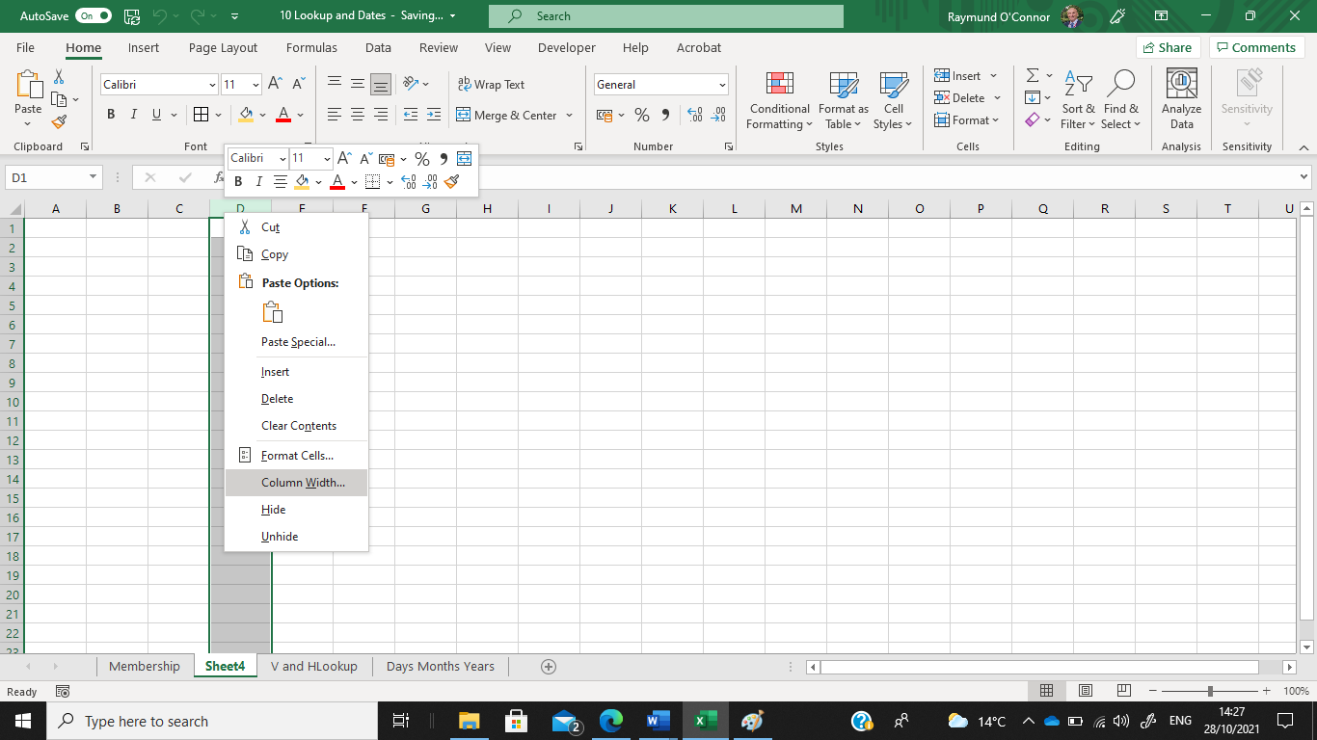
Input the required column width as shown below
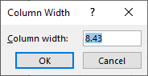

Format column entries for example decimal, currency, alignment and date

Create a spreadsheet file and input the following data:
To change the width of column A to 25, click on A and right click, select Column Width and input 25, click Ok
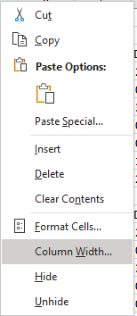
Setting the number of decimal places
Highlight the cells as shown below, right click mouse button, select Format Cells, select Number and enter number of decimal places (2 in this example)
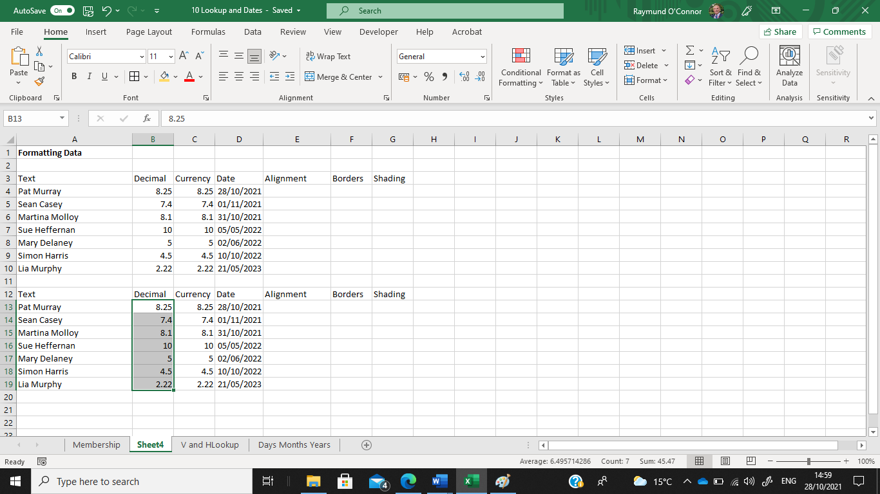
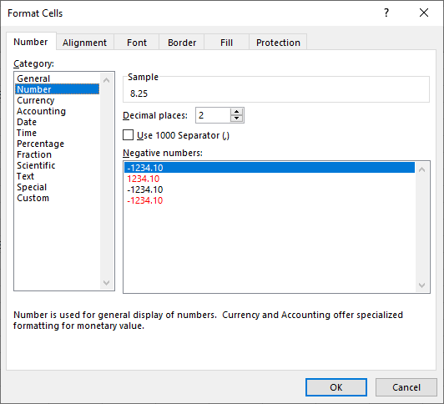

Currency Symbol (€)
Highlight the cells, right click and select Format Cells, click on Currency and select number of decimals if required as shown.

