Questions
Find the period and range of each of the following functions:
- f(x) = 3 + 2 sin 5x
- f(x) = 3 – 2 sin (^{π}/₃ – x)
- f(x) = -1 + sin 3x
- f(x) = 4 cos 2x
- f(x) = 3 – 4 sin 2x
Solutions
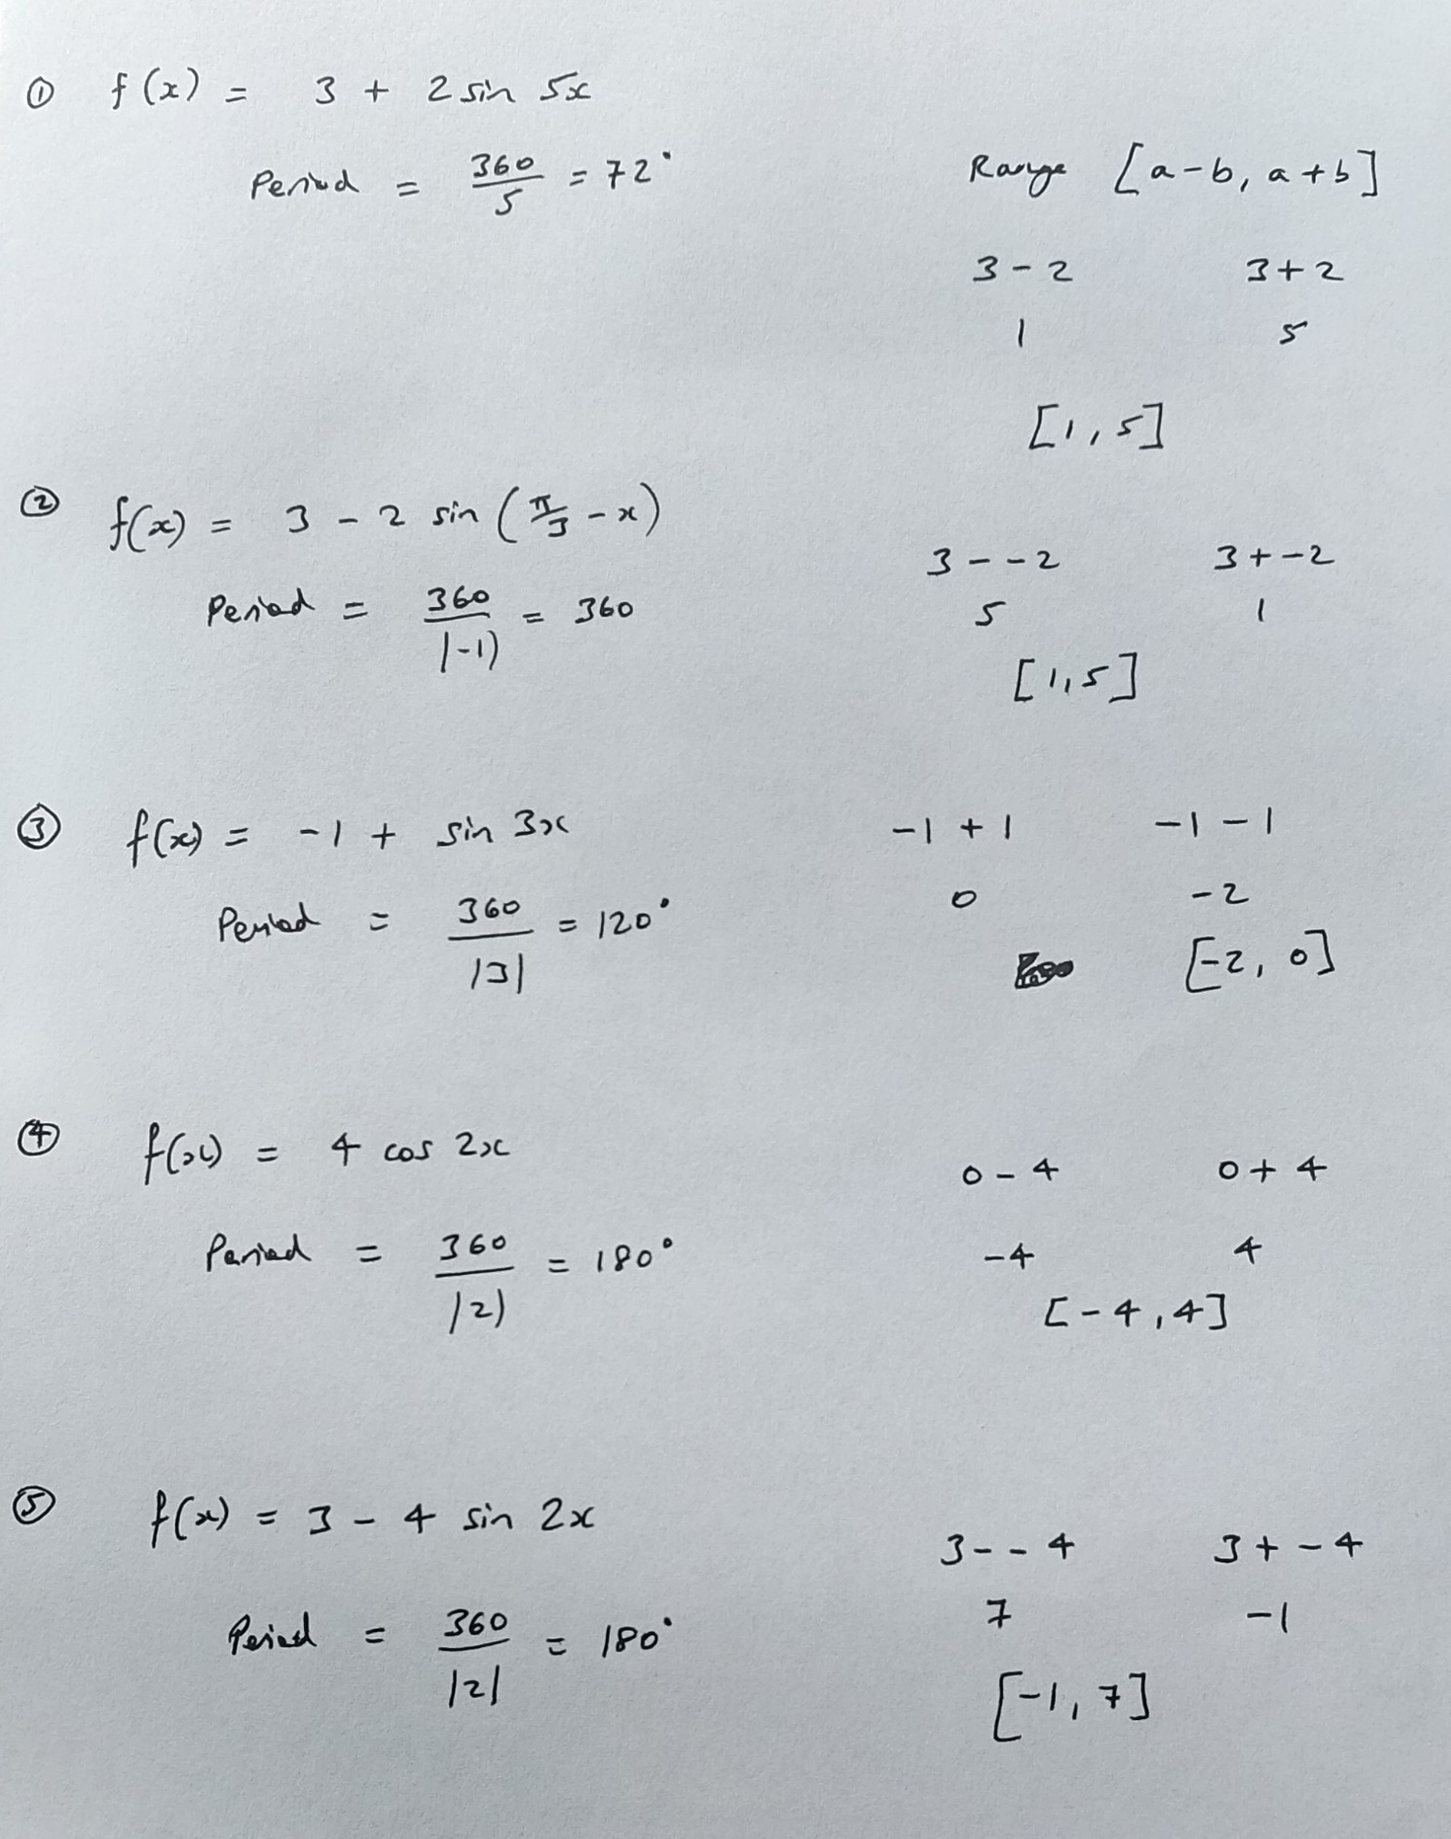
Sketch the graph of each of the following functions in the stated domain.
- y = 5 + sin x, –2π ≤ x ≤ 2π
- y = 2 sin ( x + ^{π}/₂), –2π ≤ x ≤ 2π
- y = 1 – 3 sin (2x - ^{π}/₃), –2π ≤ x ≤ 2π
- y = 3 – 2 sin (¹/₂x - ^{π}/₂), –4π ≤ x ≤ 4π
- y = 2 cos (2x + ^{π}/₂), -π ≤ x ≤ π

