Ogive – Cumulative Frequency Curve
Question 3
Age (x) | 13 | 14 | 15 | 16 | 17 | 18 | 19
No. of Teenagers (f) | 4 | 9 | 22 | 19 | 11 | 9 | 6

Age | ≤13 | ≤14 | ≤15 | ≤16 | ≤17 | ≤18 | ≤19
No. of Teenagers | 4 | 13 | 35 | 54 | 65 | 74 | 80

Cumulative Frequency Curve (Ogive)
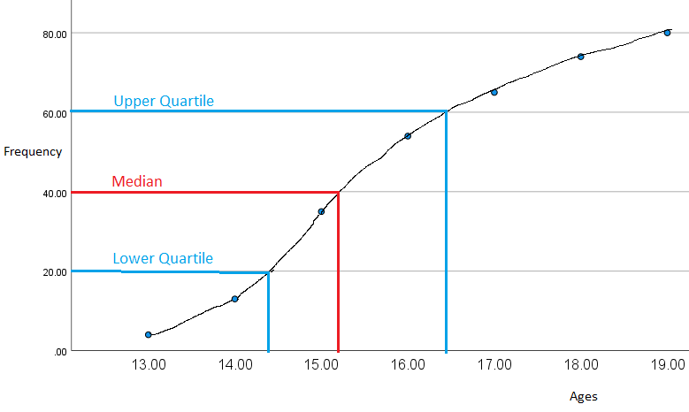

- Median (middle value) = 15.2 years old
- Interquartile Range

$Interquartile Range=Upper Qurtile-Lower Quartile$
$16.4-14.4=2 years$
Mean (arithmetic average)
x | 52 | 126 | 330 | 304 | 187 | 162 | 114 |  | sum of fx = | 1275
f | 4 | 9 | 22 | 19 | 11 | 9 | 6 |  | sum of f = | 80
 |  |  |  |  |  |  |  |  | Mean = | 15.9375

Mode (most common value or the value with the biggest frequency)
Mode = 15 years

Range (highest x value – lowest x value)
19 – 13 = 6
Range = 6 years

Question 4
Circumference (cm) | 30_35 | 35_40 | 40_45 | 45_50 | 50_55 | 55_60
Frequency | 12 | 25 | 44 | 48 | 18 | 3

Circumference (cm) | ≤35 | ≤40 | ≤45 | ≤50 | ≤55 | ≤60
Frequency | 12 | 37 | 81 | 129 | 147 | 150

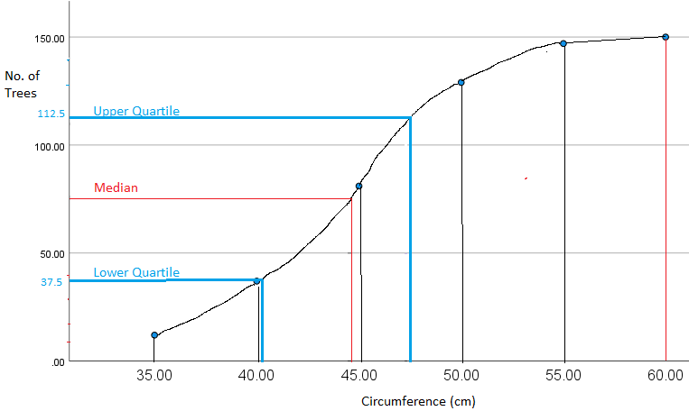

- Median (middle value of 75) = 44 cm
- Interquartile Range $Interquartile Range=Upper Qurtile-Lower Quartile$
$47.5-41=6.5 cm$
- 122 – 62 = 60 trees 