Word - Home Toolbar

Font(Type face) Font size Increase decrease font size Unordered List Ordered List Help
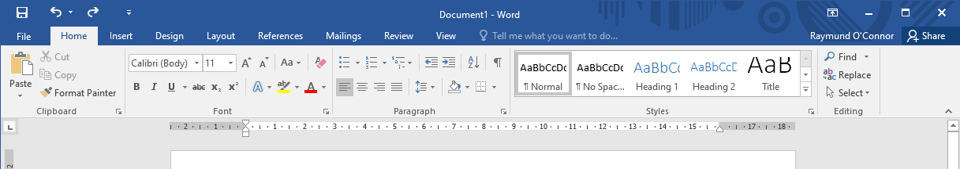
B – Embolden Strikethrough Superscript Line spacing Styles Find/Replace
I – italics Subscript
U – underline Left/Centre/Right/Justified

Text colour

