Mathematical Modelling
- Example: 3 tennis balls(radius = 2cm) in a tube - how much plastic is required to make a simple tube(surface area required).
- Example: 4 golf balls(radius = 12mm) in a cardboard box - how much cardboard is required to make the cardboard container(surface area required)
- 8 dice (side = 3.25cm) in a container etc?? Answer will depend on the container design???

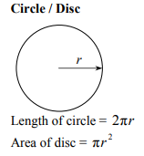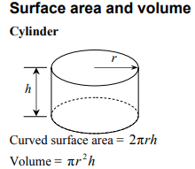

Solutions
Answers

