Programme Module for MATHEMATICS
Teacher | Raymund O’Connor
Teacher’s Email | raymund.oconnor@csn.ie
Component Name | Mathematics
Component Code | 5N1833
Level | QQI Level 5
Duration | 150 hours (Typical learner effort, to include both directed and self-directed learning.)
Topics | - Modelling using Mathematics  - Statistics and Probability  - Functions and Graphs  - Calculus (Differential & Integral)  - Complex Numbers (De Moivre’s Theorem)  - Trigonometry
Special Requirements | The following are required by all students taking this module:  - A set of formulae and tables, especially for assessments and examination  - Calculators especially for assessments and examination
Assessment  Assessment totals are added and divided by 2 to convert from 60 marks to 30% | In past years each assignment was split so that each question was a unique part with some parts completed at home and some parts completed as an open book class test.  Assigment 1 - 30% (5 questions of 12 marks)  - Question 1 Modelling using Mathematics  - Question 2 Statistics  - Question 3 Probability  - Question 4 Functions & Graphs  - Question 5 Linear Programming  Assignment 2 – 30% (5 questions of 12 marks)  - Question 1 Differential Calculus  - Question 2 Integral Calculus  - Question 3 Complex Numbers  - Question 4 De Moivres Theorem  - Question 5 Trigonometry  Examination - 40% (at end of academic year) – 80 marks divided by 2 to give 40%  - Section A: Short Answer Questions 10 short answer questions (4 marks each)  - Section B: 2 structured questions from Modelling using Mathematics, Probability and Statistics and Functions and Graphs (10 marks each)  - Section C: 2 structured questions from Calculus, Complex numbers and Trigonometry (10 marks each)

Moodle
Moodle – Learning Management System (LMS) – this is an online portal containing notes, assessments, etc.
You will receive assessment briefs on Moodle and you will submit your solutions in PDF format on Moodle also.

To access Moodle www.csn.ie and click Moodle in menu bar

Support Website
Navigate to www.raymundoconnor.com and select Mathematics Component from the menu bar as shown.
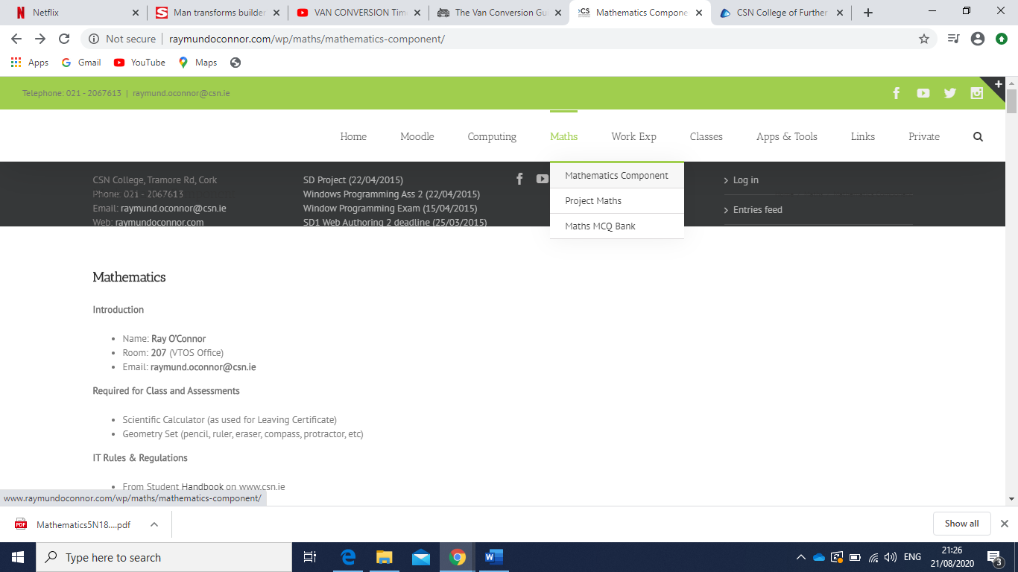

How to convert assessment solutions to PDF format and submit via Moodle
Use a black pen to write your solutions to questions in assessments(assignments/exams/etc) on an A4 page.
I use Adobe Scan (Scan; PDF Scanner with OCR; PDF Creator) but you can use any app of your choice. With this app you can take a photograph of each page containing your solutions and save as a PDF file. Some apps allow you to add photograph to your PDF file.
Note with taking a photograph of your solutions using your smartphone, use any app to convert your photographs to PDF file format. Ensure all solutions are photographed in the correct order. Ensure photographs are taken when your answer sheet is illuminated and the photo takes up the full page. I would advise placing your answer sheet directly inside a window and try not to move when taking a photograph of the whole page. If photographs are blurred or not clearly visible marks may be lost.
You will submit one PDF file only containing all pages(photographs of your solutions) to Moodle for grading.
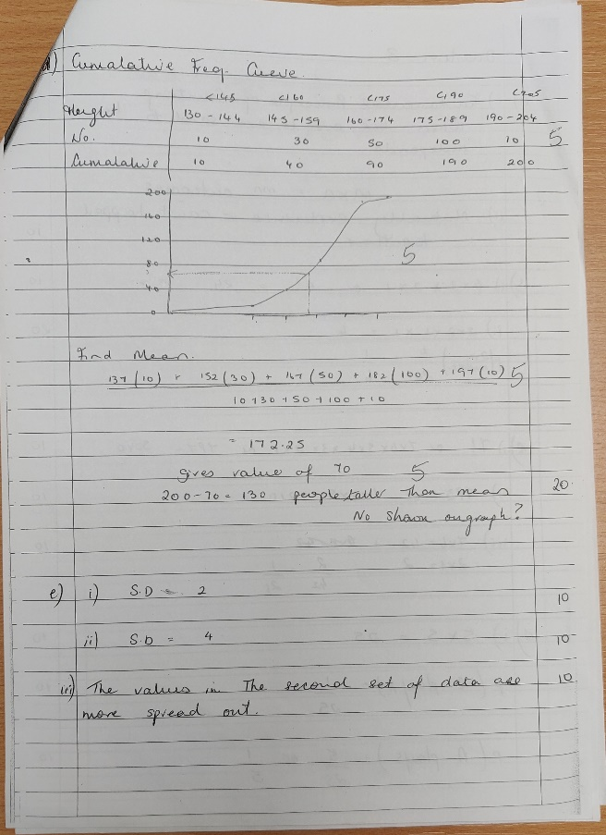
Example:

