Mathematical Modelling
Maths modelling is where we use mathematical formula and equations, etc to provide a solution to a Real World problem.
What is Mathematical Modelling?
- Mathematics is a very precise language which helps us formulate ideas.
- Mathematics is a concise language, with well-defined rules.
- All the results that mathematicians have proved over hundreds of years are at our disposal.
- Computers can be used to perform numerical calculations.
  - (https://www.mathsisfun.com/data/function-grapher.php)
- Any formula/equation/etc can be considered a mathematical model.
  - (e.g. $y=mx+c$ where m is the slope of the line and c is the y-intercept in other words where the line cuts the y-axis)
- Linear Programming is a good example of where we use mathematics concepts, formula, etc to provide valuable information in real world scenarios.
What objectives can Mathematical Modelling achieve?
- Developing scientific understanding through quantitative expression of current knowledge of a system
- Test the effect of changes in a system
- Aid decision making, including:-
  - tactical decisions by managers;
  - strategic decisions by planners.

Maths Formulae and Tables (available on website)
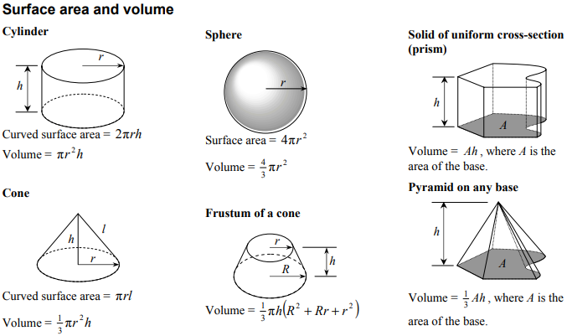

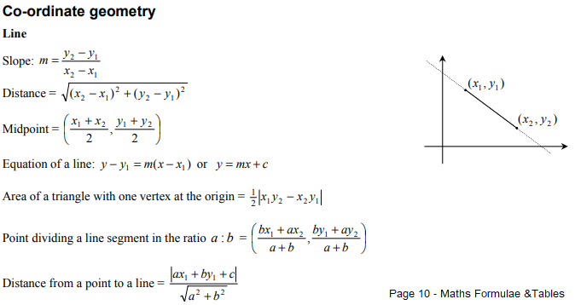

Geolocation – GPS Coordinates
