Simultaneous Equations

Solve the following simultaneous equations for x and y:-
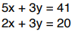

Questions including Solutions
