**Linear Functions**

## Example

Graph the function *g* : *x* → 2*x* + 1, in the domain –3 ≤ *x* ≤ 2, *x* Є **R**.

## Solution

*Y*

Let *y* = *g*(*x*) => *y* = 2*x* + 1.

**1.**

**2.**

Let *x* = -3 and *x* = 2

*g*(*x*)

(2, 5)

**3.**

*y* = 2*x* + 1

*x* = 2

*y* = 2(2) + 1

*y* = 4 + 1

*y* = 5

(2, 5)

*x* = -3

*y* = 2(-3) + 1

*y* = -6 + 1

*y* = -5

(-3, -5)

*X*

(-3, -5)



###### Questions

Graph each of the following functions in the given domain (*x* Є **R** in each case):

1. *f* : *x* → *x* + 3 in the domain –4 ≤ *x* ≤ 2
2. *g* : *x* → *x* –2 in the domain –3 ≤ *x* ≤ 3
3. *h*: *x* → 2*x* + 3 in the domain –2 ≤ *x* ≤ 4
4. *g* : *x* → 3*x* –2 in the domain –3 ≤ *x* ≤ 5
5. *f* : *x* → 5*x* + 1 in the domain –4 ≤ *x* ≤ 2

## What are the domain and range of each graph?

What are the minimum and maximum values of each graph?

## Definitions

**Function** A function is a relation (rule) that assigns each element in the domain to exactly one element in the range.

# ****Domain**** The set of all the values that may be input into a function. That is, the set of all the values the independent variable may assume. Graphically, the domain is the set of all the *x* co-ordinates.

**Range** The set of all the values that are output when the function is evaluated at all the input values from the domain. That is, the set of all the values the dependent variable may assume. Graphically, the range is the set of all the *y* co-ordinates.

## Graphing Quadratic Functions

A quadratic function is usually given in the form *f* : *x* → *ax*2 + *bx* + *c*, *a* ≠ 0, and *a*, *b*, *c* are constants. To draw a quadratic function a table is drawn using the given values of *x* to find the corresponding values of *y*. These points are plotted and joined by a smooth curve.

1. Work out each column separately, i.e. all the *x*2 terms first, then all the *x* terms and finally the constant term (watch for patterns in the numbers).
2. Work out each corresponding value of *y*.
3. The **only** column that changes sign is the *x* term (middle) column. If the given values of *x* contain 0, then the x term column will make one sign changes, either from + to – or from – to +, where *x* = 0.
4. The other two columns **never** change sign. They remain either all +’s or all –‘s. These columns keep the sign given in the question.

**Note**: Decide where to draw the *X* and *Y* axes by looking at the table to see what the largest and smallest values of *x* and *y* is. In general, the units on the *X* axis are larger than the units on the *Y* axis. Try to make sure that the graph extends almost the whole width and length of the page.

## Quadratic Functions

## Example

Graph the quadratic function

*f* : *x* → *x*2 + 3*x* – 2, in the domain –5 ≤ *x* ≤ 2, *x* Є **R**

## Solution

A table is drawn with the given values of *x*, from –5 to 4, to find the corresponding values of *y*.

Let *y* = *f*(*x*) => *y* = *x*2 + 3*x* -2

|  |  |  |
| --- | --- | --- |
| *x* | *x*2 + 3*x* -2 | *y* |
| -5 | 25 – 15 – 2 | 8 |
| -4 | 16 – 12 – 2 | 2 |
| -3 | 9 – 9 – 2 | -2 |
| -2 | 4 – 6 – 2 | -4 |
| -1 | 1 – 3 – 2 | -4 |
| 0 | 0 + 0 – 2 | -2 |
| 1 | 1 + 3 – 2 | 2 |
| 2 | 4 + 6 – 2 | 8 |

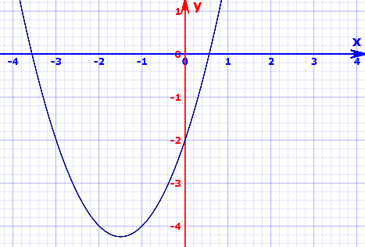

###### Questions

Graph each of the following functions in the given domain (*x* Є **R** in each case):

*f* : *x* → *x*2 – 3*x* + 2 in the domain –1 ≤ *x* ≤ 4.

*f* : *x* → *x*2 – 2*x* –3in the domain –2 ≤ *x* ≤ 4.

*f* : *x* → *x*2 +2*x* –8in the domain –5 ≤ *x* ≤ 3.

*g* : *x* → 2*x*2 – 3*x* –8in the domain –3 ≤ *x* ≤ 4.

*h* : *x* → 2*x*2 – *x* –3in the domain –2 ≤ *x* ≤ 3.

## What are the domain and range of each graph?

What are the minimum and maximum values of each graph?