What is a function?
A function is a special relationship where each input has a single output. It is often written as "f(x)" where x is the input value. Example: f(x)=$\frac{x}{2}$ ("f of x equals x divided by 2") It is a function because each input "x" has a single output $\frac{x}{2}$:
Eg : f(2) =$\frac{2}{2}=1$.
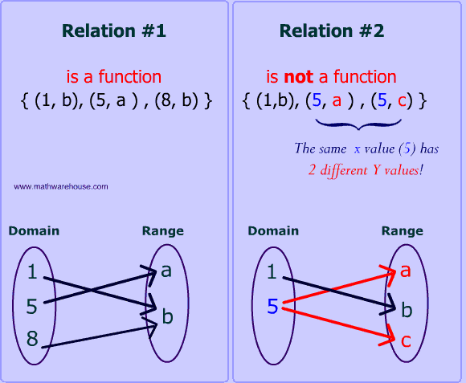

Example fx=x2 Input (Domain) -> Function -> Output (Range)
2 fx=x2 1
Function Notation

Function Notation
Function notation is used to name functions for easy reference. Imagine if every function in the world had to start off with y =. Pretty soon, you would become confused about which y = you were talking about. You need some other way of naming things. Hence we have function notation.
Function Definition
f(x) = 3x + 2
g(x, y) = x² + 3y
In this example, the f is a function of x. That is, x is the independent variable, and the value of f depends on what x is. Also, g is a function of both x and y. The notation f(x) does not mean f times x. It means the "value of f evaluated at x" or "value of f at x" or simply "f of x".
Function Evaluation
f(3) = 3(3) + 2 = 9 + 2 = 11
f(3) does not mean f times 3. It means the "value of f evaluated when x is 3".
f(t) = 3(t) + 2 = 3t + 2
Whatever is in parentheses on the left side of the function (t in this case) is substituted for the value of the independent variable on the right side.
f(x + h) = 3(x + h) + 2 = 3x + 3h + 2

Every occurrence of the independent variable is replaced by the quantity in parentheses. A common mistake is to take a quantity and apply linear transformations to it.
f(x + h) does not equal f(x) + h = 3x + 2 + h
f(x + h) does not equal f(x) + f(h) = 3x+2 + 3h + 2 = 3x + 3h + 4
It does equal 3(x + h) + 2 = 3x + 3h + 2
f(3x) does not equal 3 * f(x) = 3( 3x+2) = 9x + 6

It does equal 3(3x) + 2 = 9x + 2

You also specify which function you want to use when you use function notation.
g(x, y) = x² + 3y

Consider:
g(2, 1) = (2)² + 3(1) = 4 + 3 = 7
Since the order of the independent variables in the original definition was x and then y, the function g is evaluated when x = 2 and y = 1.
The notation y = f(x) means: ‘the value of y depends on the value of x, according to some rule’. Hence, y and f(x) are interchangeable and the Y axis can also be called the f(x) axis.
Note: When graphing a function it is very important not to draw the graph outside the given domain (i.e., the given values of x).

Exercises
If f(x) = 2x-1 and g(x)=4x find the solutions to the following:
- f(3)
- f(-4)
- f(0)
- f(c)
- g(5)
- g(-1)
- g(0)
- g(a)
- fg(1)
- gf(2)
- fg(x)
- gf(x)
Inverse Function
In mathematics, an inverse function (or anti-function) is a function that "reverses" another function: if the function f applied to an input x gives a result of y, then applying its inverse function g to y gives the result x, and vice versa, i.e., f(x) = y if and only if g(y) = x.
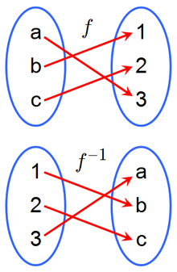
Calculating the inverse function
fx=3x+2 | Function | Inverse Function
 | x 3x+2 | x 3x+2
 |  | x−2 3x
 |  | x−23 x
 |  | f−1x=x−23

fx=4x+15 | Function | Inverse Function
 | x 4x+15 | x 4x+15
 |  | 5x 4x+1
 |  | 5x−14x
 |  | f−1x=5x−14

Exercises
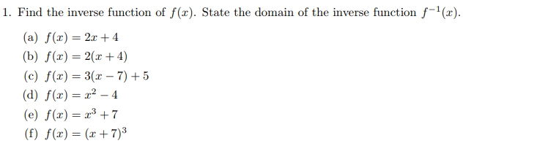

Solutions
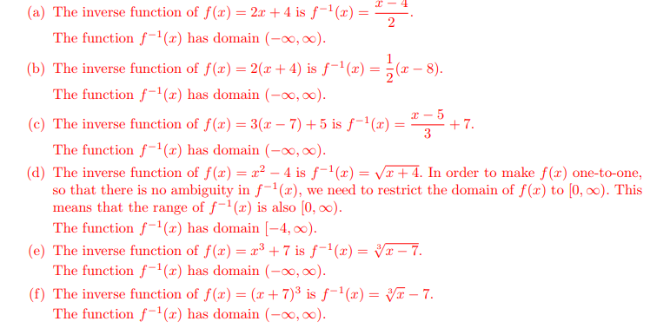

Linear Functions - https://www.mathsisfun.com/data/function-grapher.php
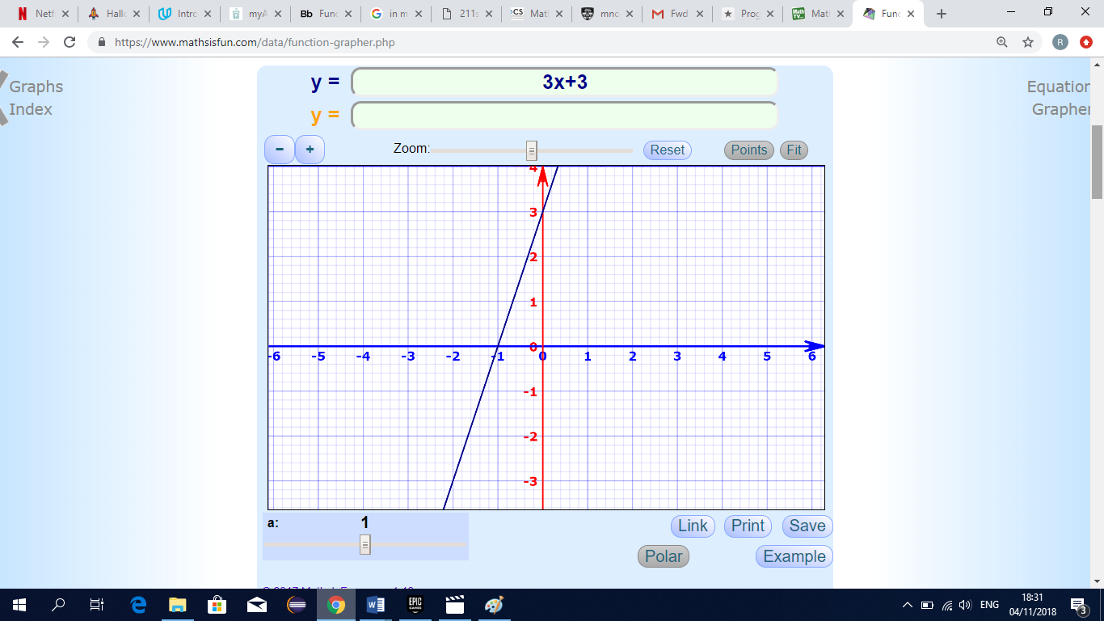
Quadratic Functions
fx=x2+2x−5
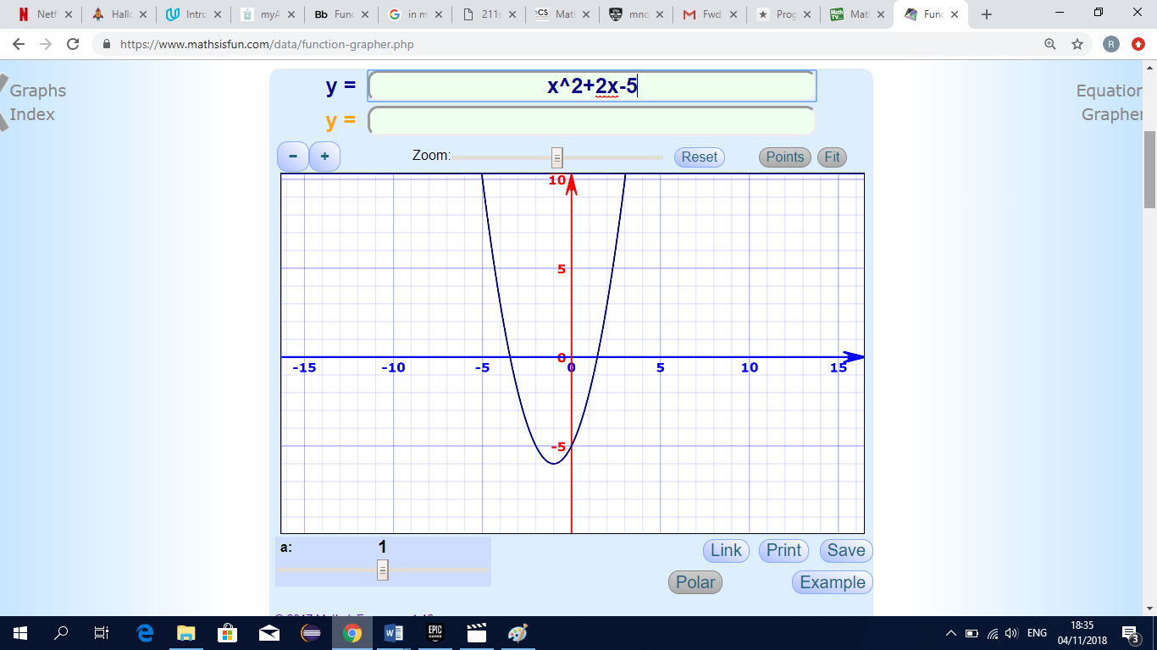

Cubic Functions
fx=x3+2x2−3x−6
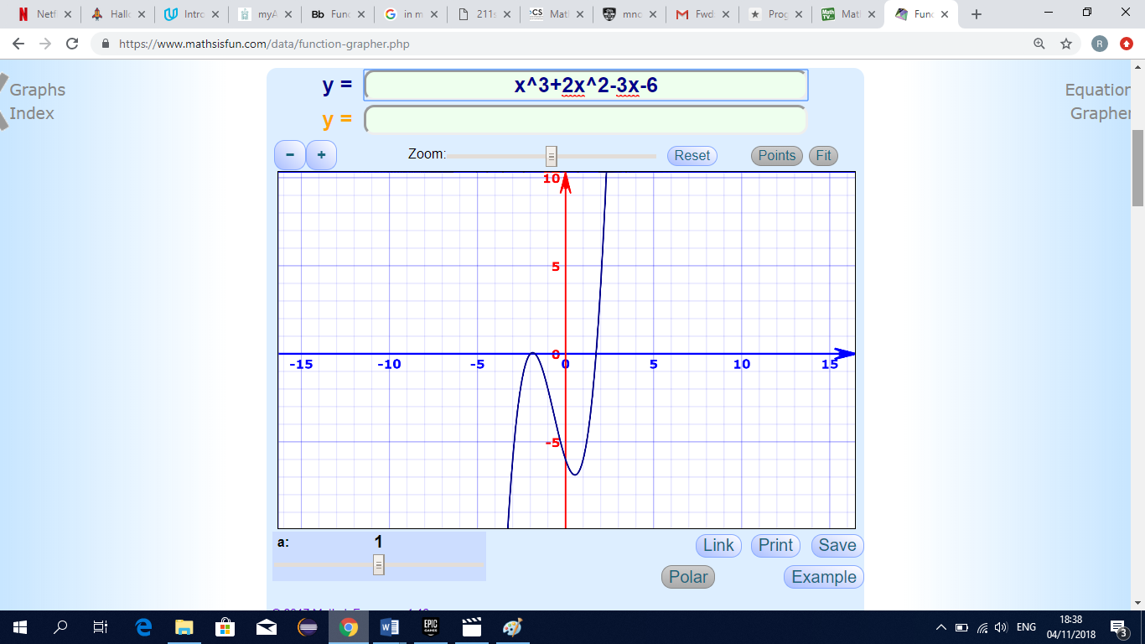

Exponential Function
The graph of y = x², is a function with an exponent. But it's not an exponential function. In an exponential function, the independent variable, or x-value, is the exponent, while the base is a constant. For example, y = 2^{x} would be an exponential function.
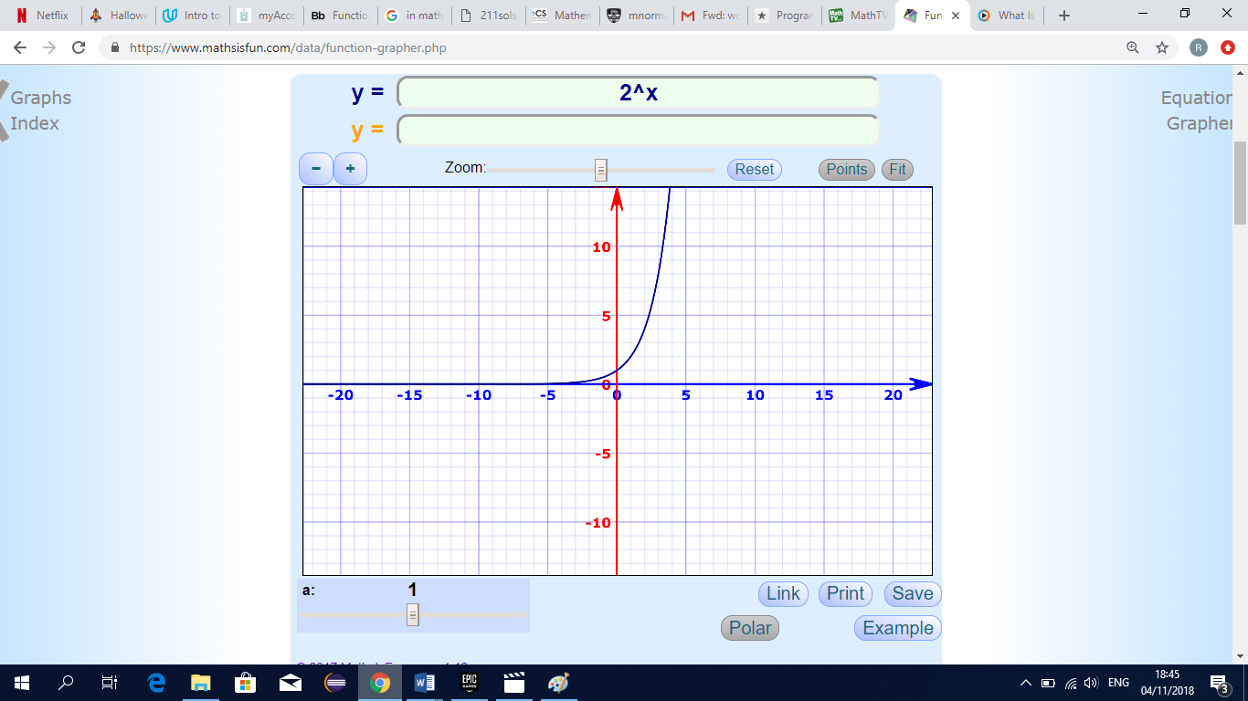
Logarithmic functions
Logarithmic functions are the inverses of exponential functions, and any exponential function can be expressed in logarithmic form. Similarly, all logarithmic functions can be rewritten in exponential form. Logarithms are really useful in permitting us to work with very large numbers while manipulating numbers of a much more manageable size. The word logarithm, abbreviated log, is introduced to satisfy this need. y = (the power on base 2) to equal x. This equation is rewritten as y = log₂x.
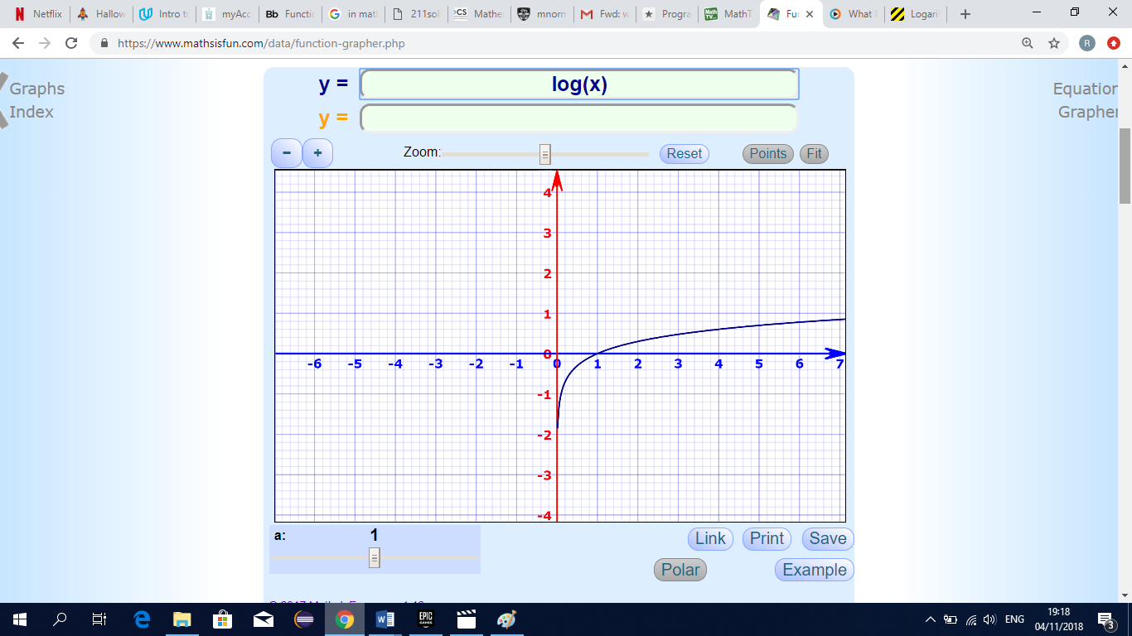
Trigonometric Functions
y=fx=sinx
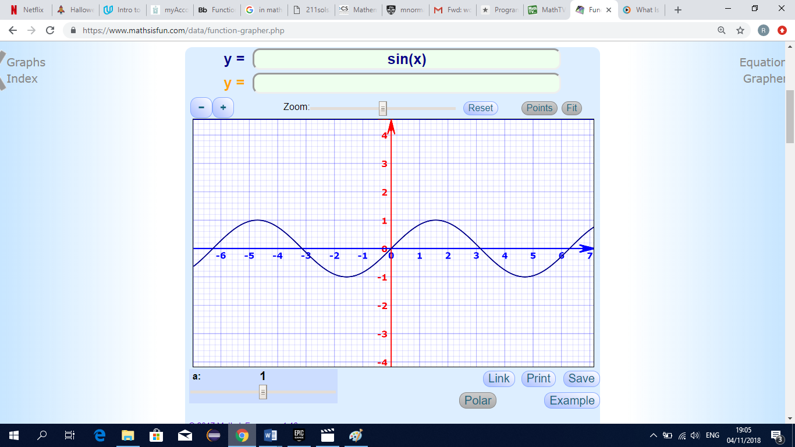

fx=3−cos⁡(2x−1)
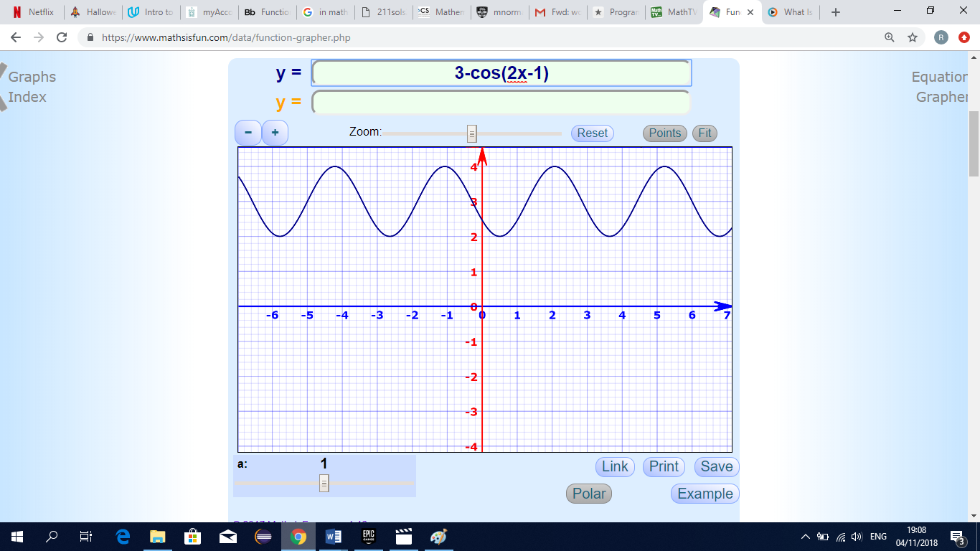

Example 1 – Linear Function
Draw a graph of the function f(x) = 5x - 2 in the domain {-3 < x < 3}
x | -3 | -2 | -1 | 0 | 1 | 2 | 3
5x | -15 | -10 | -5 | 0 | 5 | 10 | 15
-2 | -2 | -2 | -2 | -2 | -2 | -2 | -2
y | -17 | -12 | -7 | -2 | 3 | 8 | 13
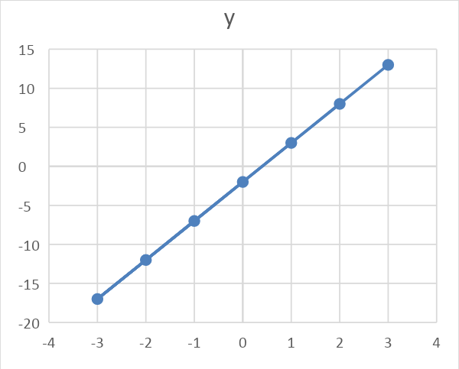

- Domain is {-3,-2,-1,0,1,2,3}
- Range is {-17,-12,-7,-2,3,8,13}

Example 2 – Quadratic Function
Draw a graph of the function f(x) = 5x^2 - 2x+3 in the domain {-3 < x < 3}
x | -3 | -2 | -1 | 0 | 1 | 2 | 3
5x^2 | 45 | 20 | 5 | 0 | 5 | 20 | 45
-2x | 6 | 4 | 2 | 0 | -2 | -4 | -6
3 | 3 | 3 | 3 | 3 | 3 | 3 | 3
y | 54 | 27 | 10 | 3 | 6 | 19 | 42
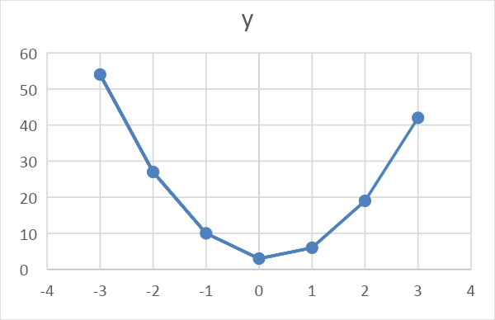
- Domain is {-3,-2,-1,0,1,2,3}
- Range is {54,27,10,3,6,19,42}

