Mathematical Model
A mathematical model is a description of a system using mathematical concepts and language. The process of developing a mathematical model is termed mathematical modelling. Mathematical models are used in the natural sciences (such as physics, biology, earth science, chemistry) and engineering disciplines (such as computer science, electrical engineering), as well as in the social sciences (such as economics, psychology, sociology, political science).
A model may help to explain a system and to study the effects of different components, and to make predictions about behaviour.
Physical Model
A physical model is a smaller or larger physical copy of an object. The object being modelled may be small (for example, an atom) or large (for example, the Solar System).
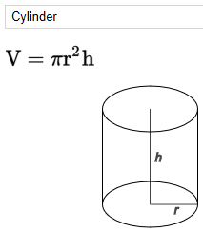
Other physical models(objects)
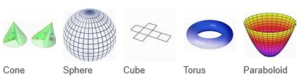
Maths Tables
