Principles of Modeling
We build models on a daily basis. Sometimes we build them deliberately, but often we are
unaware, and build models subconsciously.

In Real World situations we often make use of a Model World where models play an important role in planning and decision-making.

Models describe our beliefs about how the world functions
In mathematical modelling, we translate those beliefs into the language of mathematics. This has many advantages  - Mathematics is a very precise language. This helps us to formulate ideas and identify underlying assumptions  - Mathematics is a concise language, with well-defined rules for manipulations.  - All the results that mathematicians have proved over hundreds of years are at our disposal.  - Computers can be used to perform numerical calculations. | What objectives can modelling achieve?  - Developing scientific understanding - through quantitative expression of current knowledge of a system (as well as displaying what we know, this may also show up what we do not know);  - Test the effect of changes in a system;  - Aid decision making, including:  (i) tactical decisions by managers; (ii) strategic decisions by planners

Basic Elements of Model Construction
Four basic elements of model construction such as:

- the real world, which we attempt to model
- the model world, which is a simplified version of the real world
- the model, containing the working parts to run the model
- the data, which is required to run the model
During this course we will look at the differences between the real world and the model world. It is important to have a firm understanding of these differences to begin the model building process. We will explore conditions and time constraints required to build a purposeful model.
Finally, you will investigate problems that commonly arise when attempting to build a model.
What Is A Model?

- A model is a simplification of the real world
- It’s also a tool for problem solving

Why Model?

- Models help us communicate
- Models allow us to clarify and test understanding
- Models create credibility and accountability
- Models help you organize your thoughts
- Models simplify and solve problems
- Models help you understand your data

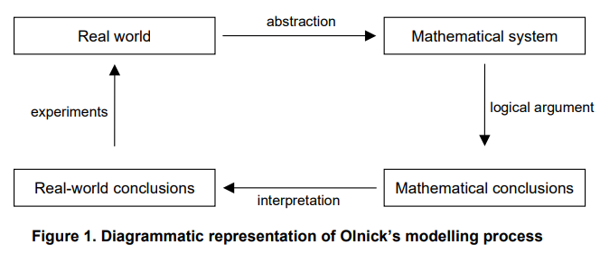
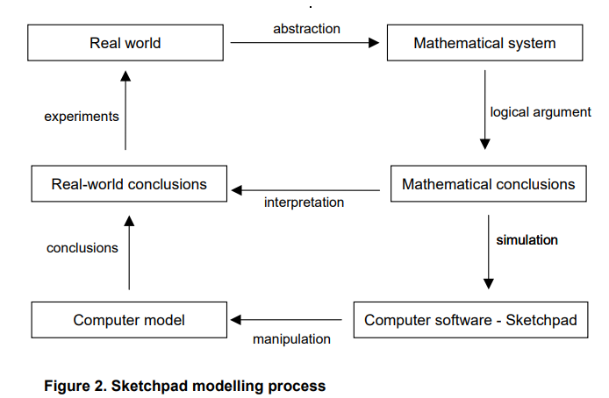
Models in Maths and Science
MODELS: Science has many different kinds of models.
- Animal Models: - To study human diseases.
- Physical Models: - To demonstrate the apparent truth of a principle.
- Mathematical Models: - To gain insight and understanding of a phenomenon which is being observed.
Inputs ⇒ MODEL ⇒ Outputs

A Probability Model is a mathematical model which incorporates the probability aspects of the observed phenomenon. If the observed process has a time parameter (or something equivalent) we refer to the probability model as a stochastic process.
The model can be used to:
- Understand the phenomenon better
- Make predictions of how outcome change with inputs

Use graphical models to make predictions or assist in decision making. Examples:

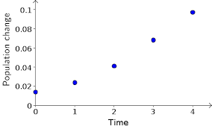
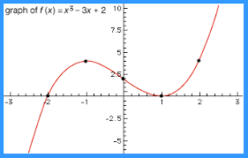

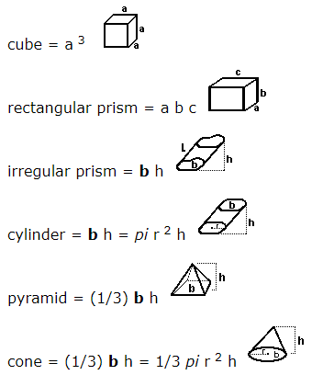

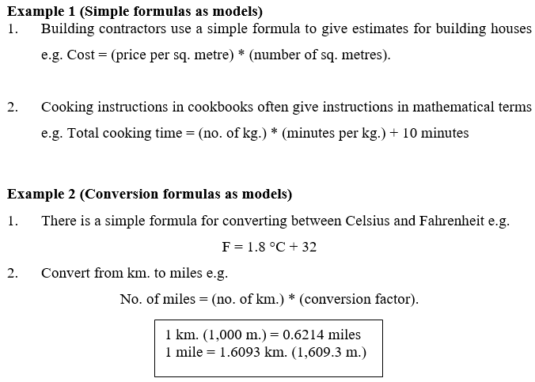

Class Exercise

- Calculate the cost of building a 3 bed semidetached house of 120m² size if the cost of building is €1600 per m²?

- Convert 28º Celsius to Fahrenheit?

- Convert 80km to miles?

Answers

- 120(1600) = 192,000
- 1.8(28)+32 = 82.4º
- Miles = 80(0.6214) = 49.712miles
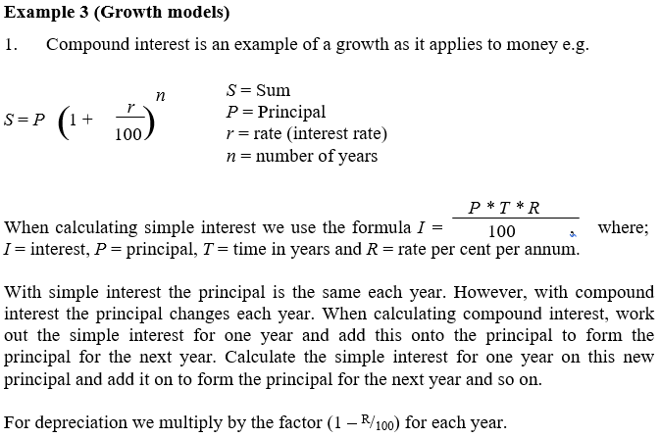

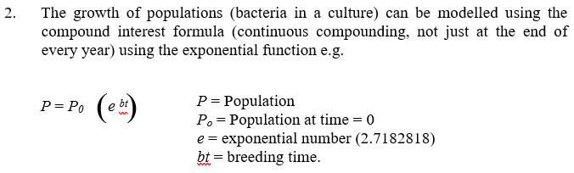

Exercise - Give the class a few minutes to solve the following.

What I want you to do is imagine a tennis ball, and then I want you to look around the room
that you're in and tell me how many tennis balls you can fit into the room without squashing
any of them.

Suggested ways of solving problem:
1 Estimate the volume of the room and divide by your estimate of volume of ping pong ball
2 Estimate how many balls would visualise along the ground on one edge then across the room and then how many you estimate on top of each other up to the ceiling (multiply etc)
3 Any other suggestions by class???

Sampling Method

A statistics teacher brings in a big bag of MMs to the class and asks: “Without counting all of the MMs, how do we determine the number of MMs of different colors, as close as possible to their distribution in the bag?” Students might say: “It is easier to count them, why go through all that?” The teacher responds by posing the problem: “Yes, you can count the MMs, but how do we determine the population of fish in the pond or the number of particular species of animal in the wild as we cannot directly count them?” In this process, she shows the power of sampling method in real life and therefore the reasons to learn it.
