Validating using Patterns – Modular Programming
Test Data
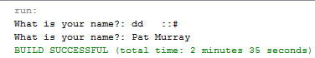

Source Code
import java.util.*;
public class ValidateUsingModules {
static Scanner stdIn;
public static void main(String[] args) {
stdIn = new Scanner(System.in);
String name=promptStringPattern("What is your name?","[a-zA-Z\\'\\- ]+");
}
private static String promptString(String question) {
System.out.print(question + ": ");
return stdIn.nextLine();
}
private static String promptStringPattern(String question, String pattern){
String answer ="";
do {
answer = promptString(question);
} while(!answer.matches(pattern));
return answer;
}
}

