Uploading your website to IIS
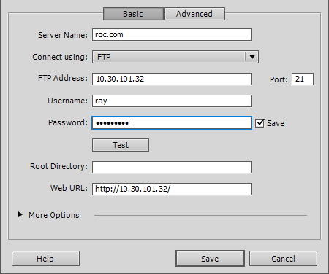

Add the following 10.30.101.32 www.roc.com hosts file located in
