Exercise
Find the coordinates of the points (eg a and b) of intersection of the curve $f\left(x\right)=x^{2}+4$ and the line $y=13$
Find the area bounded by the by $f\left(x\right)$, the x-axis and the lines x=a and x=b.
Solution
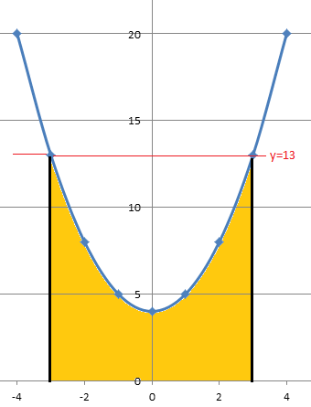
$$13=x^{2}+4$$
$$13-4=x^{2}$$
$$9=x^{2}$$
$$±3=x or x=±3$$

$\int_{-3}^{3}{x^{2}+4}$ = $\left\lfloor {\frac{1}{3}x}^{3}+4x+c\right\rfloor$ for $x=±3$
Substituting we get
$\left\lfloor {\frac{1}{3}(3)}^{3}+4(3)+c\right\rfloor - \left\lfloor {\frac{1}{3}(-3)}^{3}+4(-3)+c\right\rfloor$
=$\left\lfloor 9+12+c\right\rfloor —9-12+c=21+c+21-c$ (+c and –c cancel out)
Area = 42units²

