Cork Tourism App
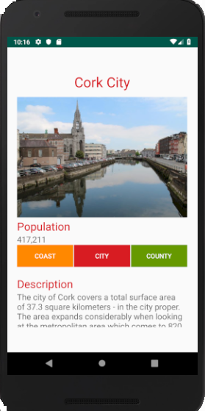

Design Cork tourism app incorporating:-
- Empty activity
- ScrollView
- Vertical Linear Layout
- Horizontal Linear Layout

XML source code (ensure you can write XML code)
<?xml version="1.0" encoding="utf-8"?>
<android.support.constraint.ConstraintLayout xmlns:android="http://schemas.android.com/apk/res/android"
xmlns:app="http://schemas.android.com/apk/res-auto"
xmlns:tools="http://schemas.android.com/tools"
android:layout_width="match_parent"
android:layout_height="match_parent"
tools:context=".MainActivity">
<ScrollView
android:id="@+id/scrollMain"
android:layout_width="368dp"
android:layout_height="551dp"
android:layout_margin="20dp"
android:layout_marginStart="8dp"
android:layout_marginTop="8dp"
android:layout_marginEnd="8dp"
android:layout_marginBottom="8dp"
app:layout_constraintBottom_toBottomOf="parent"
app:layout_constraintEnd_toEndOf="parent"
app:layout_constraintStart_toStartOf="parent"
app:layout_constraintTop_toTopOf="parent">
<LinearLayout
android:id="@+id/vLayout"
android:layout_width="match_parent"
android:layout_height="wrap_content"
android:orientation="vertical">
<TextView
android:id="@+id/textViewHeading"
android:layout_width="match_parent"
android:layout_height="wrap_content"
android:layout_marginBottom="10dp"
android:gravity="center_horizontal"
android:text="@string/cork_city"
android:textColor="@color/colorAccent"
android:textSize="30sp"
tools:layout_editor_absoluteX="67dp"
tools:layout_editor_absoluteY="112dp" />
<ImageView
android:id="@+id/imageView"
android:layout_width="wrap_content"
android:layout_height="266dp"
android:contentDescription="@string/imgcorkcity"
app:srcCompat="@drawable/corkcity"
tools:layout_editor_absoluteX="42dp"
tools:layout_editor_absoluteY="88dp" />
<TextView
android:id="@+id/textViewPop"
android:layout_width="wrap_content"
android:layout_height="wrap_content"
android:text="@string/populationHeading"
android:textColor="@color/colorAccent"
android:textSize="24sp"
tools:layout_editor_absoluteX="90dp"
tools:layout_editor_absoluteY="386dp" />
<TextView
android:id="@+id/textViewPopSize"
android:layout_width="wrap_content"
android:layout_height="wrap_content"
android:text="@string/textviewPopulation"
android:textSize="18sp"
tools:layout_editor_absoluteX="88dp"
tools:layout_editor_absoluteY="382dp" />
<LinearLayout
android:id="@+id/HLayout"
android:layout_width="match_parent"
android:layout_height="match_parent"
android:orientation="horizontal">
<Button
android:id="@+id/button1"
android:layout_width="wrap_content"
android:layout_height="wrap_content"
android:layout_weight="1"
android:background="@android:color/holo_orange_dark"
android:text="@string/button"
android:textColor="@android:color/background_light" />
<Button
android:id="@+id/button2"
android:layout_width="wrap_content"
android:layout_height="wrap_content"
android:layout_marginLeft="2dp"
android:layout_marginRight="2dp"
android:layout_weight="1"
android:background="@color/colorAccent"
android:text="@string/button1"
android:textColor="@android:color/background_light" />
<Button
android:id="@+id/button3"
android:layout_width="wrap_content"
android:layout_height="wrap_content"
android:layout_weight="1"
android:background="@android:color/holo_green_dark"
android:text="@string/button2"
android:textColor="@android:color/background_light" />
</LinearLayout>
<TextView
android:id="@+id/textViewDescHead"
android:layout_width="wrap_content"
android:layout_height="wrap_content"
android:layout_marginTop="20dp"
android:text="@string/descriptionHeading"
android:textColor="@color/colorAccent"
android:textSize="24sp"
tools:layout_editor_absoluteX="50dp"
tools:layout_editor_absoluteY="393dp" />
<TextView
android:id="@+id/textViewDecrText"
android:layout_width="match_parent"
android:layout_height="wrap_content"
android:text="@string/DescText"
android:textSize="18sp" />
</LinearLayout>
</ScrollView>
</android.support.constraint.ConstraintLayout>

