Applied Maximum and Minimum Problems
The process of finding maximum or minimum values is called optimisation.
We are trying to do things like maximise the profit in a company, or minimise the costs, or find the least amount of material to make a particular object.
These are very important in the world of industry.

Example 1
The daily profit, P, of an oil refinery is given by
$$P=8x-0.02x^{2}$$where x is the number of barrels of oil refined. How many barrels will give maximum profit and what is the maximum profit?
Solution
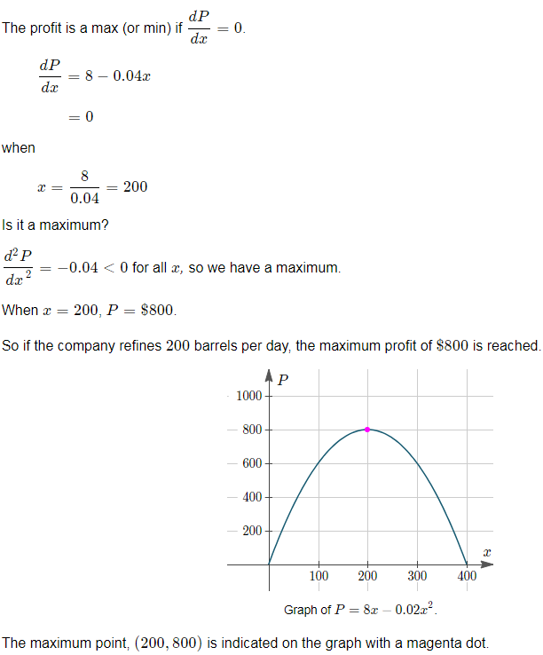

Example 2
A rectangular storage area is to be constructed along the side of a tall building. A security fence is required along the remaining 3 sides of the area. What is the maximum area that can be enclosed with 800 m of fencing?

Solution
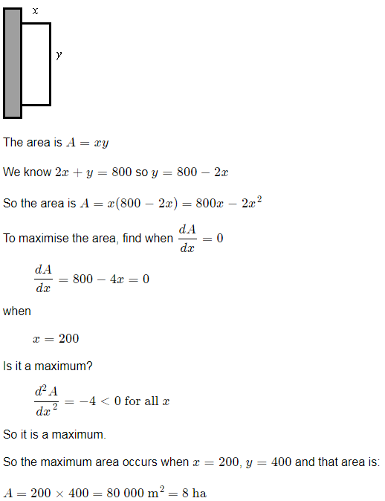

Example 3
A box with a square base has no top. If 64 cm² of material is used, what is the maximum possible volume for the box?

Solution
