De Moivres Theorem
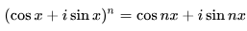
De Moivre's theorem If z = r(cos α + i sin α), and n is a natural number, then

Examples
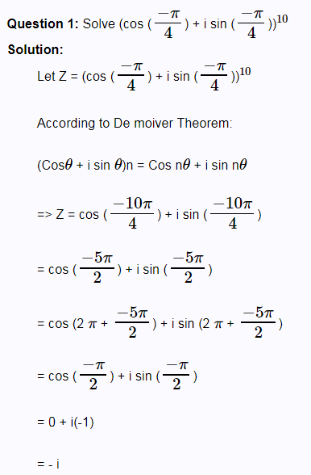
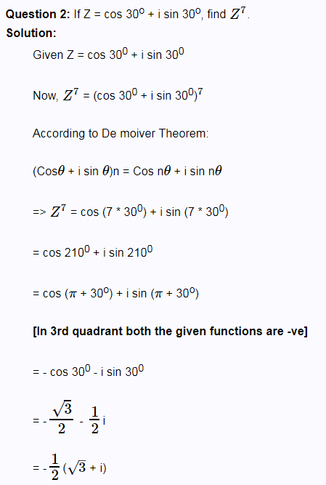

Examples
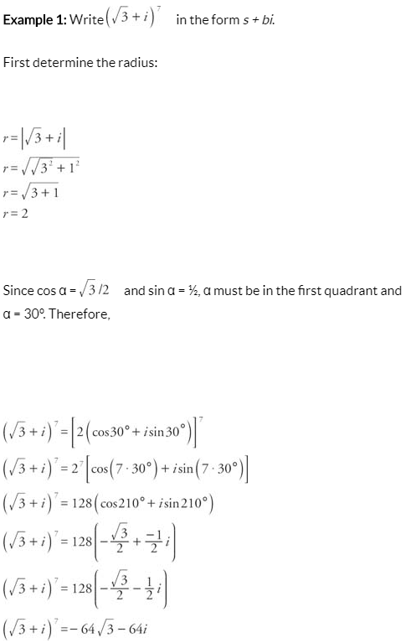

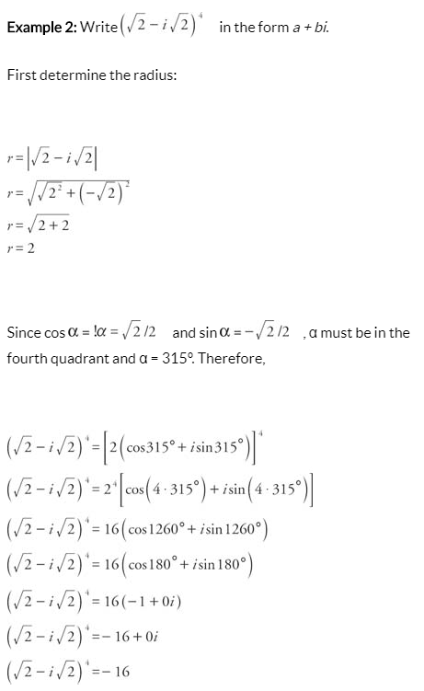

Exercises
- Find ${(1-i)}^{6}$

- Find ${(\sqrt{3}-i)}^{9}$

