Word Templates
In Word click on New – My Templates
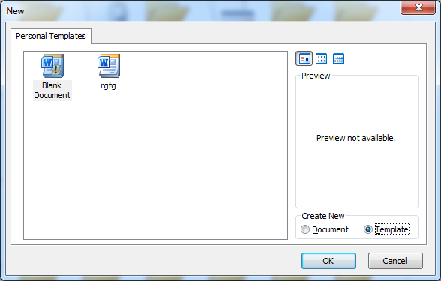
Select Template and design your template.
Click Save to save to My Templates.
You could also save this file to your own folder (eg Word Processing folder)

