Strings isDigit isLetter – Character Checking and Validating

public class StringDigitCharCheck {

public static void main(String[] args) {

// assume student ID takes the format of 45678LL or DDDDDLL
String StudentId = "45678LL";
System.out.println(StudentId);
boolean ValidId=true;
for(int counter=0;counter<StudentId.length();counter++){
char result = StudentId.charAt(counter);
System.out.println(result);
if (Character.isDigit(result)) {
ValidId=true;
} else {
ValidId=false;
}
System.out.println(ValidId);
}

for(int counter=5;counter<StudentId.length();counter++){
char result = StudentId.charAt(counter);
System.out.println(result);
if (Character.isLetter(result)) {
ValidId=true;
} else {
ValidId=false;
}
System.out.println(ValidId);
}
}
}
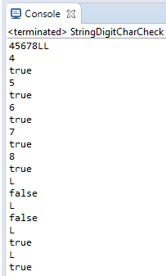

Validating Characters of a String
public class StringsOrNumbersOrAlphaNumeric {

public static void main(String[] args) {
String StudentName = "Mary O'Dnovan";
boolean ValidId=false;
System.out.println(StudentName);
for(int counter=0;counter<StudentName.length();counter++){
char ch = StudentName.charAt(counter);
System.out.println(ch);
// check if ch is a letter
if ((ch >= 'a' && ch <= 'z') || (ch >= 'A' && ch <= 'Z') || (ch >= '0' && ch <= '9') || ((ch == ' ') || (ch =='\''))) {
ValidId=true;
} else {
ValidId=false;
break;
}

}
System.out.println("Valid ID = " + ValidId);
}
}
Test Data
