Spinner
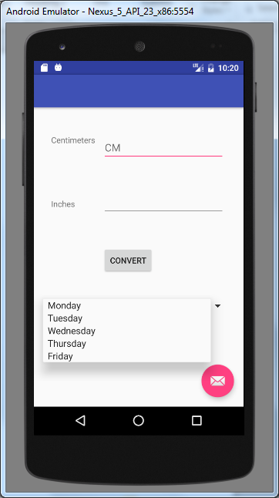
Create String Array in strings.xml in Resource folder
<resources>
<string name="app_name">CmToInches</string>
<string name="action_settings">Settings</string>
<string-array name="days">
<item>Monday</item>
<item>Tuesday</item>
<item>Wednesday</item>
<item>Thursday</item>
<item>Friday</item>
</string-array>
</resources>

Java code for Activity
public class MainActivity extends Activity implements AdapterView.OnItemSelectedListener {

Spinner spinner = (Spinner)findViewById(R.id.spinDays);
ArrayAdapter adapter=ArrayAdapter.createFromResource(this,R.array.days,android.R.layout.simple_spinner_item);
spinner.setAdapter(adapter);

