Question 1 (Use your calculator or log tables) Solution at bottom of page
If$\cos{B= -0.8660}$. $0°≤B ≤360°.$ Find two possible values for B.

Solution
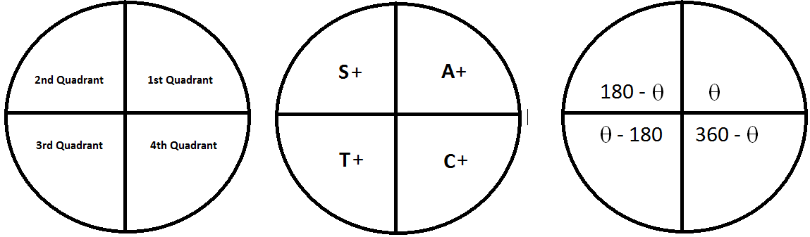
Because $\cos{B= -}$ the angle must be in the 2nd or 3rd quadrant.
Using log tables we can see that 0.8660 corresponds to $30°$
Hence because of being in the 2nd or 3rd quadrants and using the third circle diagram above we get the following
$$180-150=30$$
And
$$210-180=30$$
Therefore solutions are $210°$ and $150°$
Question 2 (Use your calculator)
If$\sin{B= 0.7660}444431$. $0°≤B ≤360°.$ Find two possible values for B.

Solution
Because $\sin{B= +}$ the angle must be in the 1st or 2nd quadrant.
Using your calculator $0.7660444431$ corresponds to $50°$
Hence because of being in the 1st or 2nd quadrants and using the third circle diagram above we get the following
$$Angle=50$$
And
$$180-130=50$$
Therefore solutions are $50°$ and $130°$
Question 2 (Use your calculator)
If $\tan{C= -0.4663076582}$ $0°≤C ≤360°.$ Find two possible values for C.

Solution
Because $\tan{C= -}$ the angle must be in the 2nd or 4th quadrant.
Using your calculator.$0.4663076582$corresponds to $25°$
Hence because of being in the 2nd or 4th quadrants and using the third circle diagram above we get the following
$$180-155=25$$
And
$$360-335=25$$
Therefore solutions are $155°$ and $335°$

