For Loop Exercise
Write the java code which accepts a number(eg Limit) input by the user and prints a list in increments of 3 until the limit is reached. Test your solution as follows:
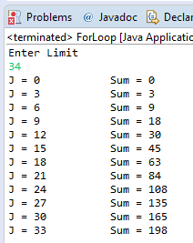

Java Code

import java.util.Scanner;

public class ForLoop {

public static void main(String[] args) {
// TODO Auto-generated method stub
Scanner Input = new Scanner(System.in);
System.out.println("Enter Limit");
int Limit=Input.nextInt();
int Sum = 0;
for (int j=0; j<=Limit; j+=3) {
Sum+=j;
System.out.println("J = " + j + "\t\tSum = " + Sum);
}
}
}

