Responsive Web Design
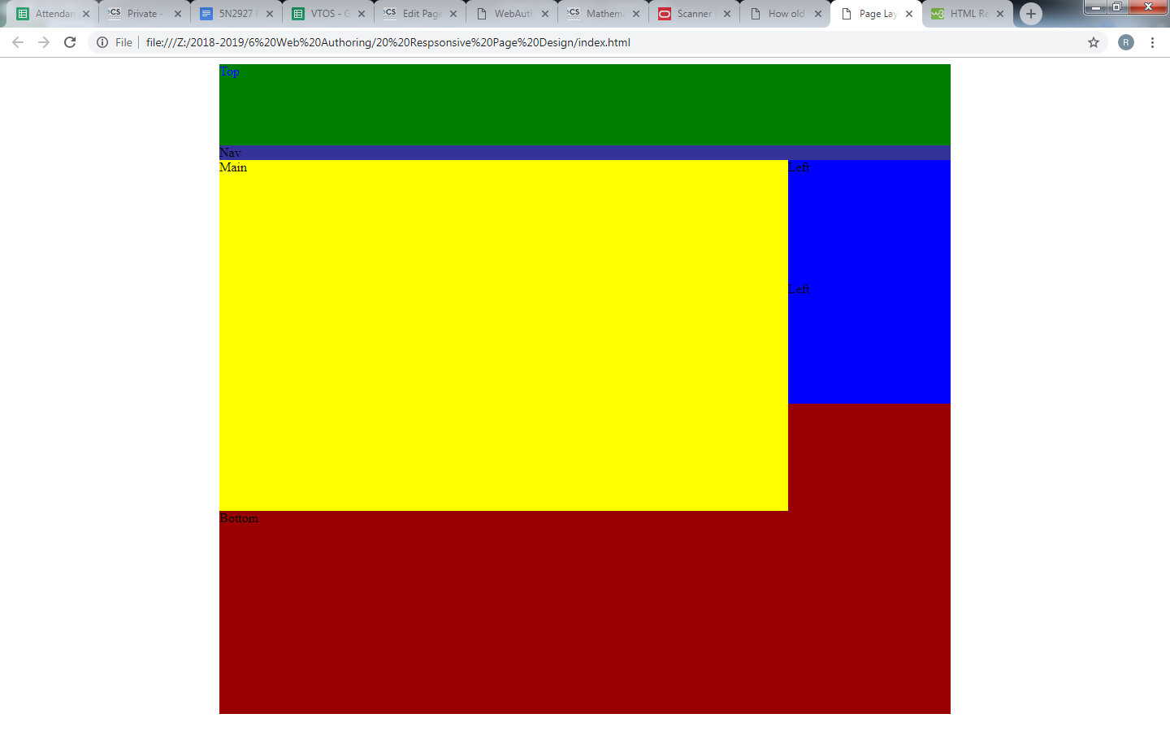
When the browser window is reduced to below 800 px the style changes (eg background changes color)
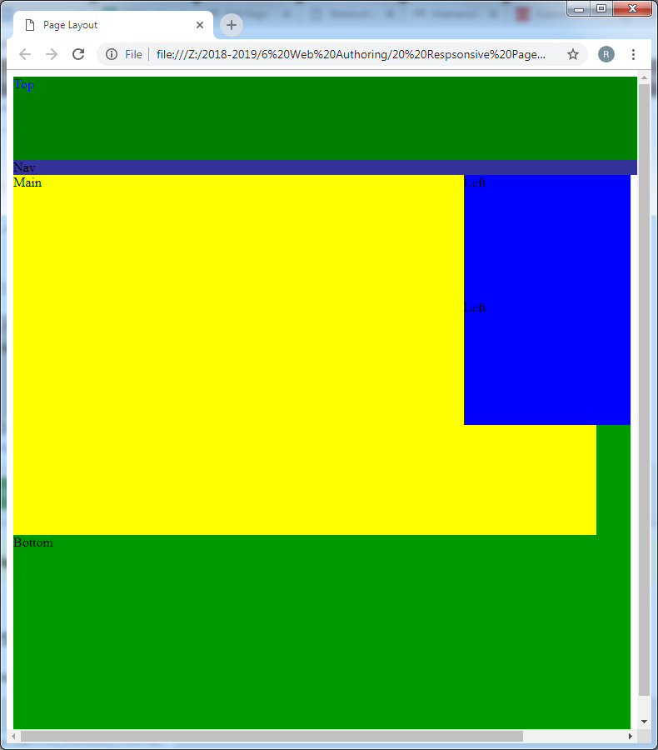
index.htm
<!DOCTYPE html>
<html">
<head>
<meta http-equiv="Content-Type" content="text/html; charset=utf-8" />
<meta name="viewport" content="width=device-width, initial-scale=1.0">
<title>Page Layout</title>
<link rel="stylesheet" type="text/css" href="style.css">
</head>
<body>
<div id="wrapper">
<div id="top">Top</div>
<div id="nav">Nav</div>
<aside>Left</aside>
<aside>Left</aside>
<article>Main</article>
<footer>Bottom</footer>
</div>
</body>
</html>
style.css
#wrapper {
width:900px;
margin:0 auto 0 auto;
background-color:#990000;
height:800px;
}
#top {
background-color:green;
color:blue;
width: 900px;
height:100px;
float: left;
}
#nav {
background-color:#339;
width:900px;
float: left;
}
#left {
background-color:#069;
width:200px;
float: left;
}
#main {
background-color:#033;
width:500px;
float: left;
}
#right{
background-color:#999;
width:200px;
float: left;
}
#bottom{
background-color:#999;
width:900px;
float: left;
}
aside {
width:200px;
height:150px;
background-color:blue;
float:right;
clear:both;
}
article {
width:700px;
height:550px;
background-color:yellow;
}

/* Use a media query to add a breakpoint at 800px: */
@media screen and (max-width: 800px) { #wrapper {
width: 100%; /* The width is 100%, when the viewport is 800px or smaller */ background-color:#009900;
}
}

