Non-Right Angled Triangles
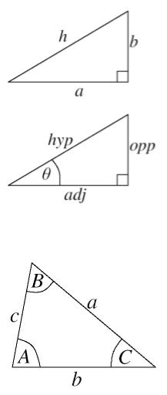
Area of a triangle – The area is half by the two sides for the angle in between

$$Area= \frac{1}{2}absinC$$

Sine Rule
- Sine Rule Formula $\frac{\sin{A}}{a}= \frac{\sin{B}}{b}= \frac{\sin{C}}{c}$

- For finding angles $\frac{\sin{A}}{a}= \frac{\sin{B}}{b}$
- For finding the length of sided $\frac{a}{sinA}= \frac{b}{sinB}$

Cosine Rule

For finding sides $a^{2}=b^{2}+c^{2}-2bccosA$
Similarly $b^{2}=a^{2}+c^{2}-2accosB$
For finding angles $cosA=\frac{b^{2}+c^{2}-a^{2}}{2bc}$

