Mail Merge Exercise - Letter 1
Letter - Type and Save the letter below as Course Letter
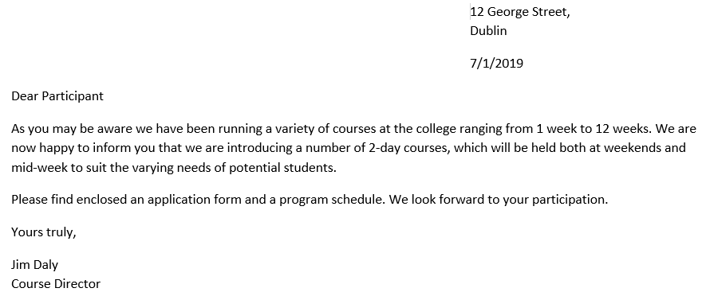
Data Source Create the following list by customising fieldnames and entering the data shown
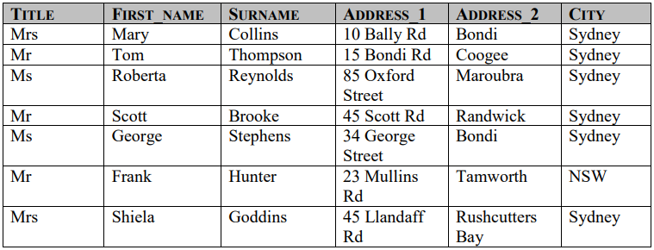
Save the data file with name Course_Participant_Data into a new folder named Mail_Merge in your Word Processsing folder.
Using the current document Course Letter as a form letter and the Course_Participants_Data as the data source merge the two documents and insert the merged fields Title, First_Name, Surname, Address and City fields above Dear Participant in the letter, as shown below.
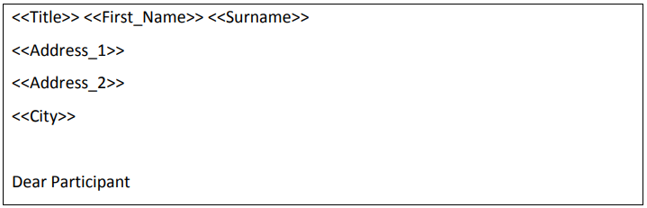
Save the merged letters file with name Course2019

