Input Ranges
Write a full program where the user enters a questionnaire result value of 1, 2, 3, or 4 and the program displays the message “Very unhappy” for 1, “Unhappy” for 2, “Happy” for 3 and “Very Happy” for 4. The program should output an error message if an out of range value is entered.

Test Data – Examples
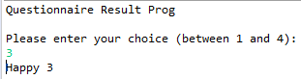
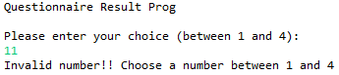

Solution – Java Source Code

import java.io.BufferedReader;
import java.io.IOException;
import java.io.InputStreamReader;

public class WithinRange {

public static void main(String[] args) {
int choice=0;
BufferedReader br = new BufferedReader(new InputStreamReader(System.in));

System.out.println("Questionnaire Result Prog\n");
System.out.println("Please enter your choice (between 1 and 4):");

try {
choice = Integer.parseInt(br.readLine());
} catch (NumberFormatException e) {
// TODO Auto-generated catch block
e.printStackTrace();
} catch (IOException e) {
// TODO Auto-generated catch block
e.printStackTrace();
}

if ((choice < 1) || (choice >4))
System.out.println("Invalid number!! Choose a number between 1 and 4");
else
{
switch(choice) {
case 1:
System.out.println("Very Unhappy = " + choice);
break;
case 2:
System.out.println("Unhappy = " + choice);
break;
case 3:
System.out.println("Happy " + choice);
break;
case 4:
System.out.println("Very Happy " + choice);
break;
default:
System.out.println("Please try again");
break;
}
}
}
}

