Age

Java Source Code
package howmanyyearsold;
import java.time.LocalDate;
import java.time.Month;
import java.time.Period;
public class HowManyYearsOld {
public static void main(String[] args) {
LocalDate today = LocalDate.now(); //Today's date
LocalDate birthday = LocalDate.of(1960, Month.JANUARY, 1); //Birth date
Period p = Period.between(birthday, today);
System.out.println(p.getYears());
System.out.println(p.getDays()+ " " + p.getMonths()+" "+ p.getYears());
}
}
Output
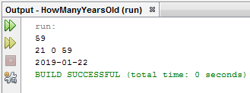
Scanner in = new Scanner((System.in));
System.out.println("Enter day of DOB");
int dobDay = in.nextInt();
System.out.println("Enter month of DOB");
int dobMonth = in.nextInt();
System.out.println("Enter year of DOB");
int dobYear = in.nextInt();
LocalDate birthday2 = LocalDate.of(dobYear, dobMonth, dobDay); //Birth date
Period p2 = Period.between(birthday2, today);
System.out.println(p2.getYears());

