Mail Merge – Writing a letter to multiple people for example
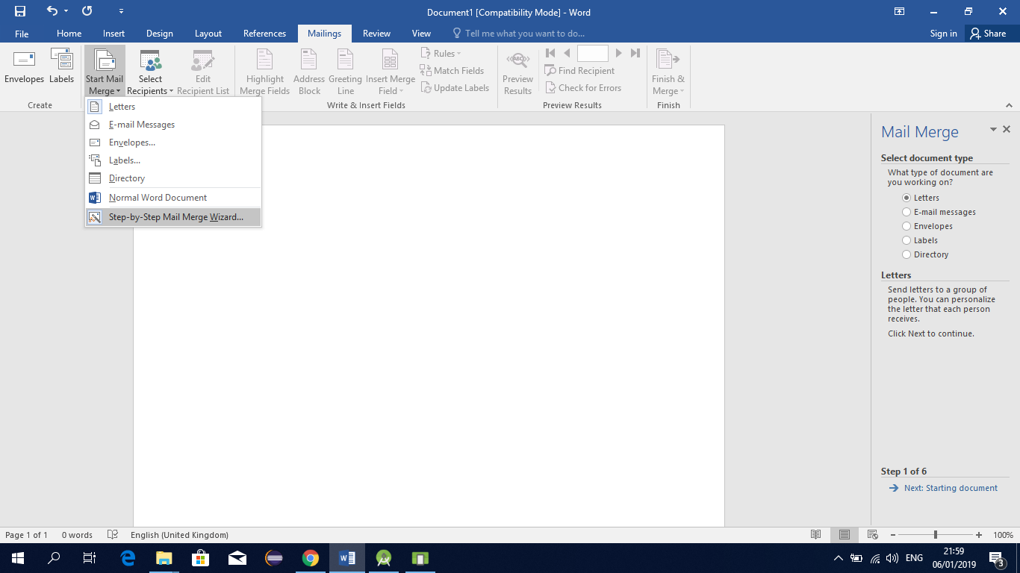
Click Letters / Labels as required and click Next
Click Use Current document and click Select recipients (bottom right)
Select Type a new list and click Create
Customise columns etc to include Title, Firstname, Surname, Address1, Address2, etc as shown below
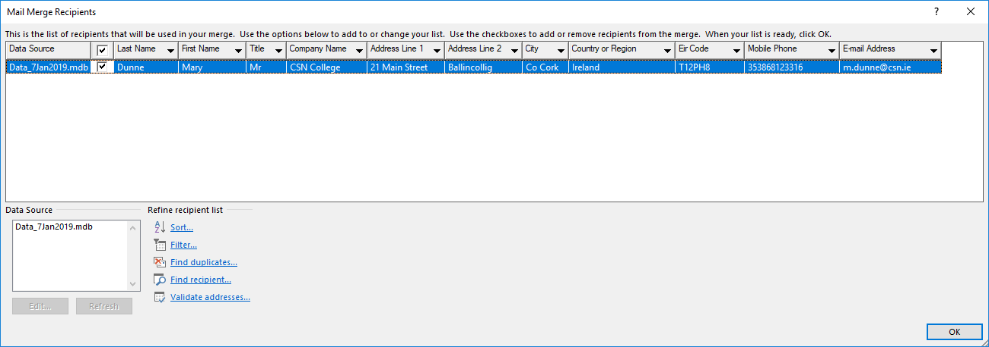
Click Ok and New Entry to continue and enter data for each person or row.
Click Select Recipients

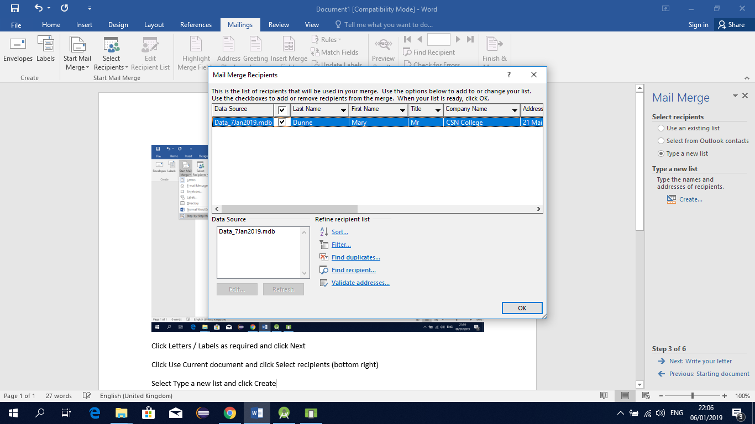
You can edit (remove etc from the list by unchecking the customers shown above.
Click Next: Write your letter
Type your letter and insert the fields you require from your data source
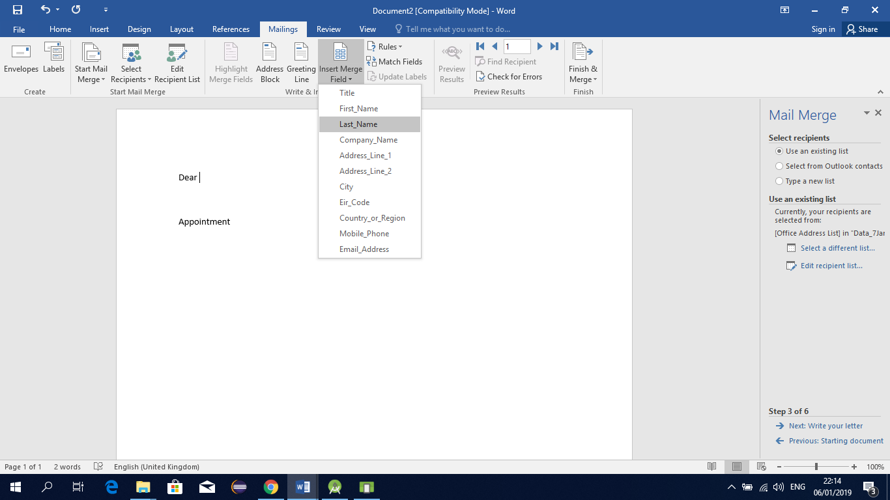

Click Next: Preview your letters
Click Edit Individual letters

