SQLite Database

1 About the Android Studio Database Example
2 Creating the Data Model
3 Implementing the Data Handler
3.1 The Add Handler Method
3.2 The Query Handler Method
3.3 The Delete Handler Method
4 Implementing the Activity Event Methods
5 Testing the Application
6 Summary

The database schema for the products table is outlined as follows:
Column | Data Type
productid | Integer / Primary Key/ Auto Increment
productname | Text
productquantity | Integer

Creating the Data Model
The application will consist of
- an activity
- a database handler class (MyDBHandler a subclass of SQLiteOpenHelper)
- a third class(Product) will need to be implemented to hold the database entry data as it is passed between the activity and the handler.
This is actually a very simple class capable of holding product ID, product name and product quantity values, together with getter and setter methods for accessing these values. Instances of this class can then be created within the activity and database handler and passed back and forth as needed. Essentially, this class can be thought of as representing the database model.
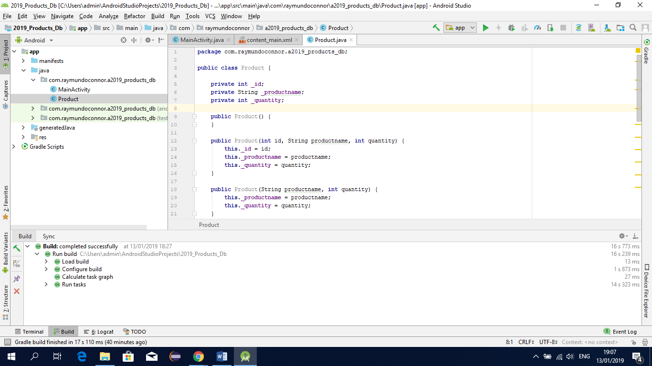
When finished your classes should look like this (see below)
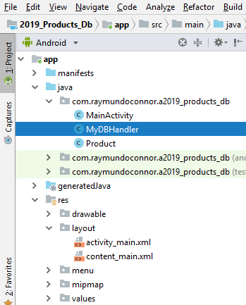
Product Class
package com.raymundoconnor.a2019_products_db;
public class Product {
private int _id;
private String _productname;
private int _quantity;
public Product() {
}
public Product(int id, String productname, int quantity) {
this._id = id;
this._productname = productname;
this._quantity = quantity;
}
public Product(String productname, int quantity) {
this._productname = productname;
this._quantity = quantity;
}
public void setID(int id) {
this._id = id;
}
public int getID() {
return this._id;
}
public void setProductName(String productname) {
this._productname = productname;
}
public String getProductName() {
return this._productname;
}
public void setQuantity(int quantity) {
this._quantity = quantity;
}
public int getQuantity() {
return this._quantity;
}
}

MyDbHandler Class
package com.raymundoconnor.a2019_products_db;
import android.content.Context;
import android.database.sqlite.SQLiteDatabase;
import android.database.sqlite.SQLiteOpenHelper;
import android.content.Context;
import android.content.ContentValues;
import android.database.Cursor;
public class MyDBHandler extends SQLiteOpenHelper{
// when you type SQLiteOpenHelper as above you must import the onCreate, onUpgrade methods
private static final int DATABASE_VERSION = 1;
private static final String DATABASE_NAME = "productDB.db"; private static final String TABLE_PRODUCTS = "products";
public static final String COLUMN_ID = "_id";
public static final String COLUMN_PRODUCTNAME = "productname";
public static final String COLUMN_QUANTITY = "quantity";
public MyDBHandler(Context context, String name,
SQLiteDatabase.CursorFactory factory, int version) {
super(context, DATABASE_NAME, factory, DATABASE_VERSION);
}
@Override
public void onCreate(SQLiteDatabase db) {
String CREATE_PRODUCTS_TABLE = "CREATE TABLE " +
TABLE_PRODUCTS + "("
+ COLUMN_ID + " INTEGER PRIMARY KEY," + COLUMN_PRODUCTNAME
+ " TEXT," + COLUMN_QUANTITY + " INTEGER" + ")";
db.execSQL(CREATE_PRODUCTS_TABLE);
}
@Override
public void onUpgrade(SQLiteDatabase db, int oldVersion, int newVersion) {
db.execSQL("DROP TABLE IF EXISTS " + TABLE_PRODUCTS);
onCreate(db);
}
public void addProduct(Product product) {
ContentValues values = new ContentValues();
values.put(COLUMN_PRODUCTNAME, product.getProductName());
values.put(COLUMN_QUANTITY, product.getQuantity());
SQLiteDatabase db = this.getWritableDatabase();
db.insert(TABLE_PRODUCTS, null, values);
db.close();
}
public Product findProduct(String productname) {
String query = "Select * FROM " + TABLE_PRODUCTS + " WHERE " + COLUMN_PRODUCTNAME + " = \"" + productname + "\"";
SQLiteDatabase db = this.getWritableDatabase();
Cursor cursor = db.rawQuery(query, null);
Product product = new Product();
if (cursor.moveToFirst()) {
cursor.moveToFirst();
product.setID(Integer.parseInt(cursor.getString(0)));
product.setProductName(cursor.getString(1));
product.setQuantity(Integer.parseInt(cursor.getString(2)));
cursor.close();
} else {
product = null;
}
db.close();
return product;
}
public boolean deleteProduct(String productname) {
boolean result = false;
String query = "Select * FROM " + TABLE_PRODUCTS + " WHERE " + COLUMN_PRODUCTNAME + " = \"" + productname + "\"";
SQLiteDatabase db = this.getWritableDatabase();
Cursor cursor = db.rawQuery(query, null);
Product product = new Product();
if (cursor.moveToFirst()) {
product.setID(Integer.parseInt(cursor.getString(0)));
db.delete(TABLE_PRODUCTS, COLUMN_ID + " = ?",
new String[] { String.valueOf(product.getID()) });
cursor.close();
result = true;
}
db.close();
return result;
}
}

MainActivity Class
package com.raymundoconnor.a2019_products_db;
import android.os.Bundle;
import android.support.design.widget.FloatingActionButton;
import android.support.design.widget.Snackbar;
import android.support.v7.app.AppCompatActivity;
import android.support.v7.widget.Toolbar;
import android.view.View;
import android.view.Menu;
import android.view.MenuItem;
import android.widget.EditText;
import android.widget.TextView;
public class MainActivity extends AppCompatActivity {
TextView idView;
EditText productBox;
EditText quantityBox;
@Override
protected void onCreate(Bundle savedInstanceState) {
super.onCreate(savedInstanceState);
setContentView(R.layout.activity_main);
idView = (TextView) findViewById(R.id.textViewID);
productBox = (EditText) findViewById(R.id.editTextProduct);
quantityBox = (EditText) findViewById(R.id.editTextQuantity);
}
public void newProduct (View view) {
MyDBHandler dbHandler = new MyDBHandler(this, null, null, 1);
int quantity =
Integer.parseInt(quantityBox.getText().toString());
Product product =
new Product(productBox.getText().toString(), quantity);
dbHandler.addProduct(product);
productBox.setText("");
quantityBox.setText("");
}
public void lookupProduct (View view) {
MyDBHandler dbHandler = new MyDBHandler(this, null, null, 1);
Product product =
dbHandler.findProduct(productBox.getText().toString());
if (product != null) {
idView.setText(String.valueOf(product.getID()));
quantityBox.setText(String.valueOf(product.getQuantity()));
} else {
idView.setText("No Match Found");
}
}
public void removeProduct (View view) {
MyDBHandler dbHandler = new MyDBHandler(this, null,
null, 1);
boolean result = dbHandler.deleteProduct(
productBox.getText().toString());
if (result)
{
idView.setText("Record Deleted");
productBox.setText("");
quantityBox.setText("");
}
else
idView.setText("No Match Found");
}
}
Testing the app
To add a product
- Enter a product name and quantity and click ADD
To find a product
- Click in the product name edit text and enter the product name you require and click FIND
To delete a product
- Click in the product name edit text and enter the product name you require and click DELETE

