Android Apps and Firebase

- Create a new project in Android Studio and copy the package name of your new project from Android Studio (eg. Com.raymundoconnor.realtimedb)
- Log into the Firebase console and create a new project (be careful as you are limited to 5 or so projects) and create a new Project in Firebase (Note: you will need to paste your package name when required)
- Download the json file and copy and paste same as shown in the screenshots below
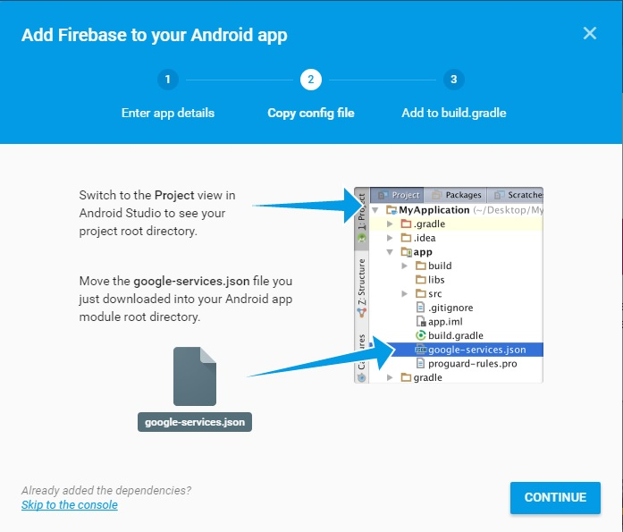

Paste the following code in the correct files as shown in the following 3 screenshots
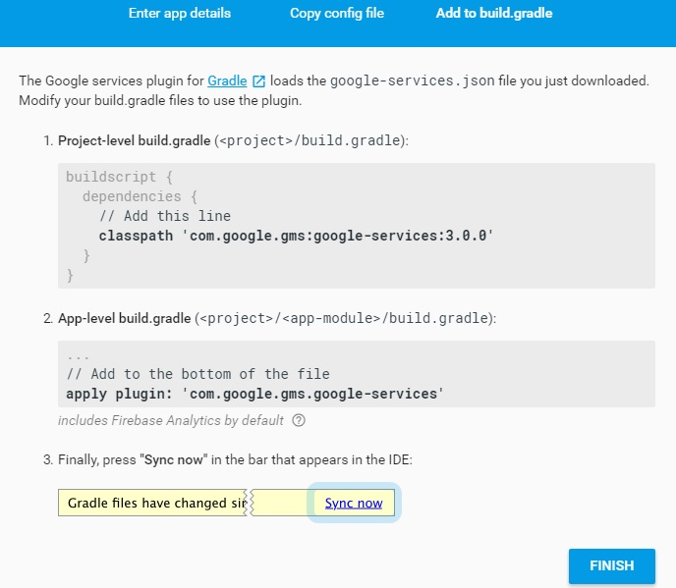

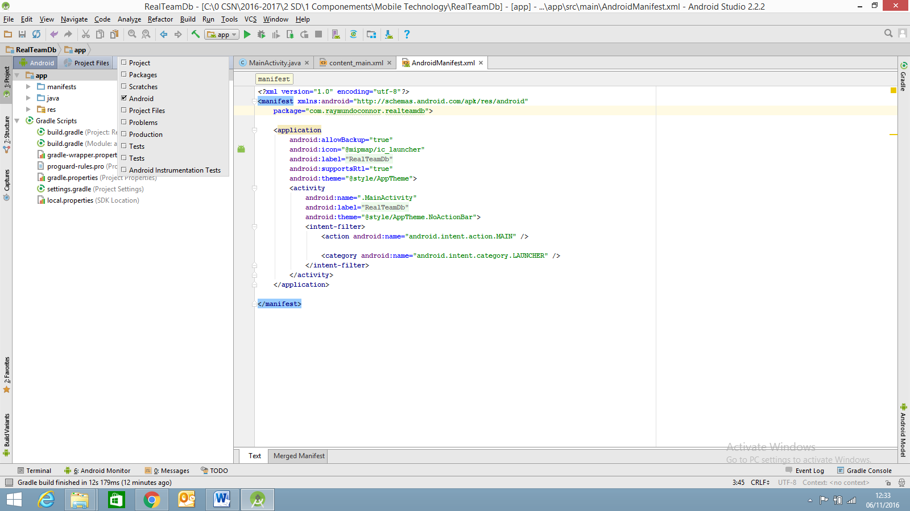

Add the code to the following files only (Note the package name in the Manifest.xml file)
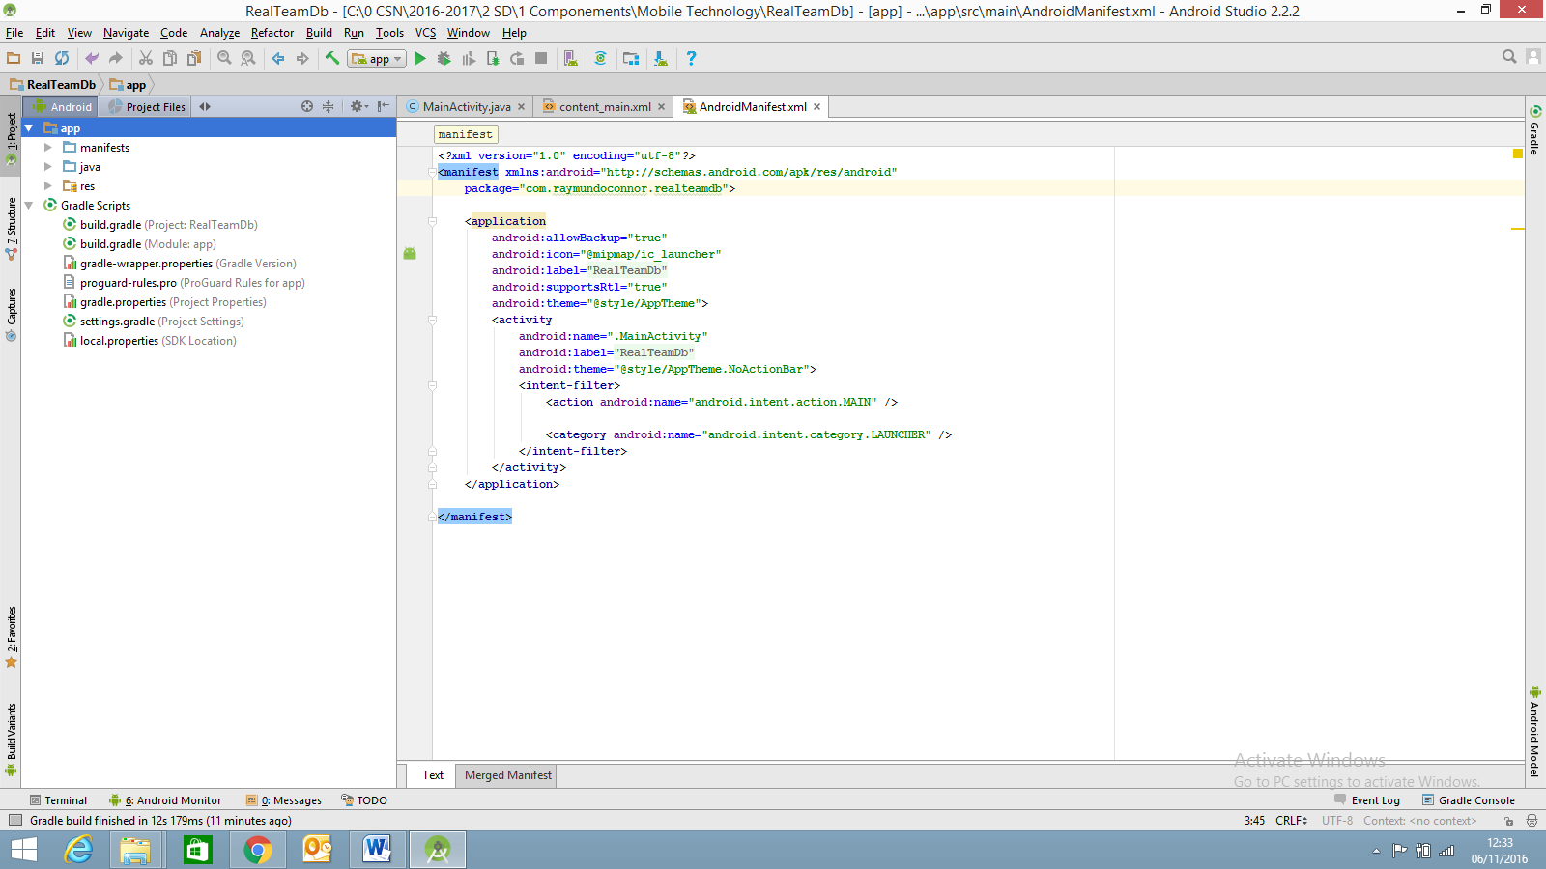

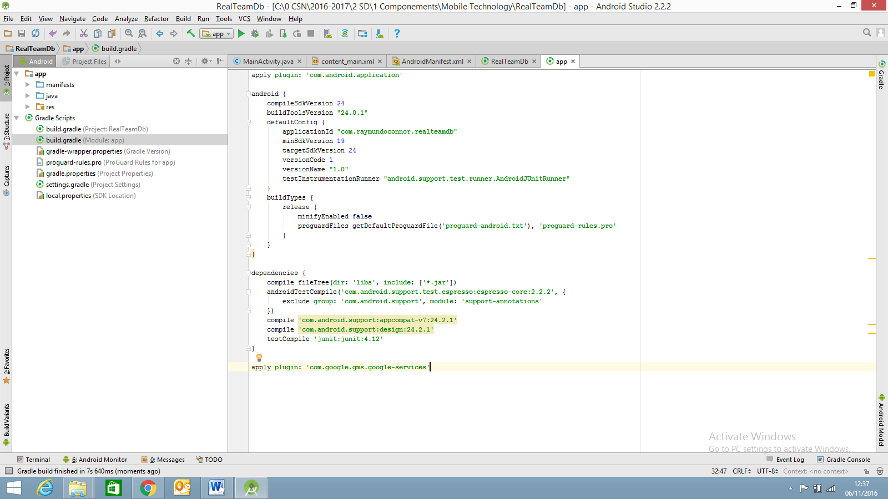

Database (Real time database)
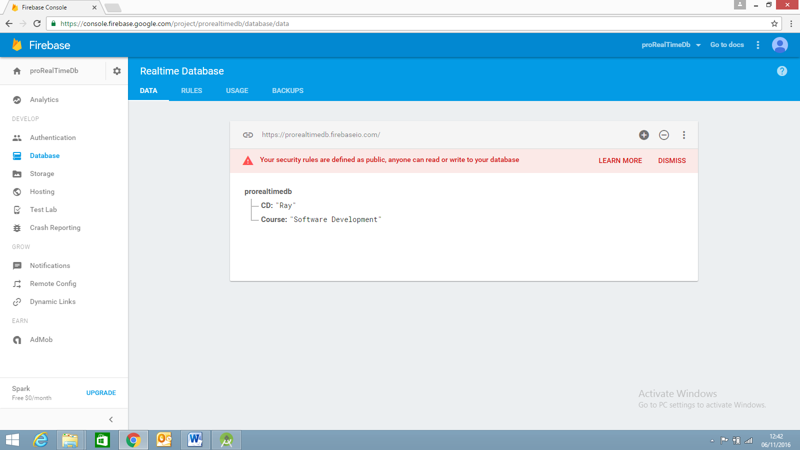
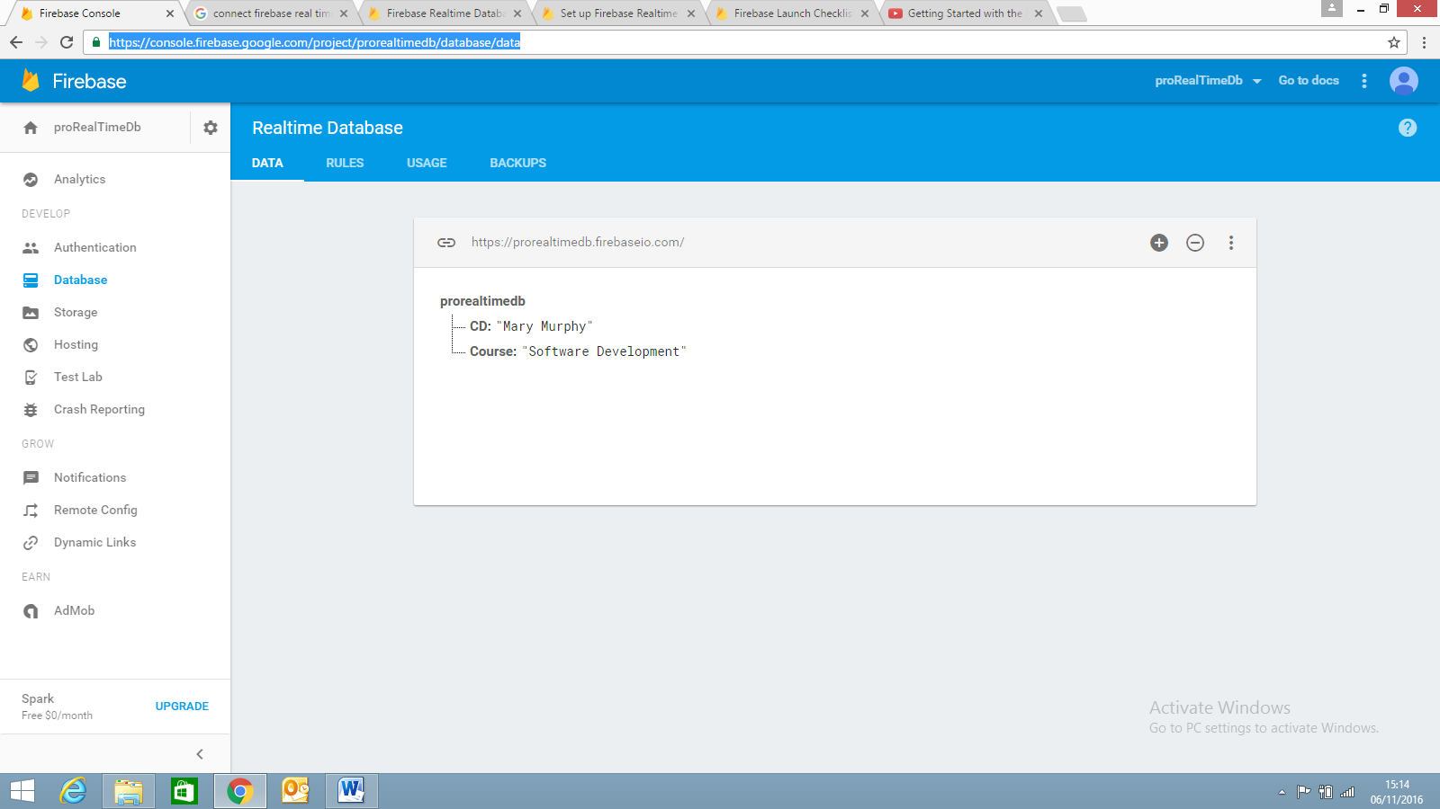
Set Rules to True which makes your data public – this would not be advisable for commercial apps but the apps we are working with do not contain important data.
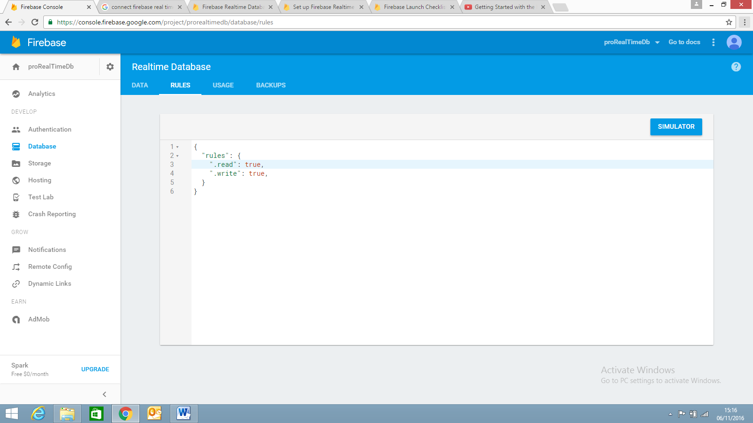

Add the Realtime Database to your app

Reference: https://firebase.google.com/docs/database/android/start/
- Add the following line to build gradle (Module app) - compile 'com.google.firebase:firebase-database:9.8.0'
- Design your UI

Example 1
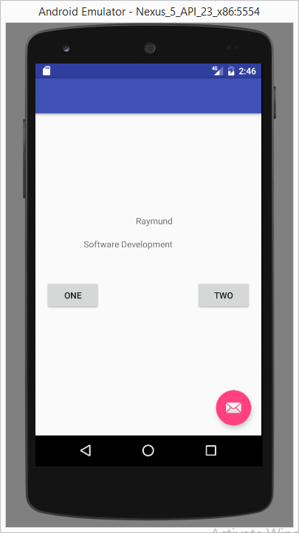
MainActivity.java Source code
public class MainActivity extends AppCompatActivity {
TextView tvOne;
TextView tvTwo;
Button buttOne;
Button buttTwo;
DatabaseReference CD = FirebaseDatabase.getInstance().getReference();
DatabaseReference CourseDirector = CD.child("CD");
DatabaseReference Course = FirebaseDatabase.getInstance().getReference();
DatabaseReference CourseName = Course.child("Course");
@Override
protected void onCreate(Bundle savedInstanceState) {
super.onCreate(savedInstanceState);
setContentView(R.layout.activity_main);
tvOne = (TextView)findViewById(R.id.textView);
tvTwo = (TextView)findViewById(R.id.textView2);
buttOne=(Button)findViewById(R.id.buttOne);
buttTwo=(Button)findViewById(R.id.buttTwo);
}
@Override
protected void onStart() {
super.onStart();
CourseDirector.addValueEventListener(new ValueEventListener() {
@Override
public void onDataChange(DataSnapshot dataSnapshot) {
String text = dataSnapshot.getValue(String.class);
tvOne.setText(text);
}
@Override
public void onCancelled(DatabaseError databaseError) {
}
});
CourseName.addValueEventListener(new ValueEventListener() {
@Override
public void onDataChange(DataSnapshot dataSnapshot) {
String text = dataSnapshot.getValue(String.class);
tvTwo.setText(text);
}
@Override
public void onCancelled(DatabaseError databaseError) {
}
});
}

Example 1 – with code for two buttons
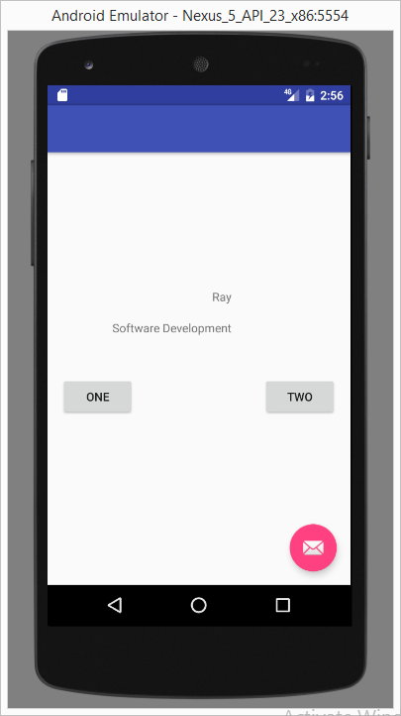
Add the following lines to code the two buttons underneath the code above but inside the onStart method
buttOne.setOnClickListener(new View.OnClickListener() {
@Override
public void onClick(View view) {
CourseDirector.setValue("Ray");
}
});
buttTwo.setOnClickListener(new View.OnClickListener() {
@Override
public void onClick(View view) {
CourseDirector.setValue("Raymund");
}
});

Example 1 with code for EditText

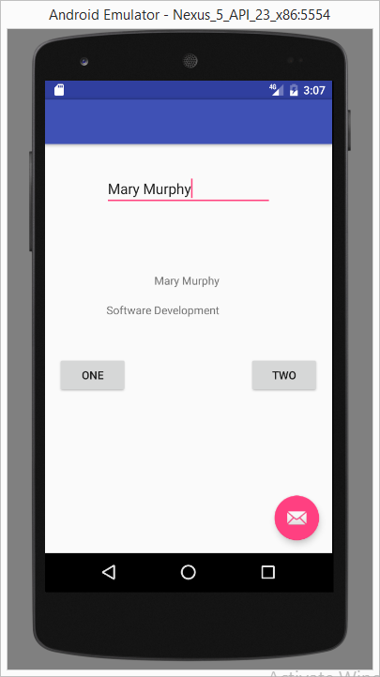
public class MainActivity extends AppCompatActivity {
TextView tvOne;
TextView tvTwo;
Button buttOne;
Button buttTwo;
EditText etName;
DatabaseReference CD = FirebaseDatabase.getInstance().getReference();
DatabaseReference CourseDirector = CD.child("CD");
DatabaseReference Course = FirebaseDatabase.getInstance().getReference();
DatabaseReference CourseName = Course.child("Course");
@Override
protected void onCreate(Bundle savedInstanceState) {
super.onCreate(savedInstanceState);
setContentView(R.layout.activity_main);
tvOne = (TextView)findViewById(R.id.textView);
tvTwo = (TextView)findViewById(R.id.textView2);
buttOne=(Button)findViewById(R.id.buttOne);
buttTwo=(Button)findViewById(R.id.buttTwo);
etName=(EditText)findViewById(R.id.editText);
}
@Override
protected void onStart() {
super.onStart();
CourseDirector.addValueEventListener(new ValueEventListener() {
@Override
public void onDataChange(DataSnapshot dataSnapshot) {
String text = dataSnapshot.getValue(String.class);
tvOne.setText(text);
}
@Override
public void onCancelled(DatabaseError databaseError) {
}
});
CourseName.addValueEventListener(new ValueEventListener() {
@Override
public void onDataChange(DataSnapshot dataSnapshot) {
String text = dataSnapshot.getValue(String.class);
tvTwo.setText(text);
}
@Override
public void onCancelled(DatabaseError databaseError) {
}
});
buttOne.setOnClickListener(new View.OnClickListener() {
@Override
public void onClick(View view) {
String strCD;
strCD=etName.getText().toString();
CourseDirector.setValue(strCD);
}
});
buttTwo.setOnClickListener(new View.OnClickListener() {
@Override
public void onClick(View view) {
CourseDirector.setValue("Raymund");
}
});
}

