Playing a Video clip in your Android app
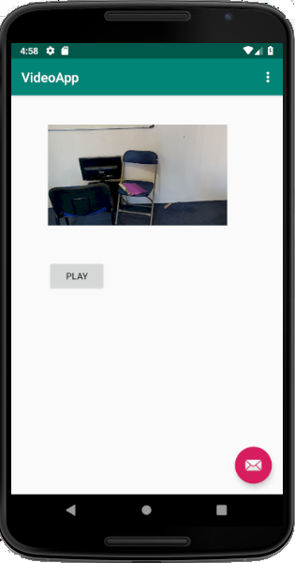 | Source code if you use a Button  Button btnPlay = (Button)findViewById(R.id.buttonPlay);  btnPlay.setOnClickListener(new View.OnClickListener() {  @Override  public void onClick(View v) {  VideoView videoView=(VideoView)findViewById(R.id.videoView);  String videoPath ="android.resource://" + getPackageName() + "/" + R.raw.rayvideo;  Uri uri = Uri.parse(videoPath);  videoView.setVideoURI(uri);  videoView.start();  }  });
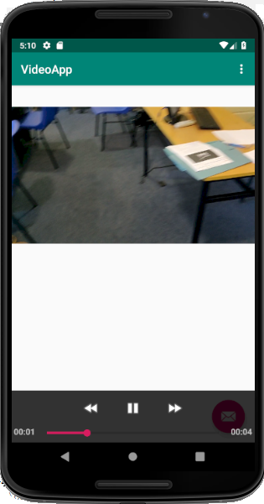 | Code if you use a mediaController as shown in screenshot  VideoView videoView=(VideoView)findViewById(R.id.videoView);  String videoPath ="android.resource://" + getPackageName() + "/" + R.raw.rayvideo;  Uri uri = Uri.parse(videoPath);  videoView.setVideoURI(uri);  MediaController mediaController = new MediaController(this);  videoView.setMediaController(mediaController);

Reference: https://www.youtube.com/watch?v=8Lq3HyBCuAA

